[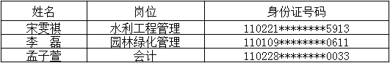](http://www.bjwater.gov.cn/pub/bjwater/swzx/swgg/201608/W020160810526721695985.png)