[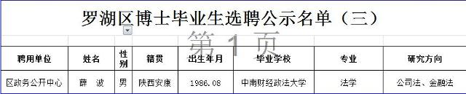](http://www.szlh.gov.cn/uploadfiles/201610/20161008113703953.jpg)