[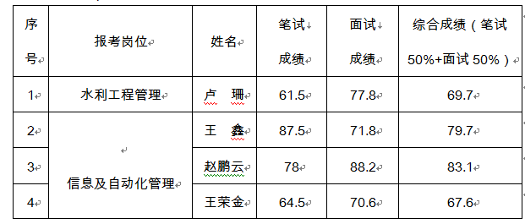](http://www.bjwater.gov.cn/pub/bjwater/swzx/swgg/201610/W020161028562010599797.png)