[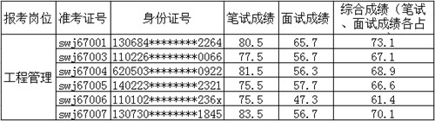](http://www.bjwater.gov.cn/pub/bjwater/swzx/swgg/201611/W020161101599955162952.jpg)