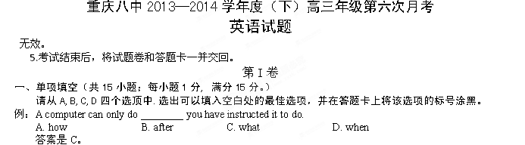1. —Hi, Mary! Do you know where Jim is?
— I think he ________ a lecture in the library.
A. will deliver B. is delivering C. has delivered D. delivered
2. —I’m sorry, but we can’t find your purse in our restaurant.
—________ I seem to lose something every time I eat out.
A. How come? B. Come on! C. Bad luck! D. Pardon me?
3. ________ Sunny Tours, I’d like to welcome you all to my city.
A. On behalf of B. On account of C. In honor of D. In hope of
4. People work through problems in ways ________ they are unaware.
A. of which B. in which C. on which D. to which
5. ________ unusual, this is not the first time the government has chosen to take control of large companies.
A. Since B. When C. Because D. While
6. —May I smoke here?
—Choose a seat in the smoking section, if you ________.
A. should B. must C. can D. may
7. It is a wise father ________ knows his child.
A. that B. which C. what D. whom
8. Knowing ________ you’re good at and doing even more of it creates excellence.
A. where B. which C. what D. that
9. Don’t you think the world would be an easier place to live in, if we all ________ the same language?
A. speak B. had spoken C. spoke D. would speak
10. His wife was busy cooking while he watched TV ________ comfortably in the sofa.
A. seat B. to seat C. seating D. seated
11. When our ancestors were hunters and gatherers 10,000 years ago, they didn’t have time to wonder much about ________ but finding food.
A. everything B. anything C. nothing D. something
12. —Did you see ________ man in ________ black pass by just now?
— No, sir. I was reading a newspaper.
A. the; the B. the; a C. a; the D. a; /
13. The government promises that relief materials ________ to the flood-hit areas in no time.
A. will be rushed B. will rush C. have rushed D. have been rushed
14. —Why did Mr. Green take his 7th grade students to the river yesterday afternoon?
—________ the river.
A. Cleaned up B. Cleaning up C. To clean up D. Clean up
15. —Why are you going to the court?
—________! I’ve been charged with parking my car in the wrong place.
A. It’s ridiculous B. You don’t say
C. Tell me about it D. Leave me alone

二、完形填空（共20小题；每小题1.5分，满分30分。）
请阅读下面两篇短文，掌握大意，然后从16-35各题所给的四个选项（A、B、C、D）中，选出最佳选项，并在答题卡上将该选项的标号涂黑。
A
There was a man who had four sons. He wanted his sons to learn not to 16 things too quickly. So he sent them each on a quest (寻求), 17 , to go and look at a pear tree that was a great distance away. The first son went in winter, the second in spring, the third in summer, and the youngest son in fall.
When they had all gone and come back, he called them together to 18 what they had seen. The first son said that the tree was ugly, bent, and 19 . The second son contradicted—it was covered with green buds and full of 20 . The third son 21 , saying it was laden with blossoms that smelled so sweet and looked so beautiful. It was the most graceful thing he had 22 seen. The last son disagreed with all of them; he said it was ripe and 23 with fruit, full of life and fulfillment.
The man then 24 to his sons that they were all right, because they had each seen but one season in the tree’s life. He told them that you cannot judge a tree, or a person, by only one season, and that the essence of who they are—the pleasure, joy, and love that come from that life—can only be 25 at the end, when all the seasons are up.
If you give up when it’s winter, you will 26 the hope of your spring, the beauty of your summer, fulfillment of your fall. Don’t let the 27 of one season destroy the joy of all the rest. Don’t judge a life by one 28 season.
16. A. determine B. judge C. analyze D. explore
17. A. by chance B. as usual C. in turn D. for sure
18. A. describe B. classify C. compare D. review
19. A. twisted B. wounded C. woodened D. deserted
20. A. delight B. pride C. faith D. promise
21. A. agreed B. approved C. argued D. announced
22. A. never B. ever C. once D. later
23. A. falling B. slipping C. going D. hanging
24. A. excused B. sighed C. explained D. instructed
25. A. measured B. considered C. affected D. committed
26. A. change B. develop C. miss D. taste
27. A. comfort B. pleasure C. regret D. pain
28. A. difficult B. magic C. lonely D. light

B
Most essays are made up of a beginning, a middle and an end. The beginning arouses the reader’s interest to 29 his attention to the subject of the essay or 30 the necessary background information. The middle gives us clear and logical 31 of the facts and ideas the writer intends to put forth. The end winds up the essay with a forceful statement to influence the reader’s 32 impression and shows consequences of the argument.
To the writer the beginning is often the hardest part of an essay, because he has to decide from what point to 33 , and in what direction to go. The end is important because it often gives the reader the deepest impression. It should be short, forceful and thought-provoking. No 34 ideas should be introduced in a concluding paragraph.
Sometimes it is good to 35 the concluding paragraph to the introduction. If, for instance, a question is raised in the beginning, an answer should be given in the end.
29. A. support B. secure C. change D. follow
30. A. provides B. proves C. confirms D. directs
31. A. indication B. direction C. expectation D. presentation
32. A. final B. good C. deep D. unique
33. A. state B. deliver C. start D. practice
34. A. ordinary B. general C. important D. new
35. A. spread B. link C. lead D. contact

三、阅读理解（共20小题；每小题2分，满分40分。）
请阅读下列短文，从每题所给的四个选项（A、B、C和D）中，选出最佳选项，并在答题卡上将该选项的标号涂黑。
A
Last summer, as part of my high school graduation project, I volunteered at Saunders House nursing home.
I choose this experience because it was something that I had never done before and I wanted to lend a helping hand. When I first came up with the idea of volunteering at a nursing home, I wanted to help out with activities and meet with some of the residents (住客).
At first it was challenging because I was extremely shy; however after getting to know the residents a little better, I started to feel more comfortable around them. My goal in volunteering was to bring a smile to the residents by doing different activities from word games to playing chess. I feel as if I had accomplished that goal.
At the nursing home, I did a lot of different activities with the residents ranging from Jeopardy, to Wheel of Fortune. One of my favorites was a word game where I would write a ten letter word on the board and the residents would try to come up with as many smaller words as possible. I could tell that it was one of their favorite games because they always seemed to be so enthusiastic when they played. I also transported residents to and from their rooms when they needed help; and whenever it was a nice day out, I would take them outside to get some fresh air and relax. On Saturday mornings, I would deliver the newspaper to the residents and on Sundays, I assisted with morning church services.
The most unforgettable part of this experience was when I had one on one conversations with the residents; it was incredible how many great stories they had to tell. One of the first residents was Mr. Charles Bowman who is one hundred and three years old!
36. The author volunteered at the nursing home because ________.
A. she was willing to help
B. the residents needed her
C. she was good with the old
D. the old people challenged her
37. What helped the author get over the challenge?
A. The determination to do the voluntary work.
B. Communicating with the residents.
C. The residents’ smiling faces.
D. The sense of achievements.
38. The author felt it ________ to do the activities with the residents.
A. enjoyable B. upset C. uncomfortable D. challenging
39. The author wrote the passage in order to ________.
A. persuade readers to care more about the old
B. encourage readers to do voluntary work
C. describe a social problem
D. share an experience
B
More and more pupils are giving teachers presents, but the practice only creates insecurity in parents and staff.
I’ve certainly noticed some pupils being feverishly overgenerous of late. Last year, I received not one bottle of wine but four for helping a disaffected pupil through his GCSEs. By and large, my colleagues report the gifts differing along gender lines. Gentlemen get ties, mugs, booze and, if they’re really lucky, tickets to football matches. The ladies are often presented with flowers, jewels, chocolates and so on.
When my son was at private school, I noticed there was a real competitiveness between the students about giving presents to teachers, with expensive baskets from fancy stores and huge bouquets being handed out on the last days of term. Since my wife and I only let my son give thank-you cards, it was clear we were not “classy”. Now he is at an inner-city primary, we’ve noticed that this kind of nonsense seems to have more or less disappeared. For one thing, there isn’t that kind of money floating around – but there isn’t that kind of competitive culture either.
Personally, I think gifts to teachers should be banned beyond the thank-you card: they cause many more problems than they solve, creating insecurity in both parents and staff. Perhaps the recession and the lack of money in people’s pockets might be a good excuse for the government to issue some guidelines to schools that gifts shouldn’t be accepted by teachers.
The gifts that I really value are the cards which say a genuine thank you. I still keep them in a file at home.
40. What can the author most probably be?
A. A teacher. B. A school nurse. C. A researcher. D. A gift shop owner.
41. The underlined word “nonsense” in Paragraph 3 refers to the fact that ________.
A. the son only gives thank-you cards to teachers
B. the author and his wife are not classy
C. the son goes to an inner-city primary
D. the students give gifts to teachers
42. To solve the problem, the author thinks it’s a good way to ________.
A. forbid the students to give any gifts to teachers
B. create insecurity by giving thank-you cards
C. make people have less money in pockets
D. issue some guidelines by the government
43. Which of the following can be the best title?
A. Don’t Forget to Give Gifts to Your Teachers
B. Presents Won’t Make Pupils Teachers’ Pets
C. Learn the Competitive Culture of Gifts
D. Refuse Presents from Your Students
C
On warm summer days with little or no wind, the air temperature in cities can be up to ten degrees higher than that of the surrounding countryside. This is a phenomenon commonly referred to as the “urban heat island” effect.
This phenomenon happens when pavement, buildings, and other infrastructure (基础设施) replace natural land cover. Large amounts of paved and dark colored surfaces—such as roofs, roads, and parking lots—absorb, rather than reflect, the sun’s heat, causing surface temperatures and overall ambient (周围的) air temperature to rise. Unlike soil, paved areas contribute to runoff, which means that as paved areas increase, the amount of water available for evaporation (蒸发) decreases. Moreover, urban areas have fewer trees and less natural vegetation which help to control the heat by providing shade and blocking solar radiation. The surfaces of leaves also provide water for evaporation which cools the air, further worsening the heat island effect.
In particular, during summer, more energy is required to cool the insides of building and for refrigeration, thereby creating additional heat output. This in turn leads to higher ambient air temperatures, which can also significantly increase the formation of urban smog in an area, degrading local air quality. Such a situation may directly affect public health with individuals more likely to suffer from heat exhaustion and the effects of asthma (哮喘).
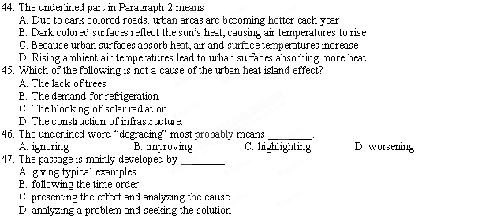
D
The U.S. government’s push to decrease the nation’s output of greenhouse gases by increasing the fuel efficiency of the cars Americans drive is arousing again an emotional argument: Does driving a small, fuel-efficient car make you more likely to die on the road?
Engineers and statistical analysts can point to data that suggest more-efficient cars don’t necessarily put motorists at greater overall risk. But most of us care less about the “overall” risk than we do about ourselves. Driving a big Chevrolet Tahoe SUV makes many of us believe we are safer than we would be in a smaller car — even if statistical measures across a large population of vehicles and all kinds of car accidents suggest the advantage of safety isn’t quite as wide as SUV owners believe.
The Obama government has put the fuel-efficiency and safety question back on the front burner by calling for new-vehicle fuel economy to rise to an average of 35 miles per gallon (加仑) by 2020 from about 25 mpg today. That goal could move higher if the government decides to adopt California’s requirement to cut vehicle greenhouse-gas giving off, which would result in stricter mileage standards.
Those moves, and the effects of last summer’s gas-price shock, are driving auto makers to offer cars such as the Toyota Yaris, Honda Fit and Daimler AG’s Smart For Two — which get the kind of mileage today that law says should be the average in a decade. Beyond that, auto makers will launch a wide range of new compact (紧凑的) vehicles, and decrease production of large, body-on-frame SUVs.
That’s leading to new concerns about “green safety”, a term for managing the balance between reducing vehicle size for efficiency and adding safety and protection features that tend to make vehicles heavier and less efficient. Undoubtedly, further work has to be done before Americans make the choice.
48. The U.S. government requires to improve the fuel efficiency in order to ________.
A. push Americans to drive smaller cars
B. reduce the output of greenhouse gases
C. drive auto makers to produce fewer SUVs
C. cause Americans to make an argument
49. According to Paragraph 2, engineers and analysts’ idea ________.
A. fails to relieve people of their worry about safety
B. persuades people to purchase smaller cars instead of SUVs
C. is based on research and therefore persuasive enough
D. makes people think of their safety as well as others’
50. About the Obama government’s new moves, the auto makers are ________ and average
Americans are ________.
A. uncertain; positive B. doubtful; uncertain
C. supportive; positive D. positive; uncertain
51. The best title for the text should be ________.
A. New Law Reduces Greenhouse Gases Output
B. Can Small Cars Overcome Accident Fears?
C. New Compact Cars Gets Popular in the U.S.
D. Do We Have to Follow the Government?
E
Everyone has some opinion about history, no matter how ill-informed. Walking through a parking lot in a university in Miami, I noticed a bumper sticker (车尾贴纸) that said, “Ruin a Liberal’s (自由派) Day—Recite Historical Fact!” But Marwick thinks this sort of opinion is just fine; it is unavoidable that we all feel a sense of ownership of history.
History never stands still, as Marwick says at the beginning of The Nature of History, “The shape and content of history, too, vary according to the methods and materials available to different generations.” Marwick’s goal is to explain, in plain language, the changes in the way history is done up to the present; one method is to connect history with advances in the physical sciences. Marwick examines a number of case studies toward the end of the book. He ends the book with a refreshing collection of aphorisms (格言) about history. History truly belongs to each and every man and we all belong to history; with the proper education, history can be made more accessible to everyone.
Marwick relates how inventions and the physical sciences have driven historical changes. Dropping a ball in a vacuum will reveal the same properties (性质) each time the experiment is conducted, providing the conditions are the same. But historians obviously do not have the luxury of reproducing such conditions; historians view the past through the present which depends on invention and science.
By looking at the changing nature of history, Marwick feels the study progressing. Although Marwick suspects some people would accuse a historian of creating job security with the endless views of the past, he insists it is imperative based on the philosophy, science, and new materials of the age. History, according to Marwick, must be for everyone and not remain locked behind the walls of academia.
52. The author mentions the bumper sticker in order to ________.
A. show his own opinion about history
B. introduce the readers to Marwick
C. explain the freedom of understanding history
D. make the readers know about the argument between historians
53. Which of the following best describes the statement “History never stands still”?
A. Marwick explains the changes in the way history is done up to the present.
B. Marwick connects history with advances in the physical sciences.
C. He ends the book with a refreshing collection of aphorisms about history.
D. The shape and content of history vary according to the methods and materials available.
54. In paragraph 3, Marwick gives the example of dropping a ball in a vacuum to prove ________.
A. the changeable nature of history
B. the difficulty of historical study
C. changeable ways of historical study
D. the difficulty of scientific study
55. The text is intended to ________.
A. state a historian’s ideas
B. argue against a historian
C. attract readers to study history
D. describe the story of a historian
第II卷
四、写作(共两个写作任务; 满分35分。)
写作一 (满分15分)
请结合材料，按要求用英文写作。
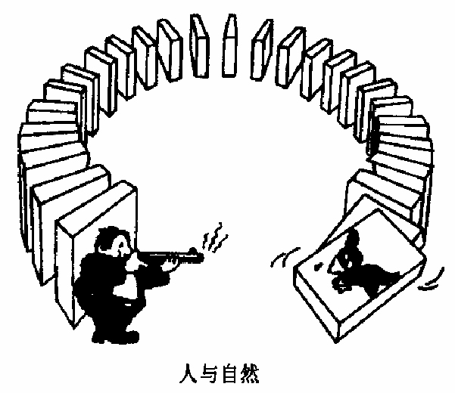
要求: (1) 就此材料发表你的看法;
(2) 紧扣材料，有明确的观点;
(3) 词数不少于60;
(4) 在答题卡上作答。
参考词汇：多米诺效应 Domino Effect
____________________________________________________________________________________________________________________________________________________________________________________________________________________________________________________________________________________________________________________________________________________________________________________________________________________________________________________________________________________________________________________________________________________

写作二 (满分20分)
假如你是中学生李华，你的英国笔友William 来信，询问你提到的“军训”是什么意思。请你写一封回信，向他介绍“军训”的情况。内容应包括：
- 时间：两周；地点：部队军营
- 内容：操练、学唱军歌、行军等
- 目的：...... (内容自拟)
- 感受：印象深刻；影响深远
注意: (1) 词数不少于80;
(2) 书信格式及开头均已给出(不计入总词数)。
参考词语：军训 military training 军营 camp
Dear William,
How are you going? I’m writing to explain to you what military training is.
____________________________________________________________________________________________________________________________________________________________________________________________________________________________________________________________________________________________________________________________________________________________________________________________________________________________________________________________________________________________________________________________________________________
____________________________________________________________________________________________________________________________________________________________________________________________________________________________________
____________________________________________________________________________
____________________________________________________________________________
Yours,
Li Hua

高2014级高三(下) 第六次月考英语试题答案
一、单项填空
1—5 BCAAD 6—10 BACCD 11—15 BDACA

二、完形填空
16—20 BCAAD 21—25 CBDCA 26—30 CDABA 31—35 DACDB

三、阅读理解
36—39 ABAD 40—43 ADDB 44—47 CCDC 48—51 BADB
52—55 BDAA

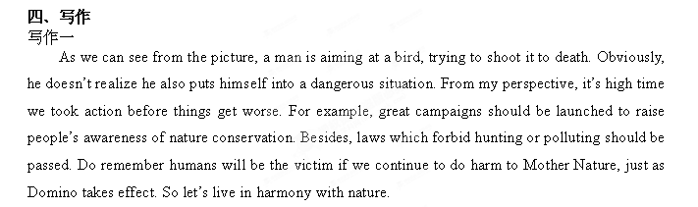
写作二(满分20分)
Dear William,
How are you going? I’m writing to explain to you what military training is.
We middle school students usually go to camps to take military training, which lasts about two weeks. We have to practise some simple military movements. In addition, we are taught to sing songs which are very encouraging. What impresses me most is the long march, which sometimes covers as far as ten kilometers.
Military training is meant to teach us how to cooperate and act as a whole. Meanwhile, good qualities such as selflessness, dedication and perseverance can be cultivated and fear conquered. In short, military training leaves me a deep impression and influences me profoundly, which is far beyond my imagination.

