辽宁省五校协作体2015届高三上学期期中考试英语试题

注意事项：
1．本试卷分Ⅰ卷、Ⅱ卷两部分，满分：150分；考试时间：100分钟。
2．答题前，考生务必将自己的姓名、考号填写在答题卡上。
3．选出每小题答案后，用铅笔把答题卡上对应题目的答案标号涂黑，如需改动，用橡皮擦干净后，再选涂其他答案标号。不能答在本试卷上，否则无效。

第I卷 (100分)
第一部分 听力（共两节，满分30分） （略）

第二部分 阅读理解（共两节，满分40分）
- （共15小题；每小题2分，满分30分）
阅读下列短文，从每题所给的四个选项（A、B、C和D）中，选出最佳选项，并在答题卡上将该项涂黑。
A
An artist in Oakland, California is using his skills to help the homeless. Greg Kloehn builds very small shelters that make life on the streets a little more comfortable. The structures offer the homeless some safety and protection from bad weather. Each little house also has wheels on the bottom so it can go wherever its owner goes.
Greg Kloehn has given away at least 20 tiny houses. Several are on the roadside near an active railroad. On a recent day, Mr. Kloehn stops at one to visit Oscar Young. The two men hug. Inside his little shelter Mr. Young gets relief from cold nights on the streets. Mr. Kloehn also visits Sweet-Pea, another friend who also lives in one of the little homes the artist built. She says it keeps her safe and protects her belongings.
In the mornings, Mr. Kloehn searches the streets for building materials. He gathers what he can and takes it to his studio. There, he puts the houses together. Empty coffee bags become roof material. A washing machine door and refrigerator part become windows. Nails, screws and the sticky glue hold all the pieces together. The artist also attaches a small electrical device to the house. The device is powered by the sun.
Some of the people living on the streets once had normal houses of their own. But some of the people say they have learned to live with less and they are thankful to that man.
Mr. Kloehn says his work is not a social project. He says he is just someone using his skills to help his homeless neighbors.
21. The following are the advantages of the small shelters except ________.
A. saving power and energy
B. protecting possessions of the homeless
C. decorating the streets where they are
D. keeping the homeless safe and comfortable
22. We can learn from the passage that ________.
A. Greg Kloehn has sold at least 20 tiny houses
B. An act of kindness has made people simple and grateful
C. The shelters are immovable
D. The government has got involved in the action
23. The passage is likely taken from ________.
A. An official report B. An art review
C. A science magazine D. A news report
24. What’s the main idea of the passage?
A. An artist creates homes for the homeless.
B. A more comfortable shelter on the streets.
C. A successful social project in Oakland.
D. An artist makes a living by designing small shelters.
B
Researchers in Hungary have confirmed something many dog owners have long suspected: that canines understand our feelings.
Using a Magnetic Resonance Scanner, or MRI, scientists found that when it comes to emotions, dogs’ brains are similar to those of humans. Dogs are usually not relaxed in a lab environment, but with a little petting and lots of treats they can be trained to sit still even in an MRI scanner. That’s how researchers in Hungary’s ELTE University were able to get images of their brains at work.
Research fellow Attila Andics says it helped them better understand the dogs’ relationship with humans. “We have known for a long time that dogs and humans share similar social environment, but now our results show that dogs and humans also have similar brain mechanisms（大脑机制）to process social information,”said Andics.
After training 11 dogs to stay motionless while their brains were scanned, the researchers checked their neurological（神经系统的）responses to about 200 emotionally significant sounds, from whining and crying to playful barking and laughing. They then compared the responses from human subjects. They found striking similarities.
Andics says it opens new possibilities for research. “It establishes a foundation of a new branch of comparative neuroscience, because until now it was not possible to measure the brain activities of a non-primate（非人灵长类动物）and the primate brain in a single experiment,” said Andics.
And what that tells ordinary dog owners, the Hungarian scientists say, is to treat your canine companions as friends, not mere animals, because they evidently understand human feelings.
25. Which of the following statements is true?
A. Dog’s behaviors are the same as those of humans.
B. Usually dogs can sit still in a lab environment.
C. Dog owners shouldn’t treat dogs as their friends.
D. The emotions of dogs are similar to those of humans.
26. What does the underlined word “canines” mean in the first paragraph?
A. Dogs B. Animals C. dog owners D. researchers
27. How do researchers get the dogs to sit still?
A. By force. B. By injection.
C. By comforting and treating. D. By ignoring.
C
Have Fun at UK’s Most Famous Theme Park
Alton Towers Theme Park re-opens with selected rides and attractions for Half-Term from 19th to 27th of February 2011, and then again for the main season, starting on 26th March, 2011.
There’s something for the whole family at Alton Towers, with lots of terrific rides, amazing live shows, and wonderful costume characters. Guests of all ages will enjoy many different fun-packed activities. Here are some of the rides.
Thirteen
Thirteen is based on the discovery of an ancient burial site in an area of unexpected woodland known as the Dark Forest, and built on the site of the old Corkscrew roller-coaster. You are invited to take the final ride on Thirteen, going deep into the seemingly living, breathing Dark Forest.
You must be at least 1.2m tall to go on the ride. If you are 1.96m or over , you can’t go on the ride.
Laughs and frights
Are you up for a bit of light-hearted fun with friends and family? The roller-coaster at the Alton Towers Resort make for an unforgettable experience. There is a great deal of fun and lots of laughs and fun frights on its amusement rides.
Attractions
There is entertainment for the whole family. There are lots of rides and activities to keep all ages happy, all day long. You may take a ride on a the Skyride or start or finish your day with a round of Extraordinary Golf.
Save 20% by booking online and benefit from Early Ride Time. There is no online booking fee—the price you see is the price you pay.
Ticket Type Including Early Ride Time | Online Only Price
Online Family of Four Ticket | £ 90.24
Online Adult Ticket | £31.68
Online Child Ticket (age 4-11) | £24.48
28. The feature of the theme park is that ________.
A. it only provides terrific rides
B. only adults can go on the ride
C. everyone in the family can have fun there
D. none of the activities are suitable for tall people
29. If little Tom is 1.15m tall, which of the following is he forbidden to do?
A. Go on the Skyride.
B. Take the final ride on Thirteen.
C. Ride on the roller-coasters.
D. Play Extraordinary Golf.
30. If a family of four wants to buy tickets to the theme park at the booking office, they should pay________.
A. about 72 pounds B. about 150 pounds
C. about 113 pounds D. about 90 pounds
31. Which of the following statements is true?
A. The theme park re-opens mainly for children.
B. A 13-year-old boy needs to pay 24.48 pounds for his ticket.
C. Guests can visit the theme park at any time of the year.
D. You can save 20% of booking fee if you book online.
D
After having more than a few acquaintances (相识的人) online, it might come a blow to keen social networkers like Barack Obama, or even Facebook founder Mark Zuckerberg himself.
According to a research, the average person has in fact twice as many online friends as physical ones. Users of social-networking sites have on average 121 online friends as compared with physical ones. The study also claims that people tend to be more open, confident and honest with their virtual friends than their “real” ones.
“For most people , the Internet is a way of keeping in touch with loved ones and friends, but for people who are isolated（隔离的） due to illness, it plays a more vital role, and can often act as a lifeline.”says Helen Oxley, a psychologist at Wythenshawe hospital.
“People with illnesses often rely on the Internet to facilitate（促进） friendships, since they blog and use networking sites as a way of dealing with their illness. It can foster（培养） a sense of social connection for those who frequently feel isolated, which is important to psychological well-being.”
In wider society, the ways in which friendships are formed are changing, with people recognizing that they can develop deep and meaningful connections with others that they’ve never met, and may never meet. About one in 10 people has either met their best friends online, or believes they can make lifelong friends on the Web.
The findings highlight how social introductions are also changing. Only five percent would ask for someone’s phone number, while 23 percent are now likely to ask for an email address or a full name with the intention of adding the person to their social network.
At the same time, however, a questionnaire completed by 4,427 suggests that 20 percent of parents believe their children’s education is affected by surfing the Net. They think their children are doing poorly at the school due to the amount of time they spend on non-educational websites.
32. The underlined word “it” in Para 1 most probably refers to ________.
A. people spending too much time surfing the Net
B. people having more virtual friends than real ones
C. people relying on the Internet to connect with friends
D. people making meaningful connections with strangers
33. We can infer from the text that________.
A. sick people can recover more quickly by surfing the Net
B. students get important information online
C. people tend to trust their virtual friends more than their real ones
D. students who surf the net always perform not so well
34. What percentage of parents believe that the Internet has a bad effect on their children?
A. About 5 percent. B. About 10 percent.
C. About 23 percent. D. About 20 percent.
35. In the next part, the author will probably discuss ________.
A. how children make use of the Internet to study
B. how much time children spend on the Internet
C. how children learn about the world through the Net
D. how parents feel about their children’s studies
第二节（共5小题；每小题2分，满分10分）
根据短文内容，从短文后的选项中选出能填入空白处的最佳选项。选项中有两项为多余选项。
We all go through times when we feel we are not good enough. We might feel that way at work or in school or even as a parent. Here are some things to remember when you feel like that.
1. 36 When I started my Ph.D. program, I felt like the dumbest person in every class. I couldn’t believe how many smart people were there. I didn’t know if I could measure up to their intelligence or compete in the same league with them. Years later, I found out that almost everyone felt this way, too.
2. You are unique and have special talents. If you can barely make Hamburger Helper , don’t compare yourself to your sister who is a chef(厨师). I’m sure you can do many things that she can’t. 37 You are you. You are not your sister.
3. You need to stop chasing perfection. It doesn’t exist. What’s perfect to me is not perfect to you. So if you think that there is some objective measurement of perfection and that the rest of the world is judging you against, then you are wrong. 38
4. 39 Our sense of self-worth is based in our thoughts. We have been programmed for many years with thoughts about ourselves. Messages come from our parents, our peers, teachers, the media and our own labels. But guess what? They are only thoughts. Just because you think these thoughts, it doesn’t make them true. 40
A. You have the power to change your future.
B. So focus on your own passions and talents.
C. You are not the only one who feels this way.
D. If you love yourself for who you are, other people will notice.
E. You need to change your thought patterns.
F. One of my favorite sayings is, “Don’t believe a negative thought you think!”
G. Most people are too worried about their own lack of perfection to judge you.
第一节 完形填空（共20小题；每小题1.5分，满分30分）
阅读下面短文，从短文后各题所给的四个选项（A、B、C和D）中，选出可以填入空白处的最佳选项，并在答题卡上将该项涂黑。
Many years ago, a baby boy came into this world. But 41 , he didn’t come with a cry, which was a big 42 from the medical point of view. The doctor turned the baby 43 and slapped his bottom sharply. The baby cried and 44 . The father smiled and silently cried 45 . He held the baby in his arms and didn’t allow the doctor to touch the baby anymore... That baby was me, and that man was my dad.
Dad never tried to hug or kiss me when I was a child. And 46 , he never said “I love you” to me, either. Maybe it’s a Chinese cultural thing, or maybe that’s the way my dad was. But 47 I felt defeated, sad or lonely, dad was always there. He was a man of 48 words, but I could always feel a very special 49 to him.
When I was in high school, dad retired and 50 a food stand on the street near my school. Every day when I finished 51 , my classmates and I 52 pass his food stand. But I really hated talking to dad in front of his food stand, 53 I did not want my classmates to know that my dad was selling noodles on the street!
One night, I couldn’t 54 it any more and shouted, “Dad, could you stop selling your 55 noodles? I don’t need a father who sells noodles on the street!” At that moment, dad was 56 . He tried to say something but didn’t. When he turned his head 57 , something happened that I had never seen and would never forget for 58 of my life. His eyes were filled with tears and sadness. It was the first time that I saw dad 59 . My mom later told me that dad was selling noodles to save money for my college education. I was such an idiot, and even today I still feel 60 for that night.
41. A. abruptly B. unfortunately C. expectedly D. fortunately
42. A. question B. problem C. challenge D. solution
43. A. upside down B. inside out C. up and down D. at the bottom
44, A, existed B. produced C. delivered D. survived
45. A. as well as B. either C. as well D. neither
46. A. of course B. by no means C. on the contrary D. in vain
47. A. whatever B. whichever C. whenever D. however
48. A. few B. a little C. little D. a few
49. A.combination B. conversation C. communication D. connection
50. A. put up B. set up C. came up D. picked up
51. A. school B. lesson C. course D. task
52. A. could B. should C. would D. might
53. A. whether B. though C. while D. because
54. A. stand B. believe C. assume D. prove
55. A. wonderful B. stupid C. delicious D. strange
56. A. confused B. frightened C. shocked D. disappointed
57. A. out B. around C. down D. away
58. A. the rest B. the other C. another D. other
59. A. laughing B. shouting C. hugging D. crying
60. A. grateful B. guilty C. proud D. embarrassed
第II卷 (50分)
第三部分：英语知识运用（共两节，满分45分）
第二节：（共10小题：每小题1.5分，满分15分）
阅读下面材料，在空白处填入适当的内容（不多于3个单词）或括号内单词的正确形式。
The Nobel Peace Prize was awarded Friday to India’s Kailash Satyarthi and Pakistan’s Malala Yousafzai for their struggles 61 the suppression（压迫）of children and for young people's rights, 62 (include) the right to education.
Yousafzai came to 63 (globe) attention after she 64 (shoot) in the head by the Taliban two years ago for her efforts 65 (promote) education for girls in Pakistan.
Through her heroic struggle, Yousafzai has become a leading spokeswoman for girls’ rights to education. According to the Nobel committee, at 17 she’s the 66 ever peace prize winner. “I’m proud that I’m the first Pakistani and the first young woman or the first young person 67 gets this award,” she said in Birmingham, England.
She doesn’t believe that she deserves the award but considers 68 an encouragement to continue her campaign and to know that she isn’t 69 .
Awarding the Peace Prize to a Pakistani Muslim and an Indian Hindu 70 (give) a message to people of love between Pakistan and India, and between different religions.
第四部分 写作（共两节，满分35分）
第一节 短文改错（共10小题；每小题1分，满分10分）
假定英语课上老师要求同桌之间交换修改作文，请你修改你同桌写的以下作文。文中共有10处语言错误，每句中最多有两处。错误涉及一个单词的增加、删除或修改。
增加：在缺词处加一个漏字符号（∧），并在其下面写出该加的词。
删除：把多余的词用斜线（╲）划掉。
修改：在错的词下划一横线，并在该词下面写出修改后的词。
注意:1.每处错误及其修改均仅限一词；
2.只允许修改10处，多者（从第11处起）不计分。
Here is a introduction to Beech School of English. Comparing with the other schools, I will think it is the best one that you can go to. First, it is very convenient of you to get there by train. Second, the school is small and the classes are very small, either. There are 24 teaching hours a week. Stay with an English family will provide you with a chance to practise your speaking English and know more about the English family life. After class, you can enjoy sports and other activity with your classmates. The price is reasonably. I will get in touch with them you are interested in it.
第二节 书面表达（满分25分）
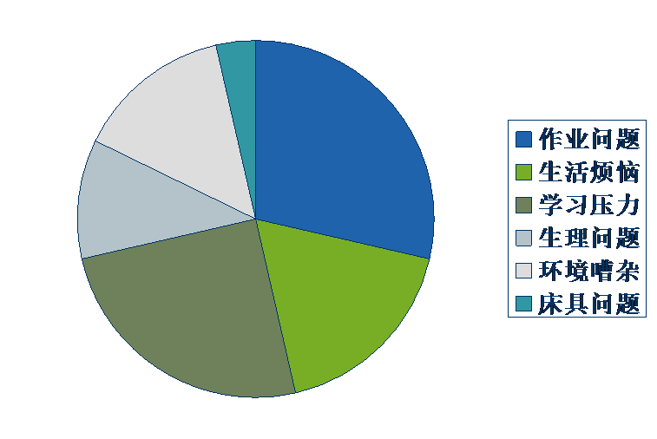
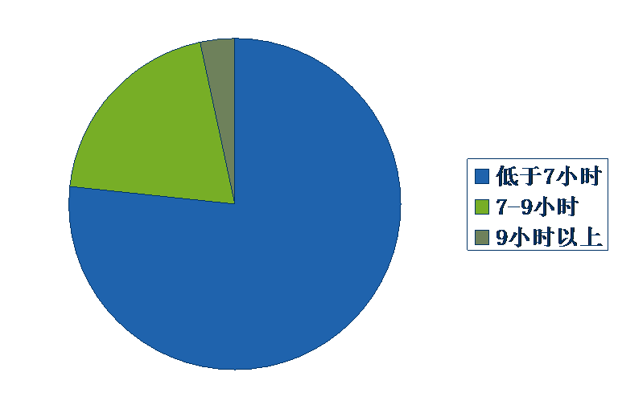
下面是对重庆市某中学的中学生睡眠情况调查的结果，请参照以下信息，用英文写一篇调查报告，并提出改进措施。

注意：1. 词数100左右，开头语已为你写好；
2. 适当增加细节，以使行文连贯。
As is shown in the chart, most students don’t have enough sleep._______________________________________________________________________________________________________________________________________________________________________
________________________________________________________________________________________________________________________________________________________
________________________________________________________________________________________________________________________________________________________
________________________________________________________________________________________________________________________________________________________
________________________________________________________________________________________________________________________________________________________
2014-2015学年度上学期五校协作体高三期中考试
英语试题参考答案
阅读： A) CBDA B) DAC C) CBCA D) BCDB
七选五：36-40 CBGEF
完型填空：41-45 BBADC 46-50 ACADB 51-55 ACDAB 56-60 CDADB
语法填空： 61. against 62.including 63. global 64. was shot
65. to promote 66. youngest 67. that/who 68. it
69. alone 70.gives
短文改错：
第一句：a改为an
第二句：comparing 改为compared; 去掉will
第三句：of 改为for
第四句：either改为too
第六句：Stay改为Staying; speaking改为spoken
第七句：activity改为activities
第八句：reasonably 改为reasonable
第九句：you前加if

参考范文
As is shown in the chart, most students don’t have enough sleep. Surprisingly, most of the surveyed students sleep less than 7 hours. Only a few students sleep 7 to 9 hours. And those who sleep more than 9 hours are in the minority.
Many factors contribute to this problem. First of all, due to the fierce competition, students can only achieve success by working hard. Secondly, with too much homework to do, students have busy schedules. Other factors, such as sleeping condition, noisy environment and pressure from life should also be considered.
Therefore, effective measures should be taken to solve the problem. Most importantly, teachers should give less homework. In the meanwhile, students should improve their study efficiency so that they can have enough sleep at night.

版权所有：()

