洛阳市2014——2015学年高中三年级期中考试
英语试卷
本试卷分第Ⅰ卷（选择题）和第Ⅱ卷（非选择题）两部分。考试结束后，将本试题卷和答题卡一并交回。
第Ⅰ卷
注意事项：
1．本试卷分第Ⅰ卷（选择题）和第Ⅱ卷（非选择题）两部分。第Ⅰ卷1页至10页，第Ⅱ卷11页至12页。
2．答题前，考生务必将自己的姓名、准考证号填写在本试卷和答题卡上相应的位置。
3．全部答案在答题卡上完成，答在本试卷上无效。
4．第Ⅰ卷听力部分满分30分，不计入总分，考试成绩录取时提供给高校作参考。
5．考试结束后，将本试卷和答题卡一并交回。
第一部分 听力（共两节，满分30分）
做题时，先将答案标在试卷上，录音内容结束后，你将有两分钟的时间将试卷上的答案转涂到答题卡上。
第一节（共5小题；每小题1．5分，满分7．5分）
听下面5段对话，每段对话后有一个小题。从题中所给的A、B、C三个选项中选出最佳选项，并标在试卷的相应位置。听完每段对话后，你都有10秒钟的时间来回答有关小题和阅读下一小题。每段对话仅读一遍。
1. What did Dick move last night?
A. His piano, B. His back. C. His book.
2. What does the man spend most of his time doing on weekends?
A. Reading books. B. Playing ball. C. Watching TV.
3. How often did Amy take lessons in the past?
A. One day a month. B. Every other day. C. One day a week.
4. What does the woman think of the man’s job?
A. Very good. B. Very bad. C. Just so-so.
5. What happened in the woman’s building?
A. A traffic accident. B. A robbery. C. A power failure.
第二节（共15小题；每小题1．5分，满分22．5分）
听下面5段对话或独白。每段对话或独白后有几个小题，从题中所给的A、B、C三个选项中选出最佳选项，并标在试卷的相应位置。听每段对话或独白前，你将有时间阅读各个小题，每小题5秒钟；听完后，各小题将给出5秒钟的作答时间。每段对话或独白读两遍。
听第6段材料，回答第6至7题。
6. Who is probably the woman?
A. A party-goer. B. A tour guide. C. A waitress.
7. How many bottles of beer did the man order?
A. 1. B. 3. C.4.
听第7段材料，回答第8至10题。
8. Who may Ted be?
A. Their son. B. Their colleague. C. Their classmate.
9. How does the man feel?
A. Angry. B. Sad. C. Ashamed.
10. What does the woman ask the man to do?
A. Talk with the boss. B. Talk with Ted. C. Forget about it.
听第8段材料，回答第11至14题。
11. Why did the woman book the room?
A. For a trip. B. For a wedding. C. For her holiday.
12. What is the check-in time that the woman booked?
A. 2 o’clock. B. 1 o’clock. C. 12 o’clock.
13. How much must the woman pay for an early check-in?
A. ￡20. B. ￡10. C. ￡10.
14. What did the man do at last?
A. He agreed with the woman.
B. He stuck to the rules.
C. He scolded the woman.
听第9段材料，回答第15至17题。
15. What is the man looking for?
A. A bag. B. A notebook. C. A tie.
16. What time is it now?
A. 7:30. B. 7:00. C. 6:45.
17. Who is also coming?
A. The man’s daughter. B. Mrs. Johnson’s sister. C. The woman’s son.
听第10段材料，回答第18至20题。
18. What does the first news want the readers to vote for?
A. Ads. B. Websites. C. Newspapers.
19. How many airline companies does the BAC serve?
A. 25. B. 50. C. 280.
20. What does the speaker talk about at last?
A. Jazz. B. Festival traditions. C. Riverdance.

第二部分 阅读理解（共两节，满分60分）
第一节（共15小题；每小题3分，满分45分）
阅读下列短文，从每题所给的四个选项（A、B、c和D）中，选出最佳选项，并在答题卡上将该项涂黑。
A
To begin your expedition of wonder, get yourself a driver’s license at your local department of motor vehicles, then rent a car and take off for New Hampshire’s Crawford Notch State Park. This beautiful park is abundant in wildlife, natural vegetation and running rivers falling from high cliffs. It is a place of spectacular mountain views, hiking trails, waterfalls and fishing locations. All you need to do is jump in your rented car or SUV and head for the sunset![]
Okay, so you’ve just finished those crazy summer final exams and you’re exhausted from all of the stress. That’s okay because New Hampshire’s State Park also offers a perfect way to recover at Coney’s Flume Park where visitors can ride all the rapids in a hollowed out log, eat hotdogs and play on the amusement tides. Good times will be had no matter what your preference at Dry River Campground, which offers wood cabins, showers, electricity, flush toilets, laundry and fire rings. It’s like a home away from home, so gather your camping gear and head for the journey!
Lake Winnipesaukee
If you’re stuck on figuring out how to access your own wheels, how about finding a bus to take you to Weirs Beach? There are fall leaves tours running in the fall through the end of October. Let the captain do the driving while you enjoy the colors along the shoreline and the mountainsides.
If you can’t find some peace of mind from those nasty final exams while relaxing in your lakeside cottage, take a cruise and go fishing, go bird sightseeing, or just kick back in a rented boat and let the coo of the birds wash your troubles away.
No matter where you go in New Hampshire, you’ll meet the most friendly people you can imagine. Do dive into that rental car or SUV, take off for a vacation to New Hampshire and treat yourself to one of America’s most beautiful states. Enjoy!
21. Who is this passage mainly intended for?
A. School students. B. Bird lovers.
C. Driving learners. D. Trouble makers.
22. Where can you enjoy riding on logs?
A. At Weirs Beach. B. In your lakeside cottage.
C. At Coney’s Flume Park. D. At Dry River Campground.
23. What type of writing is this text?
A. A tour introduction. B. A travel diary.
C. An announcement. D. An official report.
B
As temperatures go up, bison（北美野牛）get smaller. Joseph Craine, research assistant professor in the Division of Biology at Kansas State University, examined how climate change during the next 50 years will affect grazing（放牧）animals such as bison and cattle in the Great Plains.
“Bison are one of our most important conservation animals and hold a unique role in grasslands in North America,” Craine said. “In addition to their cultural and ecological significance, they’re economically important. There are about half a million bison in the world.” Craine analyzed a data set of 290,000 weights, ages and sexes collected from 22 bison herds（兽群）throughout the U. S. The organizations kept annual records of each animal in the herd and matched the data with the climates of the sites.
Based on differences in sizes of bison across herds, Craine found that during the next 50 years, future generations of bison will be smaller in size and weigh less. Climate is likely to reduce the nutritional quality of grasses, causing the animals to grow more slowly.
“We know that temperatures are going to go up,” Craine said. “We also know that warmer grasslands have grasses with less protein（蛋白质）, and we now know that warmer grasslands have smaller grazers. It all lines up to suggest that climate change will cause grasses to have less protein and cause grazers to gain less weight in the future.”
Craine said the results of climate change in coming decades can already be seen by comparing bison in cooler, wetter places with those in warmer, drier places. For example, the average 7-year-old male bison in South Dakota weighed 1, 900 pounds, while an average 7- year-old male bison in Oklahoma — a warmer place — weighed 1, 300 pounds.
“The difference in temperature between those two states is around 20 degrees Fahrenheit, which is about three times the projected increase in temperatures over the next 75 years,” Craine said. “It is a clear indicator that long-term warming will affect bison and is something that will happen across the U.S. over the next 50-75 years.”
24. In the next fifty years, researchers Say, bison will ________.
A. become smaller and lighter B. disappear in the Great Plains
C. play a less important part D. adapt to different climate changes
25. The underlined word “grazers” probably refers to ________.
A. the researchers B. the grasses C. the bison D. the protein
26. What is the main reason for the bison to become smaller?
A. The deceasing amount of grass. B. The rising temperature.
C. The rising number of bison. D. The loss of weight.
27. Paragraph 5 is written as an example to show ________.
A. Craine’s prediction will come true in 50 years
B. bison are smaller than in the past
C. the nature balance is being destroyed
D. bison’s size is linked with different climate
C
When my mother was alive, she used to tell me again and again about the value of just being nice. “Never underestimate（低估）the power of a smile,” she would say. I fear she would be very disappointed looking at the world today. A lot of people don’t smile and when it comes to service today, they’re just not nice. Now don’t give me wrong, not all service workers but a good many.
I was on the phone the other day with a computer help desk. First a man, then later a woman, who couldn’t have been ruder. And this to a customer, who didn’t know his way around a PC. But no matter, I could tell they thought I was a bother, The woman, in fact, seemed to be chewing gum as she unemotionally clicked off a series of commands for me to perform.
The next day I heard from a friend of mine who got a performance review without his boss once looking up at him. Not once.
You see it everywhere. Gone are the days when people cared about you. It’s a sign of the time, I suspect. But that makes me sad — for them and for us all. People who aren’t happy, who don’t smile, who don’t kid, who don’t joke or make light of even bad situations, make for an even worse situation.
And it spreads like a cancer. Someone’s rude to you, you’re rude to them and to the next fellow you meet, and on and on. Smiles are contagious（易感染的）but so annoyances. The boss who can’t be bothered with his workers. The celebrity who can’t be bothered with her annoying fans.
You know, my mom used to judge presidential candidates by how they smiled. I would say, “But mom, you don’t know if that smile is real.”
“Oh, yes I do,” she would tell me. “I can feel it.”
It’s in their eyes, she would say. And it’s in their smile. The rest just kind of falls into place.
28. Why did the writer mention his phone call?
A. To prove his mother is wrong.
B. To show many people aren’t nice.
C. To tell us he knows little about computer.
D. To share his funny experience with us.
29. What is the author’s attitude towards the boss of his friend?
A. Opposed. B. Doubtful. C. Respectful. D. Supportive.
30. When someone is rude to you, you’re advised to ________.
A. be rude to the next person B. be nice to the people you meet
C. become one just like him or her D. make for a worse situation
31. What’s the best title of the passage?
A. The power of a smile B. Don’t judge a person by his look
C. The effect of rudeness D. Feel a person in his eyes
D
Many Christmas customs are based on the birth of Christ, such as giving presents because of the Wise Men, who brought presents to the baby Jesus（耶稣）Singing Christmas carols is based on the scene of the birth with figures of shepherds, the Wise Men and animals surrounding the baby Jesus.
The origin of Santa Claus begins in the 4th century with St. Nicholas, Bishop of Myra, an area in the present-day Turkey. By all accounts St. Nicholas was a generous man, particularly devoted to children. After his death around 340 A. D. he was buried in Myra, but in 1087 Italian sailors were believed to steal his remains and removed them to Italy, greatly increasing St. Nicholas’ popularity throughout Europe.
His kindness and reputation for generosity gave rise to claims that he could perform miracles and devotion to him increased. St. Nicholas became the patron（保护神）saint of Russia, where he was known by his red cap, flowing white beard, and bishop’s mitre. In Greece, he was the patron saint of sailors; in France, he was the patron of lawyers, and in Belgium, the patron of children and travelers. Thousands of churches across Europe were dedicated（供奉的）to him and sometime around the 12th century an official holiday was created in his honor. The Feast of St. Nicholas was celebrated on December 6 and the day was marked by gift-giving and charity.
After the Reformation, European followers of St. Nicholas declined, but the legend was kept alive in Holland where the Dutch spelling of his name Sint Nikolass was eventually transformed to Sinterklaas. Dutch children would leave their wooden shoes by the fireplace, and Sinterklaas would reward good children by placing treats in their shoes. Dutch colonists brought this tradition with them to America in the 17th century and here the English name of Santa Claus appeared.
32. Why, as is believed, is Santa Claus so popular in Europe?
A. Because of his reputation for generosity.
B. Because he died in Italy.
C. Because of the deed of the Italian sailors.
D. Because of his devotion to Italian children.
33. What was the Feast of St. Nicholas held for?
A. Celebrating Christ’s birthday. B. Giving thanks to churches.
C. Marking a holiday. D. Honoring St. Nicholas.
34. What does “Sinterklaas” in the last paragraph refer to?
A. European followers. B. Santa Claus.
C. Jesus. D. The Dutch.[]
35. Which of the following can best describe Santa Claus?
A. Generous, devoted and honored. B. Dedicated, kind and alive.
C. Well-known, traditional and lovely. D. Popular, famous and creative.
第二节（共5小题；每小题3分，满分15分）
根据短文内容，从短文后的选项中选出能填入空白处的最佳选项。选项中有两项为多余选项。
Having a happier life is something we all always struggle for. One of the key foundations of
that is to be consistent in doing things that bring happiness. 36 Consider these 4 habits:
1. Laugh in the middle of a busy day.
It’s 3 pm on a Sunday afternoon and you’re desperate to leave, for school. On top of the homework, you’re running close to super important deadline. 37 Just take a moment to laugh. You should laugh more often, especially on a busy day.
2. Do not compare yourself to others.
Measure your own successes based on your progress and only yours. 38 No one is better than any one else.
3. Find time to work out regularly and eat well.
Exercise can produce tons of feel-good hormones（荷尔蒙）. 39 Feeding your body with whole and nutritious foods, on the other hand, can positively affect your body in both short and long term. Find time to schedule in a workout even if it’s only thirty minutes and do something you love. Eat well because foods can help you stay focused and more energized, and happier as a whole.
4. End each day with gratitude.
40 It might be something as small as a child’s laugh or something as huge as a praise from the headmaster. Whatever it is, be grateful for that day because it will never come again.
A. All of our lives are unique.
B. Surround you with people who matter.
C. Don’t blame everything not going your way.
D. Try to think you are better than anyone else.
E. Develop right habits to ensure we live a happy life.
F. These hormones can help avoid stress and depression.
G. Just before you go to bed, write down at least one wonderful thing that happened.
第三部分 英语知识运用（共两节，满分55分）
第一节 完形填空（共20小题；每小题2分，满分40分）
阅读下面短文，从短文后各题所给的四个选项（A、B、C和D）中，选出可以填入空白处的最佳选项，并在答题卡上将该项涂黑。
The very wealthy English Baron Fitzgerald had only one child, a son, who understandably was the apple of his eye. His wife died when the child was in his early teens. So Fitzgerald 41__ himself to fathering the kid. 42 , the son died in his late teens.
Meanwhile, Fitzgerald’s wealth greatly 43 . He spent a lot on art works of the 44 . Later Fitzgerald himself became 45 ill. Before his death, he had carefully prepared his
_ 46_ as to how his wealth would be 47 — to sell his entire collection at an auction（拍卖）.
Because of the large quantity and high 48 of his collection, a huge crowd of 49__ buyers gathered for the auction. Many of them were museum 50 and private collectors eager to 51 . Before the auction, the art works were shown, among, which was a painting of Fitzgerald’s son by an unknown artist. Because of its 52 quality, it received little attention.
When it was time for the auction, the auctioneer gaveled（敲槌）the crowd to 53 . First the lawyer 54 from Fitzgerald’s will that the first art work to be auctioned was the painting of his __55 .
The poor-quality painting didn’t 56 any bidders... except one — the old servant who had __57 _ the son and loved him, and who for emotional reasons 58 the only bid.
As soon as the servant bought the painting for less than one English pound, the auctioneer __59 the bidding and asked the lawyer to read again from the will. The crowd became 60 , and the lawyer read from the will: “Whoever buys the painting of my son gets all my collection.” Then the auction was over.

41. A. expected B. appointed C. devoted D. booked
42. A. Finally B. Luckily C. Secondly D. Unfortunately
43. A. declined B. increased C. remained D. affected
44. A. partners B. masters C. servants D. volunteers
45. A. seriously B. slightly C. lightly D. gradually
46. A. matter B. notice C. letter D. will
47. A. settled B. dealt C. involved D. banned
48. A. price B. spirit C. quality D. attraction
49. A. traditional B. possible C. occasional D. absent
50. A. directors B. fans C. supporters D. competitors
51. A. call B. bid C. reject D. order
52. A. known B. famous C. poor D. cheap
53. A. attention B. principle C. saying D. party
54. A. heard B. told C. wrote D. read
55. A. wife B. servant C. director D. son
56. A. receive B. remind C. need D. plan
57. A. worked B. served C. lived D. waited
58. A. played B. applied C. offered D. accepted
59. A. lost B. got C. continued D. stopped
60. A. noisy B. eager C. quiet D. anxious

第Ⅱ卷
注意事项：用0．5毫米的黑色笔迹的签字笔将答案写在答题卡上。写在本试卷上无效。
第三部分 英语知识运用（共两节，满分55分）
第二节（共10小题；每小题1．5分，满分15分）
阅读下面材料，在空白处填入适当的内容（不多于3个单词）或括号内单词的正确形式。
There was once a King who liked music so much that he searched the world for the 61__ （good）instrument there was. One day, a wizard（巫师）offered the King a harp（竖琴）.
The King took 62 to the palace, but 63 he started playing it, the harp was out of tune. Many other 64 （music）tried it, and they agreed that the harp was useless and the King had been cheated. The harp 65 （throw）out as rubbish.
A poor little girl later found the harp, and even though she didn’t know how to play, 66__ （decide）to have a try. She played and played, the whole day through, for months and years, always with the harp out of tune, but playing better and better.
Then one day, 67 （sudden）, the harp started to play the most beautiful tunes. It was __68 magic harp, and could only be played well by someone willing to put in the necessary interest and effort.
The King heard the music from his window, and summoned（传唤）the girl to the palace. When the King saw the harp playing, he was 69 （fill）with joy. At that moment he made the girl his own private musician, 70 （give）her and her family many riches.
第四部分 写作（共两节，满分35分）
第一节 短文改错（共10小题；每小题1分，满分10分）
假如英语课上老师要求同桌之间交换修改作文，请你修改你同桌写的以下作文。文中共有10处语言错误，每句中最多有两处。每处错误仅涉及一个单词的增加、删除或修改。
增加：在缺词处加一个漏词符号（∧），并在其下面写出该加的词。
删除：把多余的词用斜线（＼）划掉。
修改：在错的词下面划一横线，并在该词下面写出修改后的词。
注意：1．每处错误及其修改均仅限一词；
2．只允许修改10处，多者（从第11处起）不计分。
My parents and I went to the park last Sunday. There were lots of visitor standing in front of ticket window. We waited a long time and buy three tickets. In the Tiger Mountain of the park, I was too eager to see the fierce frightening animals that I quickened their steps through the crowd. Unfortunately, I got separated from my parents. I had a hard time look for them, but I had no lucky. Wandering in the park, I felt alone without any companions. Bad still, I had no money, so I had to walk to home, covering as much as 5 kilometers.
第二节 书面表达（满分25分）
假定你是李华，你的英国朋友Sam来信，想在你市寻找一套合适的房子居住。几日前，你在四季花园（Seasonal Garden，内设游泳池和健身馆）小区内看到一处房子。请根据下面图示回信告知。
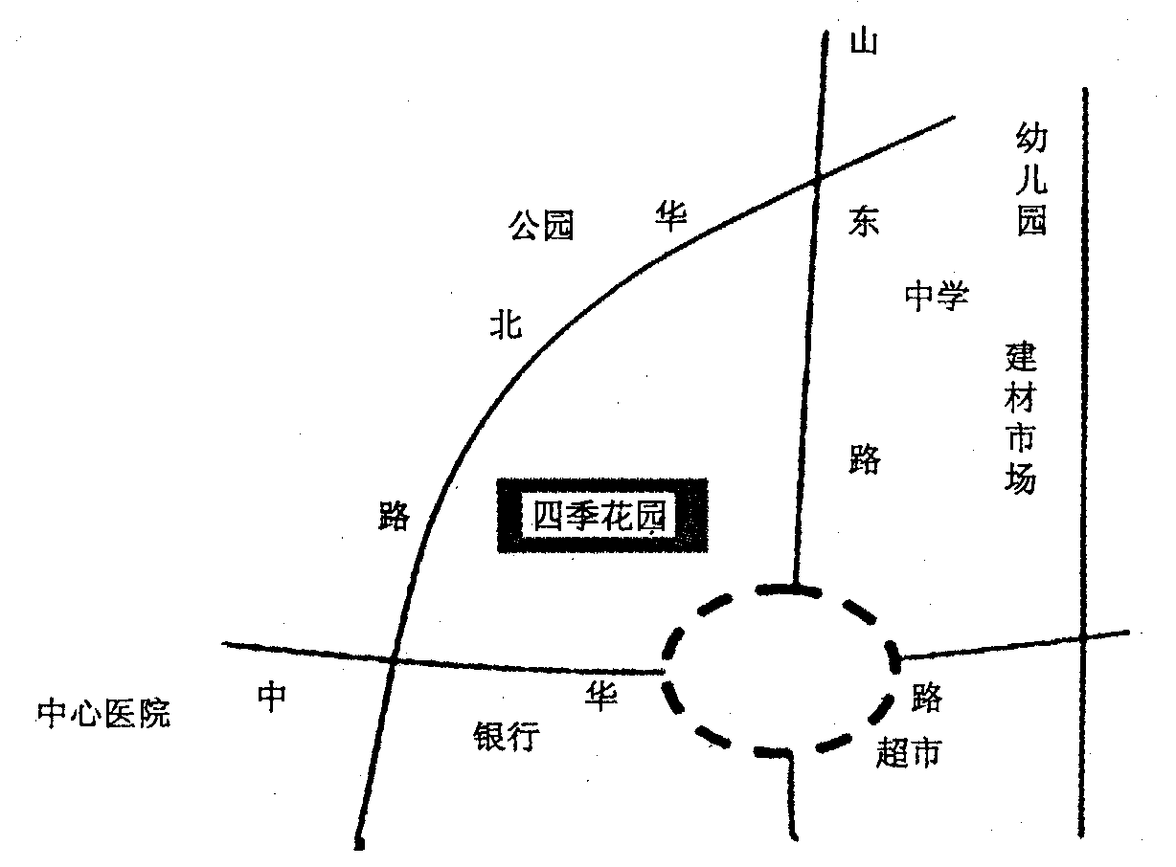

Dear Sam,
You wrote in your letter that you wanted to rent an apartment in our city. Recently I happened to find one that might be suitable for you ______________________________________________[]
________________________________________________________________________________________________________________________________________________________________________________________________________________________________________________________________________________________________________________________________________________________________________________________________________________________________________________________________________________________________________________________________________________________________________________________________________________________________________________________________________________________________________________________________________________________________________________________________________________________________________________________________________________________________________________________________________________________________________________________________________________________________________________________________________________________________________________________________________________________________________________________________________________________________________________________________________________________________________________
___________________________________________________________________________________________________________________________________________________________________________________________________________________________________________________________________________________________________________________________________________________________________________________________________________
Are you satisfied with it? If so, I will arrange it for you.
Yours,
Li Hua



