山东省烟台市2015届高三下学期一模诊断测试
英语试题

第I卷
第一部分听力(共两节，满分30分)
做题时，先将答案标在试卷上。录音内容结束后，你将有两分钟的时间将试卷上的答案转涂到答题卡上。
第一节(共5小题；每小题1．5分，满分7．5分)
听下面5段对话。每段对话后有一个小题，从题中所给的A、B、C三个选项中选出最佳选项，并标在试卷的相应位置。听完每段对话后，你都有10秒钟的时间来回答有关小题和阅读下一小题。每段对话仅读一遍。
1．Where does the conversation take place?
A．In a bookstore． B．In a library． C．In a restaurant．
2．What caused the difference in the price?
A．The color． B．The size． C．The material．
3．How much does the woman weigh now?
A．150 pounds． B．153 pounds． C．163 pounds．
4．What does the man do?
A．A traffic policeman． B．A taxi driver． C．An airport clerk．
5．What will the woman probably do tonight?
A．Work in the office．
B．Watch TV at home．
C．Go to dinner with the man．
第二节(共15小题；每小题1.5分，满分22.5分)
听下面5段对话或独白。每段对话或独白后有几个小题，从题中所给的A、B、C三个选项中选出最佳选项，并标在试卷的相应位置。听每段对话或独白前，你将有时间阅读各个小题，每小题5秒钟；听完后，各小题将给出5秒钟的作答时间。每段对话或独白读两遍。
听第6段材料，回答第6至7题。
6．What is the survey about?
A．Popular sports events．
B．TV programs people like best．
C．Things people do after work．
7．How did the woman do the survey?
A．She talked to people in public places．
B．She posted the survey on the Intemet．
C．She collected information from newspapers．
听第7段材料，回答第8至10题。
8．What is the relationship between the two speakers?
A．Neighbors． B．Salesperson and customer． C．Friends.
9．How long has the woman been living in the city?
A．A few days． B．Two years． C．Ten years.
10．Where does the woman suggest the man go shopping?
A．To a supermarket．
B．To the downtown shops．
C．To a shopping center nearby．
听第8段材料，回答第ll至13题。
11．Who is the host?
A. Thomas． B．Sandra． C．Jerry．
12．When will they go to the BBQ together?
A．Tomorrow． B．This afternoon． C．Tonight．
13．What do we know about the woman?
A．She is from Hon Kong Girls School．
B．She didn’t know Jackie at a11．
C．She will give the man a call tonight．
听第9段材料，回答第14至16题。
14．What did the boy do before he started the conversation?
A．He lost his present job．
B．He went to an exhibition．
C．He delivered some questionnaires．
15．Why is the boy excited about the job he has got?
A．He can wo rk with the robots．
B．He will receive high pay．
C．He got the job luckily．
16．What do we know about the boy?
A．He likes talking with robots．
B．He loves going to exhibitions．
C．He is interested in robots．
听第10段材料，回答第17至20题。
17．What is the speaker mainly talking about?
A．The problems of advertisements on the Internet．
B．Suggestions on daily shopping on the Internet．
C．The advantages of shopping on the Internet．
18．Which is the speaker’s advice on shopping online?
A．To download more pictures．
B．To walk around more shops．
C．To be caretul of the advertisements．
19．What is the advantage of online shopping?
A．It’s ofbetter quality． B．It’s ofgreat convenience． C．It’s a real bargain．
20．What does the speaker seem to concern most about the goods sold online?
A．The quality． B．The package． C．The price．
第二部分阅读理解(共两节，满分40分)
第一节(共15小题；每小题2分，满分30分)
阅读下列短文，从每题所给的四个选项(A、B、C和D)中，选出最佳选项，并在答题卡上将该项涂黑。
A
Dear Ms．Smith，
It is with great interest and enthusiasm that I am applying for the arts education internship (实习)advertised in Sunday’s New York Times．This position is exactly what I am looking for and an ideal opportunity for me to use my knowledge，educational background，and experience．
My arts education at Pratt Institute has helped me develop a firm foundation in the arts．The courses I have completed at Pratt，along with my study abroad in Paris，has prepared me well for a position in arts education．I have always enjoyed a passion for the arts but my undergraduate (本科)education has taken my interest to a whole new level．I not only enjoy doing art but I find myself even more enthusiastic when I have the opportun ity to teach what I have learned．
For the past two summers I have worked directly with children at CityArts．These experiences were amazing since my responsibilities included planning and directing major projects that were planned for the summer program that goes on each year for local children interested in the arts．I was given a concept at the beginning of each summer and I had complete control of how the projects were to be completed．The chi ldren were the creative force and often were the inspiration for the artwork that was eventually presented to the public．
I am very excited about the summer opportunity with the Children’s Museum of the Arts since I know that I can definitely make a positive contribution while doing what I love，teaching art to children．I will contact you in one week to discuss my candidacy(候选资格)and see ifyou have any questions about my education or experience．Thank you for your time and consideration．
Sincerely，
Samantha R．Gray
21．What is Gray’s purpose of writing this letter?
A．To advertise for herself in New York Times．
B．To show her great enthusiasm for CityArts．
C．To obtain the chance of teaching art to children．
D．To prove her successful educational experiences．
22．Paragraph 2 mainly tells us that _______________．
A．Gray tries to find chance to devote her rich art knowledge to children
B．Gray has gotten her undergraduate education at college in Paris
C．Gray had given up the art courses at Pratt Institute and left for Paris
D．the education Gray has received makes her optimistic about the opportunity
23．Which of the following isn’t mentioned by Gray in Paragraph 3？
A．Her management ability． B．Her family background．
C．Her love for children． D．Her working experience．
B
Coral reefs(珊 瑚 礁)are not just beautiful to look at，but also very useful．They shelter nearly 25％ of ocean life and provide food for billions of people．However, like many other species，this amazing ecosystem(生态系统)is in danger of dying out!
There are two main reasons for the destruction—the rising carbon dioxide levels caused by global vdarming as well as human influences like bottom operation．While not much can be done about the former，the loss caused by the latter can be reduced．
Bottom operation involves dropping nets to the ocean bed and then dragging them up when filled with fish．This action damaged the ocean floor，causing the coral branches to separate from the reefs．While that is very discouraging，the good news is that if these branches are found quickly，they can be saved．At present，that work is being performed by volunteer divers. But the method has only limited success because they cannot stay long underwater, nor reach depths of over 200 meters where some of the deep-sea coral grows．
However，this is not the case for Coralbots—mthe robots that can constantly seek out broken branches．A team of ‘coralbots’，each individually working to simple rulesl will piece together’ damaged bits of coral, allowing them to regrow. They are programmed to be able to distinguish between other things and the coral．The robots work together in groups，similar to bees．If one coralbot is damaged then the others will still be able to complete the task．
Dr Lea-Anne Henry said：“The project of using coralbots offers us the possibility to restore(修复)the function of reefs．It is in the final stage of testing．Once ready, the researchers hope to build hundreds of them and use them effectively in the waters off Scotland and then hopefully in the oceans across the world．”
24．Which of the following is a cause of the danger that coral reefs are facing?
A．The appearance of new creatures．
B．The seriously polluted sea water．
C．The activities of volunteer divers．
D．Human activities like bottom operation．
25．Compared with volunteer divers，coralbots ______________．
A．can stay longer underwater B．must work as bees do
C．can distinguish what is coral D．can never be damaged
26．What does the underlined word“them”in the last paragraph refer to?
A．Coralbots． B．Broken branches．
C．working bees． D．Bits of coral．
27．We can infer from the passage that _______________．
A．bottom operation has affected most underwater creatures
B．broken branches of coral can regrow if saved in time
C．hundreds of the coralbots have worked well in the oceans
D．with the coralbots all damaged coral reefs can be restored
C
Film director James Cameron first became interested in sea exploration when he was a little boy．His love for the ocean grew after he made the 1989 undersea adventure film The Abyss and the 1997 blockbuster Titanic，one of the most successful movies of all time．Following that big success，James Cameron decided to put his film career on hold to become an explorer．
In 2012，James Cameron made a journey to the deepest spot in the Mariana Trench，known as Challenger Deep．And now the great journey has been made into a documentary film，named James Cameron’s Deep-sea Challenger 3D．
In James Cameron’s fantasy films，such as Avatar and The Abyss，the unexplored areas are decorated in colors and full of danger．But on his dive into Challenger Deep，the reality proved far different:white, deserted and dull．
“I felt like I had gone to another planet,”Cameron said after returning from the cold and dark place in the Western Pacific Ocean，nearly 7 miles below the surface．“I really have a sense of being separated and realize how tiny I am down in this big, black and unexplored place．”
Cameron captured(获取)the moon-like landscape of the deep sea and documented the sea creatures he observed in the ocean．
James Cameron’s Deep—sea Challenger 3D tells the story of Cameron’ s journey．It is a film about deternlination，danger and the ocean’S greatest depths．The movie shows a unique insight into Cameron’s world when he makes his dream reality and makes history by becoming the first person to travel alone to the deepest point on the planet．
It’s an exciting film and inspiring reminder that our beautilhl planet still has a lot to explore．
28．When did James Cameron become interested in the ocean?
A．When he was in his childhood．
B．After his films The Abyss and Titanic．
C．After he achieved great Success in movies．
D．When he began to explore the deep sea alone．
29．What is the unexplored ocean like?
A．Colorful and dangerous． B．Boring and deserted．
C．White and attractive． D．Smail and dull．
30．What can we know about James Cameron’s Deep-sea Challenger 3D?
A．It is a film about the exploration of ocean creatures．
B．It is a story about Cameron’s film-making dream．
C．It aims to attract more people to explore the deep sea．
D．It tells us about James’ journey into Challenger Deep．
31．What is the best title for this passage?
A．The greatdream of a film director
B．A film director exploring deep sea
C．James Cameron and his documentary film
D．The first person to make films about the deep sea

D
If you’re secretly worried about your smartphone addiction, then the new NoPhone might be just the thing you need．It looks and feels exactly like a smartphone，but it does nothing．It's just a piece of plastic that you can carry around in your hand to fool yourself．
Dutch designer lngmar Larsen came up with the idea as a joke along with his two friends．To their great surprise，the idea received a lot of attention online and people from all over the world staned placing requests for NoPhones of their own．So that’s when the three friends decided to turn to collect enough fund for mass production．
NoPhone is currently a prototype(模型)that will cost only $12 once it hits the market．It is 5.5 inches high，2.6 inches wide and 0.29 inches thick,bringing it quite close to the latest smartphenes on the market．It is described as“battery free”，“no upgrades necessary”，“shatterproof(抗震)”，“waterproof'’and“an alternative to constant hand-to-phone contact that allows you to stay connected with the real world”．
“Phone addiction is everywhere．”the designers insist．“It’s ruining your dates．It’s distracting you at concerts．It’s blocking sidewalks．Now，there is a real solution．With a thin．
1ight and completely wireless design，the NoPhone acts as a substitute to any smart mobile device，enabling you to always have a phone to hold without giving up potential engagement with your direct environment．”
If you’re interested in NoPhone，but concerned about not being able to take selfies(自拍) anymore．Don’t feel upset．The makers do have an upgrade at no extra charge—the mirror sticker．That way，they say，you can enjoy‘real-time’selfies with your friends when they’re standing right behind you．
32．What can NoPhone do for people according to the text?
A．It is actually a new kind of real smartphone．
B．It can help us stay away from the real world．
C．It helps get rid of people’s smartphone addiction．
D．It’s just a piece of plastic and can do nothing．
33．What is Paragraph 3 mainly about?
A．The size of Nophone． B．The inventors of Nophone．
C．The material of Nophone． D．A brief description of Nophone．
34．What can we learn from the passage?
A．NoPhone has received unexpected attention．
B．NoPhone can completely replace smartphones．
C．The designers have made lots of money from Nophone．
D．NoPhone is able to take selfies as smartphones do．
35．What type of writing is this passage?
A．A traveI guide． B．A scientific report．
C．A medical record． D．An official document．
第二节(共5小题；每小题2分，满分10分)
根据短文内容，从短文后的选项中选出能填入空白处的最佳选项。选项中有两项为多余选项。
Everyone wants to achieve happiness and smile． 36 How do we find real happiness and smile? By getting rich'? In case you are scratching your head，looking for some reasons or ideas to be happy．here are a few．
1．Throw an impromptu(即兴的) party． 37 An impromptu one increases the．joy to a new level．And of course making other people happy is bound to have the same effect on you．
2．Treat yourself Sometimes all it takes to make one happy is a little indulgence(放纵)．So，go ahead and grab a cup of coffee and sit inside a blanket with a good book! You will be surprised at how happy it makes you．
3． 38 Happiness is can be transformed! When we feel happy and excited，it can lift the spirits of others．Your simple gesture can transform a person’s day and get him or her prepared to take on any challenge．
4．Have a conversation with a parent．If you are like most kids，you possibly spend more time texting or surfing the Internet than talking to．your family． 39 You will be surprised at the feeling of joy that it brings to you．
5．Finally，don’t forget to be happy every day! While International Day of Happiness may come about only once a year，happiness is around you all day and night 40
A．You just have to seek it out and grab it．
B．Most of your family members show no interest in texting or the Internet．
C．But life is hard，so it is very difficult to find real happiness and smile．
D．Be friendly to others and smile at a stranger．
E．Set aside your mobile phone for a few minutes and have a chat with a family member．
F．You should try to celebrate the Day of Happiness every day and everywhere．
G．Nothing makes people happier than being invited to a party.
第三部分 英语知识运用(共两节，满分45分)
第一节 完形填空(共20小题；每小题1．5分，满分30分)
阅读下而短文，从短文后各题所给的四选项（A、B、C和D)中，选出可以填入空自处的最佳选项，并在答题卡上将该项涂黑。
In my professional life I am fortunate to have acquired some skills that I find I am able to use even though I’ve retired．
Last week while at church in the morning，I met a 41 that had just moved to our state.
Unfortunately．they were robbed shortly after their 42 ．and had the valuable belongings with all their 43 papers stolen．A very kind person in the neighborhood had 44 them in，but the family had very little 45 ，no transportation，and no 46 to enroll(注册)their son in school without the paperwork．
Enrolling that little boy in school 47 to be the highest priority for the family. But the school district was playing hardball with them with no 48 for them．They had gone to the library to 49 how to replace this paperwork，but they found they could not 50 the fees to replace the items quickly．
Because of my background as a(n) 51 administrator and my computer skills，I was able to research for them online how to 52 ．the needed documents at low cost with only a slight delay．I was able to speak with them 53 and positively about the process and explain that waiting the few 54 days would make very little 55 in getting their little guy enrolled and attending school again．They told me they 56 my taking the time to sit down with them and help thern see the“forest for the trees”，for they had felt 57 with what initially had seemed the impossibility of their situation．
Taking the time to 58 my skills and “be present’’ with them had truly helped them regain some of the 59 they had come to our city with when they moved— 60 a better 1ife．
41．A．beggar B．boy C．family D．driver
42．A．arrival B．return C．flight D．change
43．A．criminal B．important C．beneficial D. expensive
44．A．forced B．hidden C．shown D．taken
45．A．money B．energy C．position D．courage
46．A．Plan B．aim C．way D．idea
47．A．happened B．seemed C．intended D．preferred
48．A．patience B．direction C．confidence D．sympathy
49．A．practice B．research C．suggest D．realize
50．A．afford B．support C．manage D．desire
51．A．politics B．education C．culture D．history
52．A．invent B．protect C．design D．replace
53．A．coldly B．shyly C．calmly D．wildly
54．A．exact B．proper C．extra D．final
55．A．sense B．difference C．room D．use
56．A．disliked B．considered C．insisted D．appreciated
57．A．surprised B．depressed C．excited D．amused
58．A．use B．pass C．take D．get
59．A．spirit B．task C．hope D．sense
60．A．putting in B．making C．taking up D．looking for
第II卷
第三部分 英语知识运用（共两节，满分45分）
第二节 （共10小题；每小题1.5分，满分15分）
阅读下面材料，在空白处填入适当的内容（不多于3个单词）或括号内单词的正确形式。
The way we cook is important. In many countries, the two choices are 61 (nature) gas or electric-powered stoves.
The World Health Organization warns that millions of people 62 (suffer) from indoor air pollution at present time, which results fuom the use of 63 (danger) fuels and cook-stoves in the home.
WHO officials say nearly three billion people are 64 (able) to use clean fuels and technologies for cooking ，heating and lighting. As a result, more than seven million people die from exposure to indoor or outdoor air pollution each year. Most of the deaths are in 65 （develop） countries, such as lndia, China and Latin American countries.
WHO officials say opening a window or door 66 （let）out the harmful air will not correct the situation 67 will only pollute the outdoors.
Nigel Bruce, 68 is a professor of Public Health at the University of Liverpool, says researchers are developing good cook-stoves and other equipment to burn fuels 69 a more efficient way.
But, this is just a start. It is urging developing countries to use 70 (clean) fuels and increase access to cleaner and more modern cooking and heating appliances（用具）.
第四部分 写作（共两节，满分35分）
第一节 短文改错（共10小题；每小题1分，满分10分）
假定英语课上老师要求同桌之间交换修改作文，请你修改你同桌写的以下作文。
文中共有10处语文错误，每句中最多有两处。错误仅涉及一个单词的增加、删除或修改。
增加：在缺词处加一个漏字符号（∧），并在其下面写出该加的词。
删除：在错的词下面一横线，并在该词下面写出修改后的词。
注意：1.每处错误及其修改均仅限一词；
2.只允许修改10处，多者（从第11处起）不计分。
Hello, Peter. I’m very grateful for your concern about my coming exam. To tell you truth. I have bccn busy prepare for the exam rccently. Some classmates are fceling real stressed due to the cxam, but I don’t takc them so seriously. I always lcarn in a relaxing mood and I’m making a great progress. Now that I had tricd my best, it doesn’t matter much to me what the result is.
In my opinion, we should keep a good balance among our study, rest or exercise. I believe we can bc succeeded if we prepare for the exam in a proper way.
I’d appreciate it if you could give me some good advices.
第二节 书面表达（满分）
下图是学校英语网站的新增部分栏目，网站负责人Mr，Black就此向同学们征询意见。假如你是李华，请你根据以下提示用英语给Mr.Black就此向同学们征询意见。假如你是李华，请你根据以下提示用英语给Mr.Black写E-mail。
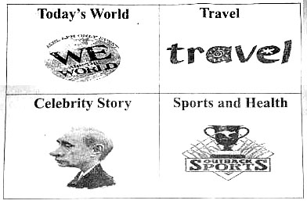

E-mail主要内容包括:
1.最喜欢的栏目及理由；
2.对栏目设置的意见或建议。
注意：1.词数100左右，开头和结尾已给出，不计入总词数；
2.可以适当增加细节，以使行文连贯。
3.参考词汇：栏目—column
Dear Mr. Black，

Best wishes.

Yours,
Li Hua
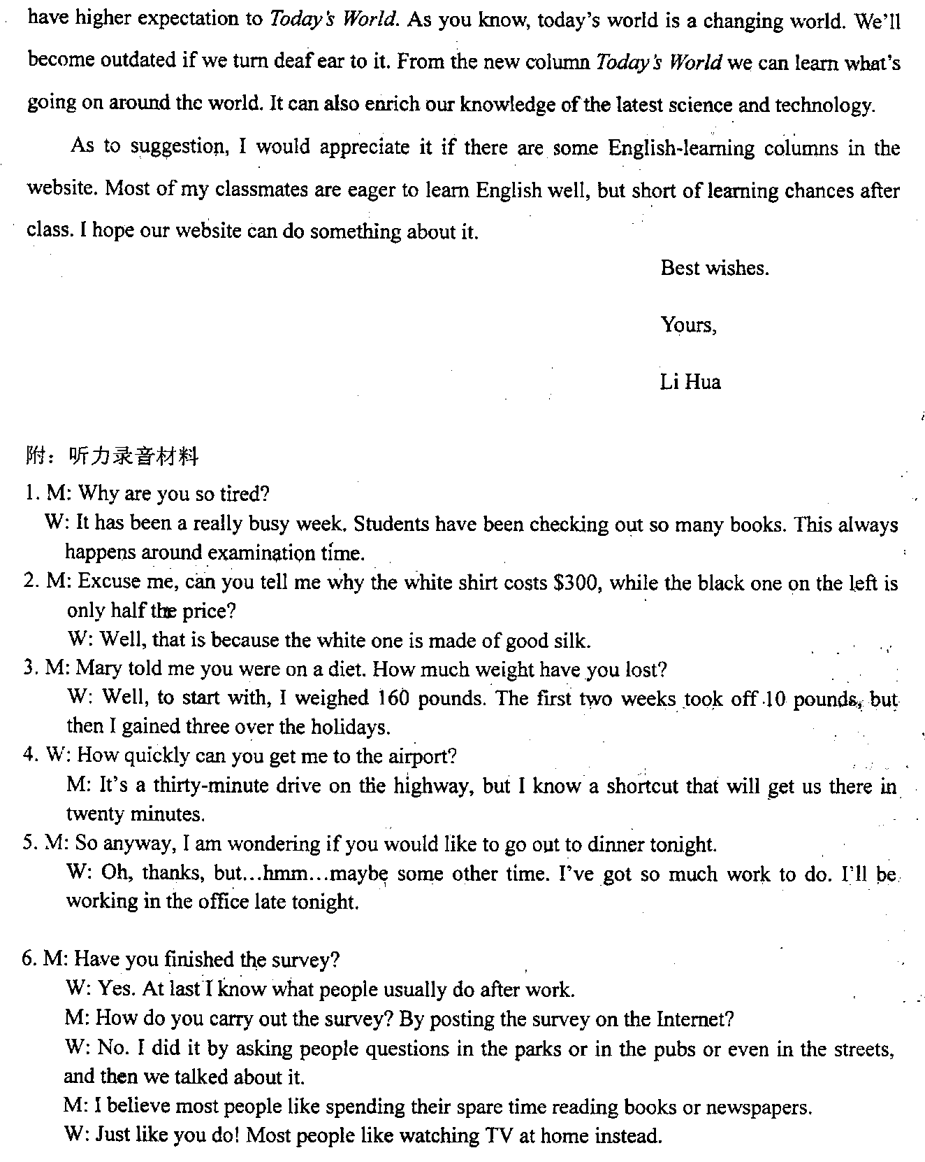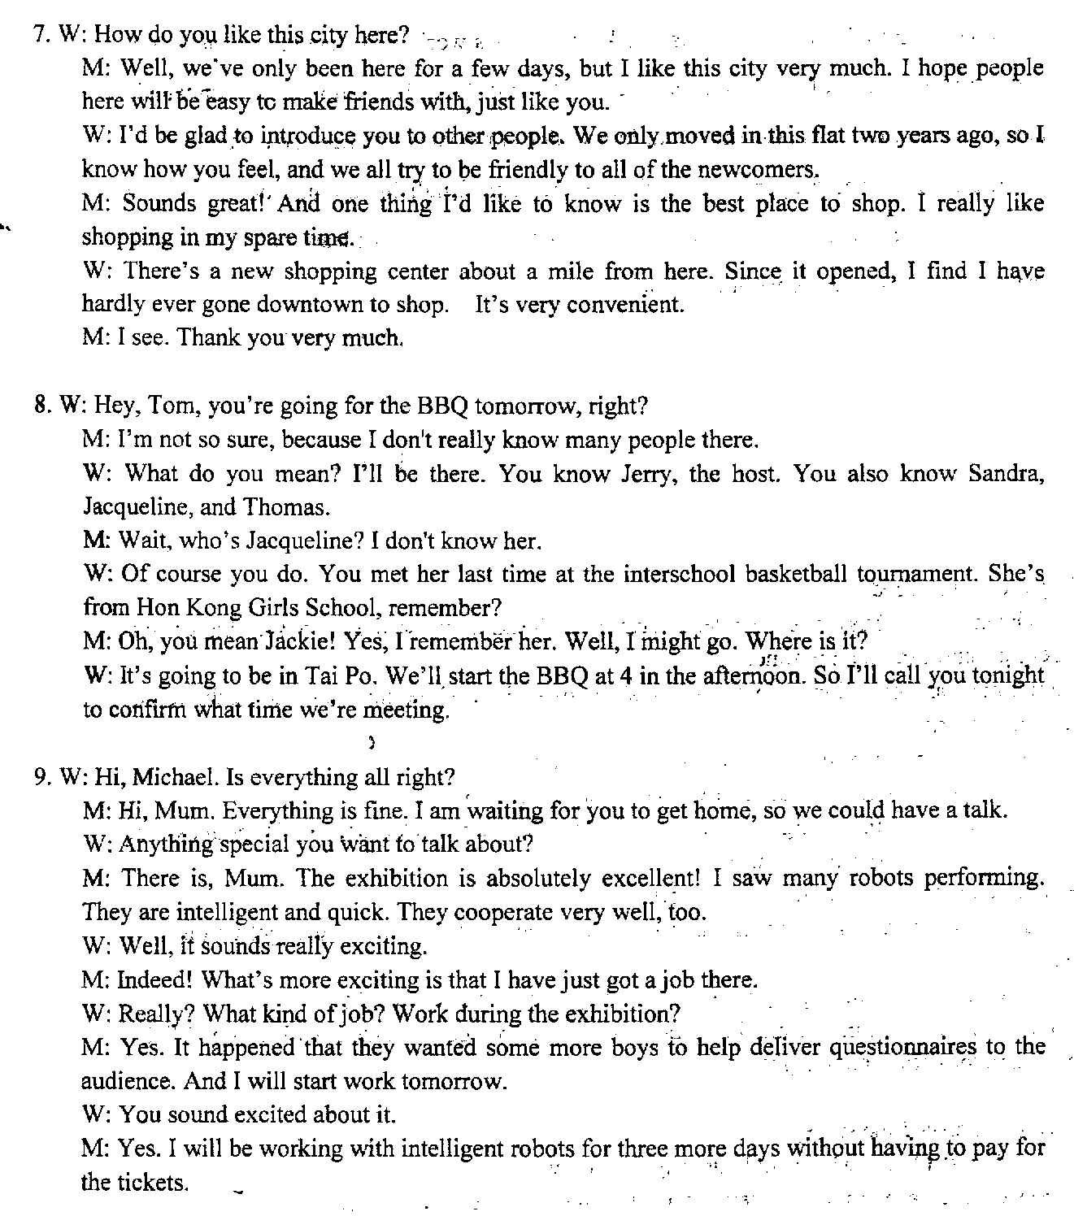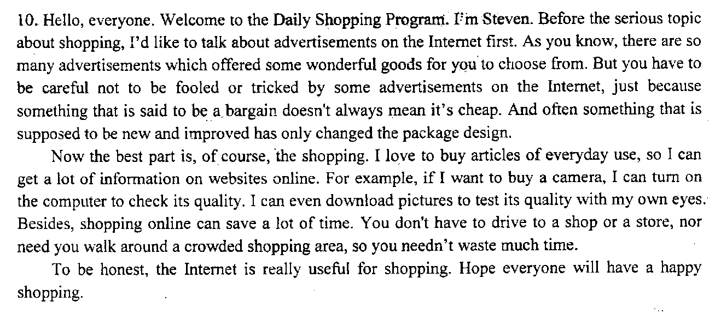

欢迎访问“高中试卷网”——http://sj.fjjy.org

