安徽省合肥市2015年高三第二次教学质量检测
英语试题
本卷分第Ⅰ卷(选择题)和第Ⅱ卷(非选择题)两部分，满分150分，考试时间120分钟。
第Ⅰ卷
第一部分：听力理解(共两节。满分30分)
第一节（共5小题;每小题1.5分,满分7. 5分)
听下面5段对话。每段对话后有一个小题, 从题中所给的A、B、C三个选项中选出最佳 选项, 并标在答题卷的相应位置。用答题卡的考生, 先把选出的最佳选项标在试卷的相应位置, 再转涂到答题卡上。听完每段对话后, 你都有10秒钟的时间来回答有关小题和阅读下一小题。每段对话仅读一遍。
1. When does the woman's train leave?
A. At 2:45 pm. B. At 3:15 pm C. At 3:30.
2. What does the woman think of English learning?
A. Difficult. B. Easy. C. Boring.
3. What do we know about the man?
A. He wasn't ready for the puzzle.
B. He didn't take part in the puzzle.
C. He wasn't interested in the puzzle.
4. What are the speakers mainly talking about?
A. The weather forecast. B. Personal dislikes. C. The weather.
5. What is the probable relationship between the two speakers?
A. Assistant and patient. B. Doctor and patient. C. Employer and employee.
第二节（共15小题, 每小题1.5分, 满分22. 5分)
听下面5段对话或独白。每段对话或独白后有几个小题, 从题中所给的A、B、C三个选 项中选出最佳选项,并标在答题卷的相应位置。用答题卡的考生,先把选出的最佳选项标在 试卷的相应位置, 再转涂到答题卡上。听每段对话或独白前,你将有时间阅读各个小题, 每小题5秒钟；听完后, 各小题将给出5秒钟的作答时间。每段对话或独白读两遍。
听第6段材料, 回答第6至7题。
6. Which is the first course of a meal in the man's country?
A. Tea or soup. B. Cold dishes. C. Hot dishes.
7. What will the speakers do next?
A. Pay the bill. B. Order the food. C. Drink some water.
听第7段材料, 回答第8至10题。
8. What major does the woman want to change to?
A. Physics. B. Drama. C. Astronomy.
9. What are the speakers mainly talking about?
A. Personalities. B. Experiences. C. Choices.
10. How does the man feel about the woman's decision?
A. Worried. B. Satisfied. C. Uninterested
听第8段材料, 回答第11至13题。
11. What are the speakers mainly talking about?
A. The details of the matches.
B. The arrangement of a trip.
C. The training plan for a team
12. What will the team do in Tianjin?
A. Go to the beach. B. Play five matches. C. Go to the mountains.
13. How many matches will the team play in Tsingtao?
A. Two. B. Three. C. Five.
听第9段材料, 回答第14至16题。
14. Where does the woman prefer to live?
A. In a suburb. B. In a city. C. It depends.
15. How does the man think of the life in a city?
A. Crowded. B. Noisy. C. Costly.
16. What do we know about the speakers?
A. They finally reach a consensus.
B. They decide to find a better job.
C. They fail to convince each other.
听第10段材料, 回答第17至20题。
17. Why is a board interview challenging?
A. Because a group of strangers will attack the candidate.
B. Because the candidate is questioned by strangers in a new situation.
C. Because the candidate is left in the room with nobody else around.
18. How do you know whether you are making sense in your interview?
A. By using your body language.
B. By explaining in another way.
C. By reading the audience's expression.
19. How many tips does the speaker offer?
A. Two. B. Three. C. Four.
20. What's the speaker mainly talking about?.
A. How to perform better in a board interview.
B. How to make preparations for &n interview.
C. How to set up an interview ahead of time.
第二部分:英语知识运用（共两节, 满分45分)
第一节：单项填空（共15小题;每小题1分, 满分15分)
从A、B、C、D四个选项中, 选出可以填入空白处的最佳选项, 并标在答题卷的相应位置。用答题卡的考生, 先把选出的最佳选项标在试卷的相应位置,再转涂到答题卡上。
21. — A US pilot says he saw a UFO in the shape of triangle, moving very low over bushes two days ago.
— ______, but I didn't think that’s true.
A. It’s a pity B. Come off it C. Excuse me D. Please say it again
22. The university is saving $ 300,000 per year by its energy ______ efforts.
A. consumption B. conservation C. suspension D. prohibition
23. It is our choices that show what we truly are, far ______ our abilities.
A. more than B. less than C. as good as D. as well as
24. It is generally believed that communication skills are becoming ______ it takes to be a good doctor.
A. whether B. that C. how D. what
25. At the end of the game, players traditionally ______ their shirts with each other.
A. substitute B. iron C. swap D. transform
26. Just as Oprah Winfrey puts it, ______ thankful for what you have and you'll end up having more.
A. be B. being C. to be D. having been
27. Teenage is an especially important stage for us, ______we are supposed to go all out to improve ourselves because anything can happen.
A. what B. where C. which D. that
28. The virus Ebola is reported ______ over 3,000 lives in 5 countries of West Africa by now.
A. taking B. having taken C. to take D. to have taken
29. The nation's top health administration office is ______ an increase in the cigarette tax to control smoking in China.
A. making for B. catering to C. pushing for D. answering for
30. — Have you got the sleeping bag needed for the camping this weekend?
— Yes, I ______ it almost the moment I heard the news.
A. bought B. had bought C. have bought D. would buy
31. Mother often reminds me that the best thing one can do ______ it is raining is to let it rain.
A. unless B when C. even if D. in case
32. ______ you keep it a secret for the time being? It’s just between us.
A. Must B Can C. Should D. May
33. ______ at his final score, he decided to treat himself to a big dinner.
A. Amazed B. Amazing C. Being amazed D. To amaze
34. So far, almost every possible means ______to provide accommodation and medical rescue for the people in the flood-stricken area.
A. were tried B. was tried C. have been tried D. has been tried
35. — I really can't put up with what he said yesterday.
—______. He was just joking.
A. I am afraid not B. Not at all C. Take your time D. Don't take it to heart
第二节：完形填空（共20小题;每小题1.5分,满分30分)
阅读下面短文, 从短文后各题所给的四个选项（A、B、C和D)中, 选出可以填入空白处的最佳选项,并标在答题卷的相应位置。用答题卡的考生, 先把选出的最佳选项标在试卷的 相应位置, 再转涂到答题卡上。
While I was waiting in line at a coffee shop earlier, a woman drove alongside the queue in a mobility scooter (踏板车). There was only a 36 space between the line of people and the tables, which she 37 to drive along. She drove over my foot and didn't 38 saying nothing at all.
I got annoyed and expected she would have 39 , but then I just decided to 40 it and got down to selecting which pastry (点心) to go with my coffee. The lady and I ended up sitting at adjacent (邻近的) tables. She was on the end of a row so that she could park her 41 . After about half an hour, when she had 42 her coffee, she got up and back onto her scooter. It 43 start. She tried to turn the key several times 44 she telephoned the place she purchased it from.
An engineer 45 within 5 minutes. The place must have been local. I couldn't 46 overhearing their conversation, and it turned out she had just 47 the scooter that morning. This was her very first outing in it. She felt really 48 about driving it 49 , she wasn't used to its speed, nor its 50 , and this combination made it quite 51 to drive it through narrow gaps.
Suddenly, I felt 52 for the lady. It really didn't 53 me at all that she'd driven over my foot. I had made an assumption, 54 , that a person doing that should apologize.
Next time you're about to 55 someone, pause for a second and remind yourself that people have judged you without knowing what was going on in your mind or your life.
36. A. private B. vast C. public D. narrow
37. A. attempted B. promised C. declined D. guaranteed
38. A. call back B. give up C. look back D. cheer up
39. A. ignored B. apologized C. explained D. forgiven
40. A. dismissed B. made C. deserved D. inspected
41. A. truck B. bike C. car D. scooter
42. A. poured B. finished C. ordered D. purchased
43. A. needn't B. shouldn't C. wouldn't D. mustn't
44. A. so B. until C. unless D. before
45. A. broke in B. turned up C. ran away D. settled down
46. A. tolerate B. allow C. resist D. postpone
47. A. collected B. stolen C. fixed D. abandoned
48. A. concerned B. excited C. confident D. nervous
49. A. Doubtfully B. Certainly C. Fortunately D. Surprisingly
50. A. width B. length C. weight D. height
51. A. cool B. convenient C. stressful D. desperate
52. A. pleasure B. regret C. appreciation D. sympathy
53. A. strike B. bother C. satisfy D. motivate
54. A. otherwise B. therefore C. however D. besides
55. A. judge B. hug C. persuade D. tease
第三部分：阅读理解（共20小题；每小题2分, 满分40分)
阅读下列短文, 从每题所给的四个选项(A、B、C和D)中, 选出最佳选项, 并标在答题卷的相应位置。用答题卡的考生, 先把选出的最佳选项标在试卷的相应位置, 再转涂到答题卡上。
A
Dogs Don't Tell Jokes - By Louis Sachar  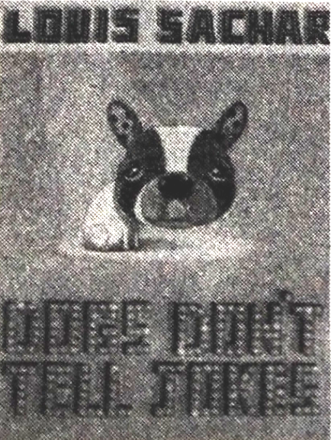  Twelve-year-old Gary Boone knows he was born to be a comedian. He never stops joking, regardless of the fact that nobody laughs much and his classmates think he is stupid. Therefore he had no real friends at school. Due to being laughed at by his classmates, Gary Boone thought winning the school talent show would be his dream of proving himself to be a real comedian, but on the big night his dream went wrong with funny results. | Winners Never Quit - By Mia Hamm  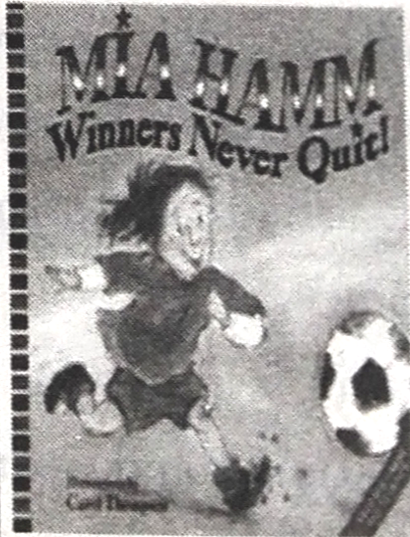  Mia Hamm, American soccer champion, tells a true-to-life inspiring story of learning that winning and losing aren't as important as being part of a team. More than anyone, soccer superstar Mia Hamm knows the value of teamwork. She shares this lesson, paired with energetic pictures by Carol Thompson, and this story is perfect for soccer kids and their soccer moms.
Shack let on s Incredible Voyage - By Alfred Lansing  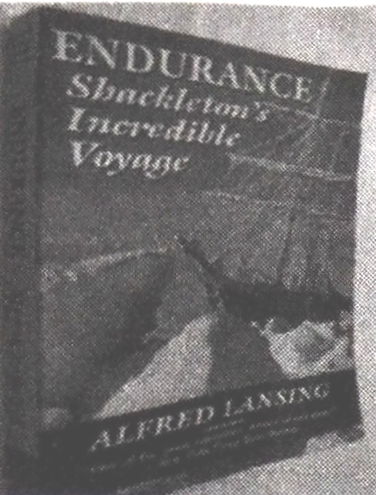  The astonishing adventure of polar explorer Ernest Shackleton's survival for over a year on the ice-bound Antarctic seas, as Time t magazine put it, "defined heroism". To write the authoritative story, Lansing consulted with ten of the surviving members and gained access to diaries and personal accounts by eight others. The book has a first-hand account, expanded with maps and illustrations especially for this edition. | The Alchemist - By Paulo Coelho  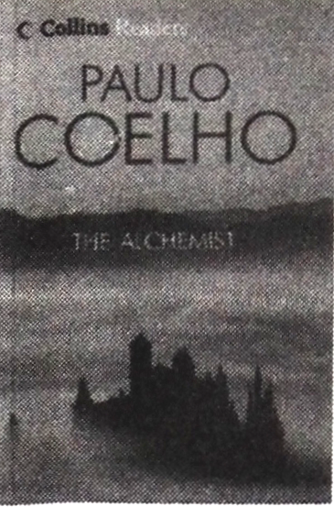  The Alchemist, by Paulo Coelho, continues to change the lives of its readers forever. It tells the magical story of Santiago, an Andulusian shepherd-boy (牧童) who desires to travel in search of treasure. The story of the treasures Santiago finds along the way teaches us about the essential wisdom of listening to our hearts and above all, following our dreams.
56. Why did Gary Boone want to win the school talent show?
A. To develop his comedy skills. B. To please his classmates.
C. To make more friends. D. To realize his dream.
57. From Shackletoris Incredible Voyage, we know the main character ______.
A. is a writer for Time magazine
B. is a survival of one polar exploration
C. has left a lot of diaries and accounts
D. has formed a close friendship with Alfred Lansing
58. If you want to know more about teamwork, you can read ______.
A. Dogs Don't Tell Jokes B. Shackletoris Incredible Voyage
C. Winners Never Quit D. The Alchemist
59. What do we know about The Alchemist?
A. It has an everlasting influence on its readers.
B. It gives people magical power over their dreams.
C. It tells a story of how to find treasures.
D. It is mainly about the wisdom of listening to others.
B
Severely disabled people may soon be able to use their noses to write, drive a wheelchair or surf the Internet, thanks to a device (装置) developed by doctors in Israel.
The device will be used by breathing in and out through the nose, according to a study. Healthy people who tested the device quickly learned to play computer games and write sentences by sniffing. Encouraged by the results, the researchers decided to test their device on people who are paralyzed (瘫痪) but whose intelligence remains normal. Ten paralyzed who tested the device quickly learned to use their noses to write words, open a webpage, copy words and put them into a search engine.
With their success in helping severely disabled people to communicate * the researchers decided to make use of the new technology to design an electric wheelchair to be driven by sniffs.
Ten healthy people easily mastered sniff—driving a wheelchair through a maze (迷宫), and a 30-year-old man who had been paralyzed from the neck down for six years was as good a sniff-driver as the healthy participants at his second attempt. In other words, a paralyzed person could use the sniff controller to drive an electric wheelchair.
At the moment, sniff-controlled technology is still in the stage of development, and the Weizmann Institute has already applied for a patent on the device. "Ill be very happy if it can help us to make money, but the real problem is that I hope someone will develop it, because this would help a lot of people," said Sobel, one of the lead researchers of the study.
60. What’s the purpose of the passage?
A. To introduce a new invention. B. To equip the disabled with life skills.
C. To show the nose's special functions. D. To instruct doctors to apply for a patent.
61. In the test, the paralyzed people with normal intelligence can use their nose to ______.
A. type long sentences quickly B. play computer games easily
C. enter a website without much difficulty D. communicate with others successfully
62. With the help of the sniffing device, a 30-year-old disabled man ______.
A. spent six years learning how to drive a wheelchair
B. failed to drive through the maze at his first attempt
C. took the wheelchair controlled by healthy participants
D. managed to drive an electric wheelchair by sniffing
63. From the last paragraph, we can infer that the sniff-controlled technology ______.
A. will be applied to other fields of research
B. needs further developing to serve more people
C. has become an important patented invention
D. shows the wisdom and talents of Israel doctors
C
Whenever someone begins to talk to me about how horrible it is to eat meat and suggests that a nice piece of tofu would be just as good, I just smile and show them those nice pointy teeth we all have in the corners of our mouths. They are called canines (犬牙), and they are there only for the purpose of eating meat.
When it comes to satisfying this kind of desire, soy (豆类) food can never match a well-prepared tri-tip (also know as triangle beef steak ). Just the thought of the beef, burning on the grill (烤架) with the smell of wood smoke gets the mouth watering and brings back memories of summer barbecues. When the knife cuts through the tri- tip, exposing the red meat bursting with juices, it's more than just cooking. It's a cultural event, showing we are at the top of the food chain, like no other food can.
Nutritionally speaking, the tri-tip is one of the better cuts of beef. It is lower in fat than many other cuts, and the proteins (蛋白质) you get from eating meat are more complete than those that come from vegetables, making meat a better choice for building and keeping up your muscle tissue healthy.
According to the National Center for Biotechnology Information, one thing to be aware of with soy products in general is that while they are high in iron, a necessary mineral for the body, they also contain something that blocks the body's absorption of iron. We can cook them in various ways to make them tasty. Anyway, the tri-tip goes a lot better with ice-cold beer than a large piece of bean-curd cheese would, no matter how you cook it.
I guess I should say at least one good thing about tofu. If you cook it just right, you can make it taste a little like the tri-tip, but only a little.
64. What's the author's attitude towards eating meat?
A. Uncaring. B. Approving. C. Ambiguous. D. Cautious.
65. From the second paragraph, we learn that a well-prepared tri-tip ______.
A. can be delicious and unforgettable B. can be served only for barbecues
C. should be eaten with soy food D. should be cooked longer on the grill
66. Compared with tofu, the tri-tip is ______.
A. more nutritious but poorer in proteins B. higher in iron and other useful minerals
C. more beneficial for muscle development D. harder for eaters to take in its iron
67. The best title of the passage is ______.
A. The tri-tip, your right choice B. Differences between tri-tip and tofu
C. Tofu, a nutritious soy food D. Best food partner — Tri-tip and tofu
D
Personal money-management website Mint.com suggests recently that responsible parents should give their kids credit cards—possibly starting as young as middle school. The website says a credit card will help children master responsible spending habits and give parents the chance to teach them some valuable lessons.
It’s absolutely true that kids should learn about how a credit card works and how to use it responsibly. But the idea that they need a card of their own to practise this is questionable.
Yes, credit cards are a teaching tool, but it’s the time you spend educating them about money management that does the teaching, not the piece of plastic. Sit down with your child—here we are referring to teens and walk them through your credit card statements. Point out important things like the due date, late fee warning, and APR (年贷款利率).
If you have good credit, adding a child as an authorized user onto one of your credit cards also provides teachable moments. Allow kids to use the card to make specific purchases and require their participation in payment.
Since the card is still in your name, you can take them off it at any point and cut off their access if they're not able to handle the responsibility.
Another option is to set them up with an account at a local bank that offers free use of a debit card (借记卡). Unlike credit card, the debit card has no overdraft (透支) function.
Children can only use the card to pay for things and the money is taken directly from their bank account. If the account is empty, the worst that will happen is the card being declined at a cash register.
68. Why does Mint.com advise parents to give middle school kids credit cards?
A. To leave their kids financially independent.
B. To help their kids form good spending habits.
C. To teach their kids' how to save pocket money.
D. To strengthen the relationship with their kids.
69. The author considers a credit card as a teaching tool because ______.
A. it motivates teens to ask their parents for less financial support
B. it helps teenagers to know some basic knowledge of credit cards
C. it contains detailed financial information on the card surface
D. it offers parents the chance to teach kids to manage money
70. What is the purpose of adding kids as credit card authorized users?
A. To avoid extremely high overdraft fees.
B. To encourage them to share household expenses.
C. To teach them to be responsible credit card users.
D. To help them pay close attention to their bank account.
71. What is most likely to be discussed in the paragraph that follows?
A. Further information about the debit card. B. The overdraft functions of a debit card.
C. More disadvantages of credit cards. D. The kids' attitude towards a credit card.
E
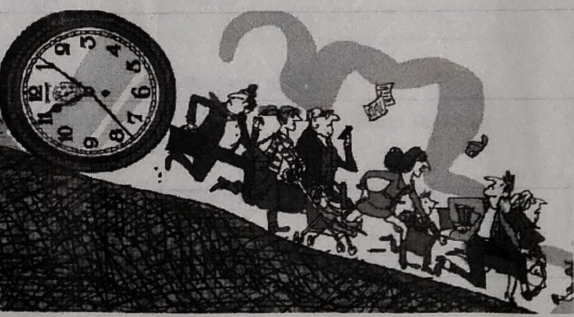
Why do people feel so rushed? Part of this is a perception (认知) problem. Generally, people in rich countries have more free time than they used to. This is particularly true in Europe, but even in America free time has been inching up. Women's paid work has risen a lot over this period，but their time in unpaid work，like cooking and cleaning, has fallen even more significantly, thanks in part to dishwashers, washing machines and microwaves, and also to the fact that men shift themselves a little more around the house than they used to.
The problem, then, is less how much time people have than how they see it. Ever since a clock was first used at a workplace to record labor hours in the 18th century, time has been understood in relation to money. Once hours are financially quantified (量化), people worry more about wasting, but tend to save or use them more profitably. When economies grow and incomes rise, everyone's time becomes more valuable. And the more valuable something becomes, the rarer it seems.
Once seeing their time in terms of money, people often grow stingy with the former to maximize the latter. Workers who are paid by the hour volunteer less of their time and tend to feel more upset when they are not working.
The relationship between time, money and anxiety is something Gary Becker noticed in America's post-war boom years. "If anything, time is used more carefully today than a century ago," he noted in 1965. He found that when people are paid more to work, they tend to work longer hours, because working becomes a more profitable use of time. So the rising value of work time puts pressure on all time. Leisure time starts to seem more stressful, as people are forced to use it wisely or not at all.
72. Women's time in unpaid work has fallen partly because ______.
A. men's ability to support a family has been improved
B. men's involvement in housework has increased
C. women's leisure time was taken up by heavy housework
D. women become more skilled at household equipment
73. From the second paragraph, we learn that ______.
A. labor hours were recorded with a clock
B. people haven't realized the value of time
C. more work hours bring in more money
D. The rise of incomes makes time less valuable
74. The underlined phrase grow stingy with can probably be replaced by "______".
A. refuses to delay B. intend to kill C. try to accumulate D. hesitate to spend
75. According to Gary Becker, what causes people feel anxious about time?
A. The wrong way of time being spent. B. People's willingness to work hard.
C. The increasing value of work time. D. More and more leisure time.
第Ⅱ卷（非选择题, 共35分)
第四部分：写作（共两节, 满分35分)
第一节 任务型读写（共10小题; 每小题1分,满分10分)
阅读下面短文,根据所读内容在表格中的空白处填入恰当的单词。
注意：每个空格只填一个单词。
Flying out of an airport in the United States is not always easy. You will need to complete the ticketing process, baggage check, and security clearance procedures before boarding the plane.
If you are flying on an international flight, you'd better arrive two hours before your plane is scheduled to leave. You might need more time in a busy airport in a large city. If you are traveling on a domestic (国内的) flight, you may only need to arrive at the airport 90 minutes before your plane takes off.
Every airport in the States is now moving its ticketing procedure to electronic ticketing device. By using a ticketing machine, you have the chance to choose a seat you like on the plane. If you use it to check-in your bags, you will only have to talk to the ticketing agent when you turn in your luggage to be tagged (加标签). At the same time a real person will be nearby to help you if you need it.
After you have checked in, you will have to pass through airport security. Have your ID card or passport and boarding pass ready to show the security officer when entering the security checkpoint line. Airport security is getting tight in the States today. You're not allowed to travel with any prohibited things like knifes or fireworks.
After the security staff has checked your travel documents, you shall put all of your belongings through a scanning machine and then walk through a metal detector (探测器) or a full body scanner. You need to take off your coat, belt, and sometimes your shoes to go through one of these scanners. Be sure not to have any metal in your pockets. If you do not understand a question you are asked at a security checkpoint, ask the person to repeat their question until you are able to respond with an accurate answer.
Title | (76)___ on air travel in the US
Time of (77)___ | ■ Arrive two hours before (78)___, and even more time in a busy airport, traveling on an international flight.  ■ Arrive 90 minutes before your plane (79)___ for a domestic flight.
Check-in | ■ Choose your seat on a ticketing machine.  ■ Get the ticketing agent (80)___ when turning in your luggage to be tagged.  ■ (81)___ to the airport staff for help if necessary.
Airport security | ■ (82)___ the security officer your travel documents.  ■ (83)___ taking those that are prohibited.  ■ Be sure not to take any metal with you when (84)___ through a scanner.  ■ Respond (85)___ when questioned at a security checkpoint.
第二节 书面表达 (满分25分)
假如你叫李华, 你发现你的英国网友Alice的生活方式不太健康。你想给她提些建议。 请你用英语给写封电子邮件，内容包括:
• 用水果代替零食；
• 用水代替可乐；
• 减少使用电子产品的时间;
• 多运动；
注意：1. 词数120左右，短文的开头和结尾已经写好，不计入总词数；
2. 可以适当增加细节, 以使行文连贯；
3. 短文中不能出现与本人相关的信息。
Dear Alice,
Hope everything goes well with you.___________________________________________
____________________________________________________________________________________________________________________________________________________________________________________________________________________________________
Yours Sincerely,
Li Hua
合肥市2015年高三第二次教学质量检测
英语试题参考答案及评分标准
第一部分 听力 (共两节，满分30分)
1—5 ABBCA 6—10 ABACA 11—15 BCBAC 16—20 CBCBA
第二部分 英语知识运用 (共两节，满分45分)
第一节：单项填空（共15小题；每小题1分；满分15分）
21—25 CBADC 26—30 ABDCA 31—35 BBADD
第二节：完形填空（共20小题；每小题1.5分，满分30分）
36—40 DACBA 41—45 DBCDB 46—50 CADBA 51—55 CDBCA
第三部分 阅读理解（共20小题；每小题2分，满分40分）
56—59 DBCA 60—63 ACDB 64—67 BACA 68—71 BDCA
72—75 BCDC
第四部分 写作（共两节，满分35分）
76. Tips/Advice/Suggestions 77. arrival 78. departure 79. leaves 80. informed
81. Turn 82. Show 83. Avoid 84. going 85. accurately
第二节：书面表达（满分25分）
One possible version:
Dear Alice,
Hope everything goes well with you. Do you still stay up very late every night? I'm writing to share my ideas on how you can live a healthy life.
First of all, I think it's a good idea to eat more fruits instead of snacks. Also, you need to get rid of the habit of drinking cola only. Why not drink more water? If you spend less time on your smart phone, you can have more time to get together with friends. What's more, don't you think doing sports often can make you look well-built and feel energetic at the same time?
All in all, a healthy life style makes us healthy, wealthy and wise in the future. Hopefully you can follow my advice and make a change from now on.
Yours sincerely,
Li Hua
