2007年福建福州初中毕业会考 高级中等学校招生考试
英语试卷
（满分：150分；考试时间：120分钟）
毕业学校________姓名_________考生号_____________
友情提示：
1．全卷共10页，包括第一卷和第二卷，共120小题；
2．请把所有答案填涂到答题卡上，请不要错位、越界答题；
3．听力测试第Ⅳ大题26—30小题的答案须填写在答题卡第二卷相应的横线上。

第一卷
Pan One听力测试（30分）
Ⅰ．听句子。选择与句子情景相关的图。每小题念一篇。（每小题1分。共5分）
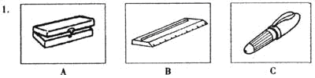
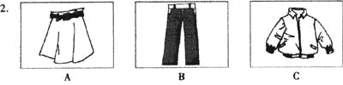
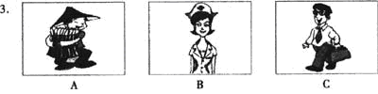
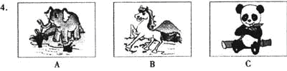
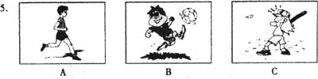

Ⅱ．听4段对话。判断第6---15小题所给句子的正误。每段对话念两遍。（每小题1分，共10分）
听第一段对话，完成第6-7小题。
6．Tim is a football player.
7．Tim is going t0 do his homework.
听第二段对话，完成第8—9小题。
8．Peter has a bad cold.
9．They wⅡl go to see Peter.
听第三段对话，完成第10一12小题。
10．They are office workers.
11．They may be in a restaurant.
12．The woman wants to eat rice and fried chicken.
听第四段对话，完成第13-15小题。
13．Sam is playing computer g8rues.
14．Salli is going to have a Chinese exam.
15．Sam is talking with hi8 teacher in the classroom.

Ⅲ．听短文，根据短文内容，选择正确答案。短文念两遍。（每小题1分，共lO分）
16．John wants to ________ in the last week 0f the holidays.
A．stay at home B．go on trip C．see his friend
17．John’S uricle lⅣes______.
A．near the sea B．in the town C．in the village
18．From the passage we can guess John likes______.
A．fishing B．skating C．swimming
19．It will be cold______.
A．next week B．next month C．next year
20．John’s home is ______ his uncle’s.
A．near B．far from C．next to
21．John will be ______ years old next year.
A．15 B．16 C．17
22．It is the first time for John to take a trip______.
A．alone B．early C．abroad
23．John’s father thinks it’s a_____experience for his son.
A．good B．bad C．dangerous
24．John is very______now.
A．sad B．nervous C．happy
25．At last____is going to trayel winl John.
A．his father B．his mother C．nobody

Ⅳ．听短文，完成下面表格，每空一词。短文念两遍。《每小题1分，共5分）
Name | Tom Smith | Hobbies | Playing 28 and collecting 29
Age | 26 | Hobbies | Playing 28 and collecting 29
Nationality | American | Hope | To visit 30 in 2008
Favorite Subject | 27 | Hope | To visit 30 in 2008

Part Two 语言知识运用 （ 25分 ）
Ⅰ．单项选择。
31.--Do you know Taiwan, Jenny?
--Yes, of course. Taiwan is _____ island. It belongs to China.
A．a B．an C．the D．不填
32．--What a lovely card! Where did you buy it?
--I made it by___________
A．me B．himself C．myself D．itself
33．--When did Hong Kong return to our motherland.'?
-- ___July 1st, 1997.
A．On B．In C．At D．For
34．--Which of the twin sisters is a doctor?
--__________are.
A．All B．Both C．Either D．Neither
35．--Why are you so____ ?
--Because our ping-pong player Wang Liqin has won the world championship.
A．excited B．exciting C．bored D．boring
36．--Could yon tell me whom the radio_____ by?
--Sorry, I have no idea.
A．invents B．invented C．is invented D．was invented
37．--Mr Green,____you_____ Three Lanes and Seven Alleys （三坊七巷） last Sunday?
--No, but I'll visit them next week.
A．will; go to B．have ; been to C．did; go to D．have ; gone to
38.--What does your cousin look like now?
--Oh,he is much than before.
A．strong B．stronger C．strongest D．too strong
39．--Hurry up. The bus is coming.
--Oh, no. We mustn't cross the street______the traffic lights are green.
A．after B．since C．while D．until
40．--Bob,may I______your MP4?
--Sure. But you'd better not_______ it to others.
A．lend ; lend B．lend; borrow C．borrow; borrow D．borrow; lend
41．--There goes the bell.
--It' s time for class. Let' s stop_______
A．talk B．to talk C．talking D．not talk
42．--How are you getting along with your classmates?
--Very well. They are all____ me.
A．afraid of B．angry with C．tired of D．friendly to
43．--There __ no milk in the fridge. Could you get some for me, Dick?
--All right, Mum.
A．is B．are C．was D．were
44．--Did Mr White tell you _______ ?
--Yes. He said he went there in 2003.
A．when he traveled to Tibet B．how he goes to Wuhan
C．where he spent his holidays D．why did he visit Kunming
45．--Excuse me, what' s the time, please?
--Sorry. I don't have a（an）_____with me.

Ⅱ．完形填空（每小题1分，共10分）
Do yon think of your parents? "Yes, of course," you may answer, "I buy a present for my mother on 46 And I give my father a present on Father' s Day,
47 ." Then what about the other days of a year? Always 48 to think of your parents, not just on some important days.
I have a friend who 49 alone, because her parents live in another city. One day I went to see her. We had a nice chat. Then she wanted to make a 50 . She dialed （~） the number, but then she put the phone 51 . After about ten seconds, she dialed the number again. "Hi, Mum..."
Later I asked, "Why did you dial the number 52 ?" She smiled, "My parents are old. They can' t get close to the telephone 53 . I always do so when 1 call them. I just want to give them 54 time to answer the call. "
My friend is a good girl. She is always 55 her parents. You also want to be a good child, right? So why not leant from her?
46．A．Father's Day B．Mother's Day C．Teachers' Day D．Children's Day
47．A．too B．also C．either D．yet
48．A．refuse B．forget C．decide D．remember
49．A．live B．lives C．lived D．living
50．A．face B．card C．call D．cake
51．A．up B．off C．down D．on
52．A．once B．twice C．several times D．many times
53．A．lonely B．slowly C．quietly D．quickly
54．A．less B．little C．enough D．a lot
55．A．thinking about B．laughing at C．picking up D．looking for

Part Three阅读理解（20分）
Ⅰ．根据短文内容，选择最佳答案。（每小题2分，共10分）
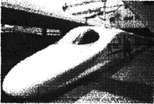
Beijing-Shanghai Railway was completed in 1968. The line runs 1,462 km between China's two main cities and passes through five provinces and the city of Tianjin.
Since opening, it has been one of the busiest routes in our country. The Beijing-Shanghai route is now served by 10 trains a day, five of which are non-stop. The journey time is just under 12 hours.
Now trains are allowed to travel at 250 kph （ kilometers per hour） and the journey time is only 10 hours.
With the sixth railway speedup, China has joined the ranks （行列） of countries with high-speed rall serviees. Trains are able to run at speeds of 200 kph on some 6,003 km of track（轨道）, and on some sections, the highest speed can increase to 250 kph. The 6,003 kmof track serves both high-speed passenger trains and low-speed cargo （货物） trains.
Railway operators have to deal with the problem of the speed gap （差距） between the two kinds of trains to make sure they both run safely.
56．The Beijing-Shanghai Railway line runs 1,462 kilometers, doesn't it?
A．Yes, it does. B．No, it doesn' t. C．1t' s very far. D．We don' t know.
57．How many times have the trains been speeded up so far?
A．Five. B．Six. C．Seven. D．Eight.
58．When the Beijing-Shanghai train runs at 250 kph, the passengers spend on the train.
A．ten hours B．twelve hours C．one day D．two days.
59．Which of the following sentences is TRUE?
A．Only one train is served on the 6,003 km of track.
B．Beijing-Shanghai Railway passes through six provinces.
C．All of the trains run without any stops on Beijing-Shanghai Railway .
D．Since opening, Beijing-Shanghai Railway has been one of the busiest routes in China.
60．The passage above is probably from
A．a story-book B．a dictionary C．a newspaper D．an advertisement

Ⅱ．根据短文内容，判断下列句子的正误。正确的用“T“。错误的用“F”。（每小题2分，共l0分）

Have you seen the videos on TV? Do you wear large T-shirts and baggy jeans? Or have you heard someone rap （说唱） ? Hip-Hop is very hot now.
Hip-Hop music was started in the middle of the 1970s by African Americans in New York. The music, break-dancing（霹雳舞） and graffiti （涂鸦 ） make up Western Hip- Hop culture. Most of the Hip-Hop songs are about love, jobs or even games.
Usually in rap, singers speak words very quickly to a certain beat. Most of the wonts are fun. Singers play off words to make fun of themselves or others. Hip-Hop music has few rules. Singers just do what they think and rap it out in a clever or creative way. The freedom makes a lot of teenagers fall in love with the music. Many of them like wearing large T-shirts and baggy jeans. Famous rap and Hip-Hop stats include Eminem in the U.S. and Jay Chou from China.
Today Hip-Hop is more and more popular across most of the world.
61．African Americans started Hi,r-Hop music in the middle of the 1970s in New York.
62．There are three main kinds of music in Western ttip-itop culture.
63．Hip-Hop music is very popular，but it has a lot of rules to follow.
64.From the pas~sage we know jay Chou is a famous rap and Hip-Hop star.
65．Many'teenagers don't like wearing large T-shirts or baggy jeans.

第二卷
Part One语言知识运用（35分）
Ⅰ．词汇（10分）
i．根据图画内容，完成下列句子。每空一词，首字母已给出。（每小题1分，共5分）
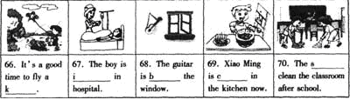
ii.根据中文提示，用词组的适当形式填空。每空一词。（每小题1分。共5分）
71一hope that my dream will__________（实现）in the future.
72．My grandma goes to the park_____________（步行）every morning.
73．一Are you_____________（擅长）chemistry? 一Yes，I am，
74．一The physics problem is so difficult that I can't______it_________（算出）。
75．One of my classmates is going to be a policeman when he___________（长大）。
iii．口语应用（15分）
根据对话内容，选择恰当的句子补全下列对话。（每小题1分，共5分）
A：The plane is late，isn’t it?
B：Yes. it is.
A：76
B：No，I don't. I'm just a tourist.
A： 77
B：Yes. I have been here three times.
A： 78
B：Mount Gu. Xichan Temple，Jiangbin Park and so on.
A：What do you think of Fuzhea?
B：lt’s beautiful. 79
A：How do you like Min Food?
B：Very much. 80 I must go now.Bye-bye!
A：Bye!
A．1 don't think so.
B．Do you work here in Fuzhou?
C．Oh，here’s my plane at last.
D．What places have you been to?
E．How long have you stayed in Fuzhou?
F．Have you ever been here before?
G．Great changes have taken place these years.

Ⅱ．从Ⅱ栏中选出I栏中每句话的正确答语。（每小题1分，共5分）
Ⅰ Ⅱ
81．Merry Christmas! A．Spring.
82．Hello!May I speak to Linda，please? B．It doesn’t work.
83．Which season do you Ⅱke best? C．The same to you.
84．What’s wreng with your bike，Lucy? D．Sorry. I’ll do it at once.
85．Would you mind turning down the music? E．Just a moment，please.

Ⅲ．用恰当的词语填空，完成对话。每空一词。（每小题1分，共5分）
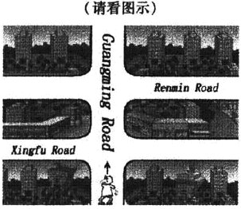
A：Hi，Kate!Are you free tomorrow afternoon?
B：Yes. What’s up?
A：I 86 to a new apartment last week. Would you 87 to come to my new home?
B：Yes，I’d love to. But 88 can I get to your home?
A：Walk along Guangming Road and turn 89 onto Renmin Road. You will see three tall buildirigs on your left，I live in Apartment 905，Building A.
B：0K. I’v be 90 at 2:00.
A：See you then.
B：see you.

Ⅲ．完形填空（每小题1分，共lO分）
用方框中所给单词的适当形式填空，使短文正确、通顺。每词限用一次。
try，Calldy，after，Such，something，watch，together，usual，south，clearn
The Spring Festival
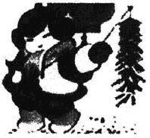
In China the Spring Festival is the most important holiday. It falls on the first day of the first lunar menth（阴历月）.
Before the Spring Flestival comes，people go out to buy things， 91 as meat，chicken，fish，fruit，sweets and new clothes. They 92 their houses and decorate（装饰）them. The Chinese character"fu" is a must. It is 93 stuck（贴）upside down，which means "fu comes".
The celebrations begin on the eve of the lunar New Year. The family get一94 for a big dinner. If a person is far from home，he will always 95 to get home for this big dinner. After the dinner，the whole family will sit together， chat and 96 TV.
During the holidays，they go to visit relatives and friends and exchange New Year greetings. They sit around talking and eating 97 ，cakes and all kinds of delicious food. Every faroily prepares 98 special. Each child will get money as New Year gift. People in the north of China often eat dumplings for breakfast. People in the 99 often eat niangao because rdangao means“higher and higher one year 100 another”。
The celebrations last 15 days. It will come to an end when the Lantern Festival is finished.

Part Two阅读理解（20 分）
Ⅰ．匹配题（10分）请阅读以下对五位名人的介绍，从（A）一（E）中找到与101—105题对应的内容，把名人介绍补充完整。（每小题1分，共5分）
小词典：csosstalk master 相声大师 moustache小胡子 satirize讽刺
inherit 继承 technique技术 industry工业
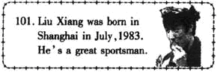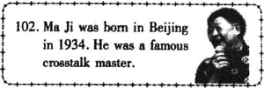
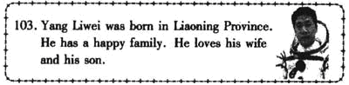
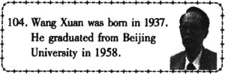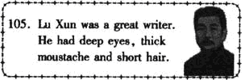
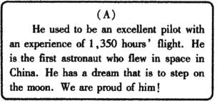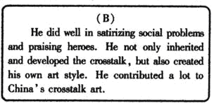
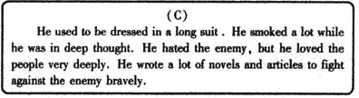
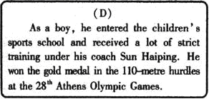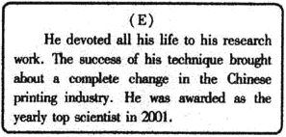

Ⅱ．阅读下列语段。把它们组成一篇连贯的短文。（每小题1分。共5分）（ A）A fire-engine will arrive quickly. The firemen know what to do. They have long ladders to reach high windows.
（B）If you want to be a fireman，you must he strong and healthy. A fireman has to be able to carry heary things. He has to be able to climb ladders and to work in high places. So he also has to be brave.
（C）They try their best to rescue the people wh0 can’t get out. If some people are hurt，they are taken to hospital in ambulantes（救护车）.
（D）when a fire begins，we must tell the fireman. Do you know how to do this?
（E）After an the people have been rescued，the firemen put out the fire. Sometimes this is very diffcult because some people keep thilags in passages and on stairs. Then the firemen can't
get past to fight the fire.
（F）Go to me nearest telephoile and dial the number 119. When solneolqe speak8，tell him about the fire. Speak slowly and clearly.
The right order is: | 第一语段： D | 106. | 107. | 108. | 109. | 110.

Ⅲ．阅读下面短文，回答问题。（每小题2分。共10分）
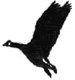
Canada Geese are large blue and white birds. When autumn comes. they have to nv$outh where the weather is warmer. The winters are so cold in Canada that the birds will die if they stay there.
Last spring，Bill Lishman found sixteen young Canada Geese on his farm. They had lost their pareilts. Bill thought，“These young birds won’t know what to do in the autumn. ”He had a small plalle and he decided to teach the birds to follow him. All through the summer，he went on short trips in his plane and the young geese new after him.
When the cold weather arrived in the autumn，Bill flew to Virginia in the United States. 600 miles South of his home in Canada. The geese followed him all the way. Bill left the geese in Virsinia and he returned home.
This spring，Bill was waiting for the birds to come back. They didn't arrive, so Bill flew to Virginia to get them. He looked for them for two weeks but he couldn't find them. When he arrived back home，he found the geese waiting for him. They had found their way home without him!
111．What will happen to the geese if they stay in Carlada in winter?
112．Where did BiU find sixteen young geese last spring?
113．Is it 600 kilometera from Bill’s home to Virginia?
114．How long did it take Bill to look for the geese in Virginia?
115．The geese found their way home by themselves，didn't they?

Part Three书面表达（20分）
I．作文A（每小题2分，共8分）
以下是某学校图书馆倡导文明的英文告示牌，请你用所给的提示词补充四条，使之完整。
提示词：★keep…clean ★take care ★smoke ★noise
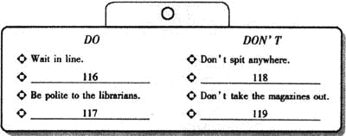

Ⅱ．作文B（12分）
120．为了交流学习经验，提高学习效率，《新世纪英文报》正在举办以“How to be a good learner?”为题的征文比赛。请你踊跃投稿。内容提示：
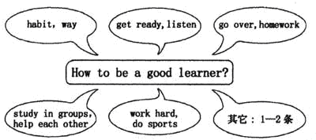
要求：
1．必须用上所有的内容提示，语句通顺，书写规范；
2．词数80左右，已给出的句子不计人总词数。
How to be a good learner?
As a good learner，we should_____________________________
______________________________________________________________________________________________________________________________________________________________________________________________________________________________
I hope all these will be helpful to us.
