厦门市2009年初中毕业及高中阶段各类学校招生考试
英 语 试 题
（满分：150分；考试时间：120分钟）
准考证号_________________ 姓名__________________ 座位号_________
考生注意：
本试卷分为两大部分，第一部分（1-75小题）为选择题，请考生将答案用2B铅笔填涂在答题卡上；第二部分为非选择题，请考生将答案用0.5毫米的黑色签字笔书写在答题卡上。
第一部分（选择题）
（一）听力测试（每小题1分，共30分）
I. Listen and choose the right pictures.
(听音，选择符合内容情景的图片。听两遍)
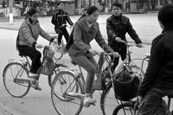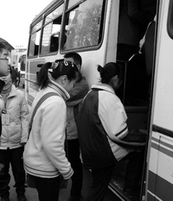
1. A B C
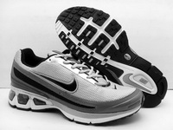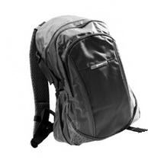
2. A B C

3. A B C
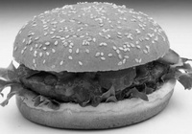
4. A B C

5. A B C
II. Listen to some short dialogues and choose the right answers to the questions you hear.
(听简短对话，然后挑选最佳答案回答所听到的问题。听两遍)
6. A. The hospital. B. The museum. C. The cinema.
7. A. Talking with his mother. B. Visiting his grandmother. C. Cleaning the room.
8. A. Tom’s pen pal. B. Tom’s classmate. C. Tom’s English teacher.
9. A. Get up early. B. Finish his homework. C. Do some housework.
10. A. Toothache. B. Headache. C. Stomachache.
11. A. Action movies. B. Comedies C. Documentaries.
12. A. An actor. B. A reporter. C. A bank clerk.
13. A. Having a meal. B. Doing some shopping. C. Having a picnic.
14. A. Australia. B. America. C. China.
15. A. The computer. B. The TV set. C. The camera.
III. Listen to a long dialogue and a passage, then choose the right answers to questions 16-20.
(听一篇较长对话和一篇短文，然后选择正确答案作答16 – 20小题。听两遍)
Text A
16. Dave saw ______ in the sea. He thought it was fun.
A. fish B. boats C. dolphins
17. Dave bought ______ at the beach.
A. a hat B. some pictures C. ice cream
Text B
18. Peter is ______ years old now.
A. 10 B. 15 C. 25
19. Peter is going to be a ______ when he grows up.
A. language teacher B. sports star C. fashion designer
20. In ten years, Peter likes to go everywhere by ______.
A. plane B. car C. bus
…………………………………………………………………………………………………………..
注意：请将该题的答案书写在答题卡的第二部分
IV. Listen to a dialogue and a passage, then fill in the blanks with the right words.
(听一篇对话和一篇短文，用恰当的单词填空完成76–85小题，每空一词。听三遍)
Text A: 听录音， 填写以下健康调查表。
Items | How often
exercise | 76.__________times a week
eat vegetables | every day
eat 77. __________ | hardly ever
drink green tea | 78. __________
drink water | every day
eat 79.__________ food | 80.__________ a month
Text B: 听录音， 记录姐妹二人的相关信息。
 | Be afraid of… | Personality | Hobbies
I | the 81.__________ | 82.__________ | like gentle music, watching TV…
My sister | a big 83._________ | outgoing and 84. ________ | like loud music, 85.__________,  living in a big city
…………………………………………………………………………………………………………..
（二）基础知识与运用（每小题1分，共30分）
V. 选择填空：从A、B、C中，选出一个最佳答案完成句子。
21. – How is the ______ there, Lingling?
– It’s a sunny day.
A. weather B. vacation C. service
22. Ben likes robots best. He often says to me that ______ is more interesting than robots.
A. something B. anything C. nothing
23. More and more foreign students come to China to learn ______ Chinese.
A. a B. the C. /
24. In the picture, the ______ one from the left is Huanhuan.
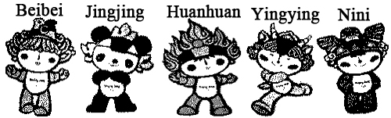
A. first
B. third
C. fifth
25. Lily used to learn English ______ watching American movies. She thought it really helped.
A. by B. to C. of
26. – ______ have you been collecting coins?
– Since I was a little child.
A. How often B. How soon C. How long
27. I was very ______ to see what happened that day. I couldn’t believe it at all.
A. relaxed B. surprised C. tired
28. It’s a nice restaurant, and the food is delicious. ______ it’s too crowded and noisy.
A. And B. So C. But
29. Look at Mary, she keeps walking here and there before talking in front of class. She _____ be very nervous.
A. can’t B. must C. need
30. My clock doesn’t ______. Can you tell me what time it is now?
A. work B. walk C. use
31. – Yeah, our team ______ the match.
– Well done! Congratulations!
A. beat B. failed C. won
32. – How many times have you been to the Great Wall?
– Only once. I ______ there last year.
A. went B. have gone C. have been
33. We’ll go camping if it ______ this Sunday.
A. won’t rain B. doesn’t rain C. isn’t raining
34. – Alice, you ______ on the phone.
– I’m coming. Thanks.
A. want B. are wanting C. are wanted
35. – What are you ______?
– My exercise book. Have you seen it anywhere?
A. looking for B. reading for C. caring for
36. After discussing, they ______ a good idea to work on the project.
A. mixed up with B. came up with C. caught up with
37. – We’re going on a school trip next week. Do you know ______ get there?
– By bus.
A. if we will B. how we will C. why we will
38. At school, you should do the things ______ are allowed by teachers.
A. that B. when C. what
39. – Don’t make any noise in the library!
– ______.
A. OK, I will B. Yes, I do C. No, I won’t
40. – Do you mind my taking this seat?
– _____. It’s for Mr. Brown.
A. Not at all B. Yes, please C. Better not
VI. 完形填空：从A、B、C中，选择一个最佳答案，使短文意思完整。
Many people catch a cold in the springtime or fall. It makes us 41 : if scientists can send a man to the moon, 42 can’t they find a good remedy(疗法) for the common cold? The answer is easy. There are hundreds of kinds of cold viruses(病毒) out there. You never know which one you will 43 , so there isn’t a remedy for each one.
When a virus attacks(攻击) your body, your body works hard to get rid of(清除) it. You feel terrible but your body is actually 44 with the virus. Your temperature goes 45 and you get a fever, but the heat of your body is killing the virus.
Different people have different remedies for 46 . In America and some other countries, some people take hot baths and drink warm water to feel better, others 47 to stop the fever and runny nose.
There is one interesting thing to note – some scientists say bodies can do an amazing job on their own when you have a cold, so taking medicine isn’t actually 48 for you. The virus stays in you
49 because your body doesn’t have a way to kill it by itself.
There is a 50 , however, on taking medicine when you have a cold. It goes like this: It takes about 1 week to get over a cold if you don’t take medicine, but only 7 days to get over a cold if you take medicine.
41. A. wonder B. invent C. wait
42. A. where B. why C. when
43. A. fix B. get C. hit
44. A. helping B. playing C. fighting
45. A. on B. down C. up
46. A. colds B. trouble C. health
47. A. take the temperature B. take some medicine C. take a chance
48. A. bad B. good C. serious
49. A. longer B. shorter C. fewer
50. A. hope B. plan C. joke

（三）阅读理解（每小题2分，共50分）
VII. 阅读下面五篇短文，根据文章的内容选择最佳答案作答51–75小题。
A
Four girls were at the same school. They were good friends, so they often studied and played together. They went to school every day by taxi.
One day one of the girls said, “There is a test this morning. Let’s go to school late. Then we won’t have to take the test.” “What can we tell the teacher?” One of the girls said. “He’ll be angry. We’ll need a good excuse.”
The girls thought for several moments, then one of them said, “Let’s tell him that our taxi had a flat tire(爆胎).” “That’s a good idea,” the other girls said. “We’ll tell him that.”
They arrived at school an hour later. The test was finished.
“Why are you late?” the teacher asked. “You miss the test.” “Our taxi had a flat tire,” one of the girls said.
The teacher thought for a moment, then he said, “Sit down, one of you in each corner of the room.” The four girls did this. Then the teacher said, “Write the answer to this question on a piece of paper: Which tire was flat?”
51. The four girls went to school every day by ______.
A. bus B. taxi C. subway
52. There was ______ that morning.
A. a test B. no classes C. a trip
53. One day the four girls were late for school because ______.
A. they didn’t like the teacher
B. there was a car accident
C. they planned to miss the test
54. We can know from the passage that the teacher ______.
A. thought they were good students
B. didn’t believe what they said
C. gave his students too many tests
55. The four girls sat down as the teacher said like Picture ______.
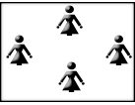
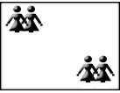
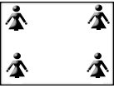
A. B. C.

B
Post your problems on the blog and get other bloggers’ advice!
My problem is my parents. They never stop going on about how I should keep my room tidy, keep my hair tidy and wear smart clothes. They even make me do the washing-up after dinner every night! What should I do?
Helen, USA
Why do you think you’re the only one with parents like that? All parents are the same. They don’t understand that fashions have changed in the last 30 years!
Tom, Canada
Hi, Helen. I think you should do what your parents ask. You should respect them. It’s their house you live in and their money you spend.
Emily, New Zealand
Helen, why should your parents do all the chores? You should help around the house. I think it’s OK for students to wear school uniforms. Teenagers should look like teenagers.
Simon, Scotland
My best friend has suddenly become an ex-friend and I don’t know why! Last week we phoned each other every day and emailed too. But at school on Monday she didn’t look at me or speak to me. I don’t know what I’ve done.
Gimbya, India
I feel sorry for you, Gimbya. My best friend did the same to me and I still don’t know the reason. Could you ask another friend to speak to her for you?
George, France
Don’t worry about it so much! Phone your friend up as usual and she won’t be able to ignore(忽视) you. Everything will be fine.
Aisha, Nigeria

56. There are ______ pieces of advice in all in the table above.
A. 3 B. 5 C. 7
57. Helen’s problem is about her ______.
A. classmates B. study C. parents
58. ______ has the same problem as Gimbya.
A. George B. Aisha C. Helen
59. ______ don’t agree with Helen. They think she should change her idea.
A. Tom and Emily B. Emily and Simon C. Simon and Tom
60. An ex-friend is a person who is ______.
A. no longer a good friend as before
B. quite helpful when you have any problem
C. ready for asking you for help all the time
C

Go to any Irish city or town on 17th March and you’ll see a strange sight: people dressed in green, wearing the shamrock on their clothes and marching in parades(游行). What’s it all about? It’s St Patrick’s Day, of course!
Irish people all over the world celebrate(庆祝) St Patrick’s Day and big parades take place in New York, Chicago and Boston in the USA because lots of Irish people live there.
Green is the main color on St Patrick’s Day as that is the national color of Ireland. Thanks to the great amount of rainfall, Ireland is a very green, rural country with some places seeing rain for 225 days in a year.
The tradition began by accident after a worker, who was using dye(染料) to test leaks(泄露) into the river, discovered his orange dye turned green when mixed with water. City officials decided to add dye to the river to celebrate St Patrick’s Day.
61. Many of Irish people ______ on March 17.
A. take part in parades B. plant lots of trees C. travel to the USA
62. We can learn from this passage that it’s quite often ______ in Ireland.
A. snowy B. windy C. rainy
63. St Patrick’s Day started by accident when a worker used the ______ dye in his job one time.
A. green B. orange C. blue
64. The best title of this passage is “______”.
A. A green country B. A green dye C. A green holiday
65. Which of the following statements is TRUE according to the passage?
A. St Patrick’s Day is celebrated only in Ireland.
B. The shamrock is St Patrick’s favorite plant.
C. The river turns green because of the heavy pollution.

D
“After landing Kim is still excited. “In the air I am the happiest person alive”, she explains. “Even after years of sky surfing experience it’s still the most amazing feeling on earth.”
a)
“The beauty of free-running is that anybody can do it”, says Michel. “There are no set rules to follow. All you need is a pair of trainers(跑鞋/教练) and an open mind. The rest is up to you.”
b)
“How much time will we have in freefall?” skysurfer Kim Frisby asks her “cameraflyer” David. “Less than forty seconds”, he answers. Kim and David show the thumbs(拇指) up to the pilot and jump together.
d)
Nick is a good learner. He looks like a character out of action movies. Michel usually does this faster and higher up, but today he is teaching the less experienced man some of his free-running skills.
c)
“Follow me”, says Michel Chamois. “And do what I say, not what I do. We have to make the safest run.” Nick, the strong young man, slowly climbs up the building and jumps from roof to roof.
e)
Kim moves her body up and down, left and right, backwards and forwards. Kim is dancing with the wind, as the air hits her body faster and faster.
f)

66. We’ve got two texts in Passage D. The correct order of them should be ______.
A. Text1: d-c-a B. Text1: d-f-a C. Text1: d-a-b
Text2: e-f-b Text2: e-c-b Text2: e-c-f
67. ______ can enjoy the view from the plane.
A. Michel B. David C. Nick
68. According to the passage, Kim ______ sky surfing.
A. is good at B. starts to learn C. is afraid of
69. Michel does the free-running more slowly than before because he works as ______ this time.
A. an actor B. a pilot C. a trainer
70. This passage is mainly talking about ______.
A. extreme sports B. action movies C. space travel
E
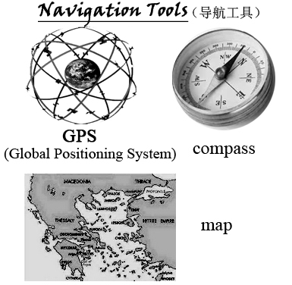
One of my favorite things to do is hiking in mountains. Because nobody likes the idea of getting lost, I always prepare before every trip. But what’s the best navigation tool, a Global Positioning System(GPS) or a good old map and compass?
Five of my friends and I hiked through the mountains on a trail(路线) I marked. One team of three carried a GPS, and the other team used a map and compass.
It took the GPS team 3 hours and 11 minutes to get through the whole hike, however, it took the map and compass team only 2 hours and 49 minutes. The biggest problem the GPS team met was that they lost the satellite signal(卫星信号) in some places. With no map or compass, they had to walk around until they were in a place where the signal was good. The map and compass team was able to spot different landmarks, compare them to their maps and then use the compass to point them in the right direction.
When I head out on my future hikes, I’m bringing a map, a compass and a GPS to show me the way.
71. The writer prepared before every trip because he didn’t ______.
A. like the old map and compass B. know how to use the GPS C. want to get lost in mountains
72. There were ______ people in each team.
A. 3 B. 5 C. 6
73. The two teams ______.
A. had the same navigation tool B. went along the same trail C. had the same problem
74. The GPS team spent ______ time than the map and compass team in the whole hike.
A. less B. more C. the same
75. In the end, the writer found out ______.
A. the map and compass were too old navigation tools to use any more
B. it wasn’t necessary to bring a map and a compass together with a GPS
C. the GPS had some disadvantages in hiking in mountains
第二部分（非选择题）
（四）情景交际运用（共20分）
VIII. 根据对话情景，填入恰当的单词。（每空一词，每词1分，共6分）
A: Hi, Daniel. I didn’t see you at school yesterday. What’s wrong with you?
B: I was (86.__________). I had to stay in bed and have a good rest.
A: I’m sorry to hear that. Have you gone to see the (87.__________)?
B: Yes. And I feel much better now.
A: That’s good. Well, have you finished your (88.__________) homework?
B: Not yet. It’s really (89.__________) for me. You know, I’m always weak at math.
Can you give me a hand?
A: Sure, I’m glad to (90.__________) you. Why not come to my home this evening?
B: Thanks a lot. Then we can do our (91.__________) together first, and watch TV after that.
A: OK. See you then.
B: See you.
IX. 根据情景提示，用恰当的短语或句子填空。（每空2分，共8分）
* 本周末你要开一个生日派对，你想邀请Lucy参加，你可以这样说：
92. _________________________________________ my birthday party this weekend, Lucy?
* Tim请你一起去迪斯尼乐园玩，你想告诉他这个主意很棒，你可以这样说：
93. ________________________________________________________________________.
* 你想让你的笔友知道你妹妹的长相是 “高个子，留长卷发”，你可以这样描述：
94. My sister is tall, and she ____________________________________________________.
* 你想知道如果Jack有一百万元，他将会怎么做？你可以这样问他：
95. _____________________________________________ if you had a million dollars, Jack?
X. 根据语篇情景，用恰当的短语或句子填空，使之意思完整。（每空2分，共6分）
Henry lives in a small town in England. Many of his friends have been to China for their holidays. They often say China is a beautiful country. So, last year, Henry decided to (96._________________) for his holiday, too.
On the first night when he arrived in Beijing, he went out for a walk. He was crossing the street when a car came towards him. Luckily, the car (97.____________________). When the driver got out of the car and said sorry to him, Henry said, “You should drive (98.______________________), and you should be more careful and slower next time.” The driver said friendly, “Maybe you don’t know that here in China we all drive on the right. Do as the Romans do, you know?”
（五）写作（共20分）
XI. 看图写句。（每句2分，共8分）
根据图示和提示词，写出恰当的句子，每图一句。
（要求：1. 使用全部的提示词；2. 写出完整的句式结构。）
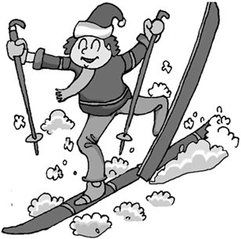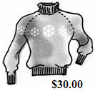
99. he, now 100. cost, Joe
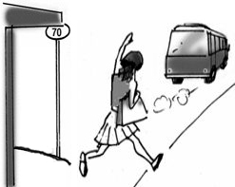
101. Lucy, favorite 102. when, leave
XII. 短文写作。（本题12分）
每个人的心目中都有自己喜欢或崇拜的偶像，他/她可能影响到你日常生活的喜怒哀乐，甚至影响到你对人生目标和成长道路的选择。请你用英语写一篇80词以上的短文，谈谈你心目中的偶像（或自己最喜欢的人）。
内容要求：1. 他/她大致的外貌和个性特征；
2. 你为什么特别喜欢或崇拜他/她；
3. 他/她对你最大的影响是什么？
参考词汇：make sb. one’s idol 把某人作为偶像，崇拜某人
注 意：短文中不允许出现与考生本人相关的真实姓名和校名等信息。

__________________________________________________________________________________

__________________________________________________________________________________

__________________________________________________________________________________

__________________________________________________________________________________

__________________________________________________________________________________

试题结束，请认真检查!

