绝密★启用前 试卷类型：A

泰安市二〇一一年初中学生学业考试

英 语 试 题
本试卷分第I卷（选择题）和第II卷（非选择题）两部分。第I卷1至8页，第II卷9至12页，共120分。考试时间120分钟。
第I卷（选择题 共80分）
注意事项：
1. 答第I卷前, 考生请务必将自己的姓名、准考证号、考试科目等涂、写在答题卡上。
2. 第I卷选出答案后, 用铅笔把答题卡上对应题目的答案标号涂黑。如需改动, 用橡皮擦干净后, 再选涂其他答案标号。
3. 答案答在试题上无效。考试结束后，试题和答题卡一并收回。
第一部分 听 力（共25小题；每小题1分，满分25分）

（一）听句子，选择适当的应答语。每个句子读两遍。
1. A. She is a nice girl. B. I’m sorry to hear that. C. What a pity!
2. A. Thank you. B. I don’t like them at all. C. Coffee, please.
3. A. That’s all right. B. That’s wrong. C. You are welcome.
4. A. Yes, I’d love to. B. I don’t mind. C. I feel terrible.
5. A. Red roses. B. Sounds good. C. I like white.

（二）听对话，选择相应的图画。每段对话读两遍。

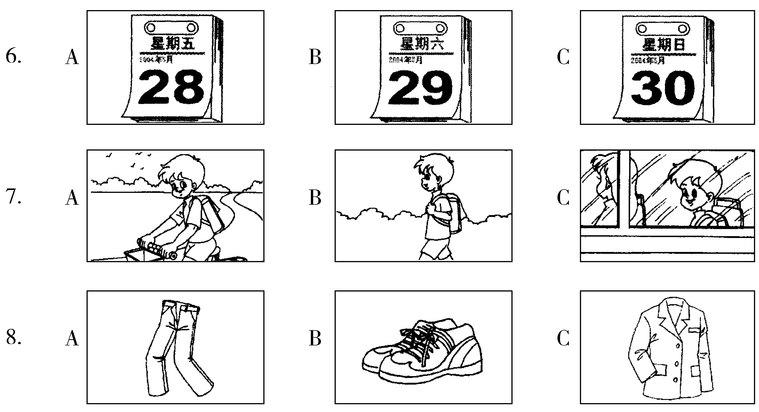

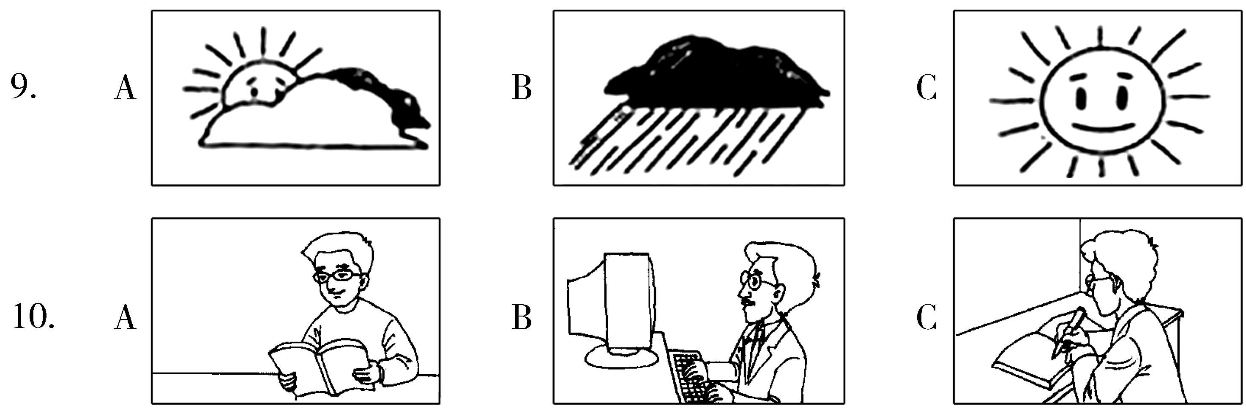

（三）听五段对话和五个问题，选择正确答案。每段对话及问题读两遍。你将有15秒钟的时间阅读下面5个小题。
11. A. French fries. B. Salad. C. Hamburgers.
12. A. Her grandfather. B. Her father. C. Her mother.
13. A. The music is nice. B. The story is interesting. C. It is too long.
14. A. 2 dollars. B. 4 dollars. C. 6 dollars.
15. A. Take some medicine. B. Drink some chicken soup. C. Call the doctor back.

（四）听两段长对话，选择正确答案。每段对话读两遍。你将有20秒钟的时间阅读下面5个小题。
听第一段对话，回答16、17小题。
16. What does Mr. Brown do?
A. A doctor. B. A teacher. C. A driver.
17. What time does Mr. Brown get up in the morning?
A. At 6:00. B. At 7:00. C. At 8:00.
听第二段对话，回答18至20小题。
18. What is Rose busy with?
A. Her trip plan. B. Her school exam. C. Her summer report.
19. Who will go camping with Rose?
A. Bill. B. Her sister. C. Her classmate.
20. How does Rose find Bill’s suggestion about camping?
A. Wonderful. B. Crazy. C. Strange.

（五）听短文，选择正确答案。短文读两遍。你将有20秒钟的时间阅读下面5个小题。
21. When did Jenny write the letter to Lucy?
A. On November 25th. B. On December 5th. C. On December 24th.
22. When did Jenny leave Lucy?
A. About four weeks ago. B. About two months ago. C. About one year ago.
23. Where is Jenny working now?
A. In New York. B. In London. C. In Washington.
24. What does Jenny think of her new job?
A. Interesting. B. Easy. C. Bad.
25. Why can’t Lucy go to Jenny’s Christmas party?
A. She is busy with her work.
B. She has to visit her grandfather.
C. Her grandfather will come to visit her family.
第二部分 语言知识运用（共两节, 满分25分）
第一节 语法和词汇（共15小题；每小题1分，满分15分）
从每小题A、B、C、D四个选项中, 选出能填入相应空白处的最佳选项, 并在答题卡上将该项涂黑。
26. —Did you get there by ______ bike?
—No, I took ______ taxi.
A. a; a B. 不填; a C. the; the D. a; the
27. —Excuse me, are these ______ new shoes?
—No, they aren’t. ______ are black over there.
A. your; Mine B. my; Your C. her; Her D. mine; Yours
28. —Mom, shall we have supper now?
—Oh, we won’t have supper ______ your dad comes back.
A. until B. since C. while D. after
29. —Which do you like , summer or winter?
—I prefer summer.
A. good B. well C. better D. best
30. —Your sweater looks nice, is it made of wool?
—Yes, and it’s made ______ Shanghai.
A. by B. in C. for D. from
31. —I prefer speaking to listening in English learning.
—Oh, really! I think you should be good at ______ of them.
A. both B. neither C. some D. all
32. —Yao Ming is very popular among teenagers.
—Yes. Many middle school students are his ______.
A. heroes B. stars C. fans D. brothers
33. —I feel tired and sleepy.
—Why not stop ______ for a while?
A. rest B. to rest C. resting D. rested
34. —Jack, could you help me when the plane will take off on the Internet?
—I’m sorry, my computer doesn’t work.
A. get out B. look out C. take out D. find out
35. —The little girl ______ her seat to an old man on the bus.
—What a kind girl!
A. brought B. offered C. gave D. lent
36. —Tom wants to know if you will have a picnic tomorrow.
—Yes. But if it ______, we’ll play chess instead.
A. will rain B. rained C. is raining D. rains

37. — ______ do you read English newspapers?
—I read China Daily every day.
A. How long B. How soon C. How often D. How far
38. —Must I learn all these words by heart?
—No, you ______. It’ll be fine if you copy them in your exercise books.
A. needn’t B. can’t C. shouldn’t D. mustn’t
39. —Can you guess ______ the new schoolbag yesterday?
—Sorry, I’ve no idea.
A. how much did he pay for B. how much he spent
C. how much he paid for D. how much did he spend
40. —Happy birthday to you, Mary!
— ______.
A. Thanks a lot B. The same to you
C. You’re welcome D. It’s kind of you
第二节 完形填空（共10小题；每小题1分，满分10分）
阅读下面短文，掌握其大意，然后从每题所给的A、B、C、D四个选项中，选出能填入短文相应空白处的最佳选项，并在答题卡上将该项涂黑。
Jack 41 in a small town in England. He always stayed in England 42 his holidays, but last year he thought, “I’ve never been to 43 countries. All my friends go to Spain, 44 they like it very much, so this year I’m going there, too.” So he got on a 45 to Spain and 46 at the airport of the capital, Madrid, and stayed in a hotel for a few days. On the first morning he went 47 for a walk. In England people drive on the left, but in Spain they drive on the right. Jack forgot about this, and 48 he was walking on a busy street, a bicycle knocked him down.
Jack 49 on the ground for a few minutes and then he sat up and said, “Where am I?”
Just then an old man selling maps went past him. When he heard Jack’s words, he said to him 50 , “Maps of the city, sir?”
41. A. flew B. lived C. went D. dropped
42. A. for B. off C. with D. into
43. A. all B. both C. other D. any
44. A. and B. but C. though D. however
45. A. bus B. plane C. train D. bike
46. A. reached B. left C. arrived D. stayed
47. A. down B. up C. away D. out
48. A. before B. while C. since D. after
49. A. lay B. stood C. fell D. jumped
50. A. once again B. on time C. at times D. at once
第三部分 阅读理解（共20小题；每小题1.5分，满分30分）
阅读下列短文，从每题所给的A、B、C、D四个选项中, 选出能回答所提问题或完成所给句子的最佳选项, 并在答题卡上将该项涂黑。
A
A teacher stood in front of his history class of twenty students just before handing out the final exam. His students sat quietly and waited for him to speak.
“It’s been a pleasure teaching you this term,” he said. “You’ve all worked very hard, so I have a pleasant surprise for you. Everyone who chooses not to take the final exam will get a ‘B’ for the course.”
Most of the students jumped out of their seats. They thanked the teacher happily, and walked out of the classroom. Only a few students stayed. The teacher looked at them. “This is your last chance,” he said. “Does anyone else want to leave?” All the students there stayed in their seats and took out their pencils.
The teacher smiled. “Congratulations (祝贺),” he said. “I’m glad to see you believe in yourselves. You all get A’s.”
51. This story most probably took place .
A. at the beginning of the term B. in the middle of the term
C. at the end of the term D. at the beginning of the school year
52. Most of the students got Grade ______.
A. ‘A’ B. ‘B’ C. ‘C’ D. ‘F’
53. Why did some students stay in their seats?
A. Because they wanted to take the exam.
B. Because the teacher told them to stay in their class.
C. Because they were afraid to leave.
D. Because they didn’t have anything to do.
54. The teacher gave the students who stayed in the classroom A’s because ______.
A. the teacher liked them
B. they were cleverer than the other students
C. they believed in themselves
D. they studied hard
55. The underlined word “them” in Paragraph 3 refers to “______”.
A. students staying in their seats B. students leaving the classroom
C. their seats D. all the students
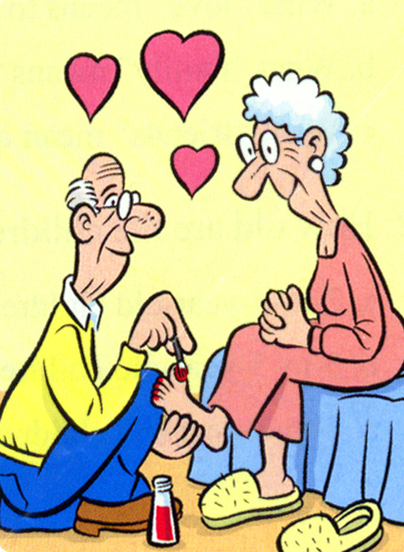
B
A group of people asked this question to a group 4-to-8-year-old children. “What does love mean?” The answers were surprising. The children would answer like they did below.
“When my grandmother hurt her knees (膝盖), she couldn’t bent (弯腰) over and paint her toenails (脚指甲) any more. So my grandfather does it for her all the time, even when his hands hurt too. That’s love.”
Rebecca–age 8
“Love is when someone hurts you. And you get so mad but you don’t shout at them because you know it would hurt her feelings.”
Samantha–age 6
“Love is what makes you smile when you’re tired.”
Terri–age 4
“I let my big sister pick on (捉弄) me because my mum says she only picks on me because she loves me. So I pick on my baby sister because I love her.”
Bethany–age 4
“I know my older sister loves me because she gives me all her old clothes and has to go out and buy new clothes.”
Lauren–age 4
“Love is when Mommy gives Daddy the best piece of chicken.”
Elaine–age 5
“My mommy loves me more than anybody. You don’t see anyone else kissing me to sleep at night.”
Clear–age 5
“You really shouldn’t say ‘I love you’ unless you mean it. But if you mean it, you should say it a lot. People forget.”
Jessica–age 8
56. The passage mainly tells us about ______.
A. what “life” means to children B. what “family” means to children
C. what “friends” means to children D. what “love” means to children
57. Who told us the love between mum and dad?
A. Clear. B. Elaine. C. Rebecca. D. Lauren.
58. Which of the following is NOT true?
A. Rebecca’s grandmother ever couldn’t bend over.
B. Bethany is willing to be picked on by any other person.
C. If Samantha becomes angry, she will not shout at others.
D. Lauren prefers to wear her sister’s old clothes.
59. What does Jessica mean about love?
A. Too much love is no love. B. You should say love more often.
C. You mean what you think. D. Say love more often if you have it.
60. What is love according to Terri?
A. Love is the care between husband and wife.
B. Love is a rest when you are tired.
C. Love is what cheers you up when you are tired.
D. Love is a kiss from parents.
C
What does it feel like to break a bone (骨头)? It’s different for everyone, but the pain is often sharp (严重). If the break is small, however, the person may not feel much pain at all. If you think that you or someone else has broken a bone, the most important things to do are to stay calm, make the hurt person comfortable, and call the doctor. Do not move the injured body part since movement could make it worse.
To treat the break, the doctor will need to take an X-ray. This gives the doctor the information he or she needs to set (接上) the bone: to put it back to its normal place. If the bone is large or it is broken in more than one place, the doctor may need to use metal pins (钢钉) to set it. After the bone has been set, the next step is usually putting on a cast, the special, hard thing that will keep the bone in place for a month or two.
Your bones are excellent at healing themselves. Broken bones will produce many new cells (细胞) and tiny blood vessels (血脉). These cover both ends of the broken part, and close up the break until the bone is as whole and strong as before.
61. Which of the following is the best title for the passage?
A. How to Know if a Bone is Broken
B. How Broken Bones Heal Themselves
C. Common Causes (原因) of Broken Bones
D. What You Should Know about Broken Bones
62. When someone breaks his bone, the following should be done except ______.
A. asking the doctor for help B. comforting the hurt person
C. moving the injured part D. staying calm
63. Which is the correct order to treat the break?
a. take an x-ray b. use metal pins to set it c. put it back to its normal place d. put on cast
A. a→b→c→d B. a→c→b→d C. a→d→c→b D. d→a→b→c
64. The underlined word “heal” in Paragraph 3 is closest in meaning to “______”.
A. break again B. become worse C. wound or hurt D. become healthy again
65. Where would you probably read this passage?
A. In a story book. B. On a poster. C. In a health care book. D. In a chemistry book.
D

Welcome Aboard (乘坐) your Piccadilly Flight to Heathrow
The Piccadilly line to Heathrow (伦敦西斯罗机场) is not only the fast way to travel but also the cheapest. So the next time you’re flying to Heathrow, make sure you fly Piccadilly line.
Your Piccadilly flight features (特点):
- Departures (发车) from 36 stops on the Piccadilly line, or from over 200 stations only one change way
- Service every 5 minutes to and from Heathrow throughout the day
- Journeys from central London taking less than 50 minutes
- Only £3.70 for a single adult fare (费用)
- See tables below for journey times

Fares to and from London
Adult single £3.70
Child single £1.50
If you are traveling as a group, then you are allowed to use the family travel card, which means each adult can travel for £3.40, and each child for £0.80.

Traveling to Heathrow
 | Monday - Saturday |  |  |  | Sunday
From | Journey  time | Frequency  （频率） | First  train | Last train | First train | Last train
Earls Court | 39mins | 5mins | 05:55 | 00:43 | 07:15 | 23:49
Piccadilly Circus | 49mins | 5mins | 05:45 | 00:32 | 07:05 | 23:38

Traveling from Heathrow
 | Monday - Saturday |  |  |  | Sunday
To | Journeytime | Frequency | First train | Last train | First train | Last train
Earls Court | 34mins | 5mins | 05:13 | 23:49 | 05:57 | 23:30
Piccadilly Circus | 45mins | 5mins | 05:13 | 23:49 | 05:57 | 23:30
66. At what time does the first train leave Earls Court on Sunday?
A. 07:15 B. 05:55 C. 05:13 D. 05:57
67. If your father wants to take the train, how much should he pay?
A. £1.50 B. £3.40 C. £3.70 D. £5.20
68. If you miss a train, how long will it take to wait for another?
A. 39 minutes B. 49 minutes C. 50 minutes D. only 5 minutes
69. The last train to Piccadilly Circus on Wednesday leaves at ______.
A. 00:32 B. 00:43 C. 23:49 D. 23:30
70. If you travel with your mum and dad as a child, what is your best choice?
A. All pay full fare. B. Use the family travel card.
C. Each pay for his or her own. D. Look for free tickets.
绝密★启用前 试卷类型：A
泰安市二〇一一年初中学生学业考试
英 语 试 题

成绩统计栏
题 号 | 第一节 | 第二节 | 第三节 | 总 分
得 分
第II卷（非选择题 共40分）
注意事项：
1. 答卷前将密封线内的项目和右下角的座号填写清楚。
2. 用钢笔或圆珠笔直接将答案答在试卷上。
第四部分 书面表达（共三节）
第一节 词汇运用（共两题，满分15分）
得 分 | 评卷人

（一）单词拼写（共5小题；每小题1分，满分5分）
根据句意和首字母或汉语提示，将单词的正确形式写在题中相应的横线上。
71. There’s nothing in this box. Look, it’s e______________.
72. You’d better to keep your v______________ down when talking in public.
73. Jack is so smart that he can answer these questions ______________ (容易地) .
74. Both of my best friends were born in ______________ (十月) .
75. People will use robots to do the ______________ (家务) in the future.
（二）综合填空（共10小题；每小题1分，满分10分）
根据短文内容，用方框中所给词语的适当形式填空，使文章通顺、完整。（每词限用一次）
first, use, be, another, buy, open, whenever, talk, but also, touch
“Thank you” is widely (76) in a modern society. It is a very good manner. You should say “Thank you” (77) others help you or say something kind to you. For example: when someone (78) the door for you, when someone says you have done your work well, when someone says you have (79) a nice shirt, or your city (80) very beautiful, you should say “Thank you”. “Thank you” is used not only between friends, (81) between parents and children, brothers and sisters, husbands and wives.
“Excuse me” is (82) short polite usage. We use it as the same as “Thank you”. When you hear someone say so behind you, you’d got to know that somebody wants to walk past you without (83) you. It is not polite to interrupt (打断) others while they are (84). If you want to have a word with one of them, please say “Excuse me” (85), and then begin to talk. You should also do so when you want to cough or make any unpleasant noise before others. Let’s say “Thank you” and “Excuse me” on the right occasion.
第二节 任务型阅读（共5小题；每小题2分，满分10分）
得 分 | 评卷人
阅读下面的短文，并完成短文后的任务。
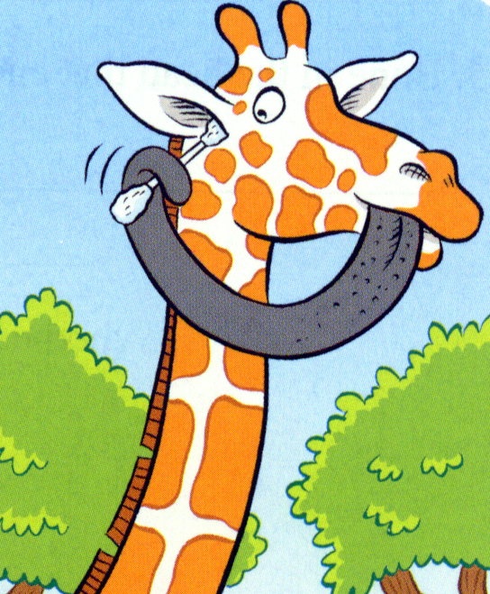
Draw a giraffe in your mind. How did you draw your giraffe? Does it have a long neck? Does it have long legs? Is it really tall? When people think of giraffes, they think of their long necks. A long neck and four long legs make the giraffe the tallest land animal on earth. A giraffe is 1.8m tall when it is born, and some giraffes get up to 6m tall when they are all grown up.
But did you know that giraffes also have long tongues? Have you seen the tongue of a giraffe before? A giraffe has a very long tongue which can hold and wrap (包) around objects. The tongue is designed for feeding, but it can be used in many different ways. For example, a giraffe can close its nose with its long tongue completely to keep out sand and dust. Also, a giraffe’s tongue is long enough to clean its owner’s ears as well!
座 号

The tongue is black in colour to protect it from getting sunburnt (晒伤). It is nearly 56cm long. Giraffe only eat plants, and a full grown giraffe can eat 33kg of leaves a day. When giraffes look for some tall trees to eat, they sometimes fight with elephants for food. Giraffes use their tongue to eat leaves from some tall trees. The giraffe’s tongue is a helpful tool for reaching leaves and breaking off branches.
任务一：根据短文内容回答下列问题。(注意：每题答案不超过10个单词)
86. What is this article mainly about?
_________________________________________________________________________
87. What does a giraffe feed on?
_________________________________________________________________________
88. What color is the tongue of a giraffe? Why?
________________________________________________________________________
89. Give two examples of the use of the giraffe’s tongue.
(1) ___________________________________ (2) __________________________________
任务二：将文中划线的句子翻译成汉语。
90. ________________________________________________________________________
第三节 写 作（共1题，满分15分）
得 分 | 评卷人

假如你是李明，在网上看到一则美国某大学孔子学院招聘汉语老师的广告，请你根据信息内容，用英语给Mr.Smith写一封email，向他推荐一位符合条件的老师。
Chinese Teacher
Age: 25～40
Language: fluent English & standard Chinese
Experience: familiar with Confucius ideas
Email: Efl.un.@.hotmail
注意：1. 词数：80～100词，信的开头和结尾已给出，不计入总词数。
2. 可适当增加细节，说明他/她的优势，文中不要提及真实的校名和人名。
3. 参考词汇：fluent adj.流利的 familiar adj.熟知的 standard n./adj.标准(的)
Confucius n.孔子 suitable adj.合适的 healthy adj. introduce v. get along well with …
Dear Smith,
How are you? I’m very glad to introduce

I’m looking forward to your reply.
Yours sincerely
Li Ming

泰安市二〇一一年初中学生学业考试

英语试题参考答案及评分标准

第一部分：听 力（共25小题；每小题1分，满分25分）
1—5 BCAAB 6—10 CBBCA 11—15 BACAB 16—20 CABBA 21—25 BBCAC
第二部分：语言知识运用（共两节，满分25分）
第一节：语法和词汇（共15小题；每小题1分，满分15分）
26—30 BAACB 31—35 ACBDB 36—40 DCACA
第二节：完形填空（共10小题；每小题1分，满分10分）
41—45 BACAB 46—50 CDBAD
第三部分：阅读理解（共20小题；每小题1.5分，满分30分）
51—55 CBACA 56—60 DBBDC 61—65 DCBDC 66—70 ACDCB
第四部分：书面表达（共三节，满分40分）
第一节：词汇运用（共两题，满分15分）
（一）单词拼写（共5小题；每小题1分，满分5分）
71. empty 72. voice 73. easily 74. October 75. housework
（评分要求：所填单词只要符合题意，语法正确，拼写无误，都可得分；否则不得分。）
（二）综合填空（共10小题；每小题1分，满分10分）
76. used 77. whenever 78. opens 79. bought 80. is
81. but also 82. another 83. touching 84. talking 85. first
（评分要求：所填词语只要符合题意，语法正确，拼写无误，都可得分；否则不得分。）
第二节：任务型阅读（共5小题；每小题2分，满分10分）
86. Giraffes’ long tongues. / The long tongues of giraffes. / Giraffes have long tongues.
87. Plants. / Leaves. / Leaves from trees.
88. It’s black. / Black. To protect it from getting sunburnt.
89. Feeding. / Close its nose to keep out sand and dust. / Clean its ears.
/ Reach leaves and break off branches. / Eat leaves from some tall trees.
（评分要求：能写出其中任何两项即可得分，要求与参考答案的意思相近。）
90. 长颈鹿有一个长脖子和四条长腿，是地球上最高的陆地动物。
（评分要求：要求在准确、全面的基础上，翻译成较为通顺的汉语。）
第三节：写 作（共1题，满分15分）
（一）One possible version：
Dear Smith,
How are you? I’m very glad to introduce an English teacher to you. He is at the age of thirty. Though quite young, he has been teaching English for ten years. He can not only speak fluent English but also standard Chinese. What’s more, he is healthy, full of energy and is easy to get along with. Above all, he lives in the Confucius hometown. He is so familiar with the Confucius ideas that he can do well in his new work there. I’m sure that he is the most suitable Chinese teacher.
I’m looking forward to your reply.
Yours sincerely
Li Ming
（二）评分说明：
1、评分原则
（1）评分时，先根据文章的内容和语言初步确定其所属档次，然后以该档次的要求来衡量，确定或调整档次，最后给分。
（2）评分时，应注意的主要内容为：内容要点、应用词汇和语法结构的数量和准确性及上下文的连贯性。
（3）拼写与标点符号是语言准确性的一个方面，评分时，应视其对交际的影响程度予以考虑。
（4）如果书写较差，以至影响交际，将分数降低一个档次。
2、各档次的给分范围和要求
第一档（13—15分） 很好地完成了试题规定的任务。
覆盖所有内容要点；应用了较丰富的语法结构和词汇；用词准确、句子通顺、行文连贯、表达清楚，没有或基本没有语言错误；书写工整；字数符合要求。完全达到了预期的写作目的。
第二挡（10—12分） 较好地完成了试题规定的任务。
虽漏掉1、2个次重点，但覆盖所有主要内容；应用的语言结构和词汇虽不太丰富，但能满足任务的要求；句子较通顺、表达较清楚；有少量语言错误；书写工整；字数基本符合要求。达到了预期的写作目的。
第三档（7—9分）基本完成了试题规定的任务。
虽漏掉一些内容，但覆盖所有主要内容；应用的语言结构单一；句子不够通顺，行文不够连贯；语言错误较多；书写不够工整，字数较少。整体而言，基本达到了预期的写作目的。
第四档（0—6分）未恰当完成试题规定的任务。
漏掉或未描述清楚一些主要内容，写了一些无关内容；应用的语言结构单一且不规范；句子不通顺，行文不连贯；语言错误多；书写潦草，字数不足50。信息未能清楚地传达给读者。

听力录音材料
（一）听句子，选择适当的应答语。每个句子读两遍。
1. Jenny’s mother is ill.
2. Which would you like, juice or coffee?
3. Sorry, I have taken your pen by mistake.
4. Would you like to come to my party this evening?
5. Why not buy some flowers for her?
（二）听对话，选择相应的图画。每段对话读两遍。
6. M: When are you going to see your grandparents?
W: I will go to see them on Sunday.
7. M: How long does it take Tom to go to school every day?
W: It takes him ten minutes to get to school on foot.
8. W: Can I help you, sir?
M: I’d like a pair of sports shoes for my son’s birthday.
9. W: What will the weather be like tomorrow?
M: It’s sunny.
10. W: What were you doing at ten last night, Mike?
M: I was reading a book.
（三）听五段对话和五个问题，选择正确答案。每段对话及问题读两遍。你将有15秒钟的时间阅读下面5个小题。
11. W: Which do you like best, French fries, hamburgers or salad?
M: I prefer salad to French fries and hamburgers because it is good for our health.
Q: What does the man like best?
12. M: Are you waiting for your mother, Jane?
W: No, I’m waiting for my father. He’s going to take me to visit my grandfather.
Q: Who is the girl going to see?
13. M: How do you like the film?
W: Very much. The music sounds nice and the story is interesting.
M: But it lasts too long.
Q: What does the man think of the film?
14. M: Excuse me, how much is the chicken sandwich?
W: $4.
M: OK. I’ll take the chicken sandwich and a glass of milk.
W: Sure, that’ll be $6.
Q: How much is the milk?
15. W: I’ve got a terrible cold.
M: You should go to see the doctor.
W: I did, but the medicine he gave me didn’t help.
M: Well, why not try chicken soup?
Q: What does the man suggest the woman do in the end?
（四）听两段长对话，选择正确答案。每段对话读两遍。你将有20秒钟的时间阅读下面5个小题。
听第一段对话，回答16、17小题。
W: You drive a school bus, Mr. Brown?
M: That’s right. I take the children to school.
W: Do you get up early in the morning?
M: Oh, yes. I have to get up at 6 o’clock.
W: And when does school begin?
M: It begins at 8 o’clock. We always arrive on time.
听第二段对话，回答18至20小题。
M: Hi, Rose, I haven’t seen you for a few weeks.
W: Hi, Bill. I’m busy with the exam.
M: Well, the term is almost over now. Do you have a plan for summer?
W: Yes. My sister is coming for a visit, and we’d like to go to the beach. But the hotels are so expensive in this season.
M: Then, camping might be a good choice.
W: Camping? I’ve never thought about that.
M: Oh, you’ll like it. It’s cheaper and closer to nature.
W: Good ideal! It’s a good way to forget our school work for a while.
M: Right. Wish you a nice trip there!
W: Thanks for your suggestion.
（五）听短文，选择正确答案。短文读两遍。你将有20秒钟的时间阅读下面5个小题。
Dear Jenny,
I’ve got the letter you wrote to me on December 5th last Friday. I’m very happy to hear that you’re doing well.
It’s been about two months since you left. I’m very glad to hear that your new job is interesting, but I’m sorry to hear that you don’t like Washington. I think you’ll like it better once you make more friends there. Good luck to you!
Thank you very much for your invitation, but I’m very sorry that I can’t go to your Christmas party on December 24th because my grandfather will come here that day to celebrate Christmas with our family. Please forgive me! I hope you can come to New York to spend the New Year holiday with us.
Yours,
Lucy

