http://www.3773.com.cn2012年湖北省咸宁市中考英语试题及答案
注重理解 导向性强
点评人：温中英语教研组全体老师
今年英语试卷难度与去年持平，题型有所变化，阅读理解难度大。整张试卷适应城乡考生，涉及话题广泛，内容关注社会热点，具有导向性和时代感。
本次中考单选和填空题难易适中，在平常的习作中很常见，学生容易拿分。阅读理解是整张试卷的难点，词汇量大、注重考察学生的英语阅读能力。平时词汇能力强的学生，本次阅读就能取得好成绩。作文题重点突出地方特色，思维开放，学生很容易把握主题。
温泉中学英语教研组老师介绍，今年中考的英语阅读理解难度最大，与武汉中考的英语试题接近。学生不仅要夯实课内知识，更要广泛阅读课外英语书籍，扩大词汇量。整张试题题目很活，适应城乡考生，贴近生活、贴近社会、有地方色彩、有选拔性、有导向性、有时代性，让学生能学以致用。从本张试卷可以看出，今后我市的英语教学水平会越来越高，对学生的语言、词汇、写作、阅读等能力都会逐步加强。 （陈志茹）
第一部分 听力测试（共30分）
一、听对话选图（每小题1分，共5分）
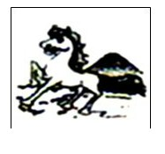
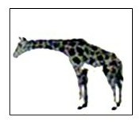
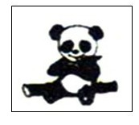
1.A. B. C.
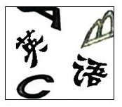
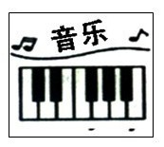
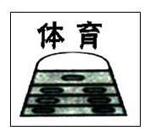
2.A. B. C.

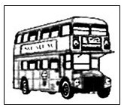
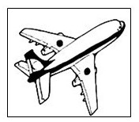
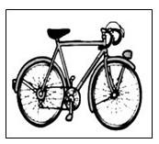
3.A. B. C.


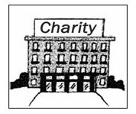
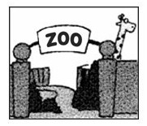
4.A. B. C.

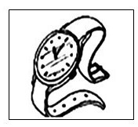
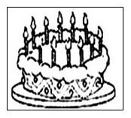
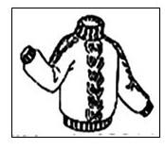
5.A. B. C.

二、对话理解 （每小题1.5分，共15分）
请听第一段对话，回答6～8小题。
6. What are they talking about?
A. A sports meeting. B. Their favorite sports. C. A class meeting.
7. What is Steven interested in?
A. Jumping. B. Running. C. Swimming.
8. Who runs the fastest?
A. Amy. B. Steven. C. Lily.
请听第二段对话，回答第9~11小题。
9. Where is Tommy's Math book?
A. Under the bed. B. On the table. C. On the dresser.
10. How many things will Tommy need?
A. Five. B. Three. C. Four.
11. When will they meet?
A. At 12. B. At 11. C. At 10.
请听第三段对话，回答第12~15小题。
12. What does Lin Shuhao do?
A. He is a football player. B. He is a volleyball player. C. He is a basketball player.
13. Where is Lin's father from?
A. America. B. Taiwan. C. Japan.
14. How old was Laura when she became a skating champion?
A. Four. B. Nine. C. Ten.
15. What does the girl think of her grandmother?
A. Hard-hearted. B. Kind and loving. C. Unfriendly.
三、短文理解 （每小题2分，共10分）
16. What did the girl find while she was walking?
A. Kangaroos. B. Rabbits. C. Birds.
17. Why did the girl love the birds?
A. Because the birds liked staying in the cage quietly .
B. Because the birds greeted her every morning.
C. Because the birds were hungry but very strong.
18. What happened to the birds when the girl left the cage's door open?
A. The two birds stayed in the cage.
B. The two birds flew away.
C. One of the birds flew out of the cage.
19. What happened to the two birds at last?
A. Both the birds died.
B. Both the birds were free.
C. One of the birds died and the other was free.
20. How did the girl feel when the bird was flying happily in the sky?
A. Happy. B. Sad. C. Worried.
第二部分 笔试部分（共90分）
四、单项选择 （每小题1分，共15分）
21.―What do you want to be in the future, John?
― I want to be _____ fashion designer. It is ______ amazing job.
A. a ; the B. an; a C. a; an D. an; the
22.―Do you like talking with your friends on the telephone or mobile phone? ―____________. I enjoy chatting on-line.
A. Neither B. Either C. Both D. None
23.─Mrs. Zhang was sent to teach English in a poor mountain village last year.
─She said she would never forget some pleasant ______while working there.
A. experiments B. expressions C. experiences D. emotions
24.―Zongzi ______ to students for free in our dining hall on Dragon Boat Festival.
―Really? That sounds cool!
A. offer B. have offered C. are offered D. will be offered
25.― I think drinking milk every morning is good _________ our health.
―Yes. I agree ________ you.
A. to; to B. with; to C. at; with D. for; with
26. Tom, you _______ play with the knife．You______ hurt yourself．
A. won't; can't B. mustn't; may
C. shouldn't; must D. can't; should
27.―Jim, can you _______ this word in Chinese?
―Yes, I can_______ a little Chinese.
A. speak; say B. say; speak C. tell; speak D. talk; say
28.―Three _____ injured students died in a hospital ineast China's Jiangsu Province last year.
―Sorry to hear that. But our government ______ much about the school bus safety management.
A. serious; did B. bad; did
C. seriously; has done D. badly; was done
29. We all like the story about the teacher _______ happened in our school last week.
A. which B. who C. whom D. what
30.―Are these CDs ________?
―No, they are not mine. They belong to _______.
A. your; her B. yours; her
C. you; hers D. yours; she
31. I didn't see Lucy at the party last night. Do you know_______?
A. why didn't she come B. what happened
C. when would she arrive D. where she has been
32. Drivers shouldn't be allowed _______ after drinking, or they will break the law.
A. drive B. driving C. to drive D. to be driven
33. Jack _____ dislike the weather in Beijing in spring, because there is so much wind and sand. But now he ____ it.
A. is used to; used to B. used to; is used to
C. was used to; is used to D. used to; uses to
34. Which of the following underlined parts has different pronunciation?
A. great B.feature C. peaceful D. dream
35. ―Teddy, don't draw on the wall. It's not a good behavior. ―___________________.
A. Never mind B. Yes, I'd love toC. Sorry, I won't D. Of course not
五、完形填空 （每小题1分，共15分）
Start Today
"What can you do when you have done nothing but mess up your whole life long?" These were the words I heard when I 36 the TV the other day. They were coming from one of the talk shows 37 are so popular on TV these days. I started to turn the channel but the words I had 38 made me stop for a moment. I 39 the speaker of them. He couldn't have been more than 18 years old, but already he was writing off （认为……已失败） his life as a useless waste.
I wanted to shout at him:" You're not 40 yet!"
It is 41 sad that so many people cannot get beyond (摆脱) their pasts and live 42 the present. There are so many people like that talk show guest. There are people still in their teen years 43 that their lives are over. There are people in their twenties who already think they have 44 the boat to success and happiness. There are people in their thirties and forties who sit around complaining that life has passed them by. I want to shout to them all:" Wake up! You're still 45 ! What have you done today?" If you want a happy life, you can't dwell on(细想、纠缠于)your past 46 . If you want joy and love in your life, you have to choose them today. God gives us a new chance at life every time we wake up in the morning. It is up to us to seize it.
Today 47 be the beginning of a new life for each of us. We can choose joy right now. We can share love today. We can live in delight starting at this moment. It doesn't matter how hard our past has been. Our present can be full of joy and our future can be full of 48 . It doesn't matter if we are eight 49 eighty--we can still make our lives 50 . Life isn't over until your last heartbeat. Start today, then, to make your heart beat with joy, love, and light.
36. A. turned down B. turned off C. turned on D. turned up
37. A. when B. that C. one D. what
38. A. heard B. found C. seen D. listened to
39. A. looked up B. looked after C. looked for D. looked at
40. A. death B. dead C. die D. died
41. A. so B. so a C. such D. such a
42. A. at B. with C. in D. to
43. A. think B. thinking C. thinks D. to think
44. A. taken B. caught C. missed D. lost
45. A. alive B. living C. lively D. lovely
46. A. mistake B. mistakes C. wrong D. ideas
47. A. must B. mustn't C. can't D. can
48. A. pain B. happiness C. sadness D. challenge
49. A. and B. to C. or D. between
50. A. wonder B. wondering C. wondered D. wonderful
六、阅读理解 （每小题2分，共30分）
A
Years ago I worked at a factory in a small county. Every day I got up very early and often did much extra work at night. I was so tired and exhausted. My whole life was hopeless. Then one day I read the following article from a magazine:
"A woman went to live with her husband in camp on the Mojave Desert (沙漠)during the war. She simply hated the place: the heat was almost un－bearable, 125 degrees in the shade, the wind blew incessantly, and there was sand--sand everywhere. Finally, in desperation(不顾一切地)she wrote her parents in Ohio that she couldn't stand it another minute and was coming home.
Quickly came the reply by airmail from her father--just two lines:
'Two men looked out from prison bars. One saw the mud, the other saw stars.'
The daughter did some real thinking, not only with the intellect (思维)but also with her heart. She decided to stick to her post.
She made friends with the natives, learned to love the country, and eventually wrote a book about it.
The desert hadn't changed, but her attitude had. Because she listened with her heart to the words her father sent, a whole new world opened up to her."
A change of attitude could change everything.
After reading the article, I was deep in thought（陷入沉思）…
51. The underlined word "unbearable" means ____________ in Chinese.
A. 难以想象的 B. 难以克服的C. 难以忍受的 D. 难以适应的
52. After she received her father's reply, the woman____________.
A. went back home B. was coming home
C. decided to stay there D. decided to go back home with her husband
53. From her father's reply, we can infer (推断) that ______________.
A. two men looked out from prison bars
B. one man was in prison, the other was out of prison
C. two men were out of prison
D. her parents wanted her to stay there with her husband
54. Which of the following is wrong according to the passage?
A. A woman went to live with her husband in a big city.
B. The woman finally made friends with the natives.
C. She wrote her parents that she was coming.
D. The woman received her parents' reply by airmail.
55. The main idea of this passage is that __________.
A. a woman went to live with her husband in camp
B. the desert hadn't changed, but her attitude had
C. the daughter's parents wanted her to stay with her husband
D. a change of attitude could change everything

B
LiNa jumps two places in WTArankings(排位)
China's Li Na moved up two places to seventh in the latest WTA rankings released on Monday despite (尽管) losing the Rome WTA final last Sunday to Russian Maria Sharapova, Yahoo reported.
Li will begin her French Open title defence next week in Paris. It was the first win ever at a Grand Slam event for someone representing China.
LiuXiang back toworld top
With a world fastest time of the season so far, Chinese star hurdler Liu Xiang showed the world that he is back to the world top level.
Running into 13 seconds on a wet track. In spite of running on a wet track, the 28-year-old Liu claimed (宣称) an overwhelming victory against three American first-class hurdlers at the 2012 Diamond League Shanghai last Saturday.
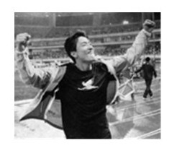
The Athens Olympic champion clocked a world leading time of 12.97 seconds to claim title of men's 110m hurdle event, and the result bettered (胜过) the previous season best of 13.03s set by America's Aries Merritt two weeks ago.
David Oliver of the United States finished second in 13.13s whi le another American Jason Richardson, newly crowned world champion in Dague last year, settled third in 13.16s. Merritt was fourth in 13.26s.
56. The passage aboveis about _________.
A. a story B. an advertisementC. sports news D. a poem
57. Li Na was _______ in the latest WTA rankings despite losing the Rome WTA final.A. second B. ninth C. seventh D. sixth
58. There are _______ players at the 2012 Diamond League Shanghai mentioned in this passage.A. 3 B. 4 C. 5 D. 6
59. Liu Xiang was first in ________ at the 2012 Diamond League Shanghai.A. 12.97s B. 13.03s C. 13.13s D. 13.26s
60. Which of the following isn't mentioned in the passage?
A. Merritt was fourth in 13.26s at the 2012 Diamond League Shanghai.
B. Li Na lost the Rome WTA final by 1:2 last Sunday.
C. The Athens Olympic champion clocked a world leading time of 12.97 seconds.
D. China's Li Na moved up two places to seventh in the latest WTA rankings.
C
Dragons can be friendly or fierce (凶狠), they can bring good luck or cause death, but one thing is sure--people talk about them almost everywhere in the world. For a creature that doesn't actually exist, that's quite something.
In Chinese culture, dragons are generous and wise, although they can be ①unpredictable. The dragon was closely connected to the royal family: theemperor's robes (礼袍)have a symbol of a gold dragon with five claws. ②Other members of the royal family were allowed to wear dragon symbols, too, but with fewer claws and of a different colour. According to popular belief, if you were born in the year of the dragon, you are intelligent, brave, and a natural leader.
But in the west, dragons had a different reputation （名声）. The very first text in English, the Anglo-Saxon poem Beowulf, tells the story of a Scandinavian hero, Beowulf, who fights and kills a dangerous dragon but is himself killed in the fight. However, across the border in Wales, the red dragon which appears on the Welsh flag is a positive symbol, indicating strength and a sense of national identity.
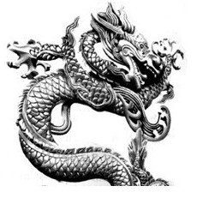
③Why should the dragon have a different character in different parts of the world? Some experts believe it is due to the animals that the myths grew out of. In the west, the idea of the dragon probably came from the snake--an animal which people hated and ④____ ____of（害怕）.
But in China, the idea of the dragon may have come from the alligator--a shy animal which lives in rivers, but which is usually only seen when there is plenty of water--a good sign for agriculture(农业). So the Chinese dragon was a bringer of ⑤good fortune.
61.(A) 请写出文中画线部分①unpredictable的汉语意思：______________________.
(B) 请从文中找出与画线部分⑤good fortune意思相近的短语：_______________.
62.将文中画线部分②改成主动语态：They ____________________________________
63.将 文 中 画 线 句 子 ③ 翻 译 成 汉 语 ：_______________________________
64.根据文中④处的汉语提示，用英语将句子补充完整，每空一词。
In the west, the idea of the dragon probably came from the snake-an animal which people hated and _______ _______ of（害怕）.
65．What are the differences between Chinese dragons and western dragons? （从文中找出相关描
述的英语单词或短语，每空至少一个。 ）
Chinese dragons：_____________ Western dragons：___________..
七、短文填空 （共12个空，做对一个得1分，共10分）
An eight-year-old child heard her parents talking about her little brother. All she knew was that he was very sick and they had no money. Only a very (66)e operation could save him now but there was no one to lend them the money.
When she (67)h her daddy saying to her tearful mother, "Only a miracle (奇迹) can save him now," the little girl went to her bedroom, took out her money and counted it (68)c .
She hurried to a drugstore (69)w the money in her hand.
"What do you want?" asked the salesman. "It's for my little brother," the girl answered. "He's really, really (70)s and I want to buy a miracle." "Pardon? " said the salesman.
"My brother Andrew has something bad (71)g inside his head and my daddy says only a miracle can save him. So how much does a miracle cost?" "We don't sell a miracle here, child. I'm sorry," the salesman said with a smile.
"Listen, if it isn't (72)e , I can try and get some more. Just tell me how much it costs."
A well-kind man heard it and (73)a , "What kind of miracle does your brother need?"
"An operation!" she answered with her eyes full of (74)t . " But my daddy can't afford it, so I have brought all my money."
"How much do you have?" asked the man. "$1.11, but I will do my (75)b to make more," she answered.
"Well, what a good piece of advice you have!" (76)s the man. "$ 1.11, the price of a miracle for your little brother."
He took up the girl's hand and said, "Would you mind taking me to your house? I want to see your brother and your parents. Let's see if I have the kind of miracle you need."
That well-dressed man was Carlton Armstrong, a (77)f businessman. The operation was successful. And it wasn't long before Andrew was well again.
八、补全对话 （每小题2分，共8分）
（Sally在武汉上学，打算暑假和同学一起出去旅游。现在她正在和旅行社联系。 ）an: Hello, Sunlight Travel. May I help you?Sally: (78)___________________. I'd like some information on vacation packages, please.Man: Sure. (79)___________________________?Sally: Well, I hope to visit some places of interest in Hunan Province.Man: Well, how about Chairman Mao's Hometown?Sally: Oh, my Chinese friends have told me that it's really a beautiful village. By the way, (80)_______________________________?Man: Lei Feng's Hometown is in Hunan, too. It isn't far from Changsha. It's a famous place. Many tourists will visit here this summer vacation. Sally: (81)_____________________________________?Man: 800 yuan each person. Sally: 800 yuan? I think it's a little expensive.Man: But anybody can afford our prices! Let's make it, shall we?Sally: Sure. I will call you later. Thank you!Man: You're welcome!
九、书面表达（共12分）
同学们，咸宁市被列为首批国家旅游标准化四个示范城市之一了。让我们也行动起来吧！为了让母校变得更加美好，为家乡建设添砖加瓦，请同学们为校园建设积极建言献策。假如你是滨海中学初三年级学生刘雨，请你写一份建议书。 (以上背景内容无需表述)内容要点：1、校园环境（如：植树、种花、运动场、图书馆……）
2、特色课程（如：舞蹈、音乐……）
3、……注意：1、文中不得出现真实姓名和学校名称；词数80左右。文章开头、结尾已经给出，不计入总词数。
2、要点齐全，语言通顺，意思连贯，书写规范，可以适当发挥。
3、提示词：hope; organize; interestingDear Headmaster,
I am very glad to write to you. These days we are talking about how to make our school more beautiful. Here are some of my suggestions.________________________________________________________________________________________
Thanks for your reading!
Yours sincerely,
Liu Yu

2012年湖北省咸宁市中考英语参考答案
第一部分 听力测试 （共30分）
一、听对话选图（每小题1分，共5分）
1. C 2.B 3.C 4.B 5.A
二、对话理解（每小题1.5分，共15分）
6-10 BACCA 11-15 ACBCB
三、短文理解（每小题2分，共10分）
16-20 CBCCA
第二部分 笔试部分（共90分）四、单项填空（每小题1分，共15分）
21-25 CACDD 26-30 BBCAB 31-35 BCBAC
五、完形填空（每小题1分，共15分）
36-40 CBADB 41-45 ACBCA 46-50 BDBCD
六、阅读理解（每小题2分，共30分）
51-55 CCDAD 56-60 CCBAB
61. (A)：难以预料（测）的； (B)：good luck
62.They allowed other members of the royal family to wear dragon symbols.
63.为什么世界上不同地方的龙有不同的特性？
64. were; afraid
65. Chinese dragons: generous; wise; a bringer of good fortuneWestern dragons: dangerous; positive; strength; a sense of national identity(每空至少填一个词或短语，每空1分)
七、短文填词（本大题共12个小题，做对一个得1分，共10分）
66.expensive 67.heard 68.carefully 69.with 70.sick 71.growing 72.enough 73.asked 74.tears 75. best 76.smiled/said 77. famous/friendly
八、补全对话（每小题2分，共8分）
凡与本答案不同的，只要符合题意、句子连贯、语法正确，每个句子均可给满分；凡语句欠通顺或有单词拼写错误、语法错误，每处扣0.5分。
78. I hope so ./Sure./ Of course./ Yes./ Certainly.
79. What kind of vacation are you looking for?/Where (Which place) would (do) you like to visit?/ Where are you going to visit?
80. where is Lei Feng's Hometown?/ what (how) about Lei Feng's Hometown?/ anywhere else?
81. How much is that (the trip)? /How much does that(the trip) cost?/ How much?/ What's the price?
九、书面表达（本大题共1个小题，共12分）
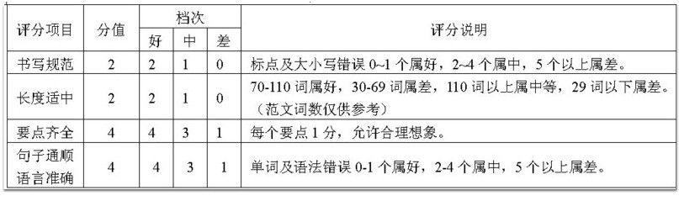
One possible version: (107 words)Dear Headmaster,
I am very glad to write to you. These days we are talking about how to make our school more beautiful. Here are some of my suggestions.
First, a library with a lot of interesting books in it should be built, so that we can read in our spare time every day. Second, we expect our own dancing hall and piano room. Many of us like dancing, and some are even good at playing the piano. Third, we dreams of having a playing-field with many flowers and green trees around. We can exercise there every day to make our body strong. Finally, I suggest teachers in our school organize more colorful after- class activities for students.
In a word, I hope our school will attract more visitors and I wish her a good future.
Thanks for your reading!Yours sincerely,
Liu Yu

