更多精彩资料请关注http://www.3773.com.cn/zhongkao/
南充市2012年高中阶段学校招生统一考试
英语试卷
第一部分：听力(共两节，满分20分)
第一节(共5小题；每小题l分．满分5分)
听下面五段对话．每段对话后有一个小题，从题中所给的A、B、C三幅图片中选出与对话内容相符的图片．并将其字母代号标在题前的括号内。听完每段对话后，你都有l0秒钟的时间来回答有关小题和阅读下一小题。每段对话读两遍。
1. What does the women usually do?
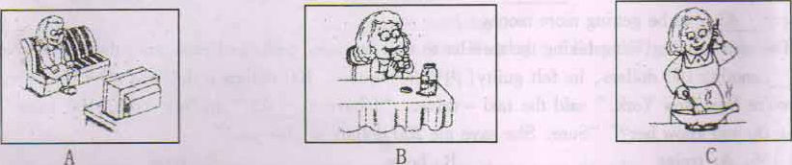
2. What will they do?
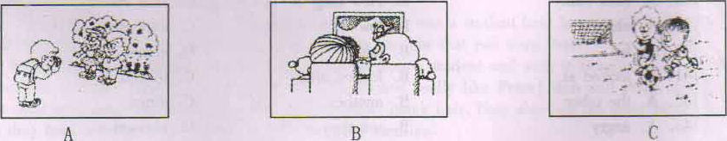
3. What was Alice doing?
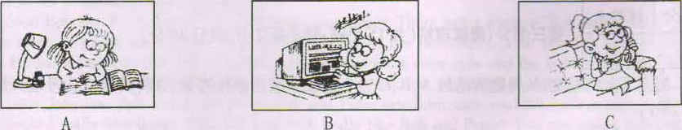
4. What's the weather like?
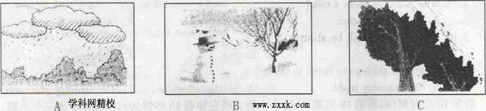
5. What does the boy usually do?
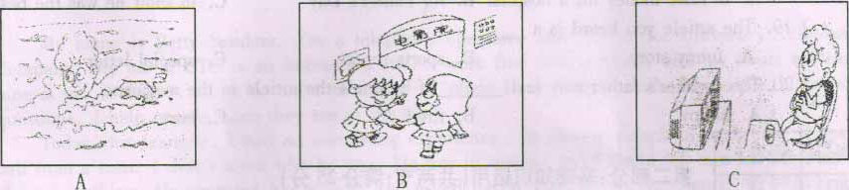
第二节(共l5小题；每小题l分，满分l5分)
听下面五段对话或独白。每段对话或独白后有几个小题，从题中所给的A、B、C三个选项中选出最佳选项，并将其字母代号标在题前的括号内。听每段对话或独白前．你将有时间阅读各个小题，每小题5秒钟；听完后．各小题将给出5秒钟的作答时间。每段对话或独自读三遍。
听第6段材料，回答第6至第8三个小题。现在你有15秒钟的时间阅读下面三个小题。
6. Where is the new sports center?
A. On Station Road. B. In Bridge Street. C. On Long Road.
7. What did Tony do in the sports center last week?
A. He played table tennis and volleyball.
B. He played tennis and basketball.
C. He played football and basketball.
8. When will Mary and Tony go to the sports center?
A. Next Tuesday. B. Next Thursday. C. Next Friday.
听第7段材料．回答第9至第11三个小题。现在你有l5秒钟的时间阅读下面三个小题。
9. How is the weather today?
A. It's cloudy. B. It's fine. C. It's bad.
10. What's the woman doing now?
A. She's cooking. B. She's reading a book. C. She's writing a letter.
11. Where will the man wait for the woman?
A. In the garden. B. Near the garden. C. Outside the park.
听第8段材料，回答第12至第l4三个小题。现在你有15秒钟的时间阅读下面三个小题。
12. What's the relationship(关系) between Ted and Jane?
A. Doctor and nurse B. Father and daughter. C. Classmates.
13. What did Jane use to be like?
A. Shy. B. Serious. C. Outgoing.
I4. Who used to be afraid of flying in an airplane?
A. Ted. B. Jane C. Both Ted and Jane.
听第9段材料．回答第l5至第l7三个小题。．现在你有l5秒钟的时间阅读下面三个小题。
15. Who will give them a talk?
A. A famous teacher. B. A famous writer. C. A famous farmer.
16. What will the talk be about?
A. Drawing. B. Singing. C. Dancing.
17.When will they go to listen to the talk?
A. On Saturday night. B. On Sunday afternoon. C. On Saturday afternoon.
昕第l0段材料，回答第l8至第20三个小题。现在你有l5秒钟的时间阅读下面三个小蹰。
18. The speaker's father ran in the marathon .
A. to raise money for a hospital B. for Father's Day C. to show he was the best
19. The article you heard is a _ _
A. funny story B. sports report C. special letter
20. The speaker's father may feel _ _ if he reads the article in the magazine.
A. happy B. tired C. hurt
第二部分：基础知识运用(共两节；满分25分)
第一节单项选择(共I5小题；每小题l分．满分l5分)
从所给的三个选项中选出最佳答案，井将其字母代号填人题前括号内。
21. I think it's not polite to laugh others.
A. in B. at C. over
22. Your father used to eat meal, ?
A. did you B. didn't you C. didn't he
23. Practicing in groups is good _ _ us to learn English.
A, at B. in C. for
24. Don't up English. It's very important.
A. give B. hurry C, stay
25. What would happen if he _ _ back home?
A. go B. goes C. went
26, It’s quite exciting me _ _ the Internet.
A. for, surf B. for, to surf C. for, for surf
27.--Is this your e-dictionary?
--No, is in the backpack,
A. mine B. yours C. my
28.--Math is too difficult, I nearly give it up.
--Please don't, nothing is if you put your heart into it.
A. important B. impossible C. interesting
29. -- _ _ weather! It's raining!
--Bad luck! We can't go climbing today.
A. What bad B. How bad C. What fine
30. I think should not he allowed to drive.
A. sixteen years old B. sixteen-year-old C. sixteen-year-olds
31. Our teachers are very strict us,
A. with B. to C. on
32. They can wear clothes.
A. themselves B. they own C. their own
33. Tony and I are good friends. We usually learn a lot each other.
A. of B. from C, across
34. Her sister prefers to be a _ _ star.
A. swimming B. swiming C, swim
35. --Where can I find Jack?
--He is playing volleyball in the now.
A. library B. laboratory C. gym
第二节完形填空(共l0小题；每小题l分．满分l0分)
先通读下面短文，掌握其大意．然后从短文后面各题所给的选项中选出最佳答案，并将其字母代号填入题前括号内。
A traveler came out of the airport. There were a lot of 36 . He asked every taxi - driver's name. Then he took the third one. it 37 5 dollars to go from the airport to the hotel. " 38 does it take to hire(雇请) you for the whole day?" The man asked. "100 dollars." said the
taxi-driver. This was very 39 , but the man agreed. Then the taxi - driver showed him all the
parks and museums in the city.. In the evening they went 40 to the hotel. The traveler gave the taxi -driver 100 dollars and said, " What about tomorrow?" The taxi -driver 41 the man and said, "Tomorrow? That will be 42 100 dollars. " But the man said it was OK. The taxi –driver was very. 43 to be getting more money.
The next evening, after taking the traveler to visit the same parks and museum, the tad - driver 44 another 100 dollars, he felt guilty(内疚的) became 100 dollars a day was a lot of money. "So you're from New York," said the taxi -driver. "I have a 45 in New York. Her name is Susan. Do you know her?" "Sure. She gave me 200 dollars to give you!"
36. A. trains B. boats C. taxis
37. A. cost B. paid C. spent
3g. A. How many B. How long C. How much
39. A. cheap B. low C. expensive
40. A. for B. back C, across
41. A. looked at B. looked after C. looked for
42. A. the other B. another C. other
43. A. angry B. unhappy C. pleased
44. A. received B. gave C. borrowed
45. A. brother B. son C. sister
第三部分：阅读理解(共l5小题；每小题2分，满分30分)
阅读下面的短文，从每题所给的A、B、C三个选项中选出最佳答案，并将其字母代号填人题前括号内。（精校）
Players Wanted  Are you good at playing basketball? Can you  play ping—pong or soccer? Can you swim very  well? if so．You are welcome to join our school  sports team．Please call Victor at 8863543 0r  send an email to sports@yahoo.com | Dancers Wanted  Can you dance? Do you like kids? Can you  help them with dancing on weekends?  Come and join us Call Tom at 3854922 for  more information.
Chess Club  Do you like playing chess ?Mr Wang can teach  you .He gives lessons here every ,Friday afternoon.  Tel：8358939  Add：Room l00 in Schoo1’s P．E Building | Let’s Learn Japanese  Can you speak Japanese? Do you want to  learn Japanese? Join the Japanese club  now  Time：2：00 P m一5：00 P．m．(from  Monday to Friday)  Call Mary at 6253928

46. If you want to join a sports team, what should you do?
A. Call 3854922. B. Call 8358939.
C. Send an e-mail to sports@ yahoo.com.
47. Lacy can dance well. She wants to find a job. Who should she call?
A. Victor. B. Tom. C. Mary.
48. What does Mr Wang teach?
A. Chess. B. Japanese. C. Basketball.
49. Alice wants to learn Japanese . When should she go to the club?
A. Every Saturday afternoon.
B. Every Sunday afternoon.
C. From2: 00p. m.--5: 00p. m. on weekdays.
50. Betty speaks Japanese. She wants to work from Monday to Friday. Where can she work?
A. At the Japanese club,
B. At the dance club,
C. At School's P.E. Building.
B
Bob was happy. He was at a new school, and students there were friendly. " Hi, Bob !" some
students greeted him, but some students said, "Hi, Peter!" Bob didn't understand. He asked one
student, "Why do some students call me Peter?"
"Oh, that's easy to answer , "the student said. "Peter was a student here last year. Now he is in a different school. You look like Peter. Some students thought that you were Peter. "
Bob wanted to meet Peter. He got Peter's address from a student and went to Peter's house. Peter opened the door. Bob couldn't believe his eyes. He looked really like Peter! Bob and Peter had the same color eyes and the same smile. They had the same black hair. They also had the same birthday. And they both were adopted(领养) by two different families
Bob and Peter found out that they were twin brothers. Soon after the boys were born, One family adopted Bob, and another family adopted Peter. Bob's family never knew about Peter, and Peter's family never knew about Bob.
Soon Bob and Peter's story appeared in the newspaper. There was a photo of Bob and Peter next
to the story. A young man named John saw the photo in the newspaper. John couldn't believe his
eyes. He looked exactly like Bob and Peter! He had the same color eyes and the same smile. He had the same black hair. He had the same birthday. And he,too,was adopted by another family.
Later John met Bob and Peter. When Bob and Peter saw John, they couldn't believe their eyes. John looked really like them! Why did John look really like Bob and Peter? You can guess. Bob and Peter are not twins. Bob. Peter and John are triplets.
( ) 51. Bob felt __ at the new school.
A. interested B. happy C. sad
( )52. Some students in Bob's new school thought __.
A. John was Peter B. Bob was John C. Bob was Peter
( )53. Bob saw Peter__
A. at Peter's house B. at school C. at John's house
( ) 54. John knew the story of Bob and Peter from____
A. a newspaper B. a book C. his classmates
( )55. The underlined word “triplets" means " ______. "
A挚友 B双胞胎 C．三胞胎
C
My name is Betty Sanders. I’m a telephone operator, and I work for Univerity "telephone Company. My job at UTC is an interesting one. 1 work five days a week, and my hours are from
three a. m. to five p. m, I do a lot of things—I place long-distance calls for people, I answer
questions, I help people when they are in trouble.
Today, for example, I had an interesting experience. At eleven o'clock this morning, l got a
call from a man. I didn't know who he was. He was in trouble and I could tell that he was worried
about something. He gave me his address and asked me to send for an ambulance(救护车) right
away. I asked him if somebody was hurt, but he didn't answer my question. He told me he needed
a doctor at once, so I said I'd call an ambulance for him but l still wanted to know what was wrong. Then he said, "Our keys are gone!" I didn't understand that! "Why could he need an ambulance just because he couldn't find his keys? Then I found out what the trouble was.
The man and his wife left the ear keys on a coffee table, and later they couldn't find them.
Their little son Johnny was playing in the room, and they thought he swallowed(吞下) them.
But before 1 could help him, he told me he wouldn't need an ambulance any longer. His wife found the keys in her bag. They were there all the time.
56. Betty Sanders works
A. in a factory B. in a school C. in a company
57 She works __.
A. forty hours a week B. from Monday to Saturday C. seven days a week
58. The man called Betty Sanders because ______
A. he thought Betty was a doctor
B. he couldn't find his little boy
C. he wanted to take an ambulance
)59. In fact, his keys______
A. were swallowed by his little son
B. were on a coffee table
C. were put in his wife's bag
)60. From the passage we can see _______
A. Betty Sanders likes her work
B. the man's little son likes playing with keys
C. doctors can help people find keys
第四部分：口语应用(补全对话)(共5小题；每小题l分．满分5分) （精校）
从对话后的七个选项中选择五个适当的选项补全对话．将其字母的代号填在相应的横线上。
A: Mr Smith, you often help children. 61
B: Yes, of course. Children often write to me and ask me how to solve their problem
A : 62
B: Many can't decide when to study and when to play I think they should learn to achieve a
balance between study and play,
A: I agree. Sometimes I get too much homework and 63
B: You must feel stressed out from time to time, right?
A: Yes. Can you give me some advice?
B: OK. 64
A : I see. Thanks for your advice.
B: 65
A .I don’t know which to do first．
B. What problems do most students have?
C. What’s your job?
D. You can talk to your teacher ，parents or friends
E．Can you tell me something about your job?
F． It's so kind of you to tell me this．
G .You’re welcome

第五部分：写(共三节；满分!0分)
第一节单词拼写(共5小题；每小题l分．满分5分)
根据各句中所给汉语注释，在句子右边的横线上写出其正确形式。
66. Your (发音) of the English word is wrong. 66__________
67. Will you please ( 借 ) me your oar.'? My family 67__________
will go for a vacation on May Day.
68. Do you know my next door (邻居)? He is a pianist. 68__________
69. Liu Xiang runs (快)of all the athletes. 69__________
70. Her English teacher's words have _____ ( 激动 )her a whole life. 70__________
第二节短文填空(共5小题；每小题l分．满分5分)
根据短文内容和首字母的提示，把文中所缺词语补充出来．使短文完整、正确、通顺。(每空限填一词．将其填写在文后相应编号的横线上精校)
Fishing is my favorite sport. I often fish for hours without c 71 anything. But this does not w 72 me . Some fishermen are unlucky. Instead of catching fish, they catch old shoes and rubbish. I’m even less lucky. 1 never catch anything ...not even old shoes. After having spent whole mornings on the river, I always go home with an e 73 bag. "You must give up fishing!" My friends say, "It's a waste of time . " But they didn't r 74 one important thing. I'm not r 75 interested in fishing. I'm only interested in sitting in a boat doing nothing at all.
71__________ 72__________ 73__________ 74__________ 75__________
第三节书面表达(满分l0分)
下列图片提供了上周星期五李明的有关情况，请据此以第三人称形式，写一篇80词左右
的短文。（精校）
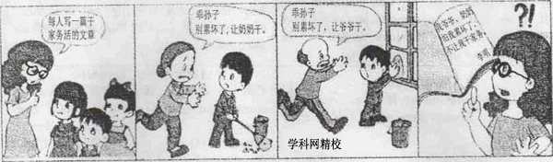
要求：1短文应体现图片基本信息，可适当发挥；
2语句通顺、意思连贯；
3．文中不可出现真实的人名、地名和校名。
__________________________________________________________________________________________________________________________________________________________________________________________________________________________________________________________________________________________________________________________________________________________________________________________________________

南充市2012年高中阶段学校招生统一考试
英语试卷参考答案
1-20(听力略)
21-25 BCCAC 26-30 BABAC 31-35 ACBAC
36-40 CACCB 41-45ABCAC 46-50CBACA
51-55BCAAC 56-60AACCA 61-65EBADG
66 pronunciation
67 lend
68. neighbor
69.fastest
70.encouraged
71.catching
72.worry
73.empty
74.remember
75.really
书面表达（略）