2013年泉州市初中毕业升学考试说明
英 语

一、命题依据
以国家教育部制订的《全日制义务教育英语课程标准》（以下简称为《课程标准》和福建省教育厅颁发的《2013年福建省初中学业考试大纲(英语)》为依据，结合我市初中英语教学实际情况进行命题。
二、命题原则
命题严格按照国家教育部制订的《课程标准》中 “五级目标 ”的要求和本市的英语教学实际，贯彻教育部基础教育司对中考改革的《指导意见》中的“中考命题要切实体现素质教育的要求, 加强与社会实际和学生生活实际的联系, 重视对学生运用所学的知识和技能分析问题、解决问题能力的考察, 有助于学生创造性的发挥，”和“外语考试应着重考查学生理解，运用语言的能力，要重视对听力的考查，要降低对语法的要求，不出偏、难的语法试题。”的精神。努力做到两个面向, 四个有利, 即: 有利于贯彻国家的教育方针, 推进中小学实施素质教育； 有利于体现九年义务教育的性质,全面提高教学质量；有利于中小学课程改革, 培养学生的创新意识和实践能力；有利于建立科学的初中毕业、升学考试管理制度, 减轻学生过重的负担, 促进学生生动活泼, 主动的学习。
三、适用范围
全日制义务教育九年级学生英语学业考试。
四、考试范围
以国家教育部制订的《课程标准》中所规定的九年级结束时应达到的“五级目标 ”的基本要求作为考试的范围。
五、内容和目标要求
在确定具体考试内容和标准时，主要以教育部颁发的《课程标准》中的“五级目标 ”规定的教学要求为依据。在突出学科特点的同时，体现贯彻新课程标准的理念，侧重考查学生的语言技能、语言知识、跨文化意识、跨文化交际能力和语言的综合运用能力，即听、说、读、写的四项基本技能。同时注重渗透思想品德教育、注重联系学生生活实际和学生创新思维能力的考查。有利于考生展示实际水平,有利于促进中小学教学改革,突出改革意识，有利于学生的终身学习。
六、考试形式
考试形式包括两部分内容：听力部分（20％）和笔试部分（80％），(因今年暂不具备口试条件，仍然在笔试部分中考查“口语应用”，占全卷10％)。试卷采取书面作答，闭卷考试的方式。听力部分测试基本语句理解，初步交际运用和短文理解等。笔试部分测试词汇，语法，日常交际用语，英语知识的综合运用，阅读理解和书面表达等。
英语试卷分为第一卷（选择题）和第二卷（非选择题）两部分。因今年仍采用网上集中评卷，考生必须按要求规范操作。答第一卷时，每小题选出答案后，用2B铅笔把答题卡上对应题目的答案标号涂黑，若有改动，用橡皮擦干净后，再选涂其他答案标号。答第二卷时，考生必须将答案写在答题卡相应的位置上，不能将答案写在试卷上。注意书写规范、答题卡整洁。
七、试卷难度
试卷难度值控制在0.8左右：易：中：难的比例为8：1：1。
八、试卷结构
试卷包括听力部分和笔试两部分。
全卷满分为150分（其中听力部分30分，笔试部分120分），考试时间为120分钟（其中听力部分测试时间不超过30分钟）。
第一卷 （100分）(答案涂在答题卡上)
第一部分 听力（30分）
考生在听每个句子、每段对话或短文前都有时间阅读各个小题，听完后，各个小题也将给出作答时间。
- 听句子：句子部分由A、B 两部分组成。(共10小题，10分)
A部分有5个句子，要求考生从A、B、C三个图画中选出符合句子内容的图画； 共5个小题，5分。每个句子读两遍。
B部分有五个句子，要求考生根据所听到问句，从每小题的三个选项中，选择恰当的答语。共5个小题、5分。每个句子读两遍。
第二节：听对话：对话部分由A、B两部分组成。(共20小题，20分)
A部分有7段对话，每段对话后各有2或3个小题，要求考生根据对话内容和要求从每小题所给的3个选项中选出正确答案。共15个小题，15分。每段对话读两遍。
B部分为1段较长的对话或独白，在对话或独白后设5个小题。 要求考生根据所听到的内容，按要求从每小题所给的3个选项中选出正确答案。共5个小题，5分,对话或独白读三遍。
听力部分语速为每分钟100-130个词左右。
第二部分 选择填空 （35分）
(A)单项填空; 选择最佳的选项完成句子。（共15小题，15分）
要求考生从A、B、C 三个选项中选出最佳的答案，考查的内容包括基础词汇知识、语法知识和习惯用法等。
(B)完形填空 (共10格、10分)
在一篇短文中留出10个空白处，要求考生从每小题的三个选项中，选择最佳答案，使补全后的短文意思通顺，结构完整。此题要求考生必须通篇考虑，掌握大意，综合运用所学的词汇和语法知识，选择最佳答案。
(C)口语应用：（10分）
补全对话 (共5空格，10分) 要求考生根据对话内容，从对话后的选项中选出能填入空白处的最佳选项，使对话意思连贯、正确。此大题间接考查考生说的能力。
第三部分 阅读理解 （45分）（其中任务型阅读10分放在第II卷）
阅读理解部分共有5篇文章，每篇文章后各有5个小题，共25小题。
（A）篇 （共5小题，10分）要求考生根据所给的阅读材料，进行正误判断（正确的涂A, 错误的涂B）。
（B）（C）二篇 （ 共10小题，20分）要求考生根据所给的材料，在阅读理解的基础上，从每小题的三个选项中，选出最佳答案。此大题考查学生的综合运用语言的能力和语言分析与逻辑推理的能力。既要理解具体的事实、细节，也要理解抽象的概念；既要理解文章的表层意思，也要理解文章的内涵，并能概括文章的中心思想。
(D)篇（共5小题，5分）是在一篇短文中留出5个空格，要求考生在阅读理解的基础上还原短文中的句子使短文通顺、连贯、意思完整。
第二卷（50分+附加题10分） (答案必须写在答题卡上)
（E）篇 任务型阅读（共5小题， 10分）
要求考生根据所给的材料，在阅读理解的基础上，根据文章内容进行段落与小标题匹配或完成表格。主要考查考生对书面语言的理解能力和信息的获取和处理能力。
第四部分 语言知识运用（25 分）
(A)词汇运用（共10小题，10分），要求考生根据所给的提示填写单词或词组，使句子的意思完整、正确。 此大题是考查考生对英语语言基础知识掌握的情况。
(B)遣词造句（共5小题，10分）要求考生根据每题所提供的图画情景和提示词，写一个与图画情景相符的句子。此大题不仅要考查考生的识图能力，而且要考查考生对基本句型的应用能力。
(C)综合填空 （共5空格，5分） 在一篇难度适中的短文中留出5个空白处，短文上方有一个备选词汇框，要求考生根据短文大意和语境选择方框内的单词，并用其正确的形式填入空白处，每空只填一个单词，使补全后的短文意思通顺，语法正确，结构完整。
此大题不仅要考查考生对基础知识和基本技能的应用能力，而且要考查考生的语篇理解能力和语言的表达能力。
第五部分 书面表达 （15分）
要求考生根据所给的提示、图片或情境，用英语写一篇词数80左右简单的短文。此题主要是考查考生的英语书面表达能力。
试卷内容、题目要求、题目数、赋分安排如下：

 | 题目 | 题目要求 | 题数 | 计分
第  一  卷 | 一、  听力 | 第一节 听句子：(A) 从A、B、C三幅图画中选出符合句子内容的图画。  (B) 根据你所听到的句子，选择恰当的答语。 | 5 | 30
第  一  卷 | 一、  听力 | 第一节 听句子：(A) 从A、B、C三幅图画中选出符合句子内容的图画。  (B) 根据你所听到的句子，选择恰当的答语。 | 5 | 30
第  一  卷 | 一、  听力 | 第二节 听对话：(A)根据你所听到的对话，选择正确的答案。 | 15 | 30
第  一  卷 | 一、  听力 | （B）根据你所听到的听对话或独白选择正确的答案。 | 5 | 30
第  一  卷 | 二、  选择填空 | （A）单项填空 从每小题A、B、C三个选项中，选出能填入空白处的最佳答案。 | 15 | 35
第  一  卷 | 二、  选择填空 | （B）完形填空 从每小题A、B、C三个选项中，选择可以填入空白处的最佳答案。 | 10格 | 35
第  一  卷 | 二、  选择填空 | （C）口语应用(补全对话) 根据对话内容，从对话后的选项中选出能填入空白处的最佳选项。 | 5格 | 35
第  一  卷 | 三、  阅读理解 | (A)篇 根据短文内容，判断文章后面的句子是否正确，对的涂（A），错的涂（B）。 | 5 | 35
第  一  卷 | 三、  阅读理解 | (B)(C)二篇 根据短文内容，从每小题A、B、C三个选项中选出一个最佳答案。 | 10 | 35
第  一  卷 | 三、  阅读理解 | (D)篇 (句子还原) 根据短文内容，把A-E五个句子填入文中空缺处，使短文内容完整、正确。  （注：E篇 任务型阅读放在第II卷） | 5 | 35
第  二  卷 |  | （E）篇 任务型阅读 根据文章内容完成要求或表格。 | 5 | 10
第  二  卷 | 四、  语言  知识运用 | (A)词汇运用 根据提示填写单词或词组，使句子的意思完整、正确。 | 10 | 25
第  二  卷 | 四、  语言  知识运用 | (B) 遣词造句 根据每题所提供的图画情景和提示词，写一个与图画情景相符的句子。 | 5 | 25
第  二  卷 | 四、  语言  知识运用 | （C）综合填空 根据短文大意和语境选择方框内的单词，并用其正确的形式填入空白处，使补全后的短文意思通顺，语法正确，结构完整。 | 5 | 25
第  二  卷 | 五、  书面  表达 | 根据所给的提示或情景，按要求写一篇简单的英语短文。 | 1 | 15

同时，面向学习困难生设置难度较低的附加题。这道题被安排在卷末，如果考生全卷得分低于90分（及格线），则本题的得分将计入全卷总分，但计入后全卷总分最多不超过90分；如果考生全卷得分已经达到或超过90分，则本题的得分不计入全卷总分。
九、试题示例：
第一卷
第一部分 听力
eg:
第一节 听句子：
（A） 从A、B、C三个图画中选出符合句子内容的图画

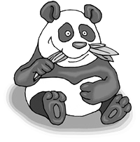

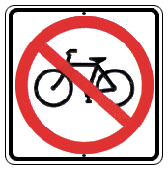
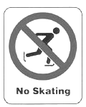

eg:
A B C
1．

2． A B C

( 听力材料
1. Hey, boy, it’s too dangerous to skate here.
2. Let’s go to see the elephants.
(Key: 1.B 2.C)

(B)根据你所听到问句，选择恰当的答语。
1. A. No, I disagree. B. Because it’s boring. C. I’m not allowed to stay out late.
2. A. It might be John’s. B. It’s on the table. C. It’s five dollars.
( 听力材料：1. What rules do you have at home?
2. Whose CD is this? )
( Key: 1.C 2.A )
第二节 听对话
(A) 听一段对话，回答第1、2小题
eg: 1. Where did the woman lose her bag?
- In a car. B. At the park gate. C. Under a big tree.
2. What colour is the woman’s bag?
A. Green. B. Blue. C. Black.
( 听力材料：M: Can I help you, madam?
W: Yes. I lost my bag in the park.
M: Where did you leave it?
W: I left it under a big tree.
M: What colour is your bag?
W: Blue. )
听一段对话，回答第1-3小题
1. Tom and Mary talked ________.
A. at home B. in the class C. on the phone
2. Jane ________ about space yesterday.
A. saw a film B. read a book C. watched a TV program
3. What have some scientists discovered on Mars?
A. Air. B. Water. C. Life.

(听力材料：W: Hello! This is Jane speaking. May I speak to Bill?
M: This is Bill speaking.
W: Bill, I watched a TV program about space yesterday.
M: Oh, can you tell me something about it?
W: Sure. Some scientists have discovered water on Mars?
M: Really? That’s very interesting. )
( Key: 1.C 2. C. 3. B)
(B) 根据你所听到的对话，选择正确的答案（5分）。
eg:
1. Mary is inviting Jack to ___________.
A. go camping B. eat dinner C. go to a movie
2. There will be a _________ tomorrow.
A. math exam B. volleyball game C. class meeting
3. Jack is going to stay at the library for _________.
A. half an hour B. two hours C. three hours
4. Jack and Mary will get home __________.
A. on foot B. by bus C. by bike
5. Jack has to go home to __________at six.
A. do the cooking B. wash clothes C. practice the piano
( 听力材料：
根据你所听到的对话选择正确的答案：
Mary: Hi, Jack. How are you?
Jack: Hi, Mary. I’m OK. A bit busy.
Mary: Can you go to the cinema with me this evening?
Jack: Sorry, I can’t. I have to study.
Mary: You always have to study. Have some fun today.
Jack: We have a math test tomorrow, you know. I’m going to the library. You should come, too.
Mary: I know, I know. What time are you going to the library?
Jack: At three o’clock. Are you coming with me? We can study together.
Mary: Hmm...How long are you staying there?
Jack: Until about five o’clock. I have to be home at six. My parents have gone to Shanghai and
I have to cook dinner for my little brother.
Mary: OK. Let’s go to the library. Then we can take the bus together at five o’clock. )
(Key: 1. C 2.A 3. B 4. B 5. A)
第二部分 选择填空
（A） 单项填空 从每小题A、B、C、三个选项中，选出能填入空白处的最佳答案
eg: 1. More than five __________ people went to the concert last night.
A. thousand B. thousands C. thousands of
2. —______ are those vegetables?
—Two yuan a kilo.
A. How many B. How much C. What
3. The boy is ______to take care of himself.
A. enough old B. enough young C. old enough
4. —Where is your father?
—He _________ Beijing on business. He will be back soon.
A. has gone to B. has been to C. has been in
5. —What is the price of your skirt, Lucy? It looks so pretty.
—It _________ me more than 120yuan.
A. paid B. cost C. spent
( Key: 1.C 2. B 3.C 4.A 5.B)
（B） 完形填空 从每小题A. B. C三个选项中，选择可以填入空白处的最佳答案
Do you need trust (信任) from others? Yes! Everyone needs, 1 his or her parents. Parents would like to give you 2 space if they trust you. If you want your parents to trust you, you have to show 3 through action.
Let your parents 4 what’s going on at school and something else. Keep your bedroom door open when you’re back. Don’t be mad when they see what you’re 5 on the Internet. Invite your friends 6 your house to meet your parents.
When you do 7 wrong, it can break trust. It’s easy to find some reasons not to tell your parents what you’ve done wrong. For example, you don’t want them to be 8 with you and …The list can go on and on. But if they find the 9 , you’ll be in hot water. Broken trust takes long time to recover (恢复), 10 you can do things gradually (逐渐地) to help your parents believe in you again.
1. A. really B. finally C. especially
2. A. many B. more C. most
3. A. him B. her C. them
4. A. know B. to know C. knowing
5. A. looking for B. looking through C. going through
6. A. on B. to C. from
7. A. something B. anything C. everything
8. A. happy B. angry C. pleased
9. A. truth B. reason C. way
10. A. or B. and C. but
( Key 1—5 CBCAB 6—10 BABAC)
（C） 口语应用（补全对话）： 根据对话内容，从对话后的选项中选出能填入空白处的最佳选项
eg:
- Certainly, what is it?
- But for how long?
- Here is the key.
- Where are you going?
- All right. See you later.

Mike: May I use your car, Jane?
Jane: Yes, of course, __________
Mike: Just one or two hours.
Jane: OK. __________ By the way, _________
Mike: I’m going to the train station to meet a friend
of mine.
Jane: Can you do something for me?
Mike: ___________
Jane: Will you buy some apples for me on your way?
Mike: _____________
(Key: B C D A E)
第三部分 阅读理解
eg:
Plants are very important living things. Life could not go if there were no plants. This is because plants can produce food from the air, water and sunlight. Animals and man cannot produce food from the air, water and sunlight as plants do. Animals get their food by eating plants or other animals which eat plants. So animals and man need plants in order to live.
If you look carefully at the plants around you, you will find that there are two kinds of plants: flowering plants and non-flowering ones.
Flowering plants can make seeds. The seeds are protected by the fruits. Some fruits have one seed. Some have two, three or four. Some have many. But a few fruits have no seeds at all. An example of a fruit without seeds is the banana.
Most non-flowering plants don’t grow from seeds. They grow from spores (孢子). Spores are very, very small. Some spores are so small and light that they can float in the air. We may say that spores are quite the same as the seeds. When these spores fall on wet and shady places, they usually grow into new plants.
根据短文内容，判断下列句子是否正确，对的涂（A），错的涂（B）。
1. Plants are very important to life.
2. Both animals and plants can produce food from the air, water and sunlight.
3. Banana is a fruit that does not have seeds.
4. All the flowering plants have many seeds.
5. Spores can grow into new plants wherever they fall. (Key:1.A 2.B 3.A 4.B 5.B)
根据短文内容，从每小题A、B、C三个选项中选出一个最佳答案。
There are many unusual hotels around the world. In Greenland, there is a hotel made out of ice, open between April and December every year. In Turkey, there is a cave hotel with a television, furniture, and a bathroom in each room. And in Bolivia, there is the Salt Palace Hotel.
Thousands of years ago, the area around the Salt Palace Hotel was a large lake. But over time, all the water disappeared. Today, the area has only two small lakes and two salt deserts.
The larger of the two deserts, the Uyuni salt desert, is 12,000 square kilometers. During the day, the desert is bright white because of the salt. There are no roads across the Uyuni desert, so local people must show guests the way to the hotel.
In the early 1990s, a man named Juan Quesada built the hotel. He cut big blocks (块) of salt from the desert and used the blocks to build it. Everything in the hotel is made out of salt: the walls, the roof, the tables, the chairs, the beds, and the hotel’s bar.
The sun heats the walls and roof during the day. At night the desert is very cold, but the rooms stay warm. The hotel has 12 rooms. A single room costs＄40 a night, and a double room costs＄60.
A sign on the hotel’s wall tells guests, “ Please don’t lick the walls－it doesn’t taste good!”
1. People can go to __________ to visit the ice hotel in April.
A. Greenland B. Turkey C. Bolivia
2. The Salt Palace Hotel is unusual because __________.
A. it has a long history B. it’s made out of salt C. the rooms stay cold all day
3. Where did the salt used for the hotel come from?
A. A salt factory. B. The desert. C. The lakes.
4. The underlined word “lick” means __________ in Chinese.
A. 摸 B. 踢 C. 舔
5. The best title for the passage is _________.
A. Unusual Hotels B. Salt Desert C. A Story of Juan Quesad（ Key: 1—5 ABBCA）
阅读下列短文，把A—E五个句子填入文中空缺处，使短文内容完整正确。
A farmer’s dog, Dolly, had babies, and the farmer needed to sell them. He painted a sign and put it in his yard. 1 , a little boy walked up to him.
“Sir,” he said, “I want to buy one of your dogs.”
“Well,” said the farmer, “these dogs are very expensive.”
“ 2 ” asked the boy.
“Sure,” said the farmer. “Here, Dolly!” he called.
Dolly ran out from the doghouse and four little dogs followed her. The boy became excited.
Then, the little boy noticed another dog. This one was smaller. 3
“I want that one,” the boy said, pointing to the little dog.
The farmer said: “ 4 He will never be able to run and play with you like these other dogs.”
The little boy reached down and rolled up one leg of his pants. He showed a cast (石膏) on his leg and a specially made shoe. He said: “You see, sir, 5 , and he will need someone who understands.”

A. Can I just look?
B. Son, you’d better not choose that dog.
C. I don’t run too well myself
D. As he was putting up the sign
E. It moved slowly and tried to catch up with the others.

（Key: 1—5 CAEDB）
第二卷（非选择题）(答案做在答题卡上)
任务型阅读
eg: 形式一： 根据文章内容完成要求。
How to Make Friends
1. It’s hard to make friends if you stay home alone all the time. Get out of the house and do things that will put you in touch with other people. Join a club or play a sport. Attend meetings or other groups. It’s easier to make friends when you have similar interests.
2. Learn from people who seem to have lots of friends. Watch carefully how they make and keep friends. Don’t copy all of the things they do, but try to notice what they do. Then try some of those things yourself.
3. Don’t be afraid to show people what you’re really good at. Talk about the things you like and do best. Don’t hide your strong points. People will be interested in you if there is something interesting about you.
4. Plan things to talk about with people. Find out what’s in the newspaper headlines, listen to CDs, learn about what’s new with your favorite TV or movie star. The more you have to say, the more people will be interested in having a conversation with you
5. Look people in the eye when you talk to them. That way, they’ll find it easier to talk to you. It’s very difficult to have a conversation with people whose eyes are looking to the left, to the right, or at the floor. People may think you’re not interested in them and may stop being interested in you.
6. Be a good listener. Let people talk about themselves before talking about “me, me, me.” Ask lots of questions and show an interest in their answers.
根据描述为下列人物选择应该借鉴文章中的哪条建议（将相应数字序号填在横线上）
____4_______a. Tony is never sure what to talk about when he meets people.
____________b. Rose wants to know why her classmate, Cindy, is so good at making friends.
____________c. Adam stays home every weekend and watches videos.
____________d. Benson is a very good dancer, but he never tells anyone about it.
____________e. Martha doesn’t care for others. She always talks about herself.
____________f. When Pedro feels uncomfortable talking to someone, he starts to look away.

a____4__; b.________; c._______; d.______; e.______; f._______
( Key: 4—2—1—3—6—5 )
形式二： 根据文章内容完成表格
“USA? Britain? Which country is better to study in?” We often hear such discussion. As China opens its door, studying abroad has become a dream for many Chinese students. They want to learn about the world. It’s true that studying abroad can help students develop themselves. Language skills will improve and it may be easier to find a job.
But there are problems that should be considered. Language is the first. Students must spend a lot of time learning another language and getting used to a different culture.
Students must also learn to live without parents’ care and deal with all kinds of things they haven’t had to do before, like looking after themselves. There are reports about Chinese students abroad sinking in an ocean of difficulties and giving up easily. When they have to take care of themselves, it is hard for the students to study well.
Finally, studying abroad brings a heavy burden (负担) to the family. For most Chinese parents, the cost of studying abroad is very high. But is it worth it?
We know that there are many famous people who succeed in great things through their hard work in China. Liu Xiang is a good example. Once an American teacher invited him there but he refused. He kept training hard with his Chinese teacher. He surprised the world when he won a gold medal at Athens Olympics. So when you wonder which country is better to study in, consider whether studying abroad is the right choice.
任务型阅读：根据短文内容，填写下列表格。（10分）

1. Studying abroad can help students develop themselves
① It can help improve them 1 skills.
② It may be easy for them to find 2 .
2. Problems that should be considered before studying abroad
① Students should spend much time learning another language and getting used to a different 3 .
② Students have to learn how to 4 themselves.
③ The cost of studying abroad is very 5 so that it brings a heavy burden to the family.
3. Is studying abroad the right choice
Different people have different ideas. In fact, whether they succeed or not depends on their 6 .

(Key: 1. language 2. jobs 3. culture 4. take care of/ look after / care for 5. high 6. hard work / effort)
第四部分 语言知识运用
A.词汇运用
形式一：选择括号内恰当的单词或词组填入空白处，使句意完整、正确。
1. –_______________ (Whose / Which) bag is this?
–I guess it’s Jack’s.
2. -3. –What’s the __________(price / color) of your new shirt?
–One hundred yuan.
3. –Could you tell me how to be a greener?
–No problem. We should save _______________ (money / water) in our daily life.
4. As we know, English is __________ (wide/widely) used around the world.
5. –It’s snowing heavily at the moment, isn’t it?
–Yes. We’d better ______________ ( put on / take off ) more clothes before starting.
(Key: Whose, price, water, widely , put on)
形式二：根据首字母提示，补全单词，使句意完整、正确。
1. –Could you tell me what colour does Jane like?
–I think she likes r .
2. –Why are you in such a h ?
–Because I am going to have a meeting in five minutes.
3. The girl is so s__________ that she is afraid of speaking in public.
4. Jack is much s_________ than before because he exercises every day.
5. If we o_________ the traffic rules, we may get a fine and even be in danger.
(Key: red, hurry, shy, stronger, obey,)
形式三：根据中文提示写出单词或词组，使句意完整、正确。
1.–How many _________(邮票) have you collected?
–More than 500.2.
2.–Excuse me. How many times have you ever been to Europe?
– (两次).
3. We should try our best to ____________(保护) the wild animals.
4. There are _________________(至少) 5000 workers in that factory.
5. The radio_______________(发明) by Guglielmo Marconi in 1895.
(Key: stamps, twice, protect, at least, was invented )
(B) 遣词造句：请根据每题所提供的图画情景和提示词，写一个与图画情景相符的句子。
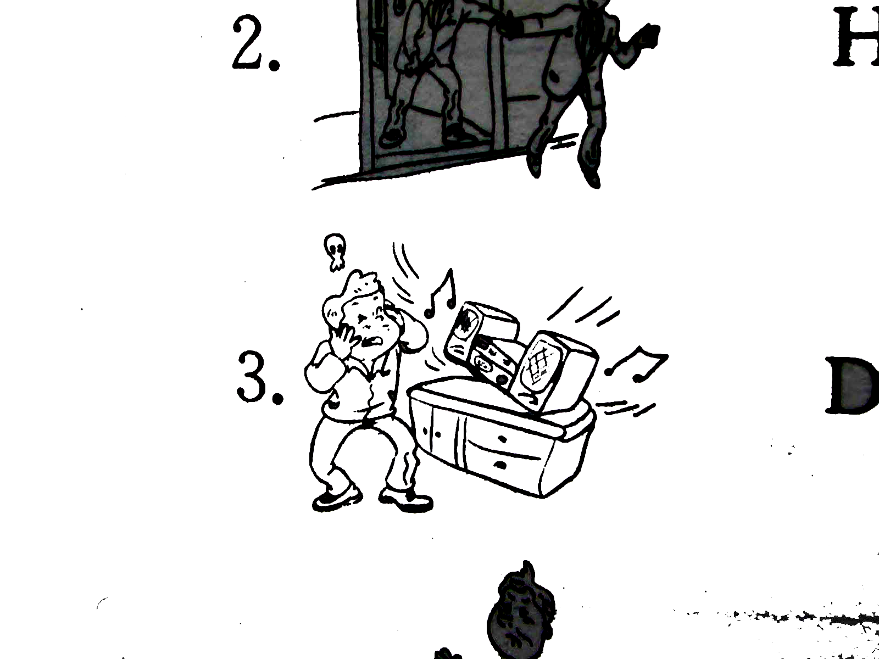

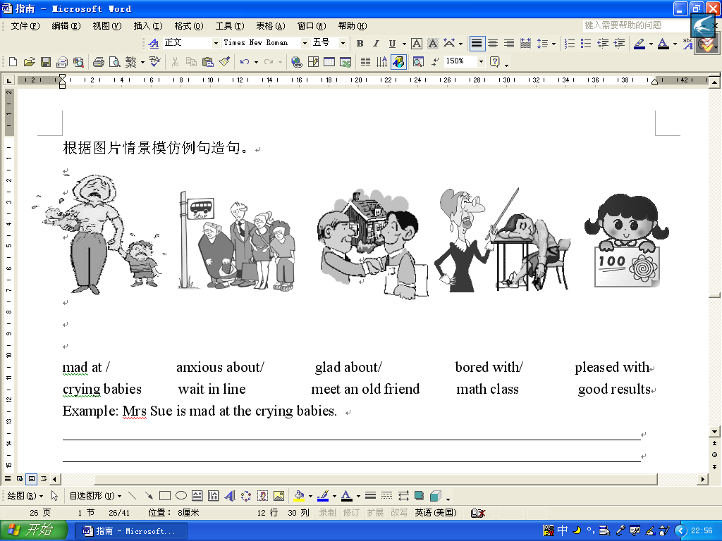

glad, meet, old friend play music, too loudly
____________________________________ ___________________________________
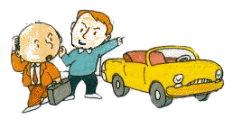


can’t park, car be pleased with, good results
__________________________________ _ __________________________________
（答案略）
(C) 综合填空 阅读下面短文，根据短文大意和语境选择方框内的单词，并用其正确的形式填入空白处，使补全后的短文意思通顺，语法正确，结构完整。
send expensive waste problem cool

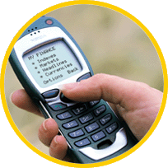
Dear headmaster,
I’m a student of Grade 9. I want to tell you something. In our school, many students have mobile phones. They think it’s 1 to have a mobile phone. Yes, the phones let students talk with their parents and friends at any time. But I don’t think it’s good for students to use them at school. Many students spend lots of time in 2 messages by mobile phone, some students even use them to play games in class or cheat (作弊) in the exams. Some students
always hope to buy the new or 3 mobile phones and this will 4 their
parents’ money. And my father tells me that most mobile phones can cause (引起)
many health 5 . Could you do something to stop it?
Yours
Sophia

(Key: 1. cool 2. sending 3. expensive 4. waste 5. problems)

第五部分 书面表达
A 假如你是泉州清源山风景区的管理人员，请你用英语为游客订出一些规章制度，内容包括：环境卫生保护、森林防火安全、乱涂乱刻(crave)、树木保护、人身安全等，至少5句。
Notice to the Tourists
1.
2.
3.
4.
5.
6.
(参考答案：
- Please keep the place clean and tidy.
- Don’t throw rubbish onto the ground.
- No smoking is allowed.
- Don’t use fire on the mountains.
- Don’t cut down the trees
- Don’t crave on the trees. Please be careful when you climb up and down the mountains. )
B．暑假就要到了，某社团将组织部分青年参加一些志愿活动。请你根据面前的海报和你个人特长，选择参加其中两项活动，谈谈你选择它们的原因以及你准备具体做些什么？（词数80左右）

Volunteers Wanted

☆★☆ Visit Old People’s Home
☆★☆ Teach in the Village School
☆★☆ Help Clean Up the City Parks
☆★☆ Help Sick Children in the Hospital
Come and join us!

___
___
___
___

(参考答案:
Dear Sir，
I am a middle student. I want to be a volunteer to help people. I think I’m the person who can get on well with the old. Although I’m busy, I still want to visit Old People’s Home as a volunteer. More than doing some cleaning for the old, performing a play with my friends is another thing I can do.
If I had another chance, I would help sick children in the hospital. I love children and I plan to put this love to good use by working in the hospital with sick children.
In a word. I would like to help people who need help. Please call me up—62878888.
Warm-hearted

C．童年是难忘的，有快乐、有悲伤。请你以“Childhood Memories”为题，写一篇短文，和大家一起分享你童年中的喜怒哀乐吧！词数：80左右
温馨提示：childhood n. 童年

Childhood Memories
________________________________________________________________________________________________________________________________________________________________________________________________________________________________________________________________________________________________________________________________________________
(参考答案：
I remember my childhood just like yesterday. There was a river around our village. When summer came, I often swam there with my friends. We played with water, and sometimes caught fishes. When we felt tired, we had fun looking for something to eat in the field nearby. Once we were found to pick tomatoes, the farmer shouted to us while we ran away as fast as possible. At that time, I had nothing to worry about. But now, everything has changed!
Goodbye, my childhood! How I wish I could meet you again!)
D. 你校与英国某中学结成姊妹学校，英方校刊编辑（Ann）来信了解你校的课外活动情况及你们的建议，请你根据下面提供的内容用英语写一篇80词左右的短文，（文章的开头已给出，不计入总词数）
生词：兴趣小组 interest group 活动 activity
活动时间：4：50 – 5：50
主要内容：（1）体育类：篮球、足球；
（2）兴趣小组活动： 绘画 歌舞 电脑等；
（3）英语角 （周三下午）。
建议：（1）增加课外活动时间;
（2）减少作业量。
Dear Ann,
I’ like to tell you something about the out- of-class activity in our school. We usually ________________________________________________________________________________________________________________________________________________________________________________________________________________________________________________________________________________________________________________________________________________ (参考答案：
I’ like to tell you something about the out- of-class activity in our school. We usually have activities from 4:50—5:50 in the afternoon. We have different kinds of activities. Some students are interested in sports. They play basketball and football. We also have some special interest groups, such as drawing, singing and dancing. And now, We computer games are the most popular. On Wednesday afternoon we go to English Corner. We like speaking English there. We hope to spend more time on such activities and less time on homework.)

E．下面是Sarah给Sue的e-mail, 请你仔细阅读原文, 然后根据你的情况,以Sue为名给Sarah发一封e-mail. 字数在80个词左右。
请注意：1. 不得写出自己或学校的真实名称；2. 不得照抄原文。
Dear Sue,
How are you? Summer holiday began last week. My brother and I are having our holiday. During the holiday we are planning to learn swimming, climb the mountains and do many other things. Yesterday we went to the museum with my parents. On the way home, we went shopping. My mother bought me a beautiful skirt and a new recorder for my English study. We are sure we’ll have a very good time.
How about you, my dear friend? Have you made any plans for your summer holiday? Please write me soon.
Sarah

Dear Sarah,
Thanks for your e-mail. I’m glad you are enjoying your holiday. Now let me tell you something about my holiday. ________________________________________________
________________________________________________________________________________________________________________________________________________________________________________________________________________________________________________________________________________________________Sue

（参考答案:
Dear Sarah,
Thanks for your e-mail. I’m glad you are enjoying your holiday. Now let me tell you something about my holiday. I didn’t do well in my maths exam, so the most important thing for me in the holiday is that I must spend most of the time on it. I’ll do some more exercises. When I have time, I’ll visit some friends. Also I’ll help my parents with their farm work. After the farm work we will make a trip to Yellow Mountains. I believe we’ll enjoy it.
I hope you can come to see me sometime in the holiday.
Sue）

