上海市闵行区2013年第二学期九年级质量调研考试
英语卷 2013.4.18
Part 1 Listening（第一部分 听力）
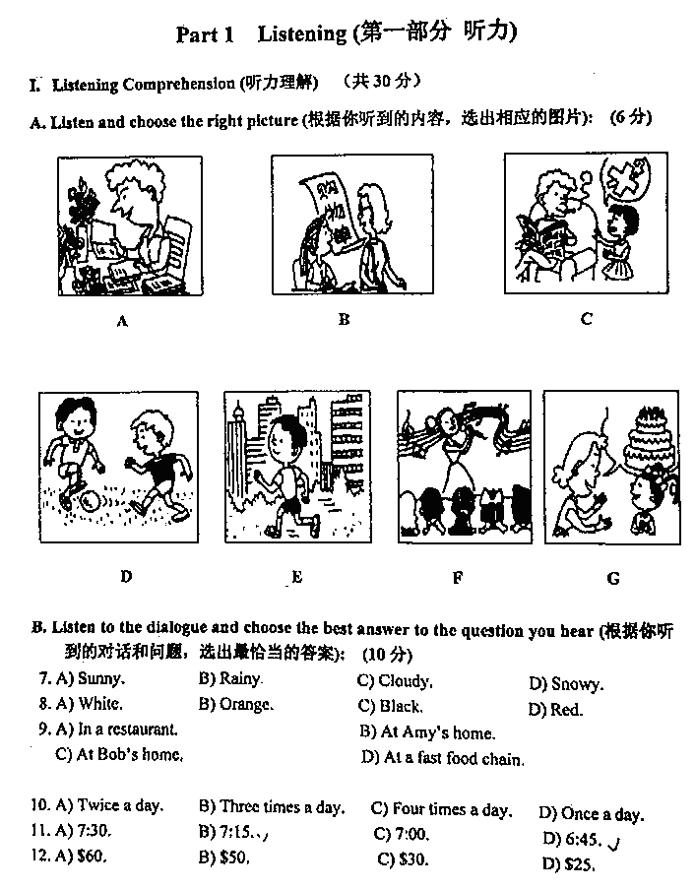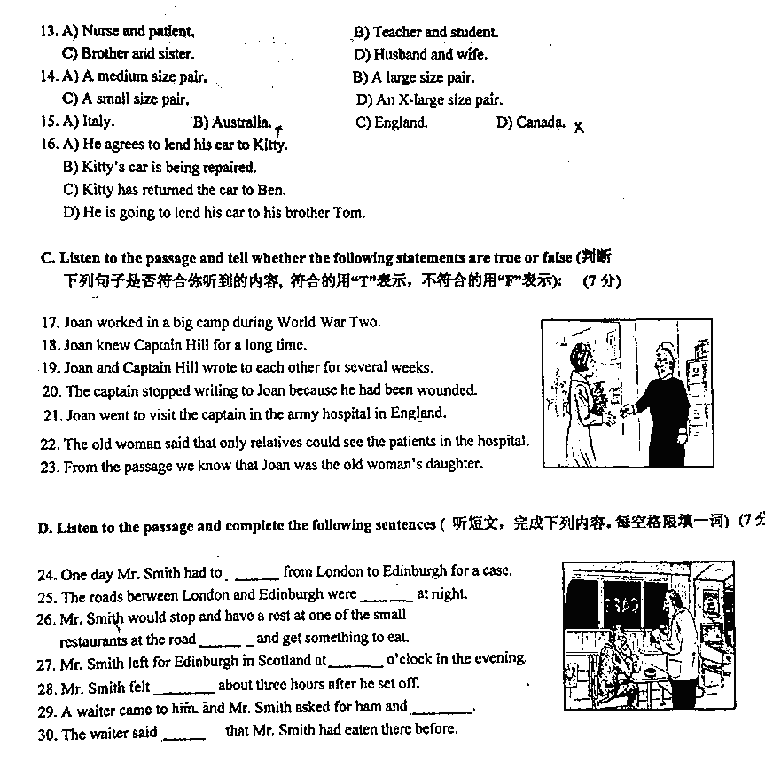
Part 2 Vocabulary and Grammar（第二部分 词汇和语法）
II．Choose the best answer．（选择最恰当的答案）（共20分）
31. The boy dreamed of playing __________ basketball in the NBA when he was in high school.
A. a B. an C. the D. /
32. Jacky Chen is my favorite movie star. I like __________ very much.
A. he B. him C. his D. himself
33. You can see quite a few __________ in the Carrefour supermarket nearby.
A. fruit B. fish C. sugar D. food
34. We were so proud __________ winning 38 gold medals at the 2012 London Olympic Games.
A. in B. of C. with D. for
35. The food smelt so __________ that nobody in the restaurant wanted more.
A. delicious B. well C. bad D. badly
36. We are so glad to see that Shanghai is developing __________ these years than ever before.
A. quickly B. more quickly C. less quickly D. the most quickly
37. My grandparents are old, __________ they still work in the fields every day.
A. or B. so C. but D. and[来源:Z*xx*k.Com]
38. It is seven o’clock. You will be late for school__________ you get up right now.
A. unless B. until C. when D. though
39. We __________ obey the new traffic rules to improve our road safety.
A. can B. must C. need D. may
40. Detective Ken interviewed Jill and Jenny. They both denied __________ the vase.
A. steal B. stole C. stealing D. to steal
41. South Korean first female president, Park Geun-hye (朴槿惠) promised __________ her best to serve people.
A. do B. doing C. did D. to do
42. --- __________can the batteries keep these cool iPhones and iPads working?
--- For about ten hours.
A. How much B. How many C. How long D. How often
43. China __________ its first successful landing of a fighter jet on the Liaoning (“辽宁号”航母) last year.
A. celebrates B. celebrated C. is celebrating D. will celebrate
44. I __________ the streets in our neighborhood this time yesterday when you called me.
A. was cleaning B. have cleaned C. am cleaning D. would clean
45. She didn’t go to see the film Lost in Thailand (《泰囧》) with us because she __________ it already.
A. sees B. saw C. has seen D. had seen
46. __________ exciting event the 2012 Shanghai F1 Race was!
A. What B. How C. What an D. What a
47. Teenagers under 19 years old __________ to visit this website according to the rules last year.
A. weren’t allowed B. weren’t allowing C. won’t be allowed D. haven’t been allowed
48. Did you ask them __________ ?
A. when are they going to set out B. when they are going to set out
C. when were they going to set out D. when they were going to set out[来源:学+科+网Z+X+X+K]
49. ---How about raising some money for the homeless children?
---__________.
A. You’re welcome. B. What a pity! C. Good idea. D. Never mind.
50. ---I’m leaving for Europe on a winter trip next month.
---__________
A. Enjoy your time. B. That’s all right. C. Congratulations! D. It’s a pleasure.
III. Complete the following passage with the words or phrases in the box. Each word or phrase can only be used once. (将下列单词或词组填入空格。每空格限填一词，每个单词或词组只能填一次)（共8分）
A. strange B. airport C. children D. looking forward to E. at first[来源:学科网]
F. downstairs G. wrong H. differently I. deliver
When I was sixteen years old, I made my first visit to the United States. It was not the first time I had been abroad. But it made a deep impression on me. Like most English ____51____, I learned French at school and I often went to France. So I was used to speaking a foreign language to the people who didn’t understand English. But when I went to America, I was really ____52____ having a nice easy holiday without any language problems.
How ____53____ I was! The misunderstanding began at the ____54____. I was looking for a public telephone to give my American friend Danny a ring. So I asked an old man, “I want to give my friend a ring. Could you help me?” “Well, that’s ____55____,” he answered in surprise. “You look very young. Are you getting married?” “Oh! No,” I replied, “I just want to give a ring to tell her I have arrived. Could you tell me if there is a phone box near here?” “Oh! Sorry,” he said, “There is a phone ____56____.”
When we met up, Danny told the misunderstanding to me clearly. “Don’t worry! I met such problems ____57____. There are lots of words which the Americans use ____58____ in meaning from us British. But most of the time British and American people can understand each other well! You will soon get used to all the funny things they say.”
IV．Complete the sentences with the given words in their suitable forms．（用括号中所给单词的适当形式完成下列句子。每空限填一词）（共8分）
59. We still need __________ more chairs for the meeting room. (fifth)
60. Drinking eight __________ of water a day can make us keep healthy. (glass)
61. Mr. Smith told his students to be more careful on __________ days. (wind)
62. Products from __________ are warmly welcomed by most of people in our country. (German)
63. The little girl answered all the questions __________ and she got a full mark. (correct)
64. The __________ of Steve Jobs made millions of people very sad all over the world. (die)
65. The little boy wanted to __________ his plans with his parents. (discussion)
66. It was __________ for anyone to get in because no one knew the password. (possible) .
V. Rewrite the following sentences as required．（根据所给要求，改写下列句子。每空格限填一词）（共14分）
67. At last Tom let his brother go to the concert instead of himself. (改为否定句)
At last Tom __________ __________ his brother go to the concert instead of himself.
68. Daniel was keen on playing tennis when he was ten years old. (保持句意基本不变)
Daniel was __________ __________ playing tennis when he was ten years old.
69. A lot of young students go to America because they want to further their study. (就划线部分提问)
__________ __________ a lot of young students go to America?
70. It was very cold yesterday. He couldn’t go swimming. (合并为一句)
It was __________ cold for him __________ go swimming yesterday.
71. We must keep our classroom clean and tidy every day. (改为被动语态)
Our classroom must __________ __________ clean and tidy every day.
72. The farmers stopped working in the fields when the sun set. (保持句意基本不变)
The farmers __________ stop working in the fields __________ the sun set.
73. “Will they come to attend the meeting?” asked the boss. (改为宾语从句)
The boss asked __________ they __________ come to the meeting.
Part 3 Reading and Writing（第三部分 读写）
VI. Reading comprehension. (阅读理解) （共50分）
A. Choose the best answer.(根据短文内容，选择最恰当的答案)（12分）
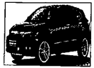
Two smart children --- Benjamin Kan, 12, and his sister Emily, 11, found a stolen in woods near Sai Kung yesterday morning. The delighted owner, Mrs. Judy Roberts, has made a decision to take the children out to dinner as a reward.
Both Benjamin and Emily are studying at Sai Kung Secondary School. They were walking along a path on their way to school when they noticed a car partly covered with branches pulled from a tree. The children were a bit surprised because very few people parked their cars there. They looked inside the car and there was nobody in it.
The children suspected something went wrong. They made a note of the type of the car and its colour. Benjamin, a secondary one student, also wrote down its number. When they returned to their school, they immediately told their teacher what they had seen. The matter was reported to the police station.
As a result of inquires (调查), Mrs. Judy Roberts was traced (追踪). The car had been stolen from her garage two days earlier.
“I lost my car two days ago and I was extremely upset. I’m glad to have it found now. I really have to thank Benjamin and Emily. My husband and I will take them out to dinner. I’m going to write to the headmaster of Sai Kung Secondary School to thank their teachers and pay tribute to (对…表示敬佩) them.” Mrs. Roberts said.
Benjamin and Emily’s teachers took a great pride in having these two small detectives. “Benjamin and Emily are not only students but also responsible members of the community.” Principal Hui said.

74. Benjamin and Emily, the two smart detectives were __________ students.
A. secondary school B. college C. secondary high school D. primary school
75. The children were surprised to notice the car in the woods because __________.
A. they couldn’t find anyone inside. B. someone covered the car with a piece of cloth.
C. nobody parked cars there before. D. people didn’t usually park cars there.
76. The underlined part “The matter” in paragraph 3 refer to __________.
A. the recording of the car number B. the discovery of the car
C. the type of the car D. the school location
77. Mrs. Judy Roberts was delighted because __________.
A. Benjamin and Emily were responsible members of the community
B. her car had been stolen two days earlier
C. she found her car at last
D. she was going to take Benjamin and Emily to dinner
78. Mrs. Judy Roberts would write to Principal Hui mainly to __________.
A. thank the teachers of Sai Kung Secondary School B. tell him that she had found her car
C. invite Benjamin and Emily to dinner D. say that Benjamin and Emily were smart detectives
79. You can probably find this passage __________.
A. in a fable B. in a newspaper C. in an encyclopedia D. in a movie review
B. Choose the words or expression and complete the passage. (选择最恰当的单词或词语完成短文)（12分）
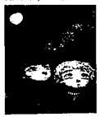
Dad lost his job after arguing with the boss, and when Christmas came that year, we had no money ____80____. On Christmas Eve, Dad took me out into the park. I had a blanket wrapped around me, so I offered to share it with Dad, but he said no thanks. We ____81____ at the sky. Those shining stars, he liked to point out, were one of the special treats for people like us who lived out in the wildness. Rich city people, he’d say, live in fancy apartments, but their air was so polluted they couldn’t even see the stars.
“Pick out your favorite star.” Dad said that night. He told me I could have it for keeping. He said it was my Christmas ____82____. “You can’t give me a star,” I said, “____83____ owns the stars.”
“That’s right,” Dad said, “But you can consider it is yours. And when you do that, it is yours.”
I raised my head, looked at the stars, and tried to figure out which was the best one. Then, I found one.
“I want that one.” I said.
Dad smiled. “That’s Venus,” he said, “Venus was only a planet. She looked bigger and brighter because she was much closer than the stars. Poor old Venus didn’t even make her own light. She shone only from reflected light.”
“I like it anyway,” I said, “I had loved Venus even before that Christmas. You could see it in the early evening, and if you got up early, you could still see it in the morning, after all the stars had disappeared.”
Dad said, “Ok, it’s Christmas. I ____84____ your decision. You can have it if you want.” And he gave me Venus.
We all laughed about the kids who believed in the Santa myth and got nothing for Christmas but a bunch of cheap plastic toys. “Many years later, when all the junk they got is broken and long forgotten,” Dad said, “you will ____85____ have your star.

80. A. at first B. at once C. at all D. at least
81. A. looked up B. looked for C. look out D. look after
82. A. dinner B. card C. party D. present
83. A. Everybody B. Somebody C. Anybody D. Nobody
84. A. desire B. respect C. recognize D. require
85. A. even B. never C. already D. still
C. Read the passage and fill in the blanks with proper words.(在短文的空格内填入适当的词，使其内容通顺，每空格限填一词，首字母已给)（14分）
Different weather makes people feel different. It influences health, intelligence (智力) and feelings.
In August, it is very hot and wet in the southern part of the United States. People there have heart trouble and other kinds of health problems such as headache and sore throat etc. during this month. In the Northeast and Middle West, it is very hot at some times and very cold at other times. People in these states have more heart trouble because of the c____86____ weather in February or March.
The weather can influence intelligence. For example, scientists gave a report in 1983 that a group of students’ IQs were very high when a very strong wind came, but after the strong wind, their IQs were 10% lower. The wind can h____87____ people have more intelligence. Very hot weather, on the other hand, can make it lower. Students often get worse on exams in the hot months of the year. So in China students usually have the entrance exams for higher e____88____ in June for it is not so hot. This year junior high school students in Shanghai will have the exam in the middle of June.
Weather a____89____ has strong influence on people’s feelings. Winter may be a bad time for thin people. They usually feel cold during the months. They might feel unhappy during cold weather. But fat people have a hard time in hot s____90____. At a temperature of about 18 ºC, people become stronger and feel best.
Low air pressure (压力) may make people f____91____. People leave more bags on buses and in shops on low air pressure days.
Are you feeling sad, tired, unhappy or hard to remember things today? If you have one of the above feelings, it may be c____92____ by weather because weather influences people’s health, intelligence and feelings.
D. Answer the questions.(根据短文内容回答下列问题)（12分）

When you hear the name Hollywood (好莱坞), you probably think of excitement, lights, cameras and movie stars. Famous actors are not the only important people in the entertainment business. Directors and producers are important, too. Today, Hollywood is full of producers and directors. And it is one of the tourist destinations in America.
In 1911 the small, peaceful village of Hollywood in California voted to become part of Los Angeles (洛杉矶). Today, over 100 years later, this village has grown into the home of one of the most well-known industries in the world --- the American film industry.
With this growth, came many well-known symbols. There is the famous Hollywood sign which stands above the hills of the town. The first sign was built in 1923. Then there is the Hollywood Hall of Fame, where great actresses, actors and directors leave their footprints or handprints. Norma Talmadge was the first actress to do this in 1927. But most famous of all are the Oscar Academy Awards (奥斯卡颁奖). In March of every year a number of actresses, actors and directors wait nervously to find out if they have won an “Oscar”. This year was the 85th Oscar Academy Awards. It was held on February 25, in Los Angeles. An Li (李安), a Chinese director won the best director again. It was his second time to win an “Oscar”.
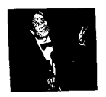
Nowadays it becomes more and more common for films to be made away from Hollywood itself, but it remains the home of films, and thousands of hopeful young actresses, actors, writers and directors still come to “the Dream Factory” every year. But not all Hollywood dreams have been happy ones --- as one actress, who later died tragically (悲惨地), said, “Hollywood is a place where they will pay you 500 dollars for a kiss, and 50 cents for your soul.”

93. How was Hollywood in 1911?[来源:学§科§网Z§X§X§K]
It was __________________________________________________
94. What is Hollywood most famous for in the world?
Hollywood ______________________________________________
95. Was the first Hollywood sign built in 1927?
_________, ______________________________________________
96. How often are the Oscar Academy Awards held?
________________________________________________________
97. An Li has won the best director twice, hasn’t he?
__________, _____________________________________________
98. How do you like Hollywood?
I think Hollywood _________________________________________

VII. Writing. (作文) （20分）
99. Write a passage of at least 60 words on the topic “An unforgettable … lesson”. （以“记一堂难忘的…课”为题写一篇不少于60个词的短文，标点符号不占格）
（注意：文中不得出现任何姓名、校名及其它相关信息，否则不予评分。）
Use the following points as a guide. （短文必须包含下列要点）
1. Which lesson do you think was unforgettable?
2. Why do you think it was so unforgettable? (give at least two reasons)
3. What have you learned/got from it?

__________ __________ __________ __________ __________ __________ __________
__________ __________ __________ __________ __________ __________ __________
__________ __________ __________ __________ __________ __________ __________
__________ __________ __________ __________ __________ __________ __________
__________ __________ __________ __________ __________ __________ __________
__________ __________ __________ __________ __________ __________ __________
__________ __________ __________ __________ __________ __________ __________

KEY：
I. A) ECFDGA B) ADCBC ABCBD C) TFFTTTF D) Monday train trouble everyone silent shouted Finally
II. 31-35 DBBBC 36-40 BCABC 41-45 DCBAD 46-50 C(A/D)DCA
III. C D G B A F H E
IV. five glasses windy Germany correctly death discuss impossible
V. didn’t let fond of/interested in Why do too to be kept didn’t until whether/if would
VI. （A）阅读单选：ADBCAB
（B）完形填空：CADDBD
（C）首字母填空：changeable help education also summer forgetful caused
（D）阅读问答：93. small and peaceful.
94. is famous for excitement, lights, cameras and movie stars.
95. No, it wasn’t
96. Once a year.
97. Yes, he has.
98. Any reasonable answers.[来源:学科网ZXXK]

