浙江省金华市六校联谊2013年中考英语模拟试卷
- 听力（共15小题，满分20分）
第一节：听小对话，，从A、B、C三个选项中选择正确的选项。回答问题。（共5小题，每小题1分，满分5分）
( ) 1. What’s the boy looking for?
A. A football. B. A basketball. C. A volleyball.
( ) 2. When will they go to the library?
A. Next Tuesday. B. Next Monday. C. Next Thursday.
( ) 3. What was Sam doing?
A. He was cleaning the floor.
B. He was playing football.
C. He was drawing on the wall.
( ) 4. What kind of music does Linda like?
A. Rock music. B. Country music. C. Light music.
( ) 5. What does the man’s answer mean?
A. The woman can’t sit beside him.
B. The woman can sit beside him.
C. Someone else will sit beside him.
第二节：听长对话，，从A、B、C三个选项中选择正确的选项。回答问题。（共5小题，每小题1分，满分5分）
听下面一段较长对话，回答6,7两个问题。
( ) 6. What color does the man’s daughter like best?
A. Yellow. B. Blue. C. Red.
( ) 7. Which coat does the man choose in the shop?
A. The 150yuan one. B. The 80yuan one. C. Neither.
听下面一段较长对话，回答8---10三个问题。
8. Why is John so excited?
A. Because his parents will take him to his uncle’s home.
B. Because his parents will take him to England.
C. Because he will meet his friends at the airport from London.
9. When and where are they going?
A. To London in two weeks. B. To the USA next Friday.
C. To England next week.
10. When are they coming back?
A. At the end of July. B. In the middle of July. C. On July 5th.

第三节：听独白，从A、B、C三个选项中选择正确的选项，完成下面的信息记录表。（共5小题，每小题2分，满分10分）
Information Card
Time now |  | 6：00 am
Weather information |  | Snow has been falling since 11
Suggested ways of transportation |  | 12
Influence to the school |  | Some schools in the countryside are 13
More information about the weather |  | 14 will last for at least two more days.
Time for the next 15 |  | In two hours
（ ）11. A. Today  （ ）12. A. Drive a car  （ ）13. A. closed  （ ）14. A. Wind  （ ）15. A. music | B. yesterday afternoon  B. Walk  B. open as usual  B. Snow  B. weather |  | C. last night  C. Take a bus  C. broken  C. Cloud  C. news

二、单项填空（本题有15小题，每小题1分；满分15分）
16. —Do you know Peng Liyuan?
—Of course, she is First Lady of China, famous singer.
A. a, a B. the, a C. the, the D. a, the
17. — Where is your mother?
—She ________ the shop. She’ll be back in an hour.
A. has been to B. has gone to C. goes to D. go to
18. —Which module is the most difficult in this book?
— I think _____ module.
A. ninth B. the ninth C. nineth D. the nineth
19. —What is the date today?
— It is _______.
A. Monday B. May 1th C. May 1st D. Children’s Day
20. —Do you like your maths teacher?
—Sure, because he is the teacher ___ helps me a lot.
A. whose B. whom C. which D. who
21. —May I swim here?
— No, you _______. It is dangerous.
A. won’t B. needn’t C. mustn’t D. don’t have to
22. —Please read every sentence carefully. you are, mistakes you’ll make.
—Thank you for your advice.[来源:学+科+网Z+X+X+K]
A. The more carefully; the fewer B. The more careful; the less
C. The more carefully; the less D. The more careful; the fewer
23. — ______ the earthquake in Yushu is!
— Yes, we should try our best to help them.
A. What terrible B. How terrible C. How terribly D. what terribly
24. —Excuse me. Could you tell me ________?
— Sorry, I am new here.
A. where the hospital is B. where is the hospital
C. where the hospital was D. where was the hospital
25. —How long has John been here?
— Two years, _______ he still has no friends.
A. and B. so C. but D. or
26. —Miss Li has taught ____ English for about 3years.
—You are lucky. ____ is a very good teacher.
A. ours, She B. our, He C. us, He D. us, She
27. —The spacecraft has never been to the moon, ________ ?
—Certainly.
A. has it B. hasn’t it C. doesn’t it D. isn’t it
28. —Has anyone taught him how to do it?
—Sure. Lots of advice________, but he hasn’t made a decision.
A. gave B. was given C. have been given D. has been given
29. —Thank you for your help.
— ___________.
A. That is right B. That is all right C. Help yourself D. With pleasure
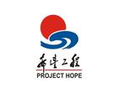
30. —What has ________ done since 1989?.
—It has built many schools for poor children .
A. Hope Project B. project hope
C. hope project D. Project Hope

三、完形填空（共15小题，每小题1分，满分15分）
阅读下面短文，掌握其大意，然后从每题所给的A、B、C、D四个选项中选出最佳选项。
One day, a teacher was speaking to a group of students about how to manage time. He gave such an interesting example that his students would never 31 .
He put a wide-mouth jar (罐子) on the table. Then he 32 some rocks and carefully placed them into the jar, one at a time. When 33 rocks would fit inside, he 34 , “Is this jar full?”[来源:学+科+网]
Everyone in class shouted, “Yes.” “Really?” The teacher pulled out a bag of small stones. He put 35 small stones in and shook the jar. The small stones went 36 into the spaces between the big rocks. He then asked the group 37 , “Is this jar full?”
“Probably not,” one of them answered. “Good!” the teacher replied. He brought out a box of sand and 38 some sand into the jar and it went between the rocks and small stones. Again he asked the 39 question, “Is this jar full?
“No,” the class shouted. Once more the teacher said, “Good.” He poured a cup of water into the jar 40 it was full. The he asked, “What is the point here?” One student 41 his hand and said, “The point is that if you try really hard, you can 42 put more things in.”
“No,” the teacher replied, “that’s not the 43 . What I want to tell you is that if you don’t put the big rocks in first, you will never get others in at all. 44 are the ‘big rocks’ in your life? Time with your friends, your education or your dreams? Remember to put the 45 in first, or you’ll never get others in at all.?”
31. A. remember B. like C. forget D. think
32. A. handed in B. took out C. gave away D. put away
33. A. no more B. not more C. no many D. not many
34. A. answered B. read C. asked D. said
35. A. no B. few C. any D. some
36. A. up B. out C. down D. away[来源:学科网ZXXK]
37. A. no more B. again C. a third time D. a fourth time
38. A. sent B. put C. bought D. collected
39. A. same B. different C. difficult D. common
40. A. since B. till C. while D. because
41. A. offered B. placed C. raised D. shook
42. A. always B. already C. never D. hardly
43. A. point B. example C. promise D. story
44. A. When B. What C. Who D. Why
45. A. sand B. small stones C. big rocks D. water

四．阅读理解（本题有15小题，每小题2分，共30分）
阅读下面短文，从每题所给的A、B、C、D四个选项中选出最佳选项。
A
A On a Quiet Night
Tang Li Bai
I saw the moonlight before my couch,
And wonder if it were not the frost on the ground,
I raised my head and looked out on the mountain moon,
I bowed my head and thought of my far-off home.
B Homesickness
-- by Yu Guangzhong
In my childhood,
Homesickness was a small stamp.
I was here.
And my mother was over there，

When I grew up,
Homesickness was a narrow ship-ticket.
I was here
And my bride was over there:

And then
Homesickness was ___47________.
With me outside
And my mother inside:

But now,
Homesickness is a shallow strait.
I am on this side.
And the mainland is on the other side
46. PoemA was written by in Dynasty.
A. Du Fu, Tang B. Bai Juyi, Tang C. Li Bai, Tang D. Sushi, Song
47. Choose the best phrase to fill in the blank.
A. a big rock B. a huge mountain C. a small tomb D. a long river
48. What’s the theme of the two poems?
A.Missing hometown B.Talking about friendship C. Missing mother D. Talking about city
B
If someone says to you: “give me five”, do not search your pocket to get five yuan! It will make others laugh! The person's not asking for your money, but your fingers.
In the US, "give me five" or "give me the high five" is a popular gesture (动作). You can see it often in films or on TV. It means the clapping (拍) of each other's raised (举起的) right hands together.
People do it when they meet for the first time or something happy happens. For example, a student has good marks in exams or wins a lottery ticket (彩票).If a football team wins a game, the players will give high fives to everyone around to celebrate.
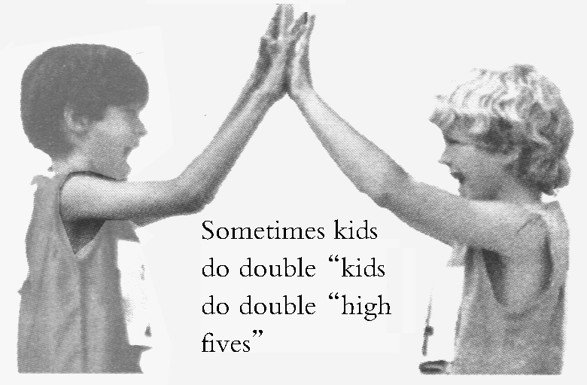
This gesture may come from the old Roman gesture of raising the right arm for the emperor(皇帝). This showed that the person raising his arm did not have a sword (刀) in his hand.
Sometimes kids do double “high
fives”.
Why not try to give the high five to your friends?
49. “Give me five” is a gesture to _______.
A. make people laugh B. ask for money
C. celebrate success D. search one’s pocket
50. The gesture “give me five” is the clapping of _______.
A. toes B. hands C. arms D. legs
51. The gesture started in _______ according to the story.
A. Rome B. America C. China D. Britain
52. What is double “high fives”?
A. Both kids clap their left hands.
B. Both kids clap their right hands.
C. Both kids do high fives several times.
D. Both kids do high fives with both right and left hands.
C
John and Bobby joined the same company together just after they completed their university studies the same year. Both of them worked very hard. Several years later, however, the boss promoted(提拔) Bobby to manager but John was still a worker. John could not take it, and gave his resignation（辞职书） to the boss. He complained that the boss did not think much of those who were hard -working, but promoted only those who flattered him.
The boss knew that John had worked very hard for the years. He thought a moment and said, “Thank you for what you said, but I hope you will do one more thing for our company before you leave”
John agreed. The boss asked him to go and find anyone selling watermelons in the market. John went and returned soon. He said he had found a man selling watermelons. The boss asked how much they cost every kilogram. John shook his head and went back to the seller to ask and returned to tell the boss $1.2 every kilogram.
The boss told John to wait a second, and he called Bobby to come to his office. He asked Bobby to go and find anyone selling watermelons in the market. Bobby went and returned, saying, “Boss, only one person is selling watermelons. $1.2 every kilogram, and $10 for 10 kilograms. The seller has 340 melons. On the table there are 58 melons, and each weighs about 2 kilograms. They were brought from the South two days ago. They are of good quality.”
Hearing what Bobby said, John realized the difference between himself and Bobby. He decided to stay and learn from Bobby.
53. How did John feel when Bobby was promoted to manager?
A. Angry. B. Nervous. C. Unlucky. D. Helpless.
54. The boss gave John a task because______________.
A. he wanted John to do more for his company
B. he wanted John to learn more about himself
C. he wanted to punish John for what he said
D. he wanted to prove what John said was right
55. We can infer from the passage that_____________.
A. Bobby was unselfish B. John was lazy
C. the seller was dishonest D. the boss was wise
56. What can we learn from the passage?
A. The boss should treat all his workers in a fair way.
B. The boss should not promote one who flatters him.
C. One should not only work hard but also use his head.
D. One should try to get every detail of watermelons.
D
Ding-Dong！
“Jason, honey? Can you answer the door?”
“I am busy, mom！” Jason shouted back at his mother. He had spent three hours so far working to this point in the game. He couldn’t stop now.
Ding-Dong！Mom′s footsteps approached the front door.
“Jason, it’s your friend Todd.” Mom called from the doorway.
Todd, his best friend, stepped into the room. “ Jason！I need a partner for playing basketball. ”He sounded excited.
Jason snorted. “No way, Todd. I′m playing a game here.”
Jason gave his friend a dirty look, and his character in the game almost got killed while he looked away, “ I almost died because of you！”
Todd looked at Jason′s mother. Jason’s mother looked back at him. They both looked at Jason. “Why don′t you play basketball with your friend?” Jason’s mother suggested.
“Tomorrow, maybe…” There were more levels to beat tomorrow, though, Maybe he had played tomorrow. He’d have to see what mood he was in. He thought he heard footsteps walking away, but he was too busy beating the next level to care.
An hour later, Jason’s father came home. It was dinner time after his father washed up and sat down. Jason didn′t even hear his name being called to the table. He didn′t hear his father walk at behind him and ask him to turn the game off, either.
When the screen suddenly went black and his father’s angry face loomed in front of him, Jason finally heard. “No more game for a month.” Jason′s father shouted at him. “You don’t play basketball, you don′t come to dinner, and you don′t do your chores. We′ll make you do something else before you play any more.”
Jason nodded slowly. He knew better than to argue with his father, and when he thought about it, he had been playing quite a bit. It was fun, but he was letting down his friends, his family, and himself by paying too much.
He′d try harder in the future.
57. What did Todd ask Jason to do?
A. Help him cook dinner B. Beat more levels for him.
C. Repair the computer for him D. play basketball with him.
58. Why did Jason finally stop playing the game?
A. He won the game. B. His mother got dinner ready.
C. His father turned off the computer. D. He decided to play basketball outside.
59. What did Jason learn in the end?
A. He thought that his father was too strict with him.
B. He found that playing computer games was quite interesting.
C. He realized it was an unhealthy habit to play games without dinner.
D. He couldn’t spend all day playing games, because he had other duties.
60. Which of the following is the best title of this passage?
A. Inside the game B. Games or Supper.
C. Jason′s Angry Father D. Use of the Computer.
五、词汇运用（共15小题，每小题1分，满分15分）
A. 用方框中所给单词的适当形式填空，每词限用一次。
take , wish , collect , listen to , present
61. Best ____ for you!
62. He has a __________ of small stones.
63. How about ______ the radio now?
64．Hard work and good marks are the best for Teachers’ Day.
65. The plane _____ off just now.
B．阅读下面短文,根据所给中文正确拼写单词，使短文意思完整。每空限填一词。(10分)
Before you go to another country, it is a great 66 (帮助)if you know the language and some of the customs of the country. When people 67 (见面)each other for the first time in Britain, they 68 (说)“How do you do.”and shake hands. Usually they do not shake hands 69 (在…以后)they haven’t met for a long time. Last year a group of German 70(学生)went to England for a holiday. Their teacher told 71 (他们)that the English people hardly shake hands. So when they met their English friends at the station, they kept their hands behind their 72 (背).The English students had learned that Germans shake hands as often as 73 (可能),so they put their hands in front and got 74 (准备)to shake hands with them. It made both of them 75 (笑).
B. 根据短文内容和所给中文提示，在空白处写出单词的正确形式。每空限填一次。

六、任务型阅读
阅读下面短文，从方框中找出每段的中心句，与每一段落匹配起来。
Maybe you think of yourself as a good friend, but are you really? If you’re not sure, it’s time to think about what makes a true friend.
________76_________. A good friend is busy but still manages to make time for your friends. He does not see friendships as a waste of time, or something to pay attention to only when he needs a favour.
_________77_______. Always be ready to listen to what the other person is telling you, even if sometimes it makes you uncomfortable.
_________78___________. Nothing ends a friendship faster than abandoning （抛弃） a friend in need.
__________79____________. When it seems like no one in your life will tell you the truth, your friend will have your back.
___________80___________. A true friend doesn’t gossip（说闲话） behind your back. When he doesn’t agree with you, it’s done in a respectful way that is meant for you both to come to an understanding.

- Be respectful.
- Be ready to listen.
- Be honest.
- Be there when your friend needs help.
- Make time for friends.

七、书面表达。
小作文: (本题5分)
目前学校中有部分同学的行为不规范，请根据以下图片，以句子或短语的形式写出他们有哪些不规范的行为，并再写出一条你发现的不规范行为。
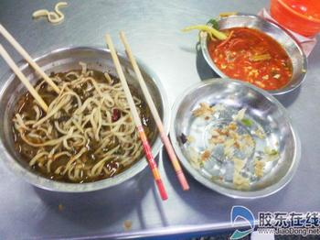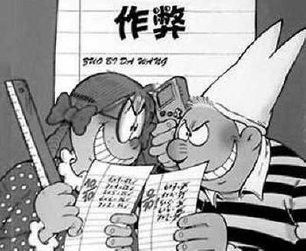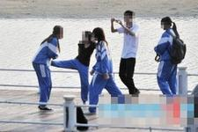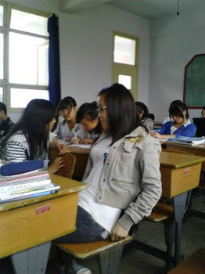
A B C D
81._________________________________________________
82. ________________________________________________
83. ________________________________________________
84.________________________________________________
85. _______________________________________________
86.大作文(本题共15分)
假如你是李华，你非常支持学校开展的“Be well-behaved”活动，为了让更多的同学加入这个活动，请你写一份倡议书,说说针对这些不规范行为我们改如何做。
要求： 文章不能出现真实的校名和人名，约80---100字左右。
作文开头已给出：
Boys and girls,
To make every student have good behaviour, our school has an activity of “ Be well-behaved”. So let’s take part in it and try to be a well-behaved student. _______
_______________________________________________________________________________________________________________________________________________________________________________________________________________________________________________________________________________________________________________________________________________________________________________________________________________________________________________________________________________________________________________________________________________________________________

Lihua

听力材料及参考答案
听力材料：
第一节．听短对话，回答问题。
1. M: Have you seen my football?
W: No, but I saw a basketball and a volleyball in the corner.
2. M: Shall we go to the library next Monday?
W: All right. See you then!
3. W: Don’t draw on the wall, Sam.
M: Pardon?
W: I asked you not to draw on the wall. You can help me clean the floor.
4. M: Do you like rock music, Linda?
W: No, I don’t. It’s too noisy. I prefer light music.
5. W: Excuse me. Do you mind if I sit here?
M: No, of course not.
第二节、听长对话，回答问题。
听下面一段较长的对话，回答第6至7两小题。
W: May I help you, sir?
M: Yes. I’m looking for a coat for my daughter.
W: These coats are for boys. This way, please.
M: Well, that yellow coat is nice. May I have a look at it?
W: Sure, here you are.
M: How much is it?
W: 150 yuan.
M: That’s a bit expensive. Do you have a cheaper one?
W: The blue one is cheaper. it's 80 yuan.
M: But my daughter doesn’t like this color. She likes red best. I’ll go to another shop to have a
look.
听下面一段较长的对话，回答第8至10三小题。
W: John, you look so excited. Any good news?
M: Yeah. My parents will take me to England by plane.
W: Great! How long are you going to stay there?
M: Well, my parents said we were going to stay there for about two weeks.
W: I see. So when will you leave? Next week?
M: Yes, we will leave on July 1st, next Tuesday.
W: Next Tuesday ?It’s only in four days’ time. Oh, have a good time. See you then.
M: Thanks, see you.
第三节：听独白，请从A、B、C三个选项中选择正确的选项，完成信息记录表。
It’s six o’clock in the morning and here is the local news. The bad weather has brought lots of trouble to the local areas. The heavy snow which has been falling since
yesterday afternoon has caused great trouble. So please don’t drive to town. If you must go to town, take a bus or take the train. As the result of the bad weather, some schools in the countryside are closed. In the city, however, schools are open as usual. It’s going to snow all day today, and for at least two more days. Well, that’s the news at six o’clock. The next news will be in two hour’s time. Now let’s have some music.
参考答案：
一、1—5 ABCCB 6—10 CCBCB 11—15 BCABC
二．16—20 BBBCD 21 —25 BDBAC 26—30 DADBD
三、31-35 C B ACD 36-40 CBBAB 41-45 CAAB C
四 46—48 CBA 49—52 CBAD 53—56 ABDC 57—60 DCDA
五、
61.wishes 62.collection 63. listening to 64.presents 65. took
66.help 67.meet 68.say 69.after 70.students
71.them 72.backs 73.possible 74.ready 75.laugh、
六、76—80 EBDCA
书面表达的评分标准：
第六档：（13—15分） 包含全部要点；语言基本无误；行文连贯，表达清楚。
第五档：（11—12分） 基本包含要点，语言有少量错误；行文基本连贯，表达基本清楚
第四档：（8—10分） 包含部分要点；语言虽有较多错误，尚能达意。
第三档：（6—7分） 要点不明确；语言错误多，影响意思表达。
第二档：（3—6分） 只挡写了提示词；错误百出，不知所云。
第一档：（0—2分） 白卷或文不对题

2010初三中考模拟考试
姓名__________学号_______
班级_________
学校__________
英语答题卷
第一部分 听力部分
一.听力
第一节:听小对话选图片。
1.________ 2.__________ 3._________ 4._________ 5._________
第二节:听长对话，回答问题。
6.________ 7.__________ 8._________ 9._________ 10.________
第三节:听独白,完成信息记录表。
11._______ 12._________ 13.__________ 14._________ 15._________

第二部分 笔试部分
二.单项填空。
16.________ 17.__________ 18._________19._________ 20._________

21.________ 22.__________ 23._________24._________ 25._________

26.________ 27.__________ 28._________29._________ 30._________
三. 完形填空。

31.________ 32.__________ 33._________34._________ 35._________

36.________ 37.__________ 38._________39._________ 40._________

41.________ 42.__________ 43._________44._________ 45._________
四．阅读理解
46.________ 47.__________ 48._________ 49._________ 50._________

51.________ 52.__________ 53._________ 54._________ 55._________

56.________ 57.__________ 58._________ 59._________ 60._________

五．词汇运用。
61．_______ 62.__________ 63.________ 64.________ 65.___________

66._______ 67._________ 68.________ 69.________ 70.___________

71.________ 72.__________ 73._________ 74._________ 75.___________
六．任务型阅读
76.________ 77.__________ 78._________ 79._________ 80.__________
七．书面表达。
81. (1)__________________________________________ [来源:Z#xx#k.Com]
(2) __________________________________________
(3)___________________________________________
(4)____________________________________________
(5)____________________________________________
82
Boys and girls,
To make every student have good behaviour, our school has an activity of “ Be well-behaved”. So let’s take part in it and try to be a well-behaved student.[来源:学科网ZXXK]
___________________________________________________________________________________________________________________________________________________________________________________________________________________________________________________________________________________________________________________________________________________________________________________________________________________________________________________________________________________________________________________________________________________________________________________________________________________________________________________________________________________________________________________________________________________________________________________________________________________________________________________________________________Li Hua

