2014年杭州中考英语试卷
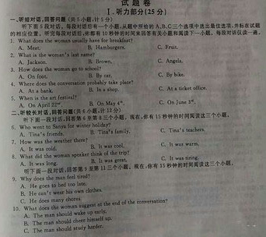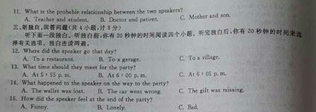
四、单项填空（共15小题，计15分）
从A、B、C、D四个选项中，选出可以填入空白处的最佳选项
- The phonetic transcription of the word “paint” is______
- /pent/ B./peint/ C./paint/ D./pænt/
- If you _____ smoke,please go outside.
- can B.may C.must D.might
- My cousin went abroad at_____ age of eighteen.
- a B.an C.the D.不填
- I am tried.This is not the right ____ to ask me to go for a walk.
- moment B.chance C.place D.season
- Many fast food restaurants paint their walls red,play loud music and have hard seats_____ customers eat quickly and leave.
- make B.to make C.made D.making
- I can’t find my ticket.I think I must have lost_____.
- it B.one C.this D.them
- To my great surprise,the famous athlete’s story______ differently in the newspapers.
- was reported B.reported C.was reporting D.reports
- In summer milk will quickly go bad_____ it is put into a fridge.
- though B.unless C.because D.once
- I will never forget the day____ we spent in the old town with small houses.
- who B.whom C.that D.what
- Of the two shirts,I’d like to choose the_____ one to save some money for a cap.
- cheapest B.cheaper C.more expensive D.most expensive
- The boats take different routes, but they all____ in the same place.
- give up B.clear up C.end up D.make up
- It’s hard to believe____ the way out of the forest without the help of the local guide.
- what they were able to find B.what were they able to find
C.how they were able to find D.how were they able to find
- After Steven sent some e-mails ,he______ surfing the Internet.
- starts B.has started C.will start D.started
- They usually go shopping____ their lunch break.
- against B.among C.between D.during
- --What about having a drink? --_______.
- Help yourself B.Never mind C.You’re right D.Good idea.

- 完形填空（共15小题，计15分）
通读下面短文，掌握其大意，然后在各题所给的四个选项（A、B、C和D）中选出一个最佳选项。

At a day care centre in Texas,Jessica McClure was playing outside.Jessica’s mother,__31__worked at the day care centre,was watching her.Suddenly Jessica__32__ and disappeared.Jessica’s mother cried and ran to her.
The well in the yard was only eight inches across,and a rock always__33__it.But children had moved the rock.__34__ Jessica fell,she fell right into the well.
Jessica’s mother ran to a phone and called 911 for __35__.Men from the fire department arrived.They __36__that Jessica was about 20 feet down in the well.Then they told Jessica’a parents their__37__. “We can’t go down into the well”they said,”It’s so small.So we are going to dig a hole ___38___well.We’ll dig down about 20 feet.Then we’ll dig a tunnel(通道) across to Jessica.When we reach her,we’ll bring her through the tunnel.Then we’ll bring her up through our__39__.”
The men began to gig the hole on a Wednesday morning.Two days later,on Friday morning,they were__40__digging.And Jessica McClure was still in the well.
All over the world people waited for news of Jessica.They read about her in newspapers and watched her rescue(营救）on TV.Everyone__41__ the little girl in the well.
At 8:00 p.m. On Friday,the men__42__ reached Jessica and brought her up from the well.Then doctors rushed her to the hospital.Jessica was badly injured but she was still__43__.A doctor at the hospital said, “Jessica is lucky she is very__44__.She’s not going to remember this very well.”
Maybe Jessica will not remember her days in the well.But her parents,her rescuers,and many other people around the world will not forget__45__.
After Jessica’s rescue,one of the rescuers made a metal cover for the well.On the cover he wrote, “To Jessica,with love from al of us.”
- A.she B.who C.whom D.which
- A.fell B.slept C.stooped D.rose
- A.broke B.hid C.covered D.opened
- A.Because B.Although C.If D.When
- A.advice B.money C.help D.information
- A.promised B.discovered C.hoped D.agreed
- A.dream B.study C.lesson D.plan
- A.next to B.along with C.far from D.out of
- A.well B.tunnel C.hole D.yard
- A.still B.already C.always D.almost
- A.looked after B.worried about C.made friends with D.stayed away from
- A.immediately B.usually C.quickly D.finally
- A.alone B.asleep C.alive D.afraid
- A.young B.popular C.clever D.pretty
- A.it B.them C.him D.us

- 阅读理解（共15小题，计30分。其中第一节10小题，计20分；第二节5小题，计10分）
- ：阅读下列短文，从每题所给的四个选项（A、B、C和D）中选出最佳选项.
A

1 I’ve been working as a professional clown(小丑）for nearly two years.Before that,I was an actor for nine years.I was never famous,but I was quite successful!I changed jobs because I wanted to do more in life than make people laugh.What if I could help people,too?
As a clown,I try to encourage sick chileren in hospital to laugh and smile.When you laugh,your mind and body relax.Clearly,people who laugh more don’t have as many colds or other problems!Children who laugh a lot often get better results in their studies,too.
It isn’t an easy job.Not all sick children get better,and sometimes I come home and cry.But I always go back to work the next day with my red nose on.I don’t earn much money as a clown, but I feel very lucky to work with such brave,wonderful patients.

2 I became a laughter yoga(瑜伽）teacher more than two years ago.Before that,I was a dentist!My job was very difficult,and I used to feel fed up.Now I still improve people’s health,but everything else is completely different.Everyone has fun in a laughter yoga class,including the teacher!
No,laughter isn’t “magic”.It doesn’t prevent all illness,keep you young,or make you beautiful.But did you know that isn’t ana excellent kind of exercise?You move your whole body when you laugh!
Sometimes I worked with famous people.It’s true that being rich can be stressful!Some famous people can be unpleasant at times,but I try to change their bad feelings.Laughter is excellent for people like musicians,artists and writers,because it helps people to be more creative.

46.According to the passage,we can see that both writers______.
- have changed their jobs B.like sports very much
C.feel unhappy at work D.are looking for jobs
- The reason why the first writer take up the jobs as a clown is that_____.
- he has had a disease for two years. B.he needs a much easier job
C.he wants to be a successful man D.he wishes to help people
- The second writer mentions famous people in the passage to show that_____.
- they are always rich B.they have stress sometimes
C.they like funny people D.they are good at doing yoga
- The underlined part “fed up” is closest in meaning to ______.
- interested B.satisfied C.disappointed D.bored
- It can be learned from the passage that both writers think of their jobs as______.
- happy moments to learn from other people
- great chances to make themselves well known
- rich expensive of acting on the stage
- good ways of making people happy and healthy

B

How quickly can you count from one to ten? Do you use ten different words to do it? Can you do it in English, or do you have to use your first languages? Do you count on your fingers?Many people think that numbers and math are the same all over the world. But scientists have discovered that it is not true.
People in different parts of the world use different ways to count on their fingers. In the United States,people think begin counting with their first fingers,which they extend or stick out.They then extend the rest of their fingers and finally the thumb(拇指）to count to five.Then they repeat this with the other hand to get to ten.In China,people count by using different finger positions.In this way, a Chinese person can easily count to ten on only one hand.
Besides ways of finger counting,scientists have found that cultures and languages are also different when it comes to numbers.Some languages have only a few words for numbers,and others have no words for numbers.A group of scientists studied aboriginal(土著的）people in Australia.These people don’t have hand movements to stand for numbers.They don’t even have word for numbers.However,they are still able to understand different ideas about numbers.
In a similar study,researchers from the Massachusetts Institute of Technology discovered that people of the Piraha tribe(部落） in northwestern Brazil don’t have words for numbers such as “one” or “three.”.They are not able to say “five trees” or “ten trees” but can say “some trees,” “more trees,” or “many trees.” Professor Edward Gibson said that mist people believe that everyone knows how to count, “but here is a group that does not count.They could learn,but is’t not useful in their culture,so they’ve never picked it up.”
Although all humans are able to understand quantities(数量）,not all languages have numbers and not all people use counting.Number words in a certain language are a result of people needing numbers in their daily lives.Now we know that people have different ideas about numbers and math,too.
- The writer begins with the four questions in order to______.
- make a survey B.interest readers
C.tell a story D.solve math problems
- What do we learn from the difference in finger counting between the U.S. and China?
- People from China count much faster than people from the U.S.
- People from China need two hands to count from one to ten.
- People of different cultures may use different ways of finger counting
- People of different cultures use the same way of finger counting.
- Which of following is true about aboriginal Australians?
- They have only a few words for numbers
- They have hand movements to stand for numbers
- They can only count to five on their fingers
- They can understand different ideas about numbers
- The study of the Piraha tribe shows that____
- people all over the world know how to count
- People of the tribe have words for number
- Some groups of people are not smart enough to count
- Counting is not useful in the culture of the tribe
- What is the main idea of the passage?
- people from different cultures have different ideas about numbers and math
- Chinese people can count more easily on their fingers than Americans
- In some aboriginal culture,people don’t even know how to count
- Some languages don’t have number words because people don’t need numbers.

第二节：下面文章中有五处（第56—60题）需要添加小标题。请从以下选项（A、B、C、D、E和F）中选出符合各段意思的小标题。选项中有一项是多余项。

A. Places to Stay B. Places to Visit
C. Weather D. Shopping
E. History F. Restaurants
Savannah City Guide
56.
If you want to spend the night in Savannah, you have lots of places to choose from. You can stay at a big hotel, a small inn, or a comfortable motel. Savannah’s hotels, motels, and inns are famous for their friendly service. Call one of these places to make your reservation…
57.
Savannah is well known for its wonderful restaurants. Many restaurants serve local seafood or old—fashioned Southern food. The following are some of the best restaurants in the area
58.
If you like to shop, Savannah is the place for you! You’ll find all kinds of stores in Savannah. You can go shopping in small stores or big shopping malls. Are you looking for a special treasure or a great deal? You’ll find it in Savannah.
59.
There are so many things to do and see in Savannah. The sightseeing is great. You can visit beautiful historic homes and museums. You can take a boat tour or visit Civil War forts. With all of Savannah’s history, art, and beautiful buildings, be sure to take the time to enjoy all that Savannah has to offer!
60.
Savannah has lots of sunshine throughout the year. Summers are hot and humid. Winters are generally mild. Temperatures usually range between 30 degrees Fahrenheit (-1 degree Centigrade) and 90 degrees Fahrenheit (33 degrees Centigrade)
七、词语填空（共10小题，计10分）
用方框中所给单词的适当形式填空，使短文通顺、正确、连贯（每个单词限用一次）。
on first give change it letter while because cheap fast

The British love sending text messages. They send more than 2.5 billion every month. And most people now understand the language of text, with its numbers and missing 61 . In fact, when a student at a Scottish school wrote the whole article “in txt”, his teacher 62 him “C+ 4 f4t ” (“C+ for effort ”).
Although texting(发短信) is a 63 way of staying in touch with your friends, it can also bring problems. In 2005, a British teenager became the 64 person in the world to receive treatment for an addiction(沉溺) to text messaging. In one year, the nineteen-year-old spent about ￡4,500 65 texts.
For some people, text messaging has 66 their lives. For example, James Trusler from Sussex in England travels around the world taking part in texting competitions and TV shows. He’s the world’s 67 texter and recently set a new world record 68 he was appearing on Australian TV. He texted:“The razor-toothed piranhas of the genera Serraslmus and Pygocentrus are the most ferocious freshwater fish in the world. In reality they seldom attack a human.” 69 took him 67 seconds. James sends a lot of text messages—about 2,500 a month. But he doesn’t get big bills 70 he works for a large mobile phone company!

八、单词拼写（共10小题，计10分）
根据下列句子及所给的首字母，在答题纸上按题号写出各单词的完全形式（每空限填一词）。
71. This kind of thing only happens in films, not in r life.
72. Your mother’s or father’s brother is your u .
73. It is p to say “thank you” when someone has helped you.
74. He s his old car for ＄5,000 yesterday. He wants to buy a new one.
75. Did she enjoy h at the party last weekend?
76. The girls were r their bikes around the lake while the boys were running
77. We often work t as a team in English classes.
78. I’m very s for using your computer without asking.
79. After he finished high school, my brother went to c for further education
80. She is t years old now and next year she will be fourteen.

- 书面表达（共1小题，计15分）
假设你是李平，最近你学习上遇到困惑。请用英语给你的英国朋友Nancy写一封电子邮件，讲述你的问题并寻求她的帮助。
注意：1.邮件必须包括下面三幅画所描述的内容。
2.词数80左右，开头和结尾已给出（不计词数）.
参考词汇：考试不及格 fail the exam 熬夜 stay up late
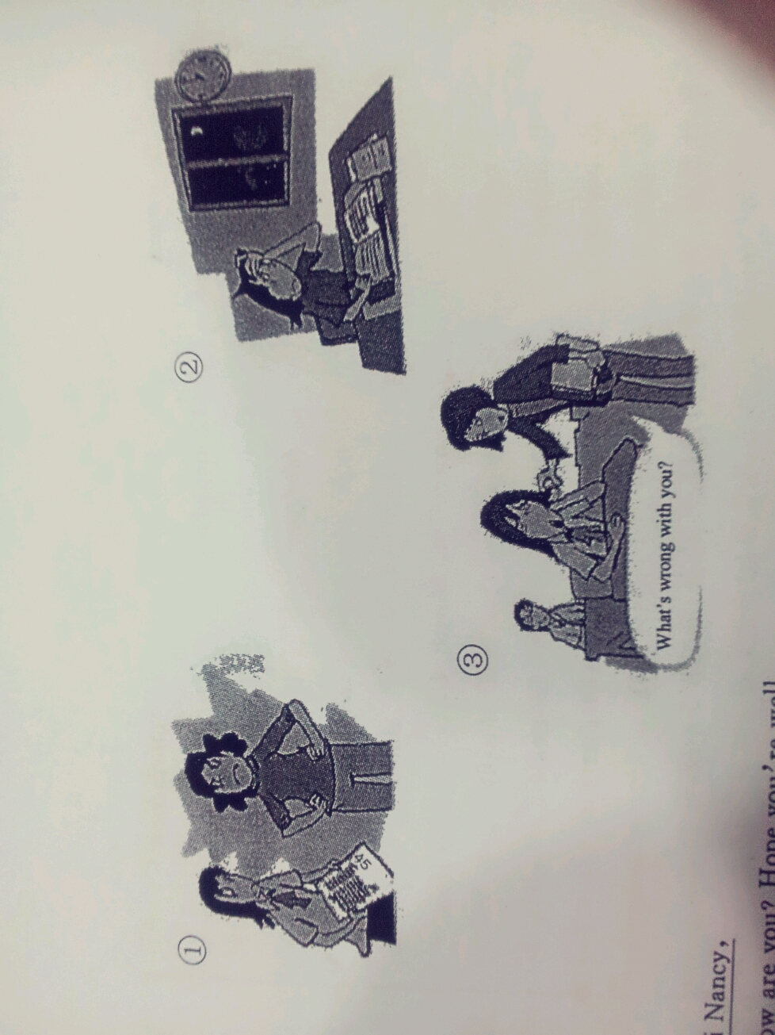
Hi Nancy,
How are you? Hope you’re well.
___________________________________________________________________________________________________________________________________________________________________________________________________________________________________________________________________________________________________________________________________________________________________________________________________________________________________________________________________________________________________________________________________________________________________________________________________
I’m ready looking forward to receiving your reply soon.
Love,
Li Ping
