2014年广州市初中毕业生学业考试
英语
本试卷共五大题，12页，满分135分。考试用时120分钟。
注意事项：
1.答题前，考生务必在答题卡上用黑色字迹的钢笔或签字笔填写自己的考生号、姓名；填写考点考场号、座位号，再用2B铅笔把对应这两个号码的标号涂黑。
2.选择题的答案用2B铅笔把答题卡上选择题答题区中对应题目选项的答案信息点涂黑，如需改动，用橡皮擦干净后，再选涂其他答案；答案不能写在试题上。
3.非选择题答案必须用黑色字迹的钢笔或签字笔写在答题卡各题目指定区域内的相应位置上；如需改动，先划掉原来的答案，然后再写上新的答案，改动后的答案也不能超出指定的区域；不准使用铅笔、圆珠笔和涂改液。不按以上要求作答的答案无效。
4.考生必须保持答题卡的整洁，考试结束后，将本试卷和答题卡一并交回。
一、听力 (共两节，满分20分）
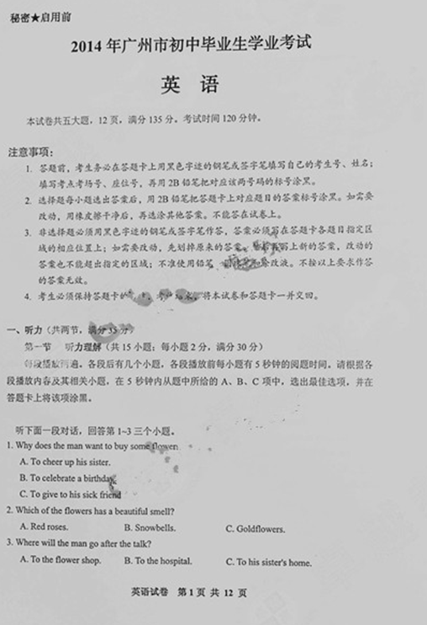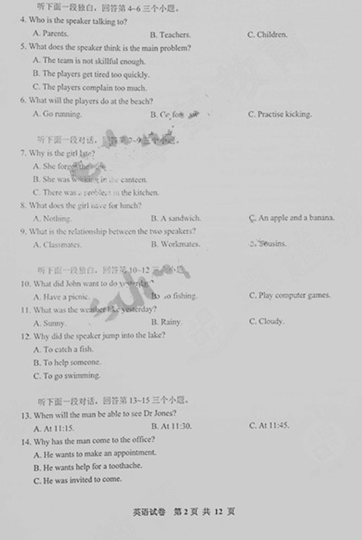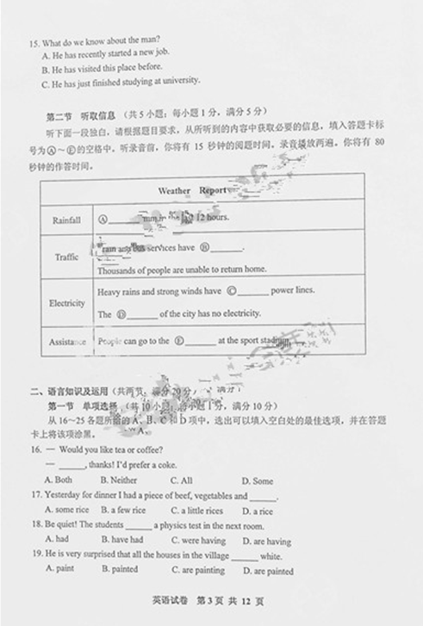
二、语言知识及运用（共两节，满分20分）
第一节 单项选择 （共10小题；每小题1分，满分10分）
从16~25各题所给的A、B、C和D项中，选出可填入空白处的最佳选项，并在答题卡上将该项涂黑。
16. --- Would you like tea or coffee?
--- ______, thanks! I’d prefer a coke.
A. Both B. Neither C. All D. Some
17. Yesterday for dinner I had a piece of beef, vegetables and ______.
A. some rice B. a few rice C. a little rices D. a rice
18. Be quiet! The students ______ a physics test in the next room.
A. had B. have had C. were having D. are having
19. He is very surprised that all the houses in the village ______ white.
A. paint B. painted C. are painting D. are painted
20. Do you know the man ______ is talking to Miss Wu?
A. he B. whom C. who D. which
21. --- Sorry I’m late.
--- _______ tell me the bus broke down again!
A. Never to B. Not C. Don’t D. No
22. --- Do you want to eat here?
--- No. Just fish and chips to ______, please.
A. get away B. take away C. send away D. throw away
23. I have a lovely room. It’s the ______ in the hotel.
A. nice B. nicer C. nicest D. most nice
24. Mum says ______ I do my homework now, I can watch TV for an hour tonight.
A. if B. though C. because D. while
25. I don’t understand ______ such a silly question in class yesterday.
A. why did John ask B. why John asked C. why is John asking D. why John asks

第二节 语法选择 （共10小题；每小题1分，满分10分）
阅读下面短文，按照句子结构语法性和上下文连贯的要求，从26~35各题所给的A、B、C和D项中选出最佳选项，并在答题卡上将该项涂黑。
As two women walked into a New Jersey hospital, they laughed. It showed the love that had held them together __26__ forty years as best friends. Although they were laughing, one of these ladies would soon put her life in danger __27__ her best friend.
Patty Hurley and Eileen Riley met at high school and have been close friends ever since. But when Eileen, __28__ nurse, became ill with kidney (肾) disease, she didn’t go running to her friend — Patty came to help her, after __29__ Eileen was sick. “My kidneys are failing,” Eileen explained.
“Can I give you one of mine?” __30__ the immediate reply.
The offer was so simple __31__ Eileen thought she had heard wrong. But Patty repeated she was willing to help, and their journey to the operating table began.
Eileen always knew that her friend would help. She said __32__, “When Patty makes a promise, she keeps __33__.”
The operation went ahead in May, and both women are now very healthy and __34__ than ever.
“There are no words to describe __35__ amazing this woman is,” Eileen said afterwards. “She gave me my life.”

26. A. in B. for C. since D. with
27. A. save B. saved C. saves D. to save
28. A. a B. an C. the D. /
29. A. hear B. heard C. hearing D. to hear
30. A. came B. comes C. come D. coming
31. A. as B. which C. that D. until
32. A. simple B. simply C. simpler D. simplest
33. A. it B. them C. its D. ones
34. A. closest B. most close C. closer D. closely
35. A. so B. why C. what D. how

三、完形填空（共10小题；每小题1分，满分10分）
阅读下面短文，掌握其大意，然后36~45各题所给的A、B、C和D项中，选出最佳选项，并在答题卡上将该项涂黑。
One morning a fox was searching for his breakfast. He went down to the lake to __36__ some fish. Suddenly he saw a rabbit digging a hole on the bank of the lake and decided to eat it instead. Not wanting the rabbit to discover him, the fox moved ___37___ towards his meal. As he got closer, he stepped on some dry leaves. The rabbit then ___38___ in fear. When he saw the fox, he started to shout.
“Quiet! Why do you rabbits shout so much?” asked the fox, slightly annoyed that he had lost his ___39___.
“I am sorry, but you scared me. Your sharp teeth make me ___40___,” replied the rabbit. “But I don’t want to eat you,” lied the fox, “I am only here to help with your____41____. I will be back tomorrow and help you dig your hole.”
The next day, the fox returned to the ___42___. There he saw a group of rabbits busily digging holes on the bank. He thought about catching one. At that moment the rabbit he had met the day before started jumping up and down, making a ___43___ noise to warn his friends. All the rabbits and even the fish quickly ___44___. The poor fox could not find anything to catch for food and ended up ___45___ fruit.

36. A. catch B. buy C. smell D. cook
37. A. noisily B. silently C. confidently D. angrily
38. A. looked down B. looked away C. turned off D. turned around
39. A. time B. place C. meal D. fish
40. A. sad B. excited C. nervous D. happy
41. A. food B. work C. story D. friends
42. A. breakfast B. house C. lake D. mountain
43. A. loud B. low C. usual D. dangerous
44. A. returned B. shouted C. entered D. disappeared
45. A. growing B. eating C. picking D. selling

四、阅读理解（共20小题；每小题1分，满分10分）
阅读下面短文，掌握其大意，然后36~45各题所给的A、B、C和D项中，选出最佳选项，并在答题卡上将该项涂黑。
(A)
I had hidden the long black bag in the garage for the past two days. Tonight, in the dark, I would finally take it away. If everything went OK, it would be done by morning. But I had to be sure no one, not even my wife, saw me.
It was more difficult to get away from the party than I expected. I said that the children were tired and needed to get to bed. It was partly true. But the main reason for leaving was that I wanted to complete my plan.
First I had to get the kids to sleep. That was never easy at any time and tonight it was even more difficult. The eldest one wanted to know why we left the party early. I told him 10:30 pm was not early. As usual, I read them a bed time story, but I had to stop myself reading too quickly or they would learn my secret.
Silence finally came, and feeling like a thief in the night, I went out of the house and into the garage. Taking one end, I dragged the bag out from its hiding place and took it into the garden. I was worried that my neighbours might see me and call the police.
It was already eleven o'clock. By the light of the moon I started working, trying to make as little noise as possible. And that was not easy with a saw (锯子) and a hammer.
After much effort, my work was finally completed. I looked down at my watch. It was exactly 4:00 am. Then I went inside to have a shower and get a few hours of sleep. It wouldn't be long now before the kids would rush into my room and wake me up to tell me about the new tree-house Father Christmas had brought them this year.

46. Why did the man feel nervous?
A. He left the party too late.
B. He was afraid of the darkness.
C. He didn’t know where the black bag was.
D. He worried that others would discover his secret.
47. The underlined word “they” in Paragraph 3 refers to __________.
A. thieves B. parents C. children D. neighbours
48. In what order did the man do the following?
a. Read the kids a story.
b. Had a shower.
c. Worked in the moonlight.
d. Dragged the bag from the garage.
e. Went to a party.
A. e-d-a-b-c B. e-a-d-c-b C. a-b-e-d-c D. a-e-d-c-b
49. What did the man want to do after finishing his plan?
A. Go to sleep. B. Wake up his children. C. Open the bag. D. Call the police.
50. How would the children feel when they saw the man’s work?
A. Confused. B. Excited. C. Tired. D. Angry.

(B)
In early November of 1503, during Christopher Columbus’ fourth and final trip America, his ship was seriously damaged in a storm. Columbus and his men had to live on a small island for several months while they tried to repair their ship and return to Spain.
At first, the local people on the island were very kind to the European visitors, giving them all the food and clothes they needed to survive. However, as the months passed, the local people became more and more unhappy with their guests, who were tricking and stealing from them. Finally the locals decided to stop helping. Without food or any way to leave the island, Columbus’ group was soon in serious trouble.
Luckily for Columbus, he had a book about the stars and planets on his ship. It described the movements of all the objects in the night sky. The book, written by a well-known German scientist, said there would be a total lunar eclipse (月食) on the evening of February 29, 1504 and how long it would last.
Columbus worked out the difference in time between Germany and North America. He then had a meeting with the local leaders just before the eclipse would take place. In this meeting, Columbus told them his god was angry because the local people were no longer giving food. So his god would take away the moon to punish them. At the moment Columbus finished talking, just as he had planned, the moon began disappearing.
The local leaders grew frightened and quickly agreed to provide Columbus with food and anything else he wanted. But first, Columbus’ god had to return the moon. Columbus told them he would have to discuss the idea with his god on his ship. Knowing the moon would stay completely hidden for about 48 minutes, Columbus returned just before the moon began to reappear. From that day on, until they finally left, Columbus and his men no longer had any trouble getting the food they needed.
51. At first, the local people helped Columbus and his men by__________.
A. giving them food B. building a house for them
C. repairing their ship D. providing them with a book
52. The local people became angry because the Europeans__________.
A. looked very different B. had nothing to trade
C. were cheats and thieves D. wanted to take their land
53. Where did Columbus learn about the lunar eclipse?
A. From a book. B. From the moon.
C. From his group. D. From the locals.
54. What did Columbus do after returning to his ship on the night of the meeting?
A. He discussed the problem with his god.
B. He waited for the eclipse to finish.
C. He read about the stars and planets.
D. He told his men what happened.
55. What can we learn about the Europeans from the passage?
A. They all believed in god.
B. They never returned to Spain.
C. They admired the local people.
D. They caused their own problems.

(C)
In today’s world of modern science and medicine, a more traditional treatment is once again becoming popular-animal friendship.
It is now well-known that people with problems such as heart disease or cancer live longer and get better more quickly if they have pets. Keeping pets lowers blood pressure and makes people less worried. Animals are increasingly important in treating older people who have memory loss and other brain problems. These people often feel nervous and upset. Activities with animals help them improve their physical condition and also give them joy, entertainment and loving friendship.
Here is a case that shows the benefits of animals. John was a six-year-old mute. He had no physical problems. He just refused to talk. His older cousin, Ned, had a parrot called Sally, and John used to visit it. When he arrived, Net used to say, “Hi, John!” We all know parrots copy what they hear. After a few visits, Sally began saying “Hi, John!” when John came into the room. Then, one day, John turned to the parrot and replied “Hi, Sally!” Staying with the parrot encouraged John to begin talking.
Another use of animal helpers is in schools. In some cases, animals are used to help children with physical or personal problems. In other cases, they are used to teach children to get on and share with others, and even to teach them about animals.
If you want to know more about animal helper programmes, you can get in touch with organizations like Riding for the Disabled or do a search under “animal therapy” on the Internet. You don’t have to be an animal trainer or a doctor to join in.

56. Which is NOT mentioned as an illness that animals can help with?
A. Heart disease B. Cancer C. Fever D. Blood pressure
57. The underlined word “mute” in paragraph 3 is closest in meaning to “_______”.
A. a person who speaks slowly B. a person who does not speak
C. a person who cannot hear D. a person who enjoys talking
58. The purpose of paragraph 3 is to _______.
A. show how animals can help with illnesses
B. discuss the problems of keeping pets
C. describe how to train animal helpers
D. introduce some new medical research
59. How can animals help school children according to the passage?
A. They can improve children’s memory.
B. They can make children more popular.
C. They can increase children’s blood pressure.
D. They can teach children to share with each other.
60. What is the best title of this passage?
A. Be kind to animals
B. Talking to animals
C. The most dangerous diseases
D. Get healthy with animal helpers

(D)
Mobile phones are more important than ever in the daily lives of students, but how they use them has changed greatly in the past six years. While phones are still widely use for communication, a recent study has found that most students think talking on mobile phones is now old-fashioned.
London University researchers surveyed 1055 young people aged 13 to 18 about their mobile phone habits. The researchers divided mobile phone use into “communication” and “entertainment”. Communication included talking on the phone and writing messages using texting（短信）or chatting software. Entertainment was made up of playing games, watching movies, listening to music and surfing the Internet. The findings were then compared to a 2008 study, to see what changed. The results are shown below:
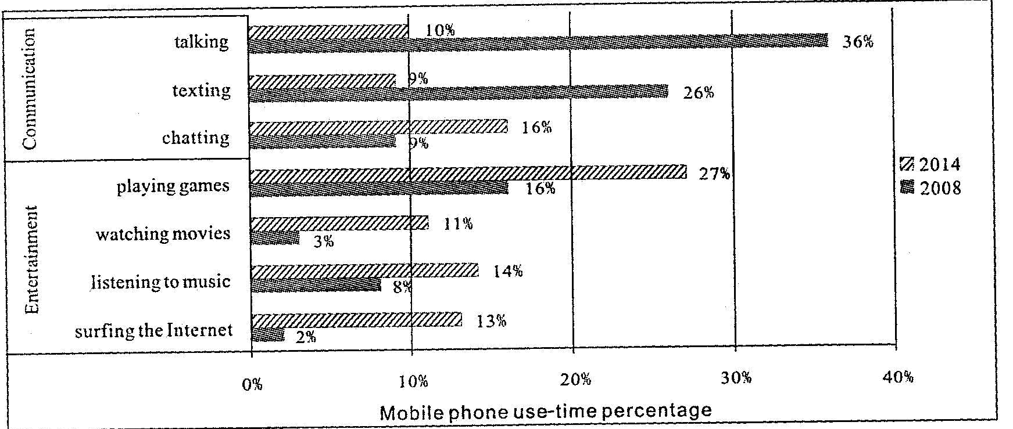

Perhaps most surprising is how little time students spend talking on their phones these days. Six years ago the average student spent 36% of their mobile phone time making or receiving calls. In 2014, only 10% of time was used for talking. When students use their phones to communicate, more and more often it is done by using chat software like qq or we chat.
“Communication is still an important function of mobile phones. But now mobile phones are being used more for entertainment than for communication,” said Dr Harry Lectre, the research leader.

61. What was the most popular mobile phone activity in 2014?
A. Talking. B. Texting. C. Playing games. D. Watching movies.
62. In total, what percentage of time did students use their mobile phones for communication in 2008?
A. 16%. B. 28%. C. 35%. D. 71%.
63. Which of the following is true about watching movies on mobile phones?
A. It has increased most over the past six years.
B.14% of students now watch movies on their mobile phones.
C. It was the most popular type of mobile phone entertainment in 2008.
D. Students now spend more time watching movies than talking on their phones.
64. Which mobile phone activities were more popular than surfing the Internet in 2014?
A. Chatting and watching movies.
B. Chatting and listening to music.
C. Playing games and watching movies.
D. Playing games and texting.
65. The passage can best be described as a/an_______.
A. report B. story C. advertisement D. argument

五、写作 （共三节，满分30分）
第一节 单词拼写 （共5小题，每小题1分，满分5分）
根据下列句子及所给单词的首字母写出所缺单词。在填写答卷时，要求写出完整单词。（每空限填一词）
66. When I was younger, my h___________ was collecting stamps, but now I like painting.
67. Don’t f___________ to turn off the lights when you leave the classroom.
68. I’m feeling h___________ now. Where can I get something to eat?
69. The box is too heavy for me. Would you please help me c___________ it?
70. I’m dreaming of a white Christmas because it never snows in w___________ in Guangzhou.

第二节 完成句子 （共5小题，每小题2分，满分10分）
根据所给的汉语内容，用英语完成下列句子。（每空限一词）
71. 长大后我想成为一名英语教师。
I want to be an English teacher when I __________ __________.
72. 呆在家里，直到你妈妈回来。
Stay in your house __________ your mother __________ __________.
73. 你们自己算出了这道数学题。多么聪明的孩子啊！
You’ve worked out the maths problem yourselves. __________ __________ children you are!
74. 为了进一步美化校园，下个月会在学校种很多树。
Next month many trees __________ __________ __________ in our school to make it more beautiful.
75. 我们计划去北京，但还没决定何时去。
We are planning to go to Beijing, but we haven’t decided __________ __________ __________.
三、书面表达 （共1题，满分15分）
为弘扬广府文化，你校在上周六举行了一次 “Guangzhou Culture Festival”的活动。请根据以下提示写一篇英语短文，介绍活动的情况并提出你对下一年文化节的建议。
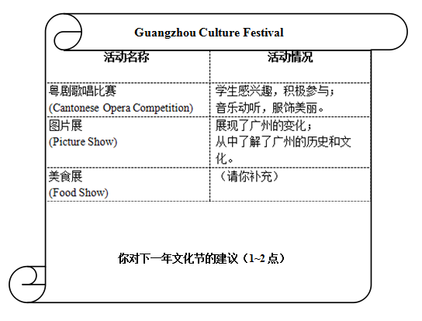
注意：1. 词数80左右（文章开头已给出，不计入词数）；
2. 不得透露学校、姓名等任何个人信息，否则不予评分。
In order to increase students’ knowledge about the traditional culture of Guangzhou, our school held a “Guangzhou Culture Festival” last Saturday. ...
