达州市2014年高中阶段教育学校统一招生考试
英 语
本试卷分为第Ⅰ卷和第Ⅱ卷两部分。第Ⅰ卷1至8页，第Ⅱ卷9至12页。考试时间120分钟，满分120分。
第Ⅰ卷（选择题 共80分）
温馨提示：
1.答第Ⅰ卷前，请考生务必将姓名、准考证号、考试科目等按要求填涂在机读卡上。
2.每小题选出正确答案后，请用2B铅笔将机读卡上对应题号的答案标号涂黑。
3.考试结束后，请监考老师将本试卷和机读卡一并交回。
第一部分 听力（共两节 满分20分）
第一节 (本题共5小题，每小题1分，计5分)
听下面五段对话，每段对话后有一个小题，从题中所给的Ａ、B、C三幅图片中选出最佳选项，并将机读卡上对应题号的答案标号涂黑。听完每段对话后，你将有5秒钟的时间来回答有关小题和阅读下一小题。每段对话读两遍。
1. Where is Kate going to travel this year?
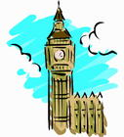
A B C
2. What does the woman suggest?
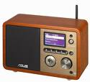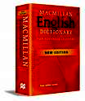
A B C
3. How does Linda’s father go to work?
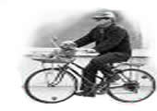
A B C
4. Which picture are they talking about?
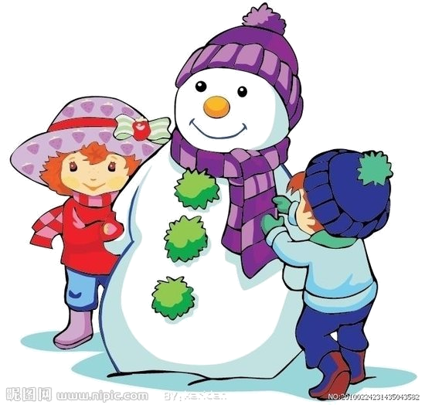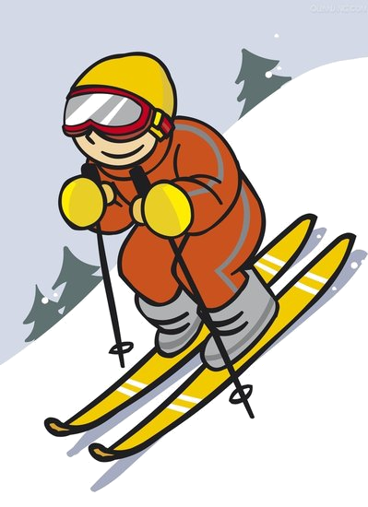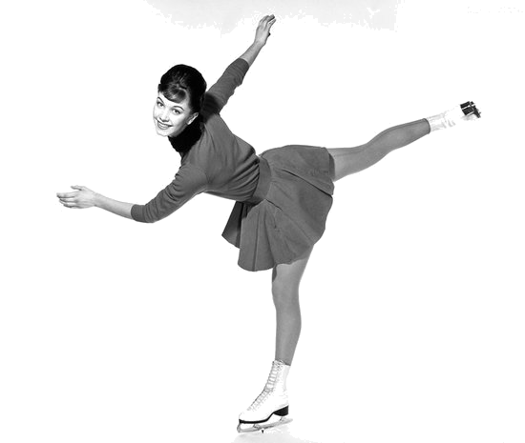
A B C
5. What food does the woman like best?
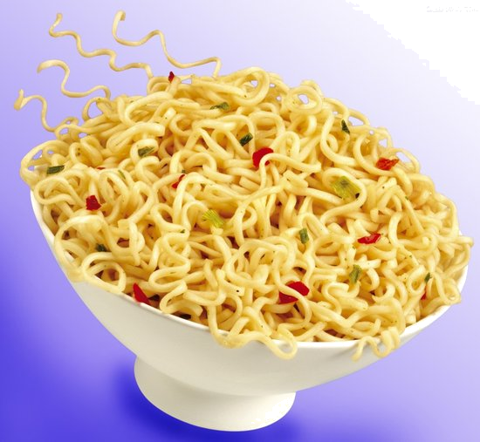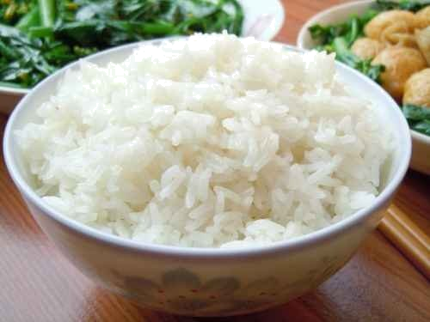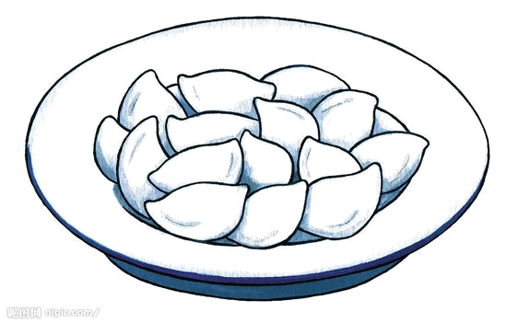
A B C
第二节 (本题共15小题，每小题1分，计15分)
听下面四段对话和一段独白，每段对话或独白后有几个小题，从题中所给的A、B、C三个选项中选出最佳选项，并将机读卡上对应题号的答案标号涂黑。听每段对话或独白前，你将有5秒钟的时间阅读各小题；听完后，各小题将给出5秒钟的作答时间。每段对话和独白读三遍。
听第6段材料，回答6—7题。
6. How long did Lucy skate today?
A. For three hours. B. For six hours. C. For seven hours.
7. Who bought the first pair of skates for Lucy?
A. Her father. B. Her mother. C. Her grandmother.
听第7段材料，回答8—10题。
8. What’s Jim doing now?
A. He’s watching TV. B. He’s sleeping. C. He’s listening to MP4.
9. Who packed the camera?
A. Jim himself. B. Jim’s father. C. Jim’s mother.
10. What’s the relationship(关系) between the two speakers?
A. Father and son. B. Brother and sister. C. Mother and son.
听第8段材料，回答11—13题。
11. What size does the man want?
A. Size S. B. Size M. C. Size L.
12. What’s the man’s favorite color?
A. White. B. Green. C. Blue.
13. How much will the man pay?
A.＄14. B.＄40. C.＄50.
听第9段材料，回答14—16题。
14. What does the boy want to do?
A. To write an article. B. To save some money. C. To recycle paper.
15. How many ways do they talk about saving the environment?
A. Two. B. Three. C. Four.
16. From the dialogue, we know the boy will tell his parents to ______.
A. turn on the lights
B. take plastic bags for shopping
C. take a bag for shopping
听下面一段独白，回答17—20题。
17. Nora was born in ______.
A. Moscow B. China C. Australia
18. Nora moved to Moscow because ______.
A. she liked the city in Russia
B. she had a lot of friends there
C. her father had a new job there
19. Nora enjoyed ______ with her friends before moving to Moscow.
A. swimming B. skating C. running
20. From the passage, we know Nora ______ her life in Moscow now.
A. dislikes B. loves C. minds[来源:学#科#网]
第二部分 基础知识运用（共两节 满分30分）
第一节 单项选择（本题共15小题，每小题1分，计15分）
从每小题所给的A、B、C、D四个选项中选出可以填入空白处的最佳答案。
21. —Look! There is a monkey eating ________ apple in the tree.
—En, ________ monkey is very cute.
A. a; a B. a; the C. an; an D. an; the
22. —Excuse me, is this ________ new pencil sharpener?
—Yes, it’s ________. He bought it just now.
A. Tom’s; his B. Tom; his C. Tom’s; hers D. Tom’s; yours
23. —After P.E., I often feel very thirsty.
—Why not buy some ________ to drink?
A. bread B. noodles C. apple juice D. teas
24. —What does your mother do?
—________.
A. She does the housework B. She is a nurse
C. She is very thin D. She looks very young
25. —I’m sorry I ________ my exercise book at home this morning.
—It doesn’t mater. Don’t forget ________ it here this afternoon.
A. left; to take B. forgot; bringing C. left; to bring D. forgot; to bring
26. —My teachers often encourage me ________ more friends but I find it difficult.
—Your teachers’ idea is right. The more friends you make, ________ you will be.
A. to make; the more happy B. to make; happier
C. making; the happier D. to make; the happier
27. —Have you ever ________ an amusement park?
—Yes, I have. I ________ Fun Times Amusement Park last year.
A. been to, have gone to B. gone to, have been to
C. go to, went to D. been to, went to
28. —We have no idea ________.
—It’s heard that he is Mr. Green’s son.
A. where he comes from B. if does he live here
C. who he is D. who is he
29. —I called you at 5:00 yesterday afternoon, but no one answered.
—Sorry, I with my parents ________ at that time.
A. was shopping B. were shopping C. are shopping D. went shopping
30. —Judy’s never been late for school, ________ she?
—________. She is always the first to get to school every morning.
A. is; Yes B. has; No C. isn’t; Yes D. hasn’t; No
31. —What kind of movies do you like?
—I like movies ________ scary monsters.
A. which has B. that have C. what has D. why have
32. —Walking more is good for our health.
—You’re right. So I’d rather ________ an hour’s walk to work than consider ________ a car.
A. take; driving B. take; drive C. take; to drive D. to take; driving
33. —Excuse me, could you please tell me if the sports meeting ________ on time?
—Hard to say. If it ________ tomorrow, we’ll have to put it off.
A. will hold; rains B. will be held; rains
C. will be held; will rain D. holds; will rain
34. —Swimming in the river for teenagers is very dangerous.
—So it is. If I ________ them, I ________ a shower at home.
A. am; would take B. were; will take
C. was; would take D. were; would take
35. —Would you mind if I turn on the radio?
—________. The baby is sleeping in the next room.
A. No, I don’t mind B. Not at all
C. Better not D. That’s all right
第二节 完形填空（本题共15小题，每小题1分，计15分）
阅读下面的短文，掌握其大意，然后从短文后各题所给的A、B、C、D四个选项中选出可以填入相应空白处的最佳答案。

A
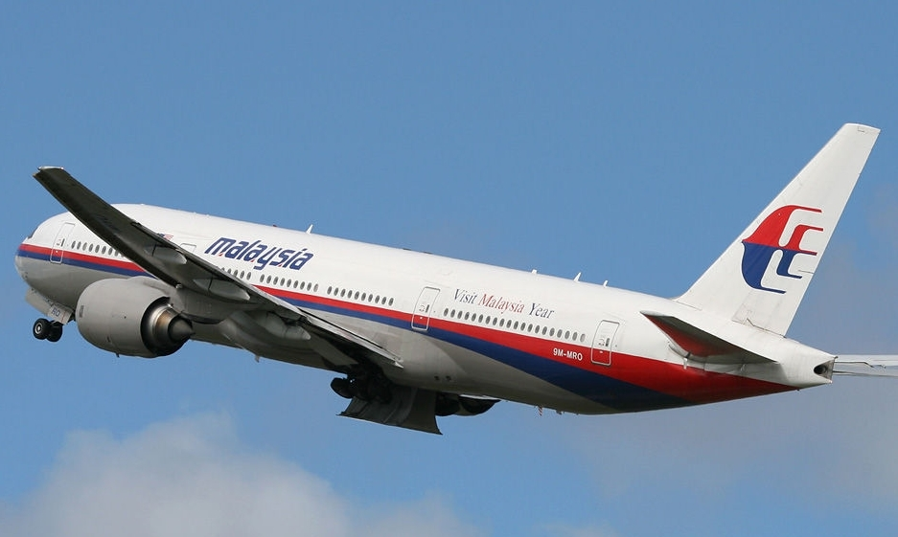
The Malaysian government announced that Malaysian flight MH370 lost the contact with the Air Traffic Control 36 the morning of March 8th. The flight 37 at 00:41 a.m. that morning and planned to arrive in Beijing at 6:30 a.m. It carried 239 passengers, 38 154 Chinese. The passengers come from 14 countries and areas. Nobody knows what happened to the plane. Over twenty countries took part in 39 it. On March 24, Prime Minister of Malaysia said that MH370 crashed in southern Indian Ocean and none of the passengers survived. When we heard the bad news, we were very sad. So far the plane wreckage(飞机残骸) 40 yet. We hope they will find it soon.
36. | A. in | B. at | C. on | D. for
37. | A. takes off | B. landed | C. was taken off | D. took off
38. | A. including | B. except | C. besides | D. inclusion
39. | A. searching out | B. searching for | C. looking for | D. looking out
40. | A. hasn’t been founded | B. wasn’t found | C. hasn’t been found | D. has been found

B
Not only adults but also teenagers have problems in their life. Here is a survey showing the main problems of 41 .
They feel stressed because they have 42 homework to do both at school and at home. They have lots of exams 43 . And parents usually send them 44 different classes at weekends. As a result, so many of them almost become bookworms(书虫). On holidays, they could hardly have 45 time to do what they are interested in. Now more and more teenagers 46 short-sighted. They often read in bed or keep 47 for a long time without having a rest. Some of them are crazy about playing computer games. Some 48 too much watching TV. 49 serious problem among teenagers is that many of them are becoming fat. They eat too much junk food, but they take little exercise.
I think teenagers should think of ways on how to 50 the problem. They should make a plan for study and hobbies and find time to relax as much as possible.
41. | A. adult | B. adults | C. teenager | D. teenagers
42. | A. too many | B. too much | C. much too | D. many too
43. | A. join | B. to be taken | C. to take | D. to join
44. | A. to | B. for | C. of | D. in
45. | A. our own | B. their own | C. his own | D. they own
46. | A. are geting | B. are getting | C. got | D. are become
47. | A. red | B. read | C. to read | D. reading
48. | A. pay | B. cost | C. spend | D. take
49. | A. Another | B. Other | C. Others | D. Some
50. | A. doing with | B. do with | C. dealing with | D. deal with

第三部分 阅读理解（共两节 满分30分）
第一节 阅读下面的短文，根据短文内容，从每题所给的A、B、C、D四个选项中选出最佳答案。（本题共11小题，每小题2分，计22分）

A
Sadness and happiness are often talked about by people in their spare time. Most people want themselves to be happy for ever, but few know how to find happiness. Others say if you own lots of money and success, you will be happy. However, money and success alone do not bring lasting happiness. A famous a Greek thinker, Aristotle, said, “Happiness depends upon ourselves.” That’s to say, we make our own happiness. Here are a few suggestions to help you be happier.
The first secret of happiness is to enjoy the simple things in life. Too often, we spend so much time thinking about the future. For example, getting into college or getting a good job, which we fail to enjoy the present. You should enjoy life’s simple pleasures, such as reading a good book, listening to your favorite music, or spending time with close friends. People who have several close friends often live happier and healthier lives.
Another secret to living a happy life is to be active. Many people go dancing or play sports. People can forget about their problems and only think about the activities. Finally, many people find happiness in helping others. Studies show that people feel good when they spend their time helping others. If you want to feel happier, do good things for someone. You can help a friend with his or her studies, go shopping or help out with some things around the house for an elderly person.
If you do above, you will be happy.
51. How many suggestions of happiness are mentioned in this passage?
A. One. B. Two. C. Three. D. Four.
52. If you want to enjoy the simple things in life, you can ________.
A. listen to your favorite music
B. remember some problems
C. think about getting into college
D. read a bad book
53. According to the passage, which of the following statements is NOT true?
A. Money and success alone do not bring you lasting happiness.
B. If you want to feel happier, you can go shopping for an elderly person.
C. Spending so much time thinking about the future can enjoy the present.
D. Active person may live a happier life than inactive person.
54. What’s the main idea of this passage?
A. How to live a happy life.
B. How to depend upon ourselves.
C. How to help the old people.
D. How to get a good job.

B
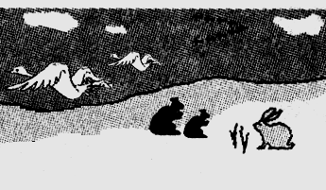
Do you know why so many animals do not stay in one place? Birds, fish and other animals move from one place to another place at a certain time. They move for different reasons: most of them move to find food more easily, but others move to get away from places that are too crowded.
When cold weather comes, many birds move to warmer places to find food. Some fishes give birth in warm water and move to cold water to feed. The most famous migration is probably the migration of fish, which is called “salmon”(鲑鱼). This fish is born in fresh water but it travels many miles to salt water. There it spends its life. When it is old, it will return to its birthplace in fresh water. Then it gives birth and dies. In northern Europe, there is a kind of mouse. They leave their mountain homes when they become too crowded. They move down to the low land. Sometimes they move all the way to the seaside, and many of them are killed when they fall into the sea.
Recently, scientists have studied the migration of a kind of lobster(龙虾). Every year, when the season of the bad weather arrives, the lobsters get into a long line and start to walk across the floor of the ocean. Nobody knows why they do this, and nobody knows where they go. So, sometimes we know why humans and animals move from one place to another place, but at other times we don’t. Maybe living things just like to travel.
55. The reason for most of the animals to move is ________.
A. to get away from un-crowded places B. to find their own parents
C. to want to kill themselves D. to find food more easily
56. Where does young salmon(鲑鱼) spend its life?
A. In fresh water. B. In salt water.
C. In mountain homes. D. In its birthplace.
57. When do the lobsters(龙虾) begin to move another place?
A. When their homes become too crowded.
B. When the season of the bad weather arrives.
C. When they want to give birth.
D. When their food is eaten up.
58. The underlined word migration in the passage means ________.
A. 迁徙 B. 习性 C. 运动 D. 寻觅

C
In modern society, people use money every day. It seems that it is very important in our life. That’s because without money you can’t buy any goods(商品) you want. But I think few people know the history of money.
Long ago, people did not need money. They lived on wild animals, fruits and other plants. As time passed, people learned to raise animals and crops. Sometimes, families produced more than they needed, so they started to trade with other families. Later, people began to use money as a means of exchange. However, it was not the kind of money we use today. They used shells, rice, salt, large stones, etc.
During the 600s BC, people began using coins as money. They soon found that coins were easier to carry than goods and lasted a long time. Later, countries began to make their won coins.
The Chinese were the first to use paper money, probably as early as the 11th century. The Italian traveler Marco Polo saw the Chinese using money when he visited China in the 1200s. However, European countries did not start using paper money until 1600s.
Today, we have many ways to pay for things. We do not use coins or paper money. Often, people prefer to pay for things by card. Paying with a card is easier and safer than carrying around a lot of “real” money.
59. People used ________ as a means of exchange before the 7th century BC.
A. paper money B. card C. large stone D. coins
60. From the passage, we know that European countries used paper money in the ________.
A. 11th century B. 12th century C. 16th century D. 17th century
61. Which of the following is TRUE in this article?
A. Marco Polo was from Canada.
B. Chinese used paper money earlier than Italy.
C. Today people often prefer to pay for things by salt.
D. Carrying around much “real” money is easier and safer than Paying with a card.
第二节 根据短文内容，从下面方框中选择适当的选项补全短文。（本题共4小题，每小题2分，计8分）
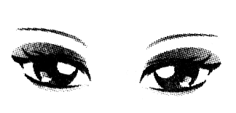
Our eyes are very important. But many of us pay little attention to the importance of eye care. It is said that if you take care of your body, then you can surely be healthy. That is why our eyes should be given a lot of care. 62 .
There are several causes leading to your poor eyesight. Like Televisions, computers and reading. Something dirty can cause redness (红肿) and they will make you feel uncomfortable. If this happens, the best way is to clean your eyes by using cold water. 63 . For example, wearing sunglasses can serve as a great way to protect your eyesight from UV rays (紫外线) in the strong sunlight.
Some foods will do good to your eyesight. Remember that vitamins A, C and E are good for eyes. Try to eat food groups that have these vitamins. 64 . If a person exercises regularly and eats the right kind of food, his eyes will stay in good condition for a long time.
All above are natural ways of eye care that help us keep healthy eyes. 65 . In a word, eye care is very important, no matter how old a person is.
A. You must also try your best to protect your eyes from harmful things
B. Being happy all the time can be helpful to a person’s eyesight, too
C. And you should do eye exercises because exercise protects your eyesight, too
D. Natural eye care should be put in a number one place

达州市2014年高中阶段教育学校招生统一考试
英 语
第Ⅱ卷 （共40分）
温馨提示：
1.答第Ⅱ卷前，请考生务必将座位号和密封线内相关内容按要求写在规定位置。
2.用蓝、黑色墨水钢笔或圆珠笔直接将答案写在试卷上，不能使用铅笔和涂改液
题号 | 第四部分 | 第五部分 | 第六部分 | 第七部分 | 第八部分 | 总分 | 总分人
题号 | 口语应用 | 任务型阅读 | 词汇运用 | 完成句子 | 书面表达
得分

第四部分 口语应用（共5小题，每小题1分，满分5分）
从下面的方框中选择适当的选项补全对话。（有两项是多余的）
得分 | 评卷人
Gary: Hi, Tony, what are you going to do this weekend?
Tony: I’m going to Dazhou.
Gary: Dazhou? 66
Tony: Because there is going to be a sports meeting. All the athletes from different schools will go there.
A. Let’s take the train there tomorrow.
B. Why not take the bus there tomorrow?
C. Why are you going to Dazhou?
D. What kind of match is it?
E. Would you like to go with me?
F. Our school will take part in the sports meeting.
G. Where is it going to be held?
Gary: 67 , right?
Tony: Yeah!
Gary: En, How wonderful!
Tony: 68
Gary: I’d like to very much. Is there going to be a volley ball match?
Tony: Yes, there is.
Gary: 69
Tony: It will be held in Dazhou Stadium.
Gary: By the way, how shall we go there?
Tony: 70 , shall we?
Gary: All right. Good-bye!
Tony: Good-bye!
66. 67. 68. 69. 70.
第五部分 任务型阅读（共5小题，每小题1分，满分5分）
根据短文后所给的任务，完成71-75小题.
得分 | 评卷人
What will our world be like in 2020? Maybe no one knows. Because we never know what will happen in the future. But it’s very interesting to make some predictions. Here are some exciting predictions.
Languages
English should still be the most popular language, but Chinese should be the second. Now, many foreign people are studying Chinese A their second language.
Water
①Water will become as expensive as oil because many rivers will disappear. We will have to save water and pay more for clean water.
Education and Science
Students won’t go to school. They will stay at home and study online. Students from all over the world may study together B the Internet. We may eat more genetically (转基因) modified food. And more robots will be around us. ②Lots of danger housework will be done by them.
Living
People will live and work under the sea. Perhaps there will be big towns, factories and farms under the sea, too. Everyone will carry a pocket computer. ③computer, the, answers, will, all, the, to, their, people, problems, give. Everyone will have telephones in the pockets, too, and they will be able to talk to their friends all over the world.
任务一: 请在文中A、B 两处的横线上填入适当的单词。(每空一词)
71. A. _________ B. _________
任务二: 请将文中①处句子译成汉语。
72. ________________________________________________________。
任务三: 请将文中②处划线句中的一个单词的错误用法找出，并改正在横线上。
73. ________________________________________________________
任务四: 请将文中③处的斜体单词连成句子。
74. ________________________________________________________.
任务五: 75. The passage is mainly talking about _________.
A. education and science B. the school life
C. the life in the future D. the most popular language
第六部分 词汇运用（共10小题，每小题1分，满分10分）
用方框中所给单词的适当形式填空，使短文完整、通顺。每词限用一次。
得分 | 评卷人
vegetable, it, healthy, long, beauty, will , argue, become, symbol, with
Once there was an 76 between the colors. Each color thought it was the best and most important. So each color looked down upon others. Here are their debates.
Green said: “Clearly I am the most important. I am the 77 of life and hope. I’m the color of grass, trees and leaves. 78 me, all animals would die.”
Yellow laughed: “I bring happiness and warmth into the world. Every time people look at a yellow sunflower, they start to smile. Without me there 79 be no fun.”
Orange shouted: “I am the color of 80 and strength. I have the most important vitamins (维生素). Think of carrots, 81 and oranges. When I appear in the sky, everyone is shocked at my beauty and nobody gives another thought to any of you.”
Red could no 82 stand it, “I am the color of danger and bravery. I am willing to fight for a cause. I bring fire into the blood.”
Their voices 83 louder and louder. The thunder(雷) got angry and the rain started to pour. When they became calm, the rain said, “You foolish colors. Don’t you know that each of you is unique (独一无二)? If you don’t agree, just follow me.” They did as the rain told 84 and together made the most 85 rainbow (彩虹).
76. ___________ 77. ___________ 78. ___________ 79. ___________ 80. ___________
81. ___________ 82. ___________ 83. ___________ 84. ___________ 85. ___________
第七部分 完成句子 （共两节 满分10分）
得分 | 评卷人
第一节：句型转换（本题共5小题，每小题1分，计5分）
按要求完成下面各句。每空一词。
86. The weather is too hot today. (对划线部分提问)
__________ __________ the weather like today?
87. Emma does her homework every evening. (变为否定句)
Emma __________ __________ her homework every evening.
88. Does the earth go around the sun? Susan wanted to know.（将两句合并为一句）
Susan wanted to know __________ the earth __________ around the sun.
89. Look! Some students are cleaning the classroom. (改为被动语态)
Look! The classroom __________ __________ cleaned by some students.
90. Jim is the tallest boy in his class. (改为同义句)
Jim is taller than __________ __________ boy in his class.
第二节：汉译英（本题共5小题，每小题1分，计5分）
根据所给的中文意思完成句子，每空一词。
91. 当你遇到生活中的困难时，你应该把它们视为挑战。
When you meet problems in your life, you should __________ them __________ challenges.
92. 幸运的是，他母亲很有耐心，没有放弃帮助他。
Luckily, his mother was very __________ and didn’t __________ up helping him.
93. 球迷们期盼着2014巴西世界杯的到来。
The football fans are _________ _________ to the coming of FIFA World Cup Brazil 2014.
94. 吉姆今天早上上学迟到了，是因为他乘坐的公交车半路上出故障了。
Jim was late for school this morning because the bus he took ________ ________ halfway.
95. 图书管理员告诉我，这本书我能借一周。
The librarian told me that I could __________ this book for __________ days.
第八部分 书面表达（10分）
96. 目前，举国畅行勤俭节约、反对铺张浪费。我们中学生应当在这些行动中该做些什么呢？请根据下面要求，联系实际，适当发挥，以“Save Food and Eat Healthily”为题，写一篇80词左右的英语短文。
得分 | 评卷人
要求：1. 条理清楚，有表明自己观点的句子。
2. 书写工整，句式规范，标点符号和大小写使用正确。
3. 短文中应尽量包括提示内容，可适当发挥，但不能出现真实的人名、地名。文章开头已给出，不计入总数。
4. 参考词汇：junk food, order the food, eat up, restaurant, healthy food.

Save Food and Eat Healthily
At present, our government has called on the people to save food. _______________________
__________________________________________________________________________________________________________________________________________________________________________________________________________________________________________________________________________________________________________________________________________________________________________________________________________________________________________________________________________________________________________________________________________________________________________________________________________________________________________________________________________________________________________________________________________________________________________________________________________________________________________________________________________________________________________________________________________________________________________________________________________________________________________________________________________________________________________________________________________________

参考答案及评分意见
第Ⅰ卷
1-5. ABCAC 6-10. BCABC 11-15. CBCAC 16-20. CBCAB
21-25. DACBC 26-30. DDCAB 31-35. BABDC 36-40. CDABC
41-45. DBCAB 46-50. BDCAD 51-55. CACAD 56-60. BBACD
61-65. BDACB
（其中1—50 小题 每题1分，共50分。51—65 小题 每题2分，共30分。合计80分。）
第Ⅱ卷
66-70. CFEGA （写对一个给1分，共5分）
71. as, on （写对每个单词0.5分，共1分）
72. 许多河流将消失，水和石油会一样贵。（只要意思通顺，表述合理均可给分。）
73. danger改为dangerous.
74. The computer will give people the answers to all their problems. 或：
The computer will give people all the answers to their problems.
75. C
76. argument 77. symbol 78. Without 79. would 80. health
81. vegetables 82. longer 83. became 84. them 85. beautiful
86. What; is 87. doesn’t; do 88. if/whether; goes 89. is; being 90. any; other
91. regard; as 92. patient; give 93. looking; forward 94. broke; down 95. keep; seven
（76—95各小题只要适当形式错误，均不给分。）
96. One possible version: Save Food and Eat Healthily
At present, our government has called on the people to save food. As middle school students, it’s our duty to do something for it.
To save food, we should remember that at any time we should eat up all the food and shouldn’t waste any of food. Especially, when we dine out, we should order the food that we can rightly eat. Because many people in our country don’t have enough food to eat.
To eat healthily, We should eat healthy food instead of junk food at school or at home. Of course, we may eat in the restaurant in case we have no time, but not too often.
At last, we hope that we all work together at once.

书面表达评分原则及标准
一、评分原则
1.本题总分为10分，按四个档次给分，英语短文中至少包含以下方面：在节约食物方面。是怎样做到节约食物？能有明显表明自己观点的句子。在健康方面，怎样做到吃得健康？在规定80词左右的词汇下能将所给参考词汇自然地融入到句子中去。
2.评分时，先根据短文的内容和语言初步确定其所属档次，然后以该档次的要求来衡量，确定或调整档次，最后给分。
3. 文中若出现真实的人名、地名，酌情扣分。
4. 所给提示性词语不受范围和顺序的限制。相同的错误不重复计算。
二、评分标准
一档 | 9-10分 | 包含了所有要点, 能围绕内容适当发挥,内容具体、丰富。应用了较丰富的语言结构和词汇, 用词准确、句子通顺、行文连贯、表达清楚，没有或几乎没有语言和语法错误，具备较强的语言运用能力，完全达到了预期的写作目的。不少于80词。
二档 | 6-8分 | 包含了所有要点，并能有所发挥，内容欠丰富。应用的语言结构和词汇能满足任务要求，句子较通顺，表达较清楚，有少量语言错误和语法错误，达到了预期的写作目的。不少于60词。
三档 | 4-5分 | 漏掉部分要点或只是简单说明要点，内容不够丰富、具体，字数较少。语言表达过于简单，句子不够通顺，行文不够连贯，有部分语言和语法错误。不少于50词。
四档 | 0-3分 | 漏掉多个要点或所写内容明显偏离所给要点，内容过少。语言不规范，句子无条理，行文不连贯，语言和语法错误较多。40词以下。

英语听力录音材料
第一节 (本题共5小题，每小题1分，计5分)
听下面五段对话，每段对话后有一个小题，从题中所给的Ａ、B、C三幅图片中选出最佳选项，并将机读卡上对应题号的答案标号涂黑。听完每段对话后，你将有5秒钟的时间来回答有关小题和阅读下一小题。每段对话读两遍。
1. M: Summer holiday is coming. Where would you like to go this year, Kate?
W: I’d like to visit Big Ben.
2. M: Cindy, could you tell me how to study English well?
W: En… listening to the English programs on radio every day will be helpful.
3. M: Hi, Linda, I saw your father riding a bicycle and going out.
W: Yes, he went to work.
4. W: Don’t stand in the snow, Tom. You will catch a cold.
M: No, I won’t, Mum. But I find it interesting to make the snowman here.
5. M: Would you like noodles or rice, Madam?
W: Neither. My favorite food is dumplings.
第二节 (本题共15小题，每小题1分，计15分)
听下面四段对话和一段独白，每段对话或独白后有几个小题，从题中所给的A、B、C三个选项中选出最佳选项，并将机读卡上对应题号的答案标号涂黑。听每段对话或独白前，你将有5秒钟的时间阅读各小题；听完后，各小题将给出5秒钟的作答时间。每段对话和独白读三遍。
听第6段材料，回答6—7题。
M: Lucy, congratulations on winning the skating marathon!
W: Thank you.
M: So, how long did you skate today?
W: What time is it now?
M: At 3 p.m.
W: Hmm… for six hours!
M: Was this your first skating marathon?
W: No, I skated in a marathon last year.
M: You’re an excellent skater, Lucy. Do you skate every day?
W: Yes. I skate with my father every day.
M: How long have you been skating?
W: Since I was seven years old. I got my first pair of skates on my birthday from my grandmother.
听第7段材料，回答8—10题。
W: Hi, Jim! Are you asleep?
M: No, I’m not. Mom.
W: What are you doing now?
M: I’m watching a football match on TV. It’s very exciting.
W: Turn off the TV. It’s your bed time. You can watch it tomorrow night. Go to bed!
M: Do I have to? I think it’s early.
W: Early? Look at your watch. It’s already eleven o’clock.
M: But it is Friday night and there will be no school tomorrow.
W: Yes, but tomorrow you’ll have to get up early and go to visit the Children’s Palace.
M: I’m sorry I forgot about that.
W: Have you packed your camera yet?
M: No. This afternoon my father did. Do I have to take a shower tonight?
W: Of course you do. Don’t forget to brush your teeth.
M: OK. Mom.
听第8段材料，回答11—13题。
W: Hello, sir. What can I do for you?
M: I’m looking for a T-shirt for myself. Have you got one?
W: I’ll just have a look. What size do you need?
M: What size do you have?
W: Size S, M and L.
M: Size L, please.
W: How about the white one?
M: I dislike white. I like green best.
W: Here you are.
M: That’s great. Can I try it on?
W: Certainly. This way, please.
M: Hmm, I like it.
W: It fits you very well.
M: How much is it?
W: It’s ＄50.
M:＄40, OK?
W: Sorry, sir.
M: That’s OK. I’ll have it.
听第9段材料，回答14 —16题。
M: Hi, Janet. Are you free?
W: Nothing much. What’s up?
M: I want to write an article on how to save the environment.
W: Good idea, Jim!
M: But I don’t know how to write it. Would you like to give me a hand?
W: Well, first, you can start with turning off the lights when you leave a room.
M: Yes. That’s too easy. Sometimes I turn on the lights without thinking. What’s next?
W: Second, how about riding a bike to go to school? Don’t take a car or a taxi if you don’t have to.
M: That will save money, too. What else?
W: Try to recycle paper.
M: Mm. Newspaper, magazines, mails… we get a lot of paper at home.
W: And last, take a bag with you when you go shopping. Don’t use plastic bags.
M: OK. My parents often go shopping. I’ll tell them about it. Thanks a lot! I will begin to write.
W: Good luck!
听下面一段独白，回答17—20题。
My name is Nora. I live in Moscow now, but I was born in Qingdao. We moved to Moscow four years ago when my dad got a new job here. I didn’t want to leave China because I had a great life there. I had lots of friends and everyone got along well with each other. We had fun swimming almost every day after school. And the weather was always great. At first, I didn’t like the life in Moscow when we arrived. It was still winter, so the weather wasn’t very nice. It was really cold and it snowed all the time. I didn’t have any friends. I felt sad and lonely and wanted to go back to China. Things got better when I started school. All the kids at school were friendly to me. Now I enjoy living here. I think Moscow is a great city.

