成都市2014年高中阶段教育学校统一招生考试
（含成都市毕业初三会考）

A 卷 （选择题：共 100 分）

第一部分 听力测试（共 25 小题，25 分）
一、听句子，根据所听到的内容选择正确答语。每小题念两遍。 （共6小题，每小题 1 分；计 6 分）

1． A．Thank you.
B．You are welcome.
C．Do you want more?
2． A．He’s in the library.
B． He’s at home.
C．He’s from Russian.
3． A．She is tall.
B．She is outgoing.
C．She likes art.
4． A．Sorry to hear that.
B．Yes, I’d love to.
C．Yes, you are right.
5． A．Do some sports.
B．Clean up your room.
C．Take this medicine.
6． A．They are American.
B．They are beautiful.
C．They have a sweet voice.

二、听句子，选出与所听句子相符的图片，并将代表图片的字母填在答
题卡的相应位置，每小题念两遍。 （共 4 小题，每小题 1 分；计 4 分）
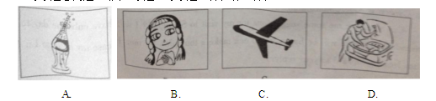
7．___________ 8．___________9．___________10．___________

三、听对话，根据对话内容选择正确的答案。每小题念两遍。 （共 10 小
题，每小题1 分；计 10 分）

11．A．It’s cloudy. B．It’s raining. C．It’s sunny.
12．A．The bank.
B．The bookstore.
C．The post office.
13．A．In a college.B．In a school. C．In a hospital.
14．A．Excited. B．Worried. C．Relaxed.
15．A．Small. B．Medium. C．Large.
16．A．Nothing. B．A little. C．A lot.
17．A．No, she doesn’t.
B．She isn’t.
C．Yes, she does.
18．A．Mary. B．Linda. C．Jane.
19．A．After-school activities.
B．Looking after the old.
C．Study plans.
20．A．At 7:00. B．At 7:50. C．At 8:20.

四、听短文，根据短文内容选择正确的答案。短文念三遍。 （共5小题，每小题1 分；记 5 分）

21．How long do farmers work a year?
A．For three weeks.
B．For three seasons.
C．For a whole year.
22．What is very important for farmers?
A．Weather. B．Animals. C．Clean air.
23．Who is Meimei?
A．Mr. and Mrs. Wang’s student.
B．One of the children in this family.
C．The only child of Mr. and Mrs. Wang’s.
24．What do Mr. and Mrs. Wang usually do?
A．Teach their kid.
B．Do farm work.
C．Do housework.
25．How does Meimei feel about the life in the countryside?
A．She feels busy and tired.
B．She enjoys her life there.
C．She doesn’t want to stay there.

第二部分 基础知识运用（共 45 小题，计 45 分）

五、选择填空（共 25 小题，每小题 1 分；计 25 分）
A) 从下面方框中选出与下列各句中划线部分意思相同或相近， 并能替换划线部分的选项。 （共 4 小题，计 4 分）
26．Frank has a lovely dog.
27．I was asked to look after my little sister yesterday evening.
28．We have invited some more countries to rebuild the Silk Road.
29．Our hometown is famous for its food, pandas and places of interest.

B)从各题的 A、B、C 三个选项中选出正确答案。 （共 17 小题，每小题 1分，计 17 分）
30．Gina, what’s this ___________English?
A．by B．for C．in
31．I’m going to be ___________basketball player.
A．the B．a C．an
32．Students in Class One ___________the museum next Friday.
A．visited B．visit C．will visit
33．Don’t worry. We have ___________food in the fridge now.
A．much B．many C．little
34．——Which month of the year do you like?
——July, the ___________month because summer vacation begins in
this month.
A．second B．seventh C．ninth
35．Mum wants to watch the CCTV news. Let’s ___________the TV.
A．turn down B．turn on C．turn off
36．Alice has a red pen, and the blue one is ___________ ,too.
A．his B．her C．hers
37．Li Ke ___________runs in the morning, for he wants to be healthy.
A．never B．often C．hardly
38．Kate, remember ___________for the sick to cheer them up.
A．to sing B．not to sing C．singing
39．——Mr. King ___________ by the reporter yesterday.
——He’s great! He helped so many disabled people.
A．was interviewed
B．is interviewed
C．is interviewing
40．——Excuse me, do you know___________?
——About five minutes’ walk.
A．where the hospital is
B．how far the hospital is
C．how I can get to the hospital
41．___________I am in trouble, my classmates will help me out.
A．Before B．Whenever C．Although
42．——Hate cannot drive out hate; only love ___________do that.
——Martin Luther King, Jr.
A．can B．must C．should
43．I like the writers ___________are popular among teenagers.
A．who B．which C．whom
44．It is ___________to do things well than do big things poorly.
A．worse B．funnier C．better
45．——Can she play the guitar or the violin ?
——___________. But she can play the drums.
A．Both B．Either C．Neither
46．Confucius once said ,“Everything has beauty, ___________not everyone
sees it.”
A．but B．or C．and

C)补全对话。根据对话内容，从右边方框中选出适当的选项补全对话。
并将选项的编号字母依次填在答题卡的相应位置。 （共 4 小题，每小题 1分；计 4 分）

David: Excuse me.
Waitress: Yes? 47
David: I ordered my dish half an hour ago, but I haven’t got it yet.
Waitress: 48 I’m going to see if it’s ready.
(The waitress comes back from the kitchen.)
David: Sir, I’ve just checked with the kitchen and your food will come up
next. … 49
David: Thank you.
Waitress: Please enjoy your food. Again, I’m sorry that I have kept you
waiting so long.
David: 50
A．Oh, here it comes.
B．It doesn’t matter.
C．I’m sorry for that.
D．What can I do for you?
47． ___________ 48． ___________ 49． ___________ 50． ___________

六、完形填空。通读下面两篇短文，根据短文内容，从 A、B、C 三个选项中选出可以填入空白处的正确答案。 （共 20 小题，每小题 1 分；计 20 分）
A
There are many problems between parents and their children. Some
parents don’t understand their 51 , and many of them even argue
with each other. If I am a parent, how will I 52 my child? Well, I
think there are many ways.
53 , I’ll encourage my child to do things he or she likes. The
things should be good 514 him or her. If it is not good for my
child, I’ll talk to him or her about the disadvantage of the thing in a
55 way.
Second, I will always take pride in everything good that my child
56 . For example, if he or she gets good grades, I’ll say something
like 57 , “Well done ! I’m very proud of you.” These words will both
make my child and me very 58 .
Third, I will spend 59 time staying with my child than my
parents did with me. I’ll chat and go shopping with my child.
I am 60 these things will make parents and their kids get on
well.
51．A．classmates B．kids C．friends
52．A．give lessons to B．get along with C．talk to
53．A．First B．Next C．Later
54．A．for B．about C．before
55．A．silent B．lazy C．patient
56．A．will do B．is doing C．has done
57．A．it B．this C．them
58．A．happy B．strange C．sad
59．A．little B．less C．more
60．A．afraid B．sure C．surprised

B
Math is one of the most boring classes for many students. But recently,
at the University of California in the US, a 61 class got 400
students interested. There were even another 35 602 from behind
windows.
63 could make a boring subject so interesting? Terence Tao,
the 31-year-old university teacher, is known as “the Mozart of Math”. Tao,
born in Hong Kong, spent his childhood in Australia. He showed his great
64 in math when he was very young. At the age of two, he could
read. At nine, he went to college math classes. At twenty, he got his doctor’s
degree(博士学位). Last summer, Tao 65 a Fields Medal which is
known as the “Noble Prize of Math”. 66 he was talented, Terence
Tao didn’t go to college until he was fourteen. “In my opinion, it’s not
67 to go to college too young.” said Tao. He added, “ 68 ,
studying is like building a large tower. It must have a strong base(基础).
Then it can be built higher.”
People don’t think Tao is 69 the rest of us. He wears a T-shirt
and an old pair of sports shoes. He reads Japanese comic books, too. But he
70 loves math. “In many ways, my work is my hobby.” he said.
61．A．math B．music C．Japanese
62．A．passing B．watching C．shouting
63．A．What B．Which C．Who
64．A．talent B．importance C．need
65．A．made B．won C．found
66．A．If B．Although C．Because
67．A．necessary B．convenient C．difficult
68．A．So far B．At times C．In fact
69．A．the same as B．different from C．similar to
70．A．even B．also C．still

第三部分 阅读理解（共 15 小题，共计 30 分）
七、阅读下面短文，根据短文内容判断句子的正误。正确的涂“A”错误的涂“B”。 （共 5 小题， 每小题 2 分；计 10 分）
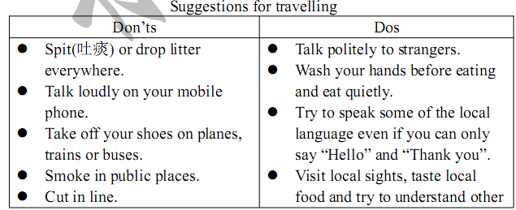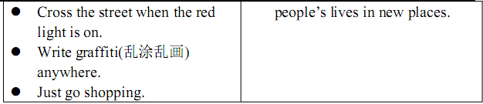
71．These suggestions are for kids only.
72．Take off your shoes in public places.
73．Cutting in line and littering are not allowed.
74．It’s impolite to talk loudly on mobile phones.
75．We are supposed to eat quietly and talk politely.

八、阅读下面两篇短文，根据短文内容选择正确答案。 （共 10 小题，每小题 2 分；计 20 分）

A
Dear Li Fei,
How are you? I will have a short holiday next week and have decided to
visit Shanghai for a second time. I have booked a room in the Peace Hotel. I
hear it is on the Bund(外滩) and has a good view of the famous Huangpu
River. I will arrive on the night of March 27 and leave early on March 29. I
would like to visit some of the most famous places, such as Nanjing Road
and Yu Garden in Chenghuangmiao.
Can you give me some suggestions for my visit to Shanghai? I will have
only one day to look around Shanghai. I will be happy if you can make a tour
plan for me. Please say hello to Lu Mei. I’m looking forward to your reply.
Yours,
Sandy
76．Who will visit Shanghai next week?
A．Li Fei. B．Lu Mei. C．Sandy.
77．Where has the writer booked a room?
A．On Nanjing Road. B．In Yu Garden. C．In the Peace Hotel.
78．We can learn from the letter that the writer ___________Shanghai.
A．has never visited B．once visited C．often visits
79．When will the writer look around Shanghai?
A．On March 27. B．On March 28. C．On March 29.
80．The most important purpose of writing this letter is to ___________.
A．ask for a tour plan B．ask for a reply C．say hello to Lu Mei

B
Mr. Smith is telling two funny stories of his police work.
Story A
I remember catching a “thief” in a clothes shop once. It was strange. The
man was hiding a yellow sweater inside his coat. I thought he had stolen it, so
I caught him. We found later that his wife gave him the sweater for his
birthday, but he hated it. He just wanted to return it to the shop for money, but
he didn’t want his wife to see him! We soon let him go.
Story B
Another day, a man called Bob went into a bank on Sixth Street. He
wrote on the back of an envelope, “Give me the money! Or I’ll kill you.” and
gave it to the bank clerk. She gave him $100,000 and the man ran away. Then
we received a phone call from the bank clerk. She told us to go to the man’s
house in Candy Town and get him. We caught him as soon as he got out of
the elevator. He couldn’t believe that we found him so quickly. We told him
that the front of the envelope he used had his name and address on it!
81．What does Mr. Smith do?
A．A bank clerk. B．A policeman. C．A thief.
82．Mr. Smith caught the man in the clothes shop ___________.
A．by exchange B．by mistake C．by accident
83．Why did the man return the sweater to the shop?
A．Because he didn’t want his wife to see it.
B．Because he liked money more than the sweater.
C．Because he hated it and wanted to get the money back.
84．Bob was caught so quickly because ___________.
A．his address was found on the envelope he used
B．he received a phone call from the bank clerk
C．the police waited for him outside the elevator
85．What do you think of Bob?
A．He is brave. B．He is careful. C．He is careless.

B 卷 ( 共50分)

一、完成对话。在对话的空格中填上适当的单词，使对话完整正确。一空一词。把答案按编号依次填入下方表格内。 （共 10 小题，每小题1 分，计 10 分）
A：I saw the “Two rooms to rent” note on the wall outside your house. Hope
I’m coming to a 1 place.
B：Yes, you are. We do have two rooms for rent. You are an office clerk,
aren’t you?
A：No, I work at a school. How much do you rent them for?
B：No 2 . I need to ask you some questions now. Are you 3 ?
A：No.
B：Well, I prefer 4 like you to live with us.
A：Really? This room faces north with a view of the hill. Not bad. But I’m
afraid it’s not big enough to be a living room for me.
B：Why? If you know how to make use of it, there’s plenty of 5
here for a single like you.
A：That sounds reasonable. Then how much should I pay you?
B：Three hundred dollars a month. How about it?
A：You’ve asked too much. Could you cut 26 a little?
B：I’m sorry. At present, the cost of 27 eeps increasing.
A：All right. Can I move in right away?
B：Of course. Have you got heavy things to move in?
A：No, 8 piano, for I am a music teacher.
B：Sorry, I’m afraid that I can’t 9 you have the two rooms. My
neighbors and I can’t stand 10 of any kind.

二、短文填空。用下面方框中单词的适当形式填入短文空格内，使短文意思正确、通顺（每词限用一次） 。将答案按编号依次填入下方表格内。 （共 10 小题，每小题 1 分，计 10 分）
check China difficult easy farm forget
little many other peace amazing serious
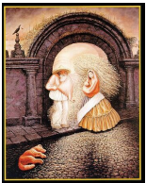
Look at the picture, what do you see?
1 , some people say it’s an old
man, while others say it’s a young woman and an
old 42 . It is a problem with many
answers. Why?
When you look at a problem from different
views, you get different answers. Just turn it in
your mind 3 bit, and you may see it
in a completely new way.
Some people only form an idea in their mind
“A problem has only one answer, and all the 4 are wrong.”
Some even laugh at the different answers others come up with. Well, they’re
wrong! If people only believed in one answer, we might still think the world
is square(方形的)!
What’s one plus one? That’s easy, two! Right? Well, that’s one right
answer, but not the only answer. You might think of 11, or some
45 characters like “二” or “十”! What’s a mom plus a dad? You
might think of two people, or a man and a woman, or a whole family! So,
even the 6 questions can have many answers.
Of course, some problems do only have one answer. If each of the
questions in a math test had 7 than one answer, it would be
quite a problem for teachers 8 .
Look at things in different ways, face your life with a 9
mind, and you’ll see a completely different world.
After reading my article, if I ask you again: “What do you see in this
picture?”, will you still give the same answer now? I’m sure this picture will
be 10 to you.
三、阅读表达。 （共 15 小题，每小题 1 分，计 15 分）
A. 根据短文内容，从短文后的选项中选出适当的选项补全短文，并将选项的编号字母依次填入题号后横线上。 （共 5 小题，每题 1 分，计 5分）
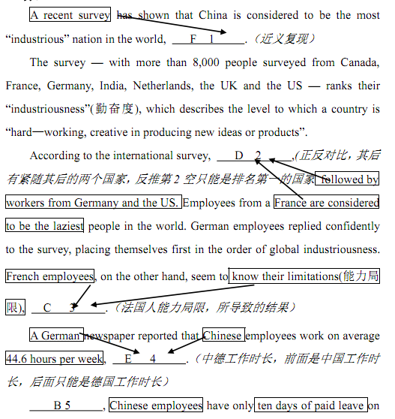
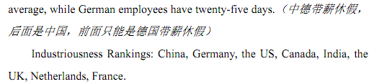
B. 阅读下面短文，根据其内容，补全表格中所缺信息。请将答案按编号
依次填入表格内的题号后横线上。 （共 10 小题，每小题 1 分：计 10
分）
becomes
clear when we look at how the kids sleep at night.
Jyoti, aged 14, Nepal
Jyoti left school at a young age and now lives with one of her sisters in
the Nepalese countryside where she works on the farm. 4、①The family
sleep on mats on the mud floor in the open air, with an open fire for cooking
and keeping warm. Jyoti loves dancing and 5、she wants to become a dancer
to make money for her family.
Tzvika, aged 12,West Bank(约旦河西岸), Israel
4、②Tzvika lives in a gated community(社区) of 36,000 Orthodox Jews
in an Israeli settlement( 定 居 点 ) on the West Bank. Televisions and
newspapers are not allowed from the settlement. The average family has nine
children, but Tzvika has just two brothers, with whom he shares his room.
Religion(宗教) is the most important subject, followed by Hebrew language
and math. Sport is not allowed in the school. Tzvika wants to be a learned
man when he grows up.
Lamine, aged 12, Bounk Village, South Africa
Lamine studies at the local all- boy Koran school and shares a room with
several other schoolmates. 6、His day starts at six o’clock when he and the
other boys work on the school farm with the guide of teachers, and in the
afternoon the boys study the Koran(可兰经). In his free time, lamine likes to
play football with his friends and when he grows up he would like to teach in
this school.
Ahkὸxet, aged 15, River Amazon, Brazil
7、①Ahkὸxet is a member of the Kraho tribe(部落) living near the river
of Amazon. There are only 1,900 members of the tribe. All the tribe members
grow and hunt their own food, and any other material 8、they need is bought,
using money made from film companies and photographers who visit their
camp. He dreams to be head of the tribe when he grows up.
Jasmine, aged 14, Kentucky, the US
7、②Jasmine lives in a big house with her parents and three brothers in
the Kentucky countryside. Her father works as a railroad engineer. Her
bedroom is filled with her favorite toys and her wardrobe is filled with her
dresses, for 9、she normally gets two new dresses every month. She enjoys
being treated like a princess, having her hair done and wearing pretty clothes
and make-up and would like to be a rock star when she grows up.
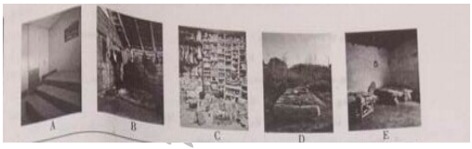
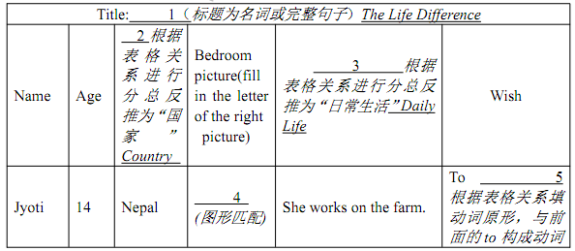
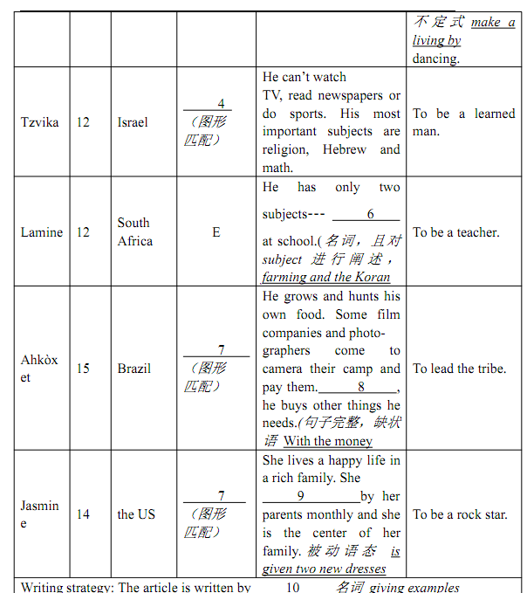

四、书面表达。 （共 15 分）
你即将升入高中，面临寄宿(a boarding school) 和走读(a day school)
两类学校的选择。请你以 “A boarding school or a day school?” 为标题，写一篇 80-120 词的短文，内容须包括：
1. 读寄宿学校的利和弊各一点；
2. 读走读学校的利和弊各一点；
3. 你的选择和理由(理由不得与上述两点内容重复)。
注意：1. 短文必须包括所有要点；
2. 可根据内容要点适当添加有关细节，使行文连贯；
3. 书写规范，卷面整洁。

