保密 ★ 启用前
2015年安顺市初中毕业生学业、升学（高中、中职、五年制专科）招生考试
英语科试题
特别提示：
1、本卷为英语试题单，共八个大题，第一卷五个大题，共85分；第二卷三个大题，共65分，满分150分，共10页。考试时间120分钟。
2、考试采用闭卷形式，用笔在特制答题卡上答题，不能在本题单上作答。
3、答题时请仔细阅读答题卡上的注意事项，并根据本题单各题的编号在答题卡上找到答题的对应位置，用规定的笔进行填涂和书写。
第Ⅰ卷（共85分）
I. 听力。（共15分）
A. 听对话，选图片。（每小题1分，共5分）
下面你将听到五段对话，请根据对话内容选择正确的图片，并将其序号填涂在答题卡上。听完每段对话后，你将有10秒钟的时间来回答有关小题。每段对话读两遍。
1.
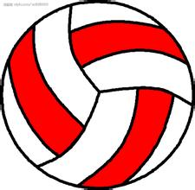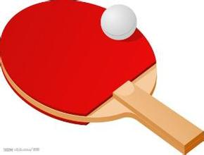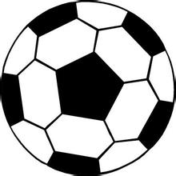
A B C D
2.
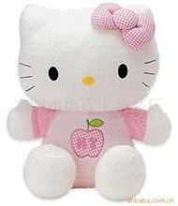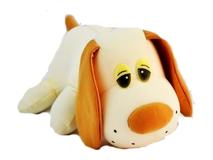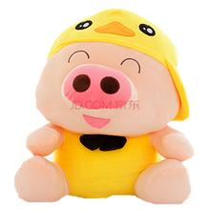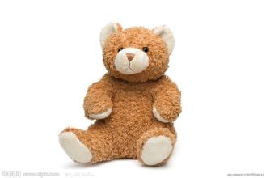
A B C D
3.
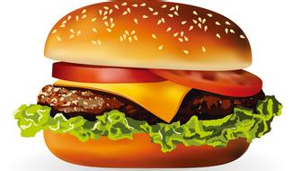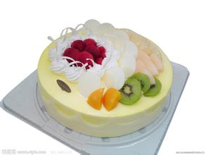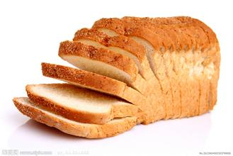
A B C D
4.
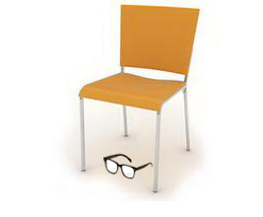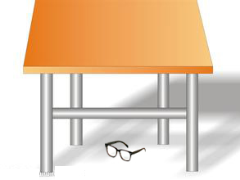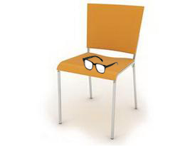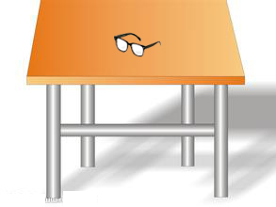
A B C D
5.
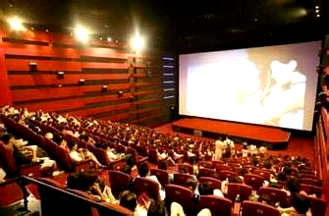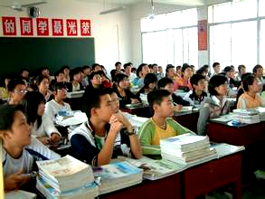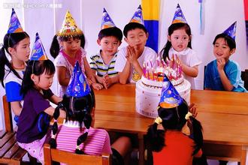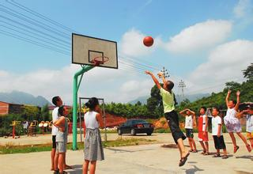
A B C D

B. 听对话，选答案。（每小题1分，共4分）
下面你将听到四段对话，请根据对话内容和问题选择正确答案，并将其序号填涂在答题卡上。听完每段对话后，你将有15秒钟的时间来回答有关小题和阅读下一小题。每段对话读两遍。
6. Where are the man and the woman talking?
A. In a bookshop. B. At a post office. C. In a library. D. In a hospital.
7. What’s wrong with the man?
A. He’s got a cold. B. He’s got a headache.
C. He’s got a fever. D. He’s got a stomachache.
8. When is the father’s birthday?
A. March 20th. B. March 21st. C. March 22nd. D. March 23rd.
9. What is the woman doing now?
A. She is enjoying the music. B. She is turning off the radio.
C. She is turning down the radio. D. She is writing a report.
C. 听短文，判断正误。（每小题2分，共6分）
下面你将听到一段短文，请根据短文内容判断正误，并将答案填涂在答题卡上，正确的填涂（T），错误的填涂（F）。听短文前，你有10秒钟的时间阅读各小题，听完短文后你将有20秒钟的时间作答。短文读三遍。
10. Maria has meat, vegetables and rice for lunch.
11. Maria often eats some fruit after meals, but she doesn’t like apples.
12. Maria is always busy studying, so she never does the housework.

II. 单项选择。（每小题1分，共20分）
13. Here are some . Do you like ?
A. oranges; them B. orange; it C. oranges; they D. oranges; their
14. It took people three months to build this great building.
A. two hundreds B. hundred of C. hundreds of D. two hundred of
15. —He be in the classroom, I think.
—No, he be in the classroom. I saw him go home a minute ago.
A. can; may not B. must; may not C. may; mustn’t D. may; can’t
16. —When is Lang Lang’s concert?
—It’s three o’clock the afternoon of December 18th.
A. at ; in B. at; on C. on; in D. in; on
17. This kind of T-shirt looks and sells in the market.
A. nice; good B. well; well C. nice; well D. good; nice
18. Why not your friends for help when you are in trouble.
A. ask B. to ask C. asks D. asking
19. —They go to school early in the morning. —
A. So do Tom. B. So Tom do. C. So does Tom. D. So Tom does.
20. —What would you like to have for supper?
—Either noodles or rice OK. I don’t mind.
A. are B. were C. is D. was
21. Premier Zhou Enlai for many years, he still lives in the hearts of Chinese people.
A. died B. was died C. has been died D. has been dead
22. Mary with her parents often for a walk in the park after supper.
A. go B. is going C. are going D. goes
23. We some robots at home in the future, and there some in the office, too.
A. will have; will have B. have; will be
C. will have; will be D. will have; are
24. Rose, you are so thin. You should eat more, you’ll make yourself ill.
A. or B. if C. and D. but
25. —Don’t be late for school next time, ______? —No, I won’t.
A. are you B. will you C. do you D. did you
26. —What’s wrong with you, Eric? You look tired.
—I to prepare for the final exam last night.
A. picked up B. woke up C. put up D. stayed up
27. —Listen! Someone is playing the piano.
— Wow! beautiful music! I like it very much.
A. What B. How a C. What a D. How
28. —Have you seen film where are we going, Daddy?
—Yes, it’s quite interesting film so that I have seen it twice.
A. a; the B. the; an C. a; an D. the; the
29. —Mum, shall we have lunch? —We will have it when your dad .
A. when; returns B. where; will return C. where; returns D. when; will return
30. —It’s too cold today. Would you mind the window? —Certainly not. Go ahead.
A. to close B. closing C. close D. closed
31. I think the first lesson we are learning is very easy.
A. that B. where C. who D. when
32. —Excuse me, can you tell me ? —At about 8 o’clock.
A. what time the plane arrive in Beijing B. what time the plane will arrive Beijing
C. what time the plane will reach Beijing D. what time will the plane get to Beijing

III. 完形填空。（每小题1分，共15分）
Mr. Clarke works in a middle school. He likes reading and often 33 some books from the library. He 34 to the radio every morning and reads 35 after supper. So he knows much and teaches well. His 36 worship(崇拜)him very much. Mike, Mr. Clarke’s little son, is only nine. He 37 likes reading books. And he often asks his father some questions. Mr. Clarke always thinks he’s too 38 to understand him and chooses 39
ones to answer. Of course the boy is not satisfied with(对……满意)it. One day Mike read
40 about the lights and was 41 it. When his father told him to do some housework, he went on thinking of it. He asked him 42 questions, and his father answered all. Then his father said proudly, “Fathers always know 43 than sons!” The boy thought for a while and said, “ 44 .” His father asked, “Oh? Why?” Mike didn’t answer, and asked,
45 , “Who invented the lights?” “ 46 ”answered Mr. Clarke. “Why didn’t his father invent them, then? ” Looking at his son, Mr. Clarke didn’t know 47 to answer!
33. A. finds B. sells C. borrows D. buys
34. A. hears B. listens C. says D. reads
35. A. CD B. music C. TV D. newspapers
36. A. teachers B. parents C. students D. classmates
37. A. also B. never C. even D. only
38. A. old B. young C. clever D. able
39. A. more difficult B. the most difficult C. easily D. the easiest
40. A. everything B. nothing C. something D. anything
41. A. worried about B. interested in C. afraid of D. angry with
42. A. few B. little C. a few D. a little
43. A. more B. most C. less D. least
44. A. I think so B. I don’t think so C. I agree D. I don’t know
45. A. instead B. carefully C. quickly D. brightly
46. A. Thomas Brown B. Allan Smith C. Thomas Edison D. Ron Jenkins
47. A. when B. where C. which D. what
IV. 阅读理解, 根据短文内容选择正确答案。（每小题2分，共30分）
A
Tom and his cousin took a boat trip. When they got on the boat, every passenger(乘客)should answer the keeper a question. If the passenger answered “yes”, he or she got one gift; if the passenger answered “no”, he or she got two gifts. Tom and his cousin saw all about this. Now it was their turn. The keeper came up to them and asked, “Are you a good sailor?” Tom wanted to get two gifts, so he answered “no” loudly, at the same time he said, “I have never been a sailor, how could I be a good sailor?” The keeper gave him two gifts. His cousin gave the same answer, so he got two gifts, too.
The boat started off. The passengers began to open their gifts. Tom and his cousin did the same. They found that one of the two gifts was a small bottle of drinking water, the other was a seasick tablet(晕船药). Tom had a look at a “yes”-passenger’s gift. His was a nice chocolate. Tom shouted at the keeper, “We are never seasick. Why do you give us seasick tablets?”
48. Tom and his cousin ________.
A. went to eat chocolates B. went on a trip by boat
C. worked for the keeper D. needed a bottle of drinking water
49. When did the keeper ask the passengers questions?
A. Before the trip. B. After the trip. C. During the trip. D. Never.
50. Why did Tom and his cousin answer “no”?
A. Because they felt sick on the boat.
B. Because they were good sailors.
C. Because they both wanted to get two gifts.
D. Because they wanted to have chocolates.
51. The underlined(下划线)part “a good sailor” means ________.
A. 晕船 B. 不晕船 C. 好销售员 D. 好水手
52. Which of the following statements is true?
A. The keeper cheated(欺骗)Tom and his cousin.
B. Tom and his cousin didn’t want the seasick tablets.
C. All the other passengers answered “yes”.
D. The keeper didn’t want to give Tom and his cousin chocolates.
B
Many years ago, there lived a very rich man who wanted to do something good for the people of his town. But first he wanted to find out if they deserved(值得)his help. So he put a very large stone in the middle of the main road into the town. Then he stood behind a tree, waiting and watching.
Soon an old man came along with his cow. “Who put this stone in the center of the road?” said the old man, but he didn’t try to move the stone away. He passed around the stone with some difficulties and continued on his way. Another man came along and did the same thing; then another came, and another. All of them complained about the stone in the center of the road, but nobody tried to move it.
Late in the afternoon, a young man came along. He saw the stone and said, “It will be dark at night. Some people will come along later in the dark and will fall over the stone and get hurt.” The young man then began to move the stone. He pushed and pulled and tried everything he could to move it out of the road. But to his surprise, under the stone he found a bag full of money and this message, “This money is for the person who moves this stone from the road. The person deserves help.”
53. Who put the stone in the center of the road?
A. An old man. B. A rich man. C. A young man. D. Another man.
54. Why did the young man move the stone out of the road?
A. Because he was strong enough to move it.
B. Because he knew there was a bag of money under it.
C. Because he didn’t want other people to fall and get hurt.
D. Because the rich man wanted him to do so.
55. When the young man moved the stone, he found ________________.
A. a bag B. a message
C. a bag full of money and a message D. a bag full of message
56. All of the people coming along the road did nothing about the stone except ___________.
A. people of the town B. the young man
C. the rich man D. the old man with his cow
57. What can we learn from the passage?
A. If we do well, we will have well.
B. If we move stones, we will have a lot of money.
C. The young man was lucky.
D. Other people were unlucky.
C
①Have you ever wondered what goes through your mind when you choose where to sit in a new classroom? Or in a waiting room full of strangers? Or on a bus? Researchers have found out some interesting facts.
②Girls sit by girls and boys sit by boys. Adults sit together and young people choose another young person to sit near. But it goes further than this. We even choose to sit near someone who looks like us. People with glasses are more likely to sit near other people with glasses. People with long hair sit closer to other people with long hair.
③We seem to believe that people with similar habits or hobbies will share similar experiences and we are more likely to be accepted by people like ourselves, or even, we think we may be safer with people who look like us. Sometimes that’s true but it’s a pity if we always stay with the same people, the same group. The danger in always staying in our comfort zone (舒适区)is that we just recycle the same opinions, the same tastes and the same ideas. We lose the chance to learn something new, find out interesting things, hear funny stories and discover differences.
④When we always stay with the same people, how can we break down the barriers which prevent us from getting to know people with different ideas? And how can we avoid the ignorance(无知)? If you want to live in a society that opens to changes, new things and different opinions, be the cat among the pigeons(鸽子).
⑤Move out of your comfort zone. Go and sit next to someone different. And don’t just sit there in silence. Say hello. Ask a question. Start a conversation. That’s how we make friends. That’s how we learn about people. That’s how we open our minds to new ideas. That’s how we live an exciting life.
58. From the passage, we know that people prefer sitting by someone who .
A. is like themselves B. has a sense of humor
C. is open-minded D. lives an exciting life
59. People like staying in their comfort zone because they may .
A. remain comfortable and special B. find out more interesting things
C. be accepted easily and feel safe D. discover differences among themselves
60. The sentence “Unsurprisingly, we prefer to sit closer to people like ourselves.” should be
put at the beginning of __________.
A. Paragraph 1 B. Paragraph 2 C. Paragraph 3 D. Paragraph 4
61. What does the underlined word “barriers” mean in Paragraph 4?
A. 联系 B. 隔阂 C. 纽带 D. 熟悉
62. What is the purpose of the passage?
A. To tell us not to talk with strangers.
B. To introduce ways to learn about the world.
C. To explain how people communicate with foreigners.
D. To encourage us to get along with different people.
V. 交际运用。（每小题1分，共5分）
补全对话：根据对话内容，从方框中选择适当的选项补全对话，其中有两项为多余选项。
A. Don’t you think it’s a little silly?
B. I’m reading a book called YU Gong Moves a Mountain(愚公移山).
C. That’s better and faster than moving a mountain.
D. In my opinion, it’s really interesting.
E. Do you prefer to read stories?
F. I still don’t agree with you.
G. How about you?
Emma: What are you doing, Li Lin?
Li Lin: 63
Emma: I have read it before. What do you think of the story?
Li Lin: 64 Yu Gong found a good way to deal with his problem.
Emma: Really? 65 It seems impossible to move a mountain.
Li Lin: But the story is trying to show us that anything is possible if you work hard. Yu Gong kept trying and didn’t give up.
Emma: 66 I think we should try to find other ways to deal with a problem.
Li Lin: But what could YU Gong do except moving the mountains.
Emma: He could build a road. 67
Li Lin: We have different opinions about the story. There’re many sides to a story and many ways to understand it.
Emma: Yes, that’s fine.

第Ⅱ卷（共65分）

I. 综合语言运用。（每小题2分，共40分）
A. 用所给词的适当形式填空。
1. There used to be many (wolf), but only a few of them remain today.
2. At present, Chinese is (wide) used around the world.
3. The doctor advised my father (not smoke) any more.

4 .We should be (friend) to others at any time.

5. It’s reported that Chinese couples can have their (two) child if one of them is an only child.

B. 从方框中选择合适的短语并用其适当形式填空。（有一项多余）
6. Last night he found it difficult because of the loud noise outside.
drop by; fall down; ever since; on one’s own; by accident; fall asleep
7. My uncle always my home when he came to our city.

8. He went to France the year before last and I haven’t heard from him then.
9. He didn’t get any help and had to complete the work .
10. I really don’t want to know your secret. I only found it .

C. 句型转换，每空一词
11. What food do you like best?(改为同义句)
What’s __________ __________ food?
12. The teacher made the students copy the text.(改为被动语态)
The students were __________ __________ copy the text.
13. She said , “I have seen the interesting film.”(改为间接引语)
She said that __________ __________ seen the interesting film.
14. Ben has finished the project on reusing natural resources.(改为否定句)
Ben __________ __________ the project on reusing natural resources.
15. Amy studied in a university for several years.(对划线部分提问)
__________ __________ did Amy study in a university?
D. 根据所给汉语提示完成对话。
A: Bill, 16 .(这些天我们太累了。) Let’s go somewhere to relax this evening.
B: OK. 17 ?(你想去哪里?)
A: Some new films are on this week. Shall we go to the cinema?
B: 18 .(听起来不错。) Which film would you like to see?
A: Let me look through the poster in the newspaper. Er…How about Coming Home?
B: Yeah, I’ve heard of it. 19 .(它很感人。) Let’s go.
A: But look at the sky, it’s going to rain soon.
B: Well, it’s better to take umbrellas with us.
A: 20 .(电影将在两小时后开始。) We can go after supper.
B: All right.
II. 任务型阅读。（每小题2分，共10分）
There once was a woman. She had a faithful(忠实的)dog. The dog was so faithful that she could leave her baby with the dog when she went out. (A) And after she returned, she would always find her baby safe.
One day, the woman left the baby with the dog and went shopping. When she returned, she found something had taken place in the house. There were bloodstains(血迹)all over the bedroom. The woman then thought of her baby. She cried and started looking for him. Then she saw the faithful dog. It was licking（舔）its mouth. It seemed that it had just finished a delicious meal. The woman was angry and thought that the dog had killed her baby. Without thinking too much, (B) ________________.
But as she continued looking for her child, she saw something else. Close to the bed, there was her baby and he was sleeping. And under the bed, there was a dead jackal(豺狼). The woman now understood what had happened. The dog tired to protect her baby from the jackal, but just now she killed the dog. How regretful she was!
21. 从文中找出与下句意义相近的句子。
The dog seemed to have just finished a good meal.
22. 将(A)处划线句子翻译成汉语。
23. 根据文章内容，将(B)处补充完整。
24. 把下面发生的事情排序：
①The woman found the bloodstains all over the room.
②The woman found her baby sleeping.
③The woman killed the dog.
④The woman started looking for her baby.
25. What is the best title for the passage?

III. 书面表达。（15分）
学会自我保护是青少年需要具备的一种意识和能力。请根据以下提示，并结合自己的观点，以“How Can We Protect Ourselves?”为题，写一篇不少于80词的短文，谈谈在生活中青少年应该怎样自我保护(self-protection)。
提示：1. never swim alone;
2. be careful to make friends;
3. call the police when you are in danger;
4. eat healthy food;
5. don’t crowd(go upstairs and downstairs)
要求：1.句子结构准确，要点齐全，内容合理，篇章结构连贯；
2.文中不能出现真实姓名、校名、地名。

