2017 年浙江省初中毕业升学考试（嘉兴卷）

英语 试题卷

考生须知：

1．本试题卷分卷 I（选择题）和卷 II（非选择题）两部分。请考生使用规定用笔，将所有试题 的答案涂、写在答题纸上。做在试题卷上无效。

2．全卷共 8 页，7 大题。满分为 120 分。考试时间为 100 分钟。

温馨提示：答题前请仔细阅读答题纸上的“注意事项”。

# 卷 I

注意：每小题选出答案后，用 2B 铅笔把答题纸上对应题目的答案标号涂黑，如需改动，用橡 皮擦干净后，再选涂其他答案标号。

1. 听力（本题有 15 小题；第一节每小题 1 分，第二、三节每小题 2 分；共计 25 分） [来源:学_科_网Z_X_X_K]

第一节：听小对话，从 A、B、C 三个选项中选出正确的选项，回答问题。

1. What is the weather like?
   1. Sunny. B. Rainy. C. Cloudy.
2. What time does Sam get up on weekends?

A. At 8:00. B. At 9:00. C. At 10:00.

1. Where does David come from?
   1. Canada. B. Britain. C. Australia.
2. How did Jack get to the cinema?[来源:Zxxk.Com]
   1. On foot. B. By car. C. By bus.[来源:Zxxk.Com]
3. What will the man probably do this afternoon?
   1. Go shopping. B. Go swimming. C. Go fishing. 第二节：听长对话，从 A、B、C 三个选项中选出正确的选项，回答问题。 听下面一段较长对话，回答第 6、7 两个问题。
4. What’s wrong with Linda?
   1. She has a headache. B. She has a cold. C. She has a fever.
5. What’s the most possible relationship between the two speakers?
   1. Father and daughter. B. Teacher and student. C. Doctor and patient.

听下面一段较长对话，回答第 8~10 三个问题。

1. What is Anna planning?
   1. A study tour. B. A school trip. C. A family vacation.
2. How long will Anna stay in England?
   1. For a week. B. For two weeks. C. For three weeks.
3. Why does Anna plan to go to Cambridge?
   1. To visit her uncle. B. To go sightseeing. C. To visit a university.

第三节：听下面一段独白，从 A、B、C 三个选项中选择正确的选项，回答问题。

1. What is Tom’s weekend job?
   1. To print newspapers. B. To sell newspapers. C. To hand out newspapers.
2. Where does Tom put the newspapers on rainy days?
   1. On the book shelves. B. In the milk boxes. C. In the letter boxes.
3. Why does Tom fix a light onto his bike?
   1. Because he has poor eyesight.
   2. Because he wants to make his bike nicer.
   3. Because he often can’t finish the task until after dark.
4. How far is Tom’s working area?
   1. Close to his school. B. Close to his home. C. Very far from his home.
5. Which word can best describe Tom?
   1. Lazy. B. Friendly. C. Hard-working.

二、完形填空（本题有 15 小题；每小题 1 分；共计 15 分） 阅读下面短文，掌握其大意，然后从每题所给的 A、B、C、D 四个选项中选出最佳选项。

It was the summer before my third grade. Our girls’ softball team was facing real pitchers(投球手) 16 the first time. Before that, we could just hit the ball on the tee(球座). When the coach started pitching, hitting

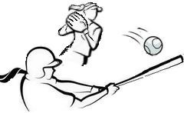

became 17 for me. I missed every single pitch. From the side, I heard my teammate Emily laughing at 18 . My face got hot and my throat



felt like it had a softball stuck in. At that moment, I was starting to 19 playing softball.

The next afternoon, when Mum said it was time to play the game, I told her I was 20 . She allowed me to lie down for a while. So I went to my room and 21 myself in bed. This was difficult for me because I was fine and just 22 to avoid softball.

Soon Mum came in and said, “Time to go!” She didn’t even ask if I felt 23 . I imagined Emily laughing from the sideline, and 24 I really did feel sick to my stomach. I began crying loudly. Still, Mum pulled my team T-shirt over my head. She said, “You have to 25 for the rest of the season, and only after that we can talk about 26 you’ll continue next year.” She added that practice was what I needed, not 27 . She promised to practice with me.

I got two hits that afternoon, and Emily didn’t make a 28 . Every week after that, I practiced at home 29 I got to be one of the best hitters on the team.

That 30 taught me being afraid is part of life, and I can do whatever is expected of me if I keep working and practicing.

1. A. for B. by C. from D. about
2. A. noisy B. natural C. hard D. possible
3. A. him B. them C. me D. us
4. A. remember B. hate C. enjoy D. practice
5. A. bored B. sick C. shy D. sad
6. A. helped B. dressed C. threw D. taught
7. A. failed B. wanted C. refused D. offered
8. A. safer B. better C. warmer D. happier
9. A. usually B. probably C. carefully D. suddenly
10. A. play B. break C. share D. relax
11. A. what B. where C. which D. whether
12. A. waking up B. hurrying up C. giving up D. speaking up
13. A. plan B. sound C. choice D. decision
14. A. until B. unless C. after D. though
15. A. accident B. business C. relationship D. experience

三、阅读理解（本题有 15 小题；每小题 2 分；共计 30 分） 阅读下面四篇短文，从每题所给的 A、B、C、D 四个选项中选出最佳选项。

## A

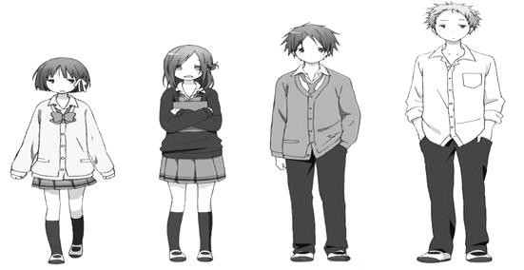

**Come on! Get in Style!**

Do you want to get some styling tips to look bright and pleasant? Come and join us in the new Styling Club to make yourself different! **What will you learn?**

★ basic haircare and skincare tips

★

★

★

make-up(化妆) and hair styling skills

proper mix-and-match skills

dressing tips for special occasions(场合)

Stylist Ms. Janice Smith will teach members the above skills. Not only will you become more confident with your look, you will also have the chance to help with the make-up and styling for school activities like fashion shows and New Year’s parties.

**When and where do we meet?**

Our club meets every Tuesday after school, from 3:30 pm to 5:30 pm, at Room TA01 in the Student Activity Centre.

**How can you be a member?**

Students who want to join the club should visit our website at *[www.kts.edu.au/stylingclub](http://www.kts.edu.au/stylingclub)* to sign up before 15th September. There are only 20 places. First come, first served!

**What is the cost?**

Each member needs to pay $50 for styling products.

**How can you get more information?**

For further information, you can email Karen Yung (*karen.yung@kts.edu.au*). She will be happy to answer all your questions.

1. The members of the Styling Club will meet every week.
   1. one hour B. two hours C. three hours D. four hours
2. The members will learn how to in the Styling Club.



* 1. dress properly B. visit websites

C. make beautiful clothes D. organize school activities

1. will most probably join the Styling Club.
   1. Kids who dream to be web designers
   2. Teachers who expect to learn skin care
   3. Students who hope to look fashionable
   4. Parents who wish to improve make-up skills

## B

Around the world, there are about 7,000 National Parks. Most of them cover huge areas of land where nobody lives. However, the National Parks in England include places where people live and work, as well as wild areas where there are few human activities.

The National Parks in England are called “England’s Breathing Spaces” because they are places where people can go to be in the open air, away from the dirt and noise of cities. They provide wonderful scenes of mountains, woods, grasslands and wetlands. And there are plenty of activities to do in all of the National Parks in England. Visitors can walk or ride bikes for fun. Many of the parks put on activities for families.



Every year there are about 110 million visitors to the parks, bringing many benefits(益处) to the

areas. At the same time, it creates problems too. First, life can be difficult for local people. Car parks and roads are too crowded. Gift shops and cafes take the place of many everyday shops. Even house prices in some areas can become too high. Besides, country roads can be damaged, for too many people walk, cycle or ride horses on them. Roads can be rebuilt, but then they look less natural. Another big problem to the National Parks is litter. In the parks it is a danger to wild animals. Broken glass can also cause fires by focusing the rays of the sun. Such fires in wild places can be out of control.

▲ ? All National Parks in England are making more rules, which tell people how to take good care of their environment. If these rules are followed, the National Parks will be well kept and continue to give pleasure to many people for a very long time.

1. Visitors to the National Parks in England can .
   1. give food to wild animals B. drive cars on the grasslands

C. enjoy fresh air and peaceful time D. have fun farming with local people

1. The third paragraph mainly tells us .
   1. the problems of the National Parks B. the pollution caused by visitors

C. the development of the National Parks D. the benefits brought by visitors

1. Which of the following is the best sentence to fill in the blank in Paragraph 4?
   1. What can people get B. How can people help

C. What are the National Parks like D. How are the National Parks set up

1. The passage is probably taken from the part of a magazine.
   1. transport B. wildlife C. history D. geography

Have you ever been in a conflict(冲突)? Do you know how to solve it? Conflict resolution is a peaceful way of trying to solve a conflict. Both sides in the conflict explain what they think happened to cause it. The person who listens to both sides is called the mediator(调解人).

After both sides tell what they think happened to cause the conflict, they discuss ways to solve it. They try to come up with a “resolution” that both sides agree to. They cannot be angry during the communication. Everyone should use good listening and attending skills while talking. If voices get too loud or it appears that someone is angry, the mediator will speak up and have them treat each other with respect. After different suggestions are shared in how to mediate the conflict, it is time for



discussing the best solution(解决办法).

Here is an example of how conflict resolution works step by step in a school playground setting:

* *Someone says a student pushed him on the football field.*
* *The person who* ***was accused*** *as the “pusher” says it was actually an accident.*
* *The person who was pushed gets the mediator.*
* *The mediator takes the two persons to a quieter place, away from others to talk.*



* *The mediator calms them down and lets them know he understands their feelings.*



* *Each person describes what happened.*



* *The mediator repeats what he heard, so it is clear to everyone.*
* *The mediator asks for ideas to solve the problem.*
* *The two persons offer their own solutions.*
* *The two persons have a discussion and come to an agreement.*
* *The mediator makes sure the persons follow the solution.*
* *The mediator offers praise for solving the problem.*

Conflict resolution can be used in many environments. It encourages people to tell what really happened, to share their feelings, and to work together peacefully to solve the problem. It offers people workable steps to reach an agreement with the help of a mediator.

1. According to the passage, if two students have had a fight, they had better .
   1. call the police B. get a mediator

C. ask parents for ideas D. describe the fight to teachers

1. In conflict resolution, the mediator’s job is to .
   1. describe what really happened to both sides
   2. help both sides reach an agreement in a proper way
   3. listen to both sides and then punish the trouble maker[来源:Zxxk.Com]
   4. write down what both sides have explained in the communication
2. The underlined words “**was accused**” in this passage might mean “ ” in Chinese. A. 被惩罚 B. 被轻视 C. 被指责 D. 被否定
3. The writer gives the example in the passage in order to .
   1. show how a mediator works in a football match
   2. help us know the importance of a mediator in daily life
   3. show how conflict resolution is used in different environments
   4. help us clearly understand the workable steps in conflict resolution



Kathy could still remember the night she had to leave her home in Hungary. It was the beginning of World War II and her family had to leave their country as soon as possible. She quickly filled a bag with a few pieces of clothing, her diary, and her treasure—a beautiful silk scarf.

Kathy and her best friend, Monica, had asked their parents to buy them matching scarves. They each would wear the scarves as a symbol of their friendship. Kathy had no idea that she was going to America that night and would not be returning.

Kathy kept that special silk scarf for many years. One day she decided to give it to her granddaughter, Eliza, to wear to her first job interview for good luck. Kathy was afraid that Eliza would lose the scarf, but the granddaughter promised, “Don’t worry, Grandma, nothing’s going to happen to your scarf. You’ll see. It is going to bring both of us luck today.” And with that, Eliza kissed her grandmother and left for the interview.

That afternoon Eliza left the interview, feeling sure that she had got the job. So she decided to celebrate by going to a restaurant. As she was sitting at her table, she felt someone looking at her. Sitting next to her was an old woman, who could not take her eyes away from her.

“I’m sorry, do I know you?” Eliza asked.

“I’m sorry, dear, but you make me think of someone I once knew,” the old woman replied. “My best friend looked like you and used to wear a scarf just like the one you’re wearing around your neck.” Eliza listened carefully, with her eyes and mouth wide open. She had heard stories of her grandmother’s best friend and knew the meaning of the scarf. Could this be Monica, her grandmother’s childhood friend?



Eliza introduced herself and waited to hear the name of the other woman.

“My name’s Monica, dear. I lived in Hungary as a child, but my family had to leave when I was fourteen years old. I’ve been living here in California ever since.” said the old woman.

Eliza could not believe her ears …

1. Kathy and her family left their country because _.
   1. Kathy found a job in the USA B. Kathy would study in California

C. they had no friends in Europe D. they wanted to get away from the war

1. From the underlined sentence in Paragraph 6, we can infer(推断) that Eliza felt .
   1. surprised B. thankful C. sorry D. nervous
2. What would Eliza most probably do after the dinner?
   1. She gave the silk scarf to Monica.
   2. She went for another job interview.
   3. She showed Monica around California.



* 1. She took Monica to meet her grandmother.



1. The best title for this passage can be .
   1. *A Gift from Parents* B. *A Scarf of Luck*

C. *A Successful Interview* D. *A Story in the War*

# 卷 II

注意：用黑色字迹的签字笔或钢笔将答案写在答题纸上。

四、词汇运用（本题有 15 小题；每小题 1 分；共计 15 分）

A. 用方框中所给词语的适当形式填空。每词限用一次。

Asian

empty

in person

paint

nearly

1. As it was getting dark, the streets in this town became almost .
2. Although Jenny is only 12 years old, she’s

as tall as her father.

1. If you can’t be there , the next best thing is watching the match on TV.



1. You can find elephants both in Africa and , but they are kind of different.
2. The students were pictures for the art show when the teacher came in.

B. 根据短文内容和所给中文提示，在空白处写出单词的正确形式。每空限填一词。

## All About “A-thons”

A marathon(马拉松) is a long-distance running race. Now it is not only a competition, but some people organize marathons for charity(慈善). Runners get friends, families and other people to

51 (支持) them. They promise to provide a certain amount of money for every race. For example, if the runner runs one 52 (千米), the providers each give the runner $1 for the charity.

A 53 (许多) of money can be raised this way. However, not everyone can run, so people in the USA have thought of other ways to raise money, using the idea of a marathon.

***Walk-a-thons*** A walk-a-thon is similar to a marathon, but people walk 54 (代替) of

running. This is one of the most 55 (受欢迎的) ways for people to raise money.

***Read-a-thons*** Many schools organize read-a-thons to raise money. Students can get money

56 (简单地) for the number of books they read in a given amount of time. They may have

57 (十) weeks to read. Little kids can also get money according to how many 58 (页) they read. The read-a-thons are 59 (举行) not only to raise money, but also to encourage teenagers to read.

***Bowl-a-thons*** Bowling is an 60 (有趣的) sport for many Americans. In a bowl-a-thon, people raise money for every point they get in the game. The higher the score is, the more money they make for the charity.

五、语法填空（本题有 10 小题；每小题 1 分；共计 10 分）

阅读下面短文，在空白处填入一个适当的词，或填入括号中所给单词的正确形式。

Justin is a 16-year-old boy. He is thinking about how 61 (spend) his money during winter vacation. He 62 (save) up about 300 dollars already. He plans to buy 63 computer with his money but he also wants to go skating with his friends. He can’t do both 64 he doesn’t have enough money. What should Justin do?

We are often in these kinds of situations. You want to see a concert 65 Saturday, but it is also your mother’s birthday and you do not want to let 66 (she) down. In this case, you don’t have enough time to go to both 67 (place). You must make a decision. You must think about

68 should be done first. You must consider the following questions 69 (serious).

* Which is more important?[来源:学.科.网]
* Which decision needs my attention more?
* Which choice would satisfy me more?

After you’ve answered these questions, it may be much 70 (easy) for you to decide what to do. So the next time you must make a decision, remember to prioritize(优先考虑).

六、任务型阅读（本题有 5 小题；每小题 1 分；共计 5 分）



Peter 将离开墨尔本（Melbourne）外出工作一年，他打算将其房屋出租。请根据下面的地 图与房屋平面示意图，把他的房屋出租信息补充完整。

**House for Rent**

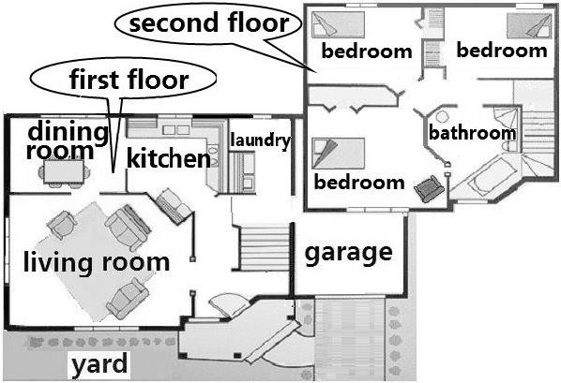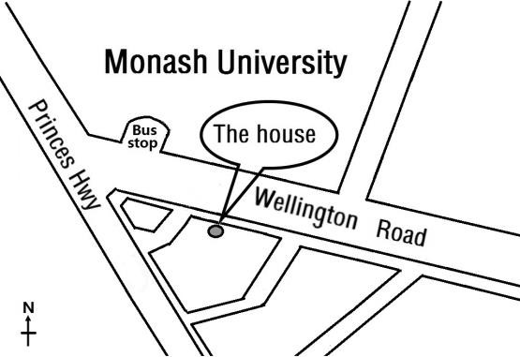

**Want a nice house for just $ 600 a week?** This house is on 71 Road in the City of Melbourne. It is just opposite Monash 72 . It is well kept by the owner. Outside the house, there is a garage and a yard in the front. On the 73 floor, there is a living room, a dining room, a 74 , and a laundry. On the second floor, there is one big 75 and three bedrooms, fully furnished.

It is the best for this price! Please call Peter at +61 3 9905 1777 in the daytime if you want to

rent it.

七、书面表达（共 1 小题；满分 20 分）

76. 学校将举办“A Summer for Better English”活动。请你从下面的推荐书单中选择 2 本想阅 读的书刊，然后用英语写一篇短文说明你的选择意向及理由，在学校的 English Corner 分享。

## A list of books for English skills and for fun

* + *Basic English Writing*
  + *Secrets of English Words*
  + *A Guide to English Listening*
  + *20 Topics for English Speaking*

□ *Treasure Island*

□ *Robinson Crusoe*

□ *Alice’s Adventures in Wonderland*

□ *Time for Kids* (a magazine)

**注意**：（1）必须从书单中选择 2 本书刊，并阐述理由。

（2）文中不得出现与你身份相关的信息。

（3）词数：80~100。短文首句仅供选择使用，不计入总词数。

短文首句：To improve our English, the school has given a list of books for us to read this summer.

2017 年浙江省初中毕业升学考试（嘉兴卷）

Ⅰ. 参考答案 **一、听力**

英语参考答案

1. A 2. B 3. A 4. C 5. A 6. A 7. B 8. C 9. B 10. A

11. C 12. B 13. C 14. B 15. C

# 二、完形填空

16. A 17. C 18. C 19. B 20. B 21. C 22. B 23. B 24. D 25. A



26. D 27. C 28. B 29. A 30. D

# 三、阅读理解

31. B 32. A 33. C 34. C 35. A 36. B 37. D 38. B 39. B 40. C

41. D 42. D 43. A 44. D 45. B

# 四、词汇运用

46. empty 47. nearly 48. in person 49. Asia

50. painting 51. support 52. kilometer/kilometre 53. lot



54. instead 55. popular/welcome 56. simply/easily 57. ten

58. pages 59. held 60. interesting/enjoyable

# 五、语法填空

61. to spend 62. has saved 63. a 64. because/as/since

65. on 66. her 67. places 68. which/what

69. seriously 70. easier

# 六、任务型阅读



71. Wellington 72. University 73. first 74. kitchen 75. bathroom

# 七、书面表达

76. *One possible version:*

To improve our English, the school has given a list of books for us to read this summer. Of all the suggested books, I have decided to choose *Secrets of English Words* and *Time for Kids*.

The first one is a book which may help use English words better. By reading this book, I will surely learn more new words. This will make my future study much easier. *Time for Kids* is a popular magazine specially written for students, in which I will read interesting stories and have a taste of teen life abroad. So it must be great fun reading it.

By being part of this activity, I am expecting a big step forward in my English.

( 100 words )

英语参考答案和评分细则（JX）第 1 页（共 4 页）